2020

ANNUAL REPORT

The University of Queensland

24 February 2021

The Honourable Grace Grace MP
Minister for Education, Minister for Industrial Relations and Minister for Racing
PO Box 15033
CITY EAST QLD 4002

Dear Minister
I am pleased to submit for presentation to the Parliament the Annual Report 2020 and financial statements for The University of Queensland. I certify that this Annual Report complies with:
- the prescribed requirements of the Financial Accountability Act 2009 and the Financial and Performance Management Standard 2019
- the detailed requirements set out in the Annual report requirements for Queensland Government agencies, July 2020.
A checklist outlining the annual reporting requirements can be found at about.uq.edu.au/ annual-reports.

Yours sincerely
Peter N Varghese AO
Chancellor, The University of Queensland

Acknowledgement of Country
We acknowledge the Traditional Owners and their custodianship of the lands on which our University stands. We pay our respects to their Ancestors and descendants, who continue cultural and spiritual connections to Country. We recognise their valuable contributions to Australian and global society.

Public availability note
This report, as at 31 December 2020, was produced by Marketing and Communication, The University of Queensland, Brisbane, Queensland 4072 Australia; and is available online at about.uq.edu.au/annual-reports, or by calling +61 7 3365 2479 or emailing publications@uq.edu.au.
The following information is available online at about.uq.edu.au/annual-reports and on the Queensland Government Open Data website at data.qld.gov.au:
  - Consultancies
  - Overseas travel.

Interpreter service statement
The University of Queensland (UQ) is committed to providing accessible services to people from all culturally and linguistically diverse backgrounds.
If you have difficulty understanding this 2020 Annual Report, please contact UQ’s Institute of Modern Languages on +61 7 3346 8200 to arrange for an interpreter to effectively communicate this report to you.

Feedback
If you have any suggestions about how we can improve this report, please complete the feedback form at
about.uq.edu.au/annual-reports.

ISSN 1837-6592 (print)
ISSN 1837-6606 (online)

CRICOS Provider Number 00025B
© (The University of Queensland) 2021

Contents
Vice-Chancellor and President’s review – page 4
    - Year in summary – page 6
    - 2020 Honour roll – page 8
Role and functions – page 10
    - Basis of authority; Controlled entities; Mission – page 10
    - Vision; UQ values; Queensland Public Service values – page 11
    - Locations; Faculties and institutes – page 12
    - Operating environment – page 13
    - Key statistics – page 15
Operational performance – page 16
- Review of activities — Student experience – page 18
- Review of activities — Research impact – page 23
- Review of activities — Partnerships – page 27
- Review of activities — Diverse community – page 29
- Review of activities — Agile operations – page 33
- Review of activities — Sustainable finances – page 36
Human resources – page 39 Governance – page 43
- University governing body – page 43
- Executive management – page 45
- Organisation chart – page 46
- Public Sector Ethics; Risk management – page 47
- Human rights – page 48
- Information systems and recordkeeping; External scrutiny – page 49
Financial information – page 50 Annual Financial Statements – page 53 Glossary – page 126

Vice-Chancellor and President’s review
Resilience and agility. These are the qualities that shone through in our community, as we negotiated our way through the many challenges that arose in 2020.

After a 6-and-a-half year absence, I was incredibly proud to return to The University of Queensland (UQ) in August this year to take up the position as UQ’s Vice-Chancellor and President.
Given that my return occurred in the second half of 2020, I would like to start by acknowledging my predecessor, Professor Peter Høj AC, and I want
to thank him for his leadership of the University
– especially through the initial stages of the COVID-19 pandemic.
While the pandemic created numerous disruptions for the University and our community in 2020,
I also want to acknowledge the remarkable resilience and agility shown by our staff as we dealt with these challenges.
In Semester 1, for instance, our staff worked incredibly hard to shift 1,529 courses to online delivery in the space of just one week. In the weeks that followed, as the nationwide lockdown came into effect, around 6,700 UQ staff quickly moved to working from home, while another 1,300 remained on campus to maintain our facilities
and grounds, and to ensure the continuity of vital research.
As we sought to keep the UQ community connected and safe, the shift to digital delivery of our programs and events became a consistent theme throughout the year. The UQ Life Virtual
Village was established in April as an online forum for students. In May, the UQ Theatre Festival and Reconciliation Week were both conducted online, while the School of Music started live-streaming its lunchtime concerts. Then, in August, we held our first fully online Open Day, attracting more than 6,000 prospective students from 109 nations.
The UQ community also pulled together in 2020 to provide much-needed support for the
thousands of students facing hardship as a direct result of the pandemic.
In total, $1 million in grants was distributed to 600 students via the UQ COVID-19 Student Emergency Support Fund. Meanwhile, an army of staff volunteers, led by Student Services, pitched in to deliver 9,000 food hampers and 28,000 free meals to students in need of support.

2020 highlights
Once again in 2020, our research and educational programs had a wide-ranging impact and UQ continued to enrich the communities that we serve.
UQ either enhanced or maintained its position in the major ranking systems of the world’s universities released in 2020. Most of these ranking systems place UQ among the world’s top 50 and Australia’s top 3 universities.
The excellence of our teaching was recognised in February at the Australian Awards for University Teaching, where UQ received more awards than any other university. Among the 8 awards won by UQ academics, I was delighted to see that
Professors Blake McKimmie, Barbara Masser and Mark Horswill were jointly named the Australian University Teachers of the Year.
The shift to teaching online in Semester 1 enabled the University to continue developing the knowledge and skills of our students, and prepare them for their future careers. In total, we taught almost 55,000 students in 2020, which was only slightly down on enrolments in the previous year.
However, one significant difference this year was that, due to the impact of border closures, we had more than 9,000 students who continued their studies purely online, from an offshore or interstate location.
This meant we were able to support these students to progress towards graduation.
Despite the challenges created by the pandemic, we ensured that the University finished the year in a relatively strong financial position and we maintained around 8,000 research projects – and continued to feed the research pipeline with the approval of 700 new projects this year.
Importantly, our research is having a global impact too, with 32 UQ researchers being included on the Clarivate Highly Cited Researchers 2020 list – up from 28 on the 2019 list.

COVID-19 response
In a year when the emergence of COVID-19 dominated most aspects of our lives, UQ’s research community played a prominent role in improving our understanding of
the virus and, importantly, informing the community response to it.
For instance, it was a UQ team working with CSIRO that developed a method of detecting viral fragments in wastewater as an early indicator of the virus being present in the community.
A number of other scientists from across UQ shifted their focus this year to work with clinicians to either study the virus’s impact in a range of different scenarios or to investigate potential treatments for COVID-19.
Of course, the most high-profile of UQ’s COVID-19 projects was the remarkable team effort that went into developing a vaccine using the University’s patented 'molecular clamp' technology.
With financial support from the Centre for Epidemic Preparedness Innovations, as well as the Australian and Queensland governments, the UQ team was able to rapidly develop a vaccine candidate that proved to be safe and elicited a robust immune response in Phase 1 trials.
Although the trials will not proceed beyond Phase 1, I want to acknowledge the extraordinary hard work and commitment of the UQ vaccine team throughout 2020. They have been tremendous ambassadors for UQ and for Queensland – and they have consistently highlighted the importance
of science and the value of the scientific process. It will be fascinating to see how they apply their innovative molecular clamp technology to the development of vaccines in the future.

Building for the future
We continued to invest across our campuses, sites and facilities in 2020 to ensure that UQ is positioned to support Queensland education and research long into the future.
The refurbishment of the Mayne Medical building at Herston was completed in January. The landscaping upgrade of the Gatton campus was completed in March. And then in August, we opened ModWest, a flat-floored building at St Lucia that features 7 rooms for large-scale interactive learning.
Two other major building projects continued to take shape at St Lucia this year with
the construction of the Andrew N. Liveris Building and the new Student Residence building. Both are on track to be completed in 2021.
Another significant milestone this year was the opening of the 64 megawatt UQ Warwick Solar Farm in July. With the
Warwick facility complete, UQ is now the only major university in the world to have the capacity to offset 100 per cent of its electricity consumption with renewable power produced from its own assets.
More importantly though, the investment at Warwick is proof of UQ’s commitment to protecting the environment and playing a leading role in renewable energy research and education.

Looking ahead
While 2020 was a very challenging year,
I am confident that UQ’s response to the pandemic has helped to instigate significant changes that will benefit the University in 2021 and beyond.
Certainly the sudden, mass adoption of online learning will create new opportunities for designing more flexible educational programs and experiences – and it will enable us to offer students greater choice in how, where and when they study into
the future.
The economic shock associated with the pandemic is already encouraging greater collaboration between government, industry and research organisations – and I am optimistic this is going to provide a vital boost to Australia’s innovation capacity
over the coming years. Given UQ is already Australia’s leading university when it comes to the commercial translation of our research, we are well positioned to play a more active role in the nation’s innovation ecosystem.
The disruption created by COVID-19 also means it’s an opportunity for UQ to reassess our strategic priorities – and this will be
the highest priority of the University as we work collaboratively with staff, students and partners to develop the next UQ Strategic Plan 2022–2025.

Thank you
Finally, I would like to acknowledge the members of the University Senate for their support and encouragement as I have settled into this role over the past 6 months.
In particular, I would like to thank the Chancellor, Peter N Varghese AO, for his wise counsel and strategic guidance. The fact that he has been re-elected for a further 5-year term as Chancellor (starting July 2021) will be of great benefit to the University as we plot our future path – and the contribution that UQ will make to pandemic recovery.
I also want to acknowledge everyone across our wonderful UQ community – our
students, staff, alumni and partners – for the way that you have so warmly welcomed me back to the University.
It really is great to be back.
Professor Deborah Terry AO
Vice-Chancellor and President

Year in summary

January
- UQ becomes first university in Australia to participate directly in the wholesale energy market
- Refurbished Mayne Medical building opens at UQ Herston
- UQ sends out 3,071 study offers, bringing the total number to nearly 8,700
- The Coalition for Epidemic Preparedness Innovations (CEPI) asks UQ to develop
a vaccine against COVID-19 using its molecular clamp technology

February
- UQ researchers link improved parenting with better social outcomes
- UQ researchers meet proof-of-concept milestone for the development of vaccine for COVID-19
- UQ tops nation in 2019 Australian Awards for University Teaching
- UQ researchers discover that metal compounds could hold key to next generation of antibiotics
- UQ researchers develop a new class of 'quantum dots' for solar power generation
- UQ participates in Austrade mission to India
- UQ receives 40 Destination Australia scholarships to study at UQ Gatton

March
- Australian Indigenous Mentoring Experience (AIME) becomes available to UQ students
- UQ is ranked Australia's top university for Agriculture and Forestry, Environmental Studies and Sports-Related subjects in QS World University Rankings by Subject
- UQ/UWA consortium receives $30 million to help mining communities rebuild after closure
- Teaching moves to online delivery due to COVID-19, and all staff are required to work from home wherever possible
- UQ receives $17 million from government and private sources to fast track the development of a COVID-19 vaccine
- UQ researchers discover new Australasian
animal species on Christmas Island
- UQ study reveals that carbon capture and storage could be option for Queensland
- UQ Gatton's grounds upgrades are completed
- Queensland Government gives planning approval for Yalingbila Bibula whale watching shelter and research centre on Stradbroke Island
- UQ Art Museum launches new 2020 creative program, Union

April
- QAAFI researchers boost sorghum's protein count for cheaper feedlot
- UQ's Triple P launches a special COVID-19 online parenting resource to help parents cope more effectively
- A UQ-developed online driver training course is shown to reduce speeding and improve driving ability
- UQ partners with Dutch biosecurity company Viroclinics Xplore to conduct crucial pre-clinical COVID-19 vaccine trials
- UQ partners with Metro South Hospital and Health Service to fast-track nursing students to enter workforce sooner
- UQLife Virtual Village begins
- IMB researchers design a novel tarantula venom mini-protein that can potentially relieve severe pain without addiction
- UQ Marketplace established to match staff skills with core business needs during COVID-19
- UQ scientists detect key identifying signatures of coronavirus in sewage for early warning of its spread
- UQ engineering students are set the task of quickly designing locally made ventilators
- UQ holds virtual Careers Fair
- Working with the Doherty Institute, UQ scientists show that COVID-19 vaccine has the ability to raise high levels of antibodies that can neutralise the virus
- UQ Student Emergency Support Fund is established for students affected by the pandemic, including Indigenous grants
May
- UQ develops online tool called Groups2Connect to enable people to stay in touch with loved ones
- School of Music begins live-streamed music concerts at lunchtime
- UQ Theatre Festival is delivered online
- Reconciliation Week is delivered online
- UQ joins with international researchers to develop 'Safe Blues' social distancing app
- UQ researchers develop mental health management guidelines for medical workers
- UQ Book Club (online) launches, with UQP as an exclusive partner
- UQ researchers determine saliva testing useful to diagnose coronavirus infection
- UQ receives $12.8 million in ARC funding for Linkage grants for 26 research projects, plus $24.1 million in partner organisation contributions, the largest investment for any Australian university
- UQ Alumni Friends formally incorporated into the University

June
- UQ and CEPI announce a major partnership with CSL to manufacture and distribute the UQ COVID-19 vaccine
- Warwick Solar Farm completes connection to Queensland electricity grid
- UQ celebrates Men's Health Week
- ARWU Global Ranking of Academic Subjects ranks 4 UQ subjects in world's top 10, the most in Australia
- Professorial Chair in Microwave and Phototonic Engineering and Applied Electromagnetics is founded at UQ
- UQ moves up to 46th place in QS World University Rankings

INTRODUCTION

July
  - UQ ranked Australia's top research institution in 2020 CWTS Leiden Rankings
  - Queensland Premier Annastacia Palaszczuk announces the start of human trials on 120 people for the UQ-developed COVID-19 vaccine
  - Warwick Solar Farm officially opens, making UQ the first university in the world to offset 100 per cent of electricity use with its own renewable energy
  - Student Success Program for new and returning international students is delivered to prepare students for Semester 2
  - With July graduation ceremonies postponed, UQ hosts its first online celebration of graduates
  - Welcome Weeks (including Orientation) are held on campus and online
  - UQ develops its first streamlined
Articulation Framework 2020–2024
  - Professor Peter Høj AC retires as UQ Vice-Chancellor and President

August
  - Professor Deborah Terry AO commences as UQ Vice-Chancellor and President
  - UQ holds its first fully online Open Day, attracting more than 6,000 future students from 109 countries
  - DEMOS (Sandstone) exhibition is held at UQ Art Museum
  - Semester 2 commences, delayed by one week
  - UQLife's From the couch weekly webseries is launched
  - UQ and CSIRO researchers begin testing Australian sewage to check for presence of COVID-19 fragments
  - UQ researchers develop a 'flavour wheel' to classify wagyu beef
  - UQ NAIDOC Festival is held online and on-campus with the theme of Always was, always will be
  - UQ Sustainability Week is held online and on-campus, featuring craft activities, film screenings, online tours and other information sessions
  - 'ModWest' teaching facility opens at St Lucia campus
  - UQ researchers discover how bacteria share antibiotic-resistance genes, enabling new solutions for eradicating ‘superbugs’
  - UQ launches its first global alumni program, ChangeMakers

September
- Human trials of COVID-19 vaccine are extended to people aged 55+ following successful pre-clinical trials on hamsters in the Netherlands
- UQ researchers discover method for personalising cancer treatments
- Emma Schimke wins UQ's 3MT Final
- UQ biotech startup company Inflazome is acquired by Roche for A$617 million
- IBM announces the opening of IBM@UQ Centre of Excellence at St Lucia
- UQ delivers inaugural UQ-CUHK Health Engineering Symposium and Ethics webinar

October
- UQ researchers develop low-tech, mobile 'dipstick' for fast extraction and analysis of genetic material for COVID-19 testing
- UQ celebrates Safe Work Month with a range of online events, including activities for Mental Health Week
- UQ hosts second Giving Day
- The BLOOM Festival is held online and on-campus to celebrate the UQ community in jacaranda season
- Play Week is held at all 3 campuses
- Mental Health Week is held on-campus and online, including official launch of UQ Strategic Framework and Action Plan for Sexual Misconduct Response and Prevention
- US Department of Defense provides $1.4 million for UQ to research back pain
- Prime Minister Scott Morrison visits UQ St Lucia
- UQ researchers use common cold virus to beat skin cancer
- QBI researchers work on crossing the blood-brain barrier to arrest the development of Alzheimer's disease
- NHMRC funds new Centre for Research Excellence on Achieving the Tobacco Endgame based at St Lucia

November
- Teaching and learning reimagined virtual event is held, replacing the usual Teaching and Learning Week
- The Merle Pledge is launched to improve women’s representation in public and professional forums
- UQ receives 3 of ARC's 9 Discovery Indigenous awards, worth $4.1 million, and 21 of 200 Discovery Early Career Researcher awards, worth $9.1 million
- Minister for Health Greg Hunt visits UQ St Lucia
- UQ hosts Diwali, the Indian Festival of Lights, at St Lucia
- NAIDOC Week festivities are held at UQ
- UQ/Siemens Industry 4.0 Energy TestLab opens
- UQ announces partnership with CQUniversity and Central Queensland and Wide Bay Hospital Services to provide a rural-based medical degree
- UQ joins Age-Friendly University Global Network
- UQ launches the Core Aboriginal and Torres Strait Islander Cultural Learning module for UQ staff
- UQ hosts week-long Graduates Hub in the Great Court with music and chill-out zone

December
- UQ acknowledges the December 2020 cohort with an Online Celebration of Graduates event
- UQ Chancellor Peter N Varghese AO is reappointed for another 5-year term
- UQ offers Refugee and Humanitarian Scholarships for students from refugee or asylum backgrounds
- UQ's COVID-19 vaccine team announces that Phase 2/3 clinical trials will not proceed
- UQ researchers develop new technique to demonstrate the time reversal of optical waves
- UQ Ventures ilab Accelerator program awards 12 startups with $10,000 each to help launch their early-stage ventures
- UQ's Summer in Queensland program for international students commences
- UQ's first comprehensive philanthropic campaign, Not If, When – the Campaign to Create Change, comes to a close, having raised $607 million altogether.

INTRODUCTION
2020 Honour roll

Fellowships

Australia’s learned academies
- Professors Carmel Hawley, David Johnson, Sarah Medland, Bala Venkatesh and Naomi Wray (Australian Academy of Health and Medical Sciences), Professors Adele Green, Justin Marshall and Alan Rowan (Australian Academy of Science), Associate Professor Felicity Meakins, Professors Andrew Neal, Graeme Orr and Thomas Suddendorf (Academy of Social Sciences in Australia), Professors Vicki Chen, Alice Clark, Darren Martin and Shazia Sadiq (Australian Academy of Technology and Engineering)

Awards

2019 Australian Awards for University Teaching (AAUT)
- Australian University Teacher of the Year: Professors Blake McKimmie, Barbara Masser and Mark Horswill
- Award for Teaching Excellence (Biological sciences, health and related subjects): Dr Kay Colthorpe
- Award for Programs that enhance learning: Indigenous Health Education and Workforce Development team (Adjunct Associate Professor Renee Brown, Condy Canuto,
Dr Leanne Coombe, Associate Professor Jodie Copley, Dr Emma Crawford, Dr Lisa Fitzgerald, Dr Anne Hill, Adjunct Associate Professor Alison Nelson, Professor Murray Phillips, Associate Professor Jon Willis), and Getting students SET for the future: BEL Faculty Student Employability team (Debbie Hathaway, Rhea Jain, Carlene Kirvan, Ken Lai, Linda McConnell, Jacqueline Niblett, Ashil Ranpara, John Walsh, Ryan Webb, Jo Williams)
- Citations for Outstanding Contributions to Student Learning: Associate Professor Rowland Cobbold, Dr Paul Harpur, Dr Christopher Leonardi, Dr Lynda Shevellar

2019 Council for Advancement and Support of Education (CASE) Awards
- Silver Circle of Excellence Award for Diversity programs: Internal constituencies (for UQ women create change article)

2019 Meetings and Events Australia: Australian Awards
- UQ Open Day – St Lucia (Australian and Queensland Corporate Event of the Year and Queensland Major Event or Festival of the Year)

2020 AusBiotech and Johnson & Johnson Innovation Industry Excellence Awards
- The University of Queensland – Dual COVID-19 Life Science Sector Collaboration Award
- The University of Queensland – Industry Choice Award

2020 Australian Water Association R&D Excellence Award
- The University of Queensland (with Queensland Urban Utilities, City of Gold Coast, SA Water, Water Corporation and University of Technology Sydney) – for Zero energy sewage treatment: harnessing the power of biogas

2020 Australian Workplace Equality Index (Silver) Award
- The University of Queensland

2020 Council for Advancement and Support of Education (CASE) Awards
- Gold Circle of Excellence Award for Fundraising Videos – Long category (for Not if, when second video)

2020 Clarivate Analytics Highly Cited Researchers*
- Professor Christine Beveridge, Professor Bhesh Bhandari, Professor Gregory Brown, Professor Matthew Cooper, Dr Alize J Ferrari, Professor Richard Fuller, Professor Wayne D Hall, Professor Alexander Haslam, Professor Ben Hayes, Associate Professor Genevieve N Healy, Professor Ove Hoegh-Guldberg, Professor Philip Hugenholtz (2 categories), Emeritus Professor Sritawat Kitipornchai, Professor Carl J Lavie, Professor Catherine Lovelock, Professor John J McGrath, Professor Peter Mumby, Professor John M Pandolfi, Dr
Donovan Parks, Professor David L Paterson, Professor Hugh Possingham, Professor Avril Robertson, Professor Gene Tyson, Professor Peter M Visscher, Professor Lianzhou Wang, Professor James EM Watson, Professor Harvey A Whiteford, Professor Naomi Wray, Professor Yusuke Yamauchi (2 categories), Professor Jian Yang, Professor Di Yu, Professor George Zhao

2020 Engineers Australia Award
- The University of Queensland (with NOJA Power Switchgear Pty Ltd, Energy Queensland, AusNet Services, Deakin
University and AEMO) – for the Intelligent Switchgear project (Professor Tapan Saha, Dr Feifei Bai, Dr Richard Yan, David Amoateng)

2020 Ericsson Innovation Award
- The University of Queensland – Team WakeShare

2020 Future of Ageing Award (Research)
- The University of Queensland – for
Longevity by design

2020 Higher Education Academy Fellowships (Senior Fellows)
- Dr Deanne Gannaway (Principal Fellow), Associate Professor Oluremi B Ayoko, Dr Simon Collyer, Sam Harris, Dr Aaron Herndon, Dr Poh Wah Hillock, Associate Professor Gerhard Hoffstaedter,
Rebecca Johnson, Jessica Leonard, Aliisa Mylonas, Dr Kelly Phelan, Sophie Plunkett, Associate Professor Steven Rynne, Dr Rebekah Scotney, Karen
Shelley, Dr Sobia Zafar

2020 Restaurant & Catering Hostplus Awards for Excellence
- Customs House – for Caterer of the year award (Queensland/Northern Territory)

2020 The Australian top researchers
Lifetime achievers – Research superstars
- Professor Neal Ashkanasy (Human resources and organisations)
- Professor Sara Dolnicar (Tourism and hospitality)
- Professor Michael Haugh (Communication)
- Professor Ben Hayes (Animal husbandry)
- Professor Julie Henry (Cognitive science)
- Professor Grant Montgomery (Genetics and genomics)
- Professor Yusuke Yamauchi (Materials engineering)
* With 34 HiCi awards, this places UQ equal 29th globally. This list only includes individuals whose primary affiliation is UQ, not those who list UQ as a secondary affiliation.

Research field leaders
- The University of Queensland (Audiology, speech and language pathology; Aviation and aerospace engineering; Biomedical technology; Dermatology; Dispersion chemistry; Environmental sciences; Family studies; Food science and
technology; Gynaecology and obstetrics; Mathematical physics; Medical informatics; Organic chemistry; Plant pathology; Sociology; Toxicology)
- Professor Bhesh Bhandari (Food technology)
- Professor Daniel Chambers (Transplantation)
- Professor Bhagirath Chauhan (Pest control and pesticides)
- Associate Professor Bryan Fry (Toxicology)
- Associate Professor Shahar Hameiri
(Diplomacy and international relations)
- Professor Brian Head (Public policy and administration)
- Dr Amy Hubbell (French studies)
- Professor Philip Hugenholtz (Microbiology)
- Professor Saso Ivanovski (Dentistry)
- Professor Sailesh Kumar (Gynaecology and obstetrics)
- Emeritus Professor Bob Lingard (Educational administration)
- Dr Ian Marquette (Mathematical physics)
- Associate Professor Alina Morawska (Family studies)
- Professor Lars Nielsen (Biotechnology)
- Professor Robert Parton (Cell biology)
- Professor David Paterson (Communicable diseases)
- Professor Michael Smart (Aviation and aerospace engineering)
- Professor Mark Smithers (Surgery)
- Professor Peter Visscher (Genetics and genomics)
- Professor Peter Walker (Virology)
- Dr Hongzhi Yin (Data mining and analysis)

Early achievers Rising stars
- Dr Nik Steffens (Human resources and organisations)
- Dr Yang Wu (Life sciences and Earth sciences)
- Dr Danni Zheng (Tourism and hospitality)

2020 Universities Australia Marketing, Communications and Development (UAMCD) Awards
- University of Queensland – for Best Fundraising or Engagement Campaign
- Large Team for COVID-19 vaccine acceleration project

2020 University of Queensland Press (UQP) Literary Awards
- Sisters in Crime 20th Davitt Awards – Best Adult Crime novel for The trespassers
- 2020 ARA Historical Novel Prize (tied first place) – Long Work Prize for Stone sky gold mountain
- 2020 Australian Scholarly Non-Fiction Book of the Year for Australianama
- 2020 Australian Speech Pathology Association's Book of the Year Awards – 8–10 years for The little wave
- 2020 Children's Book Council of Australia Book of the Year Awards – Younger readers for The little wave
- 2020 David Uniapon Award for an Emerging Aboriginal and/or Torres Strait Islander Writer for How to make a basket
- 2020 Glendower Award for an Emerging Queensland Writer for If you're happy
- 2020 Hemming Awards for Ghost bird
- 2020 NSW Premier's Literary Awards –
Indigenous Writer's Prize for The white girl
- 2020 Prime Minister's Literary Awards –
Poetry Prize for The lost Arabs
- 2020 Queensland Literary Awards – Griffith University Children's Book Award for As fast as I can; Griffith University Young Adult Book

Award for Ghost bird; Queensland Premier's Award for a work of State Significance
for Heartland: how rugby league explains Queensland; UQ Fiction Book Award for Stone sky gold mountain
- 2020 Readings Young Adult Prize for Ghost bird
- 2020 Thomas Shapcott Poetry Prize for At the altar of touch
- UNESCO Cities of Literature one of 7 initial books that reflect UN's sustainable development goals for The trespassers
- 2020 UQP Quentin Bryce Award for Throat

Individual Prizes
- Professor Andrej Atrens: International Magnesium Science and Technology Award for Lifetime Achievement
- Emeritus Professor Perry Bartlett AO: Officer of the Order of Australia
- Professor Kaye Basford AM: Member of the Order of Australia
- Emeritus Professor Warren Bebbington AM: Member of the Order of Australia
- Associate Professor Antje Blumenthal: 2020 Georgina Sweet Award for Women in Quantitative Biomedical Science
- Professor Tracey Bunda: 2020 Australian Association for Research in Education Honorary Life Member Award
- Dr Sabrina Sofia Burgener: Lutz Zwillenberg Award for best 2019 publication
- Emeritus Professor Michael Capra AM: Member of the Order of Australia
- Professor Anthony Cassimatis AM: Member of the Order of Australia
- Associate Professor Alan Chater: 2020 AMA Rural Health Medal
- Professor Matt Cooper: 2020 EY Entrepreneur of the Year Awards – Emerging category
- Joan Cribb OAM: Medal of the Order of Australia
- Professor Tamara Davis AM: Member of the Order of Australia
- Professor Vicki Flenady: Women in Technology Outstanding Achievement Science Award
- Professor Ian Frazer AC: 2020 Queensland Philanthropist of the Year: Community (with wife, Caroline Frazer)
- Cody Frear: 2020 FameLab® winner
- Benedict Gattas: Australian Financial Review's Top 100 Graduate, Quantium Data Science Award
- Thasmika Gokal: Australian Financial Review's Top 100 Graduate, Quantium Data Science Award
- Kailin Graham: Australian Financial Review's Top 100 Graduate, Broadspectrum Innovation Award
- Dr Fernando Fonseca Guimaraes: 2020 Queensland Young Tall Poppy Award
- Associate Professor Sumaira Hasnain: 2020 Queensland Young Tall Poppy Award
- Associate Professor Noel Hayman: 2020 AMA Gold Medal – for Improving health and wellbeing of Aboriginal and Torres Strait Islander communities
- Dalma Jacobs OAM: Medal of the Order of Australia
- Kathleen Jennings: World Fantasy Award 2020 – Best Artist
- Dr Denuja Karunakaran: 2020 Queensland Women in STEM (People's Choice) Award
- Joshua Keene: Australian Financial Review's Top 100 Graduate, AECOM Engineering Mechanical/Electrical Award
- Alicia Kirk: 2020 Westpac Future Leaders Scholar
- Jane Lewin: 2020 UniBank Most Outstanding MBA graduate
- Adjunct Associate Professor Colin Limpus AO: Officer of the Order of Australia

- Dr Dylan Lino: 2020 Academy of the Social Sciences in Australia Paul Bourke Award for Early Career Research
- Professor Jeffrey Lipman AM: Member of the Order of Australia
- Emeritus Professor John Longworth AM: Member of the Order of Australia
- Isabella Madamba: Australian Financial Review's Top 100 Graduate, Coles IT Award
- Associate Professor Jessica Mar: 2020 Georgina Sweet Award for Women in Quantitative Biomedical Science
- Rahul Mathur: Australian Financial Review's Top 100 Graduate, Quantium Data Science Award
- Professor Justin Marshall: Rank Prize for Optoelectronics
- Audrey McInnerney: Aurora Foundation's 2020 Charlie Perkins Scholarship
- Henry-James Meiring: Annals of Science2019 best paper prize
- Associate Professor Sarah Medland OAM: Medal of the Order of Australia
- Samantha Nixon: 2020 Queensland Women in STEM (Jury) Award, Women in Technology Young Achiever Award
- Alexandra Papalexiou: Australian Human Resources Institute Ram Charan Student Award
- Dr Stephen Papas OAM: Medal of the Order of Australia
- Associate Professor Pauline Pounds: ATSE's Batterham Medal
- Dr April Reside: 2020 Queensland Young Tall Poppy Award
- Dr Joana Revez: 2020 Life Sciences Queensland Rose-Anne Kelso Commemorative Award
- Professor Matt Sanders AO: Officer of the Order of Australia
- Bridget Scanlan: Responsible Wood Civil Engineering Prize
- Professor Kate Schroder: 2020 ANZSCDB Emerging Leader Award
- Dr Sonia Shah: Women in Technology Rising Star Science Award, 2020 Science and Technology Australia's Superstar of STEM program member
- Andrea Strachan: Australian Financial Review Higher Education Award (Emerging leader)
- Emeritus Professor Raymond Specht OAM: Medal of the Order of Australia
- Professor Deborah Terry AO: Australian Financial Review's #2 most powerful person in education in Australia
- Professor Ranjeny Thomas AM: Member of the Order of Australia
- Dr Barbra Timmer: British Society of Audiology's Jos Millar Prize (best article)
- Ziggy Turner: Australian Financial Review's Top 100 Graduate, AECOM Engineering Mechanical/Electrical Award
- Professor Peter Visscher: Associate Member of the European Molecular Biology Association
- Zhiyao Wang: 2020 AWA Student Water Prize
- Professor Ole Warnaar: 2020 Australian Mathematical Society's George Szekeres Medal
- Emeritus Professor Edward White AM: Member of the Order of Australia
- Dr Lyndall White AM: Member of the Order of Australia
- Professor Naomi Wray: 2019 NHMRC Elizabeth Blackburn Investigator Grant Award (Leadership in Basic Science)
- Honorary Professor Jeanine Young AM: Member of the Order of Australia
- Professor Zhiguo Yuan: 2020 AWA Water Professional of the Year Award
INTRODUCTION

International scholarships

2020 Rhodes Scholars
- Sophie Ryan, BA/LLB (Hons)

2020 Fulbright Scholars
- Adam Briner, Dr Kristen Radford, Chloe Yap

2020 Governor Phillip Scholarship
- John de Bhal, BA (Hons)

2020 New Colombo Plan Scholarships
- Rhiannon Bartos, Lawrence Rivera, William Topping, Anna Truffett

UQ Awards

UQ Alumni Awards
Vice-Chancellor’s Alumni Excellence Awards
- Lawrence Au, Robert Caslick, Paul Compton
- Professor Phillippa Diedrichs, Deborah Riley

Distinguished Young Alumni Awards
- Dr Michael Bonning, Dr John Maunder, Tamara Richardson, Charlie Shandil, Holly Tattersall

International Alumnus of the Year
- Fauna Ussumane Rugunato Ibramogy

Indigenous Community Impact Award
- Cameron Costello

Colleges’ UQ Alumni Award
- Sally McPherson

Alumni Friends Awards
UQ Alumnus of the Year:
- Adjunct Professor The Honourable Matt Foley
UQ Graduate of the Year:
- Josephine Auer

UQ Sport Awards
UQ Sportsman of the Year:
- Angus Scott-Young
UQ Sportswoman of the Year:
- Rebecca Greiner

UQ Honorary Awards

UQ Fellowship
–Adjunct Professor Guillermo Capati PSM
UQ Gatton Gold Medal
–John Pollock AM
UQ Honorary Doctorates
–Sister Angela Mary Doyle RSM AO
–Adjunct Associate Professor Merle Thornton AM
–Aunty Lilla Watson

UQ Principal Practitioners
- Associate Professor Pierre Benckendorff
  - for Higher Education Academy
- Professor Deborah Brown
  - for Critical Thinking
- Associate Professor Tim Kastelle
  - for Entrepreneurship
- Professor Gwendolyn Lawrie
  - for Professional Learning
- Professor Blake McKimmie
  - for Blended Learning

See also UQ Staff Excellence Awards on page 41

Role and functions

Basis of authority
The University is a body corporate governed by the University of Queensland Act 1998,
as amended (the ‘Act’). The University was founded in 1910.

Functions
The University:
- disseminates knowledge and promotes scholarship
- provides education at university standard
- provides facilities for and encourages study and research
- encourages the advancement and development of knowledge and its application
- provides courses of study or instruction (at levels of achievement Senate considers appropriate) to meet community needs
- confers higher education awards
- provides facilities and resources for the wellbeing of staff, students and others taking courses at the University
- exploits commercially, for the University’s benefit, university facilities and resources such as study, research or knowledge belonging to the University (or their practical applications), whether alone or with someone else
- performs other functions given to the University under the Act or another Act.

Powers
The University has powers outlined more fully in the Act.

Controlled entities
In accordance with the University of Queensland Act 1998, the University has established controlled entities that further the University’s educational and research aims.
They are included as part of the consolidated result in the University’s annual financial statements.
At 31 December 2020, the University operated the following controlled entities:

UQ Holdings Group JKTech Pty Ltd UniQuest Pty Ltd UQ College Limited
UQ Health Care Limited UQ Holdings Pty Ltd UQ Sport Limited
University Controlled Trusts
UQ Foundation Trust

UQ Investment Trust Group UQ Investment Trust IMBCom Pty Ltd

UniQuest Group
Dendright Pty Ltd
Jetra Therapeutics Pty Ltd Leximancer Pty Ltd
Neo-Rehab Pty Ltd Symbiosis Group Pty Ltd

JKTech Group
SMI-ICE-CHILE SpA

Other Controlled Entities Global Change Institute Pty Ltd UQ Jakarta Office Pty Ltd.

Our mission
UQ positively influences society by engaging in the pursuit of excellence through the creation, preservation, transfer and application of knowledge. UQ helps shape the future by bringing together and developing leaders in their fields to inspire the next generation and to advance ideas that benefit the world. UQ strives for the personal and professional success of its students, staff and alumni.

Our vision
UQ’s Strategic Plan 2018–2021 outlines our objectives to achieve our vision of knowledge leadership for a better world.

Long-term objectives
UQ’s vision has been translated into three long-term objectives:
- Transforming students into game- changing graduates who make outstanding contributions and address complex issues with a global perspective
- Delivering globally significant solutions to challenges by generating new knowledge and partnered innovation
- Developing a diverse community of knowledge seekers and leaders who embody a One UQ culture and use collaborative partnerships to connect and co-create.

Our values

Pursuit of excellence
We strive for excellence, seeking to apply the highest standards to benefit our communities.

Creativity and independent thinking
We welcome new ideas from our staff and students as well as from our alumni and our external partners. We support intellectual freedom, courage and creativity. We encourage the pursuit of innovation and opportunities.

Honesty and accountability
We act with integrity and professionalism and uphold the highest ethical standards. We are committed to transparency and accountability. Our decisions ensure responsible stewardship of the University’s resources, reputation and values. We lead by example in all areas, including our approaches to sustainability.

Mutual respect and diversity We promote diversity in the University community – through our people, ideas
and cultures. We create a vibrant, inclusive
environment in which ideas flourish and future generations, regardless of background, are empowered. We respect our colleagues and work together for shared success.

Supporting our people
We ensure the safety and wellbeing of our people. We create an inclusive and supportive university community in which
achievements are celebrated and rewarded. Our people have the opportunity to enrich their lives and pursue their goals.

Queensland Public Service (QPS) values
The University of Queensland’s values align neatly with the 5 Queensland Public Service values, guiding our behaviour and the way we do business:
  - Customers first
≈ Supporting our people
  - Ideas into action
≈ Creativity and independent thinking
  - Unleash potential
≈ Pursuit of excellence
  - Be courageous
≈ Honesty and accountability
  - Empower people
≈ Mutual respect and diversity.

Our locations

Campuses

UQ St Lucia
Address University Drive, St Lucia, Queensland, Australia, 4072
Phone +61 7 3365 1111
Email admissions@uq.edu.au
Web uq.edu.au

UQ Gatton
Address 5391 Warrego Highway, Gatton, Queensland, Australia, 4343
Phone +61 7 5460 1201
Email gatton.director@uq.edu.au
Web gatton.uq.edu.au

UQ Herston
Address 11 Wyndham Street, Herston, Queensland, Australia, 4006
Phone +61 7 3365 5342 or
+61 7 3346 4922 (student enquiries) Email med.reception@uq.edu.au Web campuses.uq.edu.au/herston

Faculties and institutes

Australian Institute for Bioengineering and Nanotechnology (AIBN)
Phone +61 7 3346 3877
Email reception@aibn.uq.edu.au
Web aibn.uq.edu.au

Faculty of Business, Economics and Law (BEL)
Phone +61 7 3365 7111
Email bel@uq.edu.au
Web bel.uq.edu.au

Faculty of Engineering, Architecture and Information Technology (EAIT)
Phone +61 7 3365 4666
Email enquiries@eait.uq.edu.au
Web eait.uq.edu.au

Faculty of Health and Behavioural Sciences (HABS)
Phone +61 7 3365 7487
Email habs@uq.edu.au
Web habs.uq.edu.au

Faculty of Humanities and Social Sciences (HASS)
Phone +61 7 3365 1333
Email hass@uq.edu.au
Web hass.uq.edu.au

Faculty of Medicine
Phone +61 7 3365 5342
Email med.reception@uq.edu.au
Web medicine.uq.edu.au

Faculty of Science
Phone +61 7 3365 1888
Email enquire@science.uq.edu.au
Web science.uq.edu.au

Global Change Institute (GCI)
Phone +61 7 3443 3100
Email gci@uq.edu.au
Web gci.uq.edu.au

Institute for Molecular Bioscience (IMB)
Phone +61 7 3346 2222
Email imb@imb.uq.edu.au
Web imb.uq.edu.au

Institute for Social Science Research (ISSR)
Phone +61 7 3346 7471
Email issr@uq.edu.au
Web issr.uq.edu.au

Mater Research Institute–UQ (MRI–UQ)
Phone +61 7 3163 2555
Web materresearch.org.au/About-us/
Contact-us; materresearch.org.au

Queensland Alliance for Agriculture and Food Innovation (QAAFI)
Phone +61 7 3346 0550
Email qaafi@uq.edu.au
Web qaafi.uq.edu.au

Queensland Brain Institute (QBI)
Phone +61 7 3346 6300
Email qbi@uq.edu.au
Web qbi.uq.edu.au

Sustainable Minerals Institute (SMI)
Phone +61 7 3346 4003
Email smi@uq.edu.au
Web smi.uq.edu.au

Other Queensland sites

Boyce Gardens
Address 6 Range Street, Toowoomba
Phone +61 7 5460 1489
Email boycegardens@uq.edu.au

Brisbane City
Address 293 Queen Street, Brisbane (UQ Executive Education)
Phone +61 7 3346 7100
Email brisbanecity@uq.edu.au
Address The Chambers, 308 Queen Street, Brisbane Address The Tower,
88 Creek Street, Brisbane

Customs House
Address 399 Queen Street, Brisbane
Phone +61 7 3365 8999
Email info@customshouse.com.au

Julius Kruttschnitt Mineral Research Centre
Address 40 Isles Road, Indooroopilly
Phone +61 7 3365 5999
Email jkmrc@uq.edu.au

Long Pocket site
Address 80 Meiers Road, Indooroopilly
Phone +61 7 3346 7471
Email issr@uq.edu.au
Marine Research Stations Address Heron Island, via Gladstone Phone +61 7 4978 1399
Email hirs@uq.edu.au
Address 37 Fraser Street, Dunwich, Stradbroke Island, Moreton Bay Phone +61 7 3409 9839
Email mbrs@uq.edu.au

Pharmacy Australia Centre of Excellence (PACE) and the
Translational Research Institute (TRI) Address 20 Cornwall Street, Woolloongabba Phone +61 7 3346 1900
Email pharmacy@enquire.uq.edu.au
Pinjarra Hills Research Facility Address John Francis Drive, Pinjarra Hills Phone +61 7 3346 5623
Email pinjarrahills@uq.edu.au

Rural Clinical Schools
Address Bundaberg Hospital, Bourbong Street, Bundaberg
Phone +61 7 4130 1900
Email uqrcs.bundaberg@uq.edu.au Address 2–4 Medical Place, Uraween, Hervey Bay
Phone +61 7 4194 4800
Email uqrs.herveybay@uq.edu.au Address Cnr Cambridge and Canning Streets, Rockhampton
Phone +61 7 4999 2999
Email uqrs.rockhampton@uq.edu.au Address 152 West Street, South Toowoomba Phone +61 7 4633 9700
Email rcsassist@uq.edu.au

Veterinary Teaching Clinic
Address 125 McKenzie Street, Dayboro
Phone +61 7 3425 1544

Our operating environment

Email dvs@uq.edu.au

Warwick Solar Farm Address Sladevale, via Warwick Email warwicksolar@uq.edu.au

UQ also operates a network of seismographs across the state for detecting earthquakes, mine blasts and other signals; and medical students complete training rotations in clinical units located in hospitals across Brisbane, Ipswich and the Sunshine Coast.

Offshore representatives
UQ has representatives in China, Singapore, Indonesia, Malaysia, Colombia, India, Hong Kong, Vietnam, Chile and Europe, plus a range of international partners and contacts around the globe (48 partners in North America, 27 in Latin America, 106 in Europe, 2 in Sub-Saharan Africa, 8 in North Africa and the Middle East, 19 in South and Central Asia, 148 in North-East Asia, 60 in South-East Asia, and 20 in Oceania).

Online presence
Facebook
facebook.com/uniofqld
Twitter
twitter.com/uq_news
Instagram
instagram.com/uniofqld
LinkedIn linkedin.com/school/university-of- queensland
Snapchat, WeChat
uniofqld
YouTube
youtube.com/user/universityqueensland

Statutory obligations
The chief purpose of the University is to provide education at university standard and to promote scholarship through study and research.
We have been successfully achieving this for more than a century, increasing our student cohort from 83 in 1911 to about 55,000 in 2020, and graduating more than 287,300 in that time.
Our research has also flourished. In the latest Excellence in Research in Australia (ERA) assessment in 2018, we were assessed in 98 4-digit Fields of Research, with 100 per cent rated at world standard. UQ was rated above
world standard in more specialised fields of research than any other Australian university.

Nature and range of operations UQ offers study and research opportunities across one of the
widest range of disciplines in
Australia, through our 6 faculties and 8 internationally acclaimed research institutes, with expertise in social
sciences, brain health, nanotechnology, food innovation, and many more. We currently offer about 390 programs and 3,400 courses from undergraduate diploma to postdoctoral level.

Risks, opportunities and challenges
The University operates in a dynamic global environment. The COVID-19 pandemic impacted on Australia’s higher education sector in 2020, primarily due to the closure of Australia’s international borders and the partial shutdown of campuses. Many of UQ’s international students were unable to travel to Australia, which resulted in a reduction in revenue from international student fees. Moreover, the University had to rapidly make unprecedented changes
to workplace practices and pedagogical approaches to comply with public health measures implemented in response to the pandemic.
Domestically, the university sector faces increased financial pressures, regulatory changes, and changing student, industry and government expectations. These challenges were also brought to the fore in 2020, with the Australian Government introducing the Job-ready Graduates Package, a new model for Australian higher education funding taking effect from 2021.
Within this context, UQ responded with agility to position the University to remain competitive and sustain success in the longer term.
Operational challenges in the coming years include:
- responding to the accelerated change in pedagogical delivery methods and post- pandemic student expectations
- maintaining our campuses and facilities with continued demands for the rejuvenation of teaching and research spaces and technologies
- addressing the need to continuously invest in core enterprise, IT and cyber-security systems.

Considerable opportunities include:
- refreshing UQ’s programs, majors and courses, through the Program
Architecture initiative, to ensure they are sustainable, meet student and market expectations, and optimise the student experience
- translating and commercialising our exceptional research and innovation capabilities
- offering online learning to provide opportunities for education, training, upskilling and knowledge-sharing – in Australia and internationally
- implementing world-leading energy reduction strategies
- introducing sector-leading initiatives to become an employer of choice.

Environmental factors
The Australian Government's Job-ready Graduates Package, introduced a year after the performance-based funding framework was implemented, brings a level of funding certainty across the higher education sector.
Simultaneously, UQ faces disruption arising from social, economic and technological changes, which have been intensified by the ongoing pandemic and necessitate continued fiscal restraint.
The impact of these disruptions on the future workforce was anticipated by the UQ Student Strategy, which focuses strongly on employability and enterprise as the
best means of futureproofing the value of a UQ degree. This direction is starting to show results, with the 2021 QS Graduate
Employability Rankings placing UQ 57th out of the world’s 500 leading universities – first in Queensland and fourth in Australia.
We have also invested in learning technologies, maintained a significant footprint in edX and further enhanced our

MOOCs. By the end of December 2020, UQx enrolments had reached 3,711,446. UQ’s participation in edX has allowed us to grow our brand globally and increase our exposure to international students. We
continue to expand our sphere of influence in the online learning environment, with the development of Virtual Exchange Program, X-Series and MicroMasters programs.
Most importantly, through our involvement in edX, UQ has expanded its understanding of how to use online courses to engage students, and gained access to emerging technologies, rich sources of data, and collaborative insights from consortium members. This, in turn, has supported innovation among our academic staff
and helped enrich the student learning experience through initiatives such as UQ2U. The ongoing importance of quality flexible delivery is now more critical
than ever, particularly in the area of microcredentialling.
From a research perspective, tight fiscal conditions and government reforms are increasing the competition for funding, making it challenging to meet the ongoing costs of our research and facilities. While UQ has been relatively successful in attracting industry funding, these factors, along with the financial impact of the pandemic, have highlighted the need to continue to diversify research funding sources and partnerships.
These partnerships will be needed to solve these challenges, which will mean a reskilling of our research workforce and the continued development of our research management policies, procedures and systems.

Key initiatives
See our Summary of Activities on pages
18–38.

Summary
The landscape of higher education in Australia is rapidly evolving as the
Commonwealth moves away from a demand- driven system for undergraduate degrees, places greater emphasis on employment outcomes, and seeks to develop a strategy to promote innovation in the economy.
The National Innovation and Science Agenda states, 'we need to embrace new ideas in innovation and science, and harness new sources of growth to deliver the next age of economic prosperity in Australia’,1 which has major implications for research and research training.
Staff will be an essential part of UQ’s success as we focus on continuing to deliver high-quality service to all members of our UQ community in coming years.

Looking ahead
The coming year is likely to see the gradual shaping of a post-pandemic economy, and in this context, the University must provide leadership. The competition for high- achieving students continues to increase, so we must continue to adopt a student-centric focus that makes the best use of resources, while encouraging the development of interdisciplinary programs.
We will need to diversify the student body, introduce pathway options for international students, and continue to provide globally competitive education and opportunities for domestic students. This will require us to consider factors such as location, flexible
and digital delivery, and more contemporary program options that ensure our graduates are adaptable and prepared for any future possibilities in their careers.
In 2021, we will continue to improve our research systems and ensure we have a proactive strategic approach to developing partnerships. We must also ensure that, through our higher degree by research programs, we are training the next generation with innovation and research capabilities to satisfy Australia’s demand for highly skilled labour and knowledge leadership.
We will continue to diversify our funding through greater philanthropic endeavours, and further develop a university operation that is agile and efficient, and which allows us to direct our resources to ensuring the continued quality of our teaching, research and global impact. Our staff have proven themselves to be dedicated, adaptable and innovative in response to the challenges of 2020, and we will work to ensure that UQ continues to attract this calibre of talent for the future.
1 education.gov.au/national-innovation-and-science- agenda

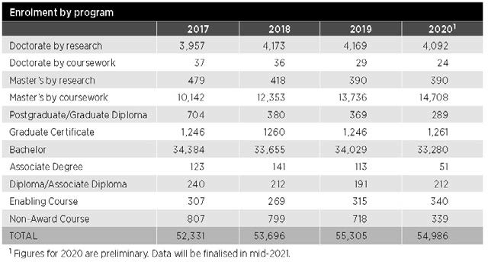

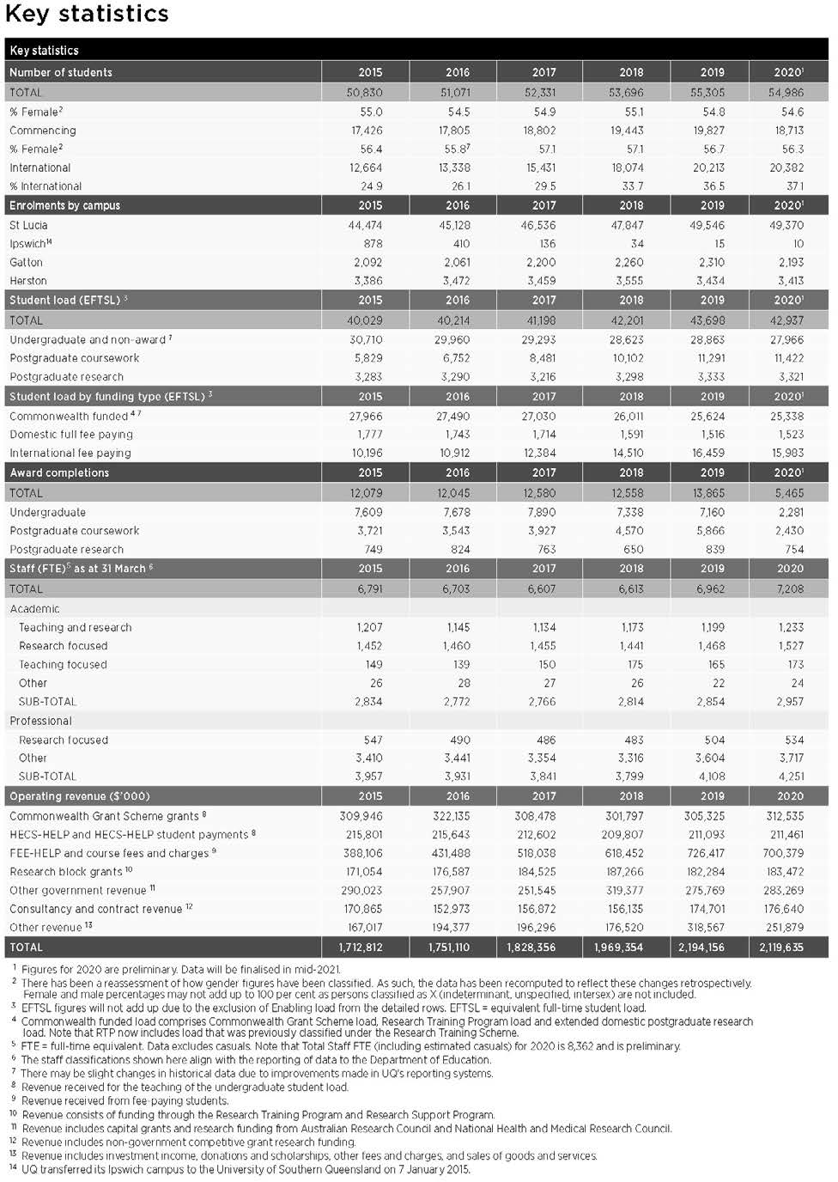

Operational performance

Government objectives for the community
The government’s objectives for the community are built around Unite and Recover – Queensland’s Economic Recovery Plan. With the underpinning principles of integrity, accountability and consultation, which are applied to carry out the activities outlined in this report, UQ contributes to the Queensland Government’s key objectives for the community:
- safeguarding our health
- supporting jobs
- backing small business
- making it for Queensland
- building Queensland
- growing our regions
- investing in skills
- backing our frontline services
- protecting the environment.

UQ contributes directly to investing in skills by ensuring Queenslanders have the skills they need to find meaningful jobs and set up pathways for the future; and both directly and indirectly – through its research and community liaison activities – to advance Queensland's other priorities.

Our objectives and performance indicators
In order to achieve our vision of knowledge leadership for a better world, we require sustained focus and a commitment to our 3 long-term objectives.
To transform students into game-changing graduates who make outstanding contributions and address complex
issues with a global perspective, we will go beyond ensuring that we develop
graduates who can easily gain employment. UQ’s students are motivated and highly capable: we want to develop an educational experience that maximises our students’ personal and academic development. We will support them to become enterprising, independent thinkers with the leadership, creativity and problem-solving skills that empower them to create positive change within industry, academia, the workplace, and society more generally.
To deliver globally significant solutions to challenges by generating new knowledge and partnered innovation, we continue to expect that research will be undertaken
at the highest academic standard with the highest ethical principles. UQ remains committed to both fundamental and translational research. However, we will be focusing on working with others – both internally through collaborations that cut across disciplinary and organisational
boundaries, and externally through partnerships and networks. We will become a hub that brings the best expertise together to creatively solve complex problems through research and innovation. This ethos will also be reflected in our approach to teaching.
To develop a diverse community of knowledge seekers and leaders who embody a One UQ culture and use collaborative partnerships to connect and co-create, we hope to bring together different perspectives and experiences
in order to find solutions to global challenges and provide an enriched learning experience. Through a One UQ culture
we can create an environment that is inclusive and collaborative, to ensure that we work together in pursuit of our strategic objectives. Universities must reflect wider society – working with and for the broader community. Through collaborative external partnerships we can create the connections and networks necessary to understand
the needs of industry, government and the community, and work with others to meet those needs: this applies to both our teaching and research endeavours.
To pursue these objectives, we have developed 6 strategic focus areas, or medium-term goals, to articulate where our efforts will be prioritised throughout the life of the Strategic Plan 2018–2021. This report addresses these 6 areas and provides
examples of initiatives adopted to meet them.
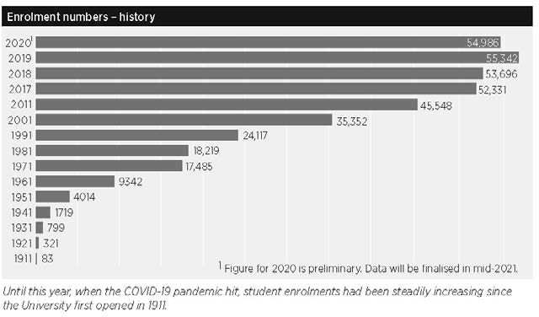
- Transforming our student experience through a flexible, integrated and partnered learning environment
- Enhancing our high-quality research by improving our capacity to collaborate to achieve greater impact
- Building engaged and strategic partnerships with a broad range of local and global networks
- Committing to activities that attract, support and retain a diverse and inclusive community of high-achieving staff and students
- Building an agile, responsive and efficient
University operation
- Diversifying our income streams and managing our resources to establish a sustainable financial base.

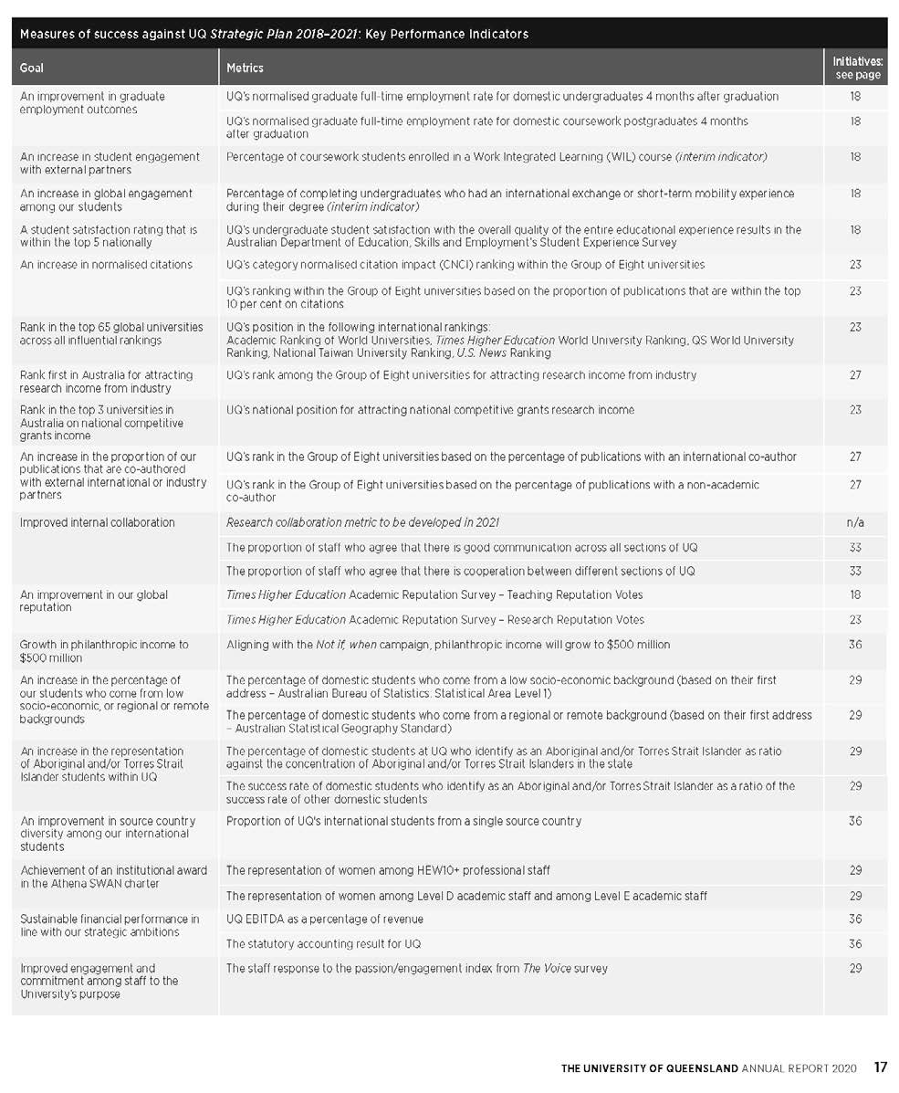
THE UNIVERSITY OF QUEENSLAND ANNUAL REPORT 2020 17

Review of activities
- Transforming our student experience through a flexible, integrated and partnered learning environment

UQ is committed to the success of our students and the quality of their educational experience. We will continue to adapt to changing expectations brought about by advances in technology, increased competition, structural reform of the workforce and economy, and impacts of the COVID-19 pandemic as we prepare our students for an unpredictable future. Implementing our Student Strategy 2016–2020 has been a key priority.

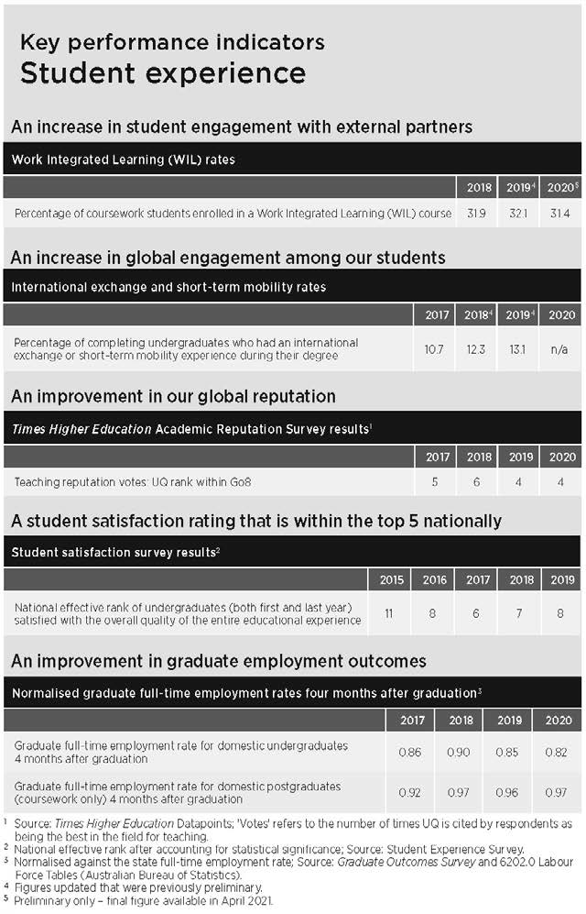
Expand opportunities for students to develop their employability.
Employability framework
Between 2018 and 2020, UQ invested almost
$12 million in employability initiatives to empower students to create change by learning from their experiences. In 2020, the University delivered discipline-specific Career Development Learning (CDL) and Work Integrated Learning (WIL) services through discipline-specific and context- relevant experiential learning opportunities, connections with industry, and learning support to enhance employability.
In 2020, more than 10,500 students attended at least one career preparation appointment or employability event. A wide range of opportunities was delivered, with volunteering and mentoring programs, research experiences, and short-term global activities – including internships and a large, formalised Students-as-Partners program. Grants and government funding totalling
$3.42 million were provided to help enable students to access these experiences.
Due to COVID travel restrictions, no global experiences were offered, which resulted in an increased focus on providing more virtual and rural/remote-based experiences, with accompanying online resources prepared and delivered.

Entrepreneurship Strategy
Officially launched in 2019, the UQ Entrepreneurship Strategy seeks to expand the breadth of activities available at UQ
to support formal and informal learning and entrepreneurship in practice. Strong outcomes were achieved in 2019 with entrepreneurship activities forming a cohesive set of idea-acceleration programs that aim to inspire the UQ community and empower the energy, resilience, creative problem-solving and collaboration essential to turn ideas into impact.

In 2020, due to COVID-19, all programs were moved online; however, demand continued to be high with more than 12,600 participants in programs across the course of the year. The inaugural Ventures Challenge in partnership with WaterStart
was a new, showcase initiative that attracted more than 40 teams across UQ and more than 1,500 views of the final pitch event.

Employability Week reinvented
With the inaugural Employability Week cancelled due to the pandemic in early March, several online workshops and presentations were conducted across faculties and from the Student Employability Centre. To supplement this, and to provide opportunities for students to engage directly with employers, the University conducted a virtual careers fair, as well as collaborating with institutional partners on 3 other virtual careers fairs: the National Indigenous Virtual Careers Fair, National Diversity Virtual Careers Fair, and Pathways to Employability’s Online Careers Fair. This was accompanied by a program of online employer presentations, workshops and presentations to help students enhance their employability and gain career-ready competencies.

Doctor of Medicine curriculum review In 2019, the Faculty of Medicine began a major review of its Doctor of Medicine (MD) program, revisiting its values, purpose, structure, graduate capabilities, learning, teaching, assessment principles and methods. Building on the curriculum transformation already underway in the
current MD, the review is designed to create an integrated, innovative experience to prepare doctors for a career in 21st century healthcare. In 2020, work commenced on graduate attributes, clinical experiences, assessment strategies, transition to internships, and the rural and regional contextualisation of the program.

Work Integrated Learning (WIL) embedded in program design During 2020, the faculties progressed WIL within their curricula. The Faculty
of Business, Economics and Law revised programs to move from extracurricular employability activities to a WIL focus. Staff were supported in curriculum innovation and broad-based assessment frameworks. WIL has been central to the mapping of graduate attributes. In the Faculty of Engineering, Architecture and Information Technology, a Year in industry opportunity for Engineering Honours students was explored; and in the Health and Behavioural Sciences Faculty,
an industry placement team worked with industry partners, staff and students to ensure greater streamlining of placement activities and flexibility for students. The Student Employability Centre supported systems and process improvements to enable
the efficient management of WIL across the University, as well as allocating funding to students experiencing financial hardship as a result of their WIL engagement.

Related initiatives for 1.1 | Page
1.4 Students as partners | 20
4.6 Mobility and leadership opportunities, Ventures, Indigenous student leadership | 32

Configure our pedagogies, assessment and learning spaces to encourage active and collaborative learning.
Student Strategy
The Institute of Teaching and Learning Innovation (ITaLI) continued implementing the Student Strategy 2016–2020 throughout the year, which included ongoing work
on blended and active learning via the UQ2U program, shorter-form credentials, professional learning, digital learning strategy, learning analytics, student employability, entrepreneurship education, and student–staff partnerships. With the current Student Strategy drawing to a close, work began on evaluating the outcomes and benefits of the current initiatives to provide insights and recommendations for future strategic development of UQ’s student experience.

Learning spaces
High-quality learning space is critical to the University’s mission. Extensive work was carried out in 2019 to provide new contemporary formal and informal learning spaces as well as a major refurbishment of the new Central Library. A new temporary teaching and learning facility, ‘ModWest’, became operational for the start of Semester 2, 2020. Work also continued
on improving the quality and quantity of learning spaces in library branches, as these became important student hubs throughout 2020, including when on-campus teaching was largely suspended due to COVID-19.
Outdoor learning spaces were introduced to provide an opportunity for teaching staff to take learning outside the confines of
the classroom and provide a COVID-safe learning environment.

UQ CBD base
Following the purchase of a new CBD base in 2019, 2020 saw the Queen Street site becoming UQ-branded and the master plan for the building completed for UQ to fully occupy the building from June 2023. Stage 1 of the works commenced in late 2020 and the School of Architecture will be the first
to occupy the building, with their teaching spaces opening in Semester 1, 2021.

Related initiatives for 1.2 | Page
1.1 Employability framework | 18
1.3 Digital learning strategy, Learning analytics | 19, 20
1.4 Science precinct, Students as Partners | 20
1.5 Vibrant campuses | 20
1.6 Program Architecture 2 | 22
1.7 UQ2U blended learning | 22
5.4 Space management policy, ModWest | 35

Expand online and digitised delivery to provide students with flexibility to engage with learning in a way that suits their personal needs.
Digital learning strategy
The Digital Learning sub-committee was formed by ITaLI in early 2019 to oversee significant improvements to the digital experience for UQ students. This resulted in a number of new centrally supported capabilities being introduced, including
a real-time virtual classroom and a move towards eAssessment. In 2020, a proposed Digital Learning Capability Roadmap 2020– 2023 was developed to improve existing practices and platforms, to experiment with emerging digital learning technologies,
and to better align the UQ virtual learning environment with the future world of work. This was supported by updates to the digital literacy strategic framework and a revamp of Digital Essentials, along with a staff survey to support skills development activities.

Assessment
Assessment continued to be a focus for ITaLI in 2020. The eAssessment initiative identifies electronic assessment options that facilitate improved pedagogical practices and address existing administrative issues. In 2020, a small-scale pilot was implemented in 16 courses across all faculties, with 1,766 students and more than 115 assessment items. The aim was to test how well the solutions aligned to assessment practices,
as well as to provide insights into future support, business processes, and teaching and learning opportunities the platform offers and will extend into 2021.
In response to the pandemic, face-to-face exams were transitioned online and an online proctoring service was implemented. However, 81 per cent of Semester 1 assessments were able to be redesigned so that they did not require online invigilation. For the remaining assessments, online invigilated exams were needed for students to retain the academic integrity of their studies, particularly where required by accrediting bodies and particularly

STUDENT EXPERIENCE

as many students were not in the country at the time. Moves to strengthen academic integrity accelerated and a revised academic integrity module will be mandatory for incoming students from 2021.

Learning analytics
In 2020, ITaLI continued to support the development and use of learning analytics. The primary aim of the UQ learning analytics agenda is to improve learner experiences and outcomes through the provision of meaningful data that can be acted upon before, during, and after the course life cycle. In 2020, the University continued
to enhance and promote 2 platforms: the 'Course Insights’ dashboard that provides data and trends on filterable segments of the student cohort as well as suggestions for interventions; and ‘RiPPLE’, an adaptive system that recommends personalised learning activities to students, based on their knowledge state, from a pool of crowdsourced learning activities generated and evaluated by educators and students. In addition, the RiPPLE platform is designed to match students together to form study groups based on learning needs and preferences.

Enhancements to support teaching
To further extend and enable a more personalised digital experience for students, staff and alumni, several new service models for learning resources were developed and trialled in 2020. More than 1,300 staff
attended 136 eLearning workshops to support the transition to online learning; and more than 500 staff attended professional learning workshops that supported hybrid teaching. With the traditional on-campus Teaching and Learning Week being reimagined as a virtual experience in 2020, more than 700 staff registered to attend – another example of the reward and recognition opportunities afforded them.

Digital library access
Initiatives were undertaken during 2020 to support faculties and schools, and to enable adjustments made as a result of the COVID-19 travel ban. This included
negotiating with publishers for better deals and access to more digital content to help students continue to study online, together with working alongside academics to identify and purchase digital alternatives to print textbooks so that students had access to key learning resources for their courses. In addition, AskUs service hours were extended, an upgraded reading list system was implemented, and the success of Library frontline services was leveraged
to provide a ‘first-stop-shop’ experience for students.
To support UQ research, the Library provided a priority retrieval service for researchers and HDR and Honours students who required access to print
materials. Librarians continued to support HDR students to reach their milestones and offered tailored online training and consultations to help with creating a structured thesis, setting up their ORCID, and accessing and using UQ Research Data Manager.

Laptop loan scheme
To ensure students had access to a computer or laptop to continue their studies, the Library worked with ITaLI and Information Technology Services to identify 420 campus laptops that could be diverted to student use. The Library administered the laptop loan scheme and provided access to laptops for 373 students.

Related initiatives for 1.3 | page
1.4 Students as Partners | 20
1.7 UQ2U blended learning | 22
4.4 HEA Fellowships | 31
2020 Honour roll | 8

Strengthen partnerships between students, researchers, industry and alumni to create a more collaborative approach to teaching and learning.
The University was successful in maintaining high teaching quality, with 80 per cent of students in 2019 satisfied
with the overall quality of their educational experience.

Students as Partners
The Students as Partners initiative continued to provide valuable opportunities for students and staff to partner to enhance the UQ student experience. In 2020, more than 384 student-partner and 370 staff- partner engagements took place across
the University through the formalised Student–Staff Partnership Program. The program also supported more than 350 student representative engagements, where the student voice directly influenced decision-making across UQ. This provided opportunities for students to develop the key skills necessary in these roles and build a community in which peer mentoring and
guidance can thrive. A culture of partnership continues to grow across the institution.
Health and behavioural sciences Providing work integrated learning opportunities in the health field continued in 2020, with negotiations taking place to create formal partnerships with the aged
care sector, the expansion of the UQ Healthy Living Centre, and involvement with the Logan Health Hub.
Student-built rocket
In a world first, UQ could soon be the first university to fly a student-built rocket and scientific payload into space. Having commenced in 2019, the UQ Space team
spent 2020 designing and building ‘Project Asteria’, a rocket that will zoom past the Kármán Line, 100 kilometres above sea level, reaching speeds greater than Mach-5. Despite delays caused by the COVID-19 pandemic, the team anticipates the rocket will be launched in 2021.

Related initiatives for 1.4 | page
1.2 Student Strategy | 19
1.3 Digital learning strategy | 19
1.5 Student Life Plan | 21
2.4 Research partnerships | 24
3.4 CX program | 28

Develop our campuses to create a more vibrant learning environment that integrates on- campus learning, community engagement and student life.
Student Complex
The construction and completion of the proposed 2018 Student Hub concept will not proceed as originally conceived. UQ is committed to redeveloping the site and is progressing a revised program that will acknowledge the Forum’s tradition of fostering debate about a range of social issues.

Andrew N. Liveris building
Construction continued on the 11-storey Andrew N. Liveris Building at UQ St Lucia, scheduled for fit-out in early 2021 and due for completion in May 2021. This building will primarily meet the School of Chemical Engineering’s long-term teaching and research accommodation needs and directly address serious laboratory safety concerns in the School’s current home, the Don Nicklin Building. The Liveris building will also provide significant, innovative, generic teaching and learning spaces, creating
environments for an ‘open’ and collaborative relationship between students, teachers, researchers and the wider industry.

St Lucia campus facilities
The proposed Health and Recreation Centre approved by UQ Senate in December 2019 was delayed and its design and location reviewed. The new Centre will replace the old gymnasium building and will include a musculoskeletal and sports injuries clinic, as well as a UQ Wellness space. Work to firm up the cost of the updated design will continue in 2021. Construction is pending future decisions about capital investments.

Science Precinct
In 2020, due to the impact of COVID-19, the Science building and Seddon site projects were paused. However, work continued
on critical projects such as additional PC3 laboratories and a new plant growth facility.

Gatton and Herston campuses
UQ Gatton saw $4.6 million worth of new campus grounds work introduced in March; and the Mayne Medical building
at UQ Herston had a full refurbishment of Levels 2–4, at a cost of $7 million, to boost teaching and research facilities.

Virtual campus and sense of belonging The effect of the pandemic on UQ students was unprecedented. In light of the COVID-19 restrictions, UQ’s campus activation program moved online in Semester 1, with a slate of over 178 online activities delivered across UQLife’s social media accounts and the introduction of the Virtual Village – a platform designed to create communities, share information and deliver support in
response to emerging needs and challenges. Activities covered a range of interest areas and modes of delivery, from online dance, fitness and cooking classes, to virtual panel discussions, workshops and performances – with multiple opportunities for students to not only connect with each other, but also to contribute to the content being delivered. The Virtual Village provided opportunities for students to engage with each other, both from a mentoring perspective and for shared interests, and to engage with staff for guidance and support.
In Semester 2, campus activation was delivered both on-campus and online, with major events including the BLOOM Festival, NAIDOC, 3x3 UQ Slam and the inaugural Ibis International Film Festival. A
key online engagement activity in Semester 2 was the introduction of the student-led and delivered weekly web series, From the couch, which gave a core group of students the opportunity to share the on-campus experience with those unable to attend in- person themselves.
Student residences project
The student residences building commenced construction in early 2020, in preparation for opening in Semester 1, 2022. The 610 ensuite rooms will offer high-quality, affordable on-campus accommodation for students from a range of backgrounds. The building will be operated by a UQ-owned company, to be established in early 2021.
UQ is also restoring Cairngorm House, which was constructed in the early 1900s and has been home to the UQ Alumni Association for more than 25 years, as a space for students to meet and relax.

Misconduct prevention
In 2020, work continued on the prevention of various forms of misconduct, particularly sexual misconduct. Adopting a trauma- informed approach in awareness, prevention and support provision, UQ reviewed existing policies and created a new online training module, UQ respect: sexual consent, ethical bystanding and compassionate response, for students, and promoted a staff-facing module in collaboration with UA. A sector- wide national survey was postponed until 2021.
Work is currently underway to implement the outcomes of a review of student general and academic misconduct policy and procedures. This will be underpinned by a new Student Code of Conduct due to go through the approval process in 2021.
In addition, the new Academic Integrity modules will be mandated for commencing students from Semester 1, 2021 along with implementation of an enterprise-wide complaints management system that will support consistent practice for misconduct matters across the University.

Student Life Plan
Working in tandem with the Teaching and Learning Plan 2018–2021, the Student Life Plan 2018–2021 seeks to help students make the most of their time at university. Areas of focus include accessibility, sense of belonging, health and wellbeing, services improvement, and opportunities to become more employable.
Since its introduction in 2018, good progress has been made towards achieving the Plan’s goals and actions. The COVID-19 pandemic adversely affected that progress in 2020, and in some cases caused a need to rebuild or accelerate mitigating initiatives. The
full impact of the pandemic is expected to emerge in 2021, along with consideration of future arrangements.
Summer in Queensland
The Summer in Queensland program was introduced in partnership with Allianz Global Care to encourage international students to remain in Queensland between Semester 2, 2020 and Semester 1, 2021 due to COVID-19 travel and mobility restrictions. The 3-month program featured a variety of activities, workshops, social experiences and opportunities to engage with and receive mentoring from staff. The program attracted approximately 1,200 registrations.

Public art initiatives
The UQ Art Museum is in the process of developing and rolling out a series of
public art initiatives, which will encourage visitors to our campuses and enrich the University and external communities by enhancing the campus and stimulating cultural learning. The first project, a major Indigenous commission, is being developed in consultation with the Office of the Pro- Vice-Chancellor (Indigenous Engagement) in response to the goals and spirit of the Reconciliation Action Plan, which addresses Aboriginal and Torres Strait Islander people. Financial constraints due to the pandemic delayed the project during 2020; however, the project is progressing with the support of restricted funds and is expected to be realised in 2021.

UQ BLOOM Festival
The third annual UQ BLOOM Festival was held at the St Lucia campus from 17 October to 1 November with the theme of Celebrate
- Innovate - Illuminate. Participants celebrated at a number of events and activities that brought the UQ community together; discovered a variety of innovative projects, collaborations and achievements produced by UQ students; enjoyed light and sounds displays illuminating UQ Lakes; and immersed themselves in outdoor spaces and exhibits on display throughout the festival. The Ibis International Film Festival, showcasing the filmmaking talents of UQ students, was also held for the first time.

Related initiatives for 1.5 | page
1.1 Employability framework | 18
1.2 Student Strategy | 19
4.1 NAIDOC | 30
5.4 ModWest, Supporting students facing hardship, Outdoor event space | 35

Adjust our approach to the development of educational offerings so that there is a greater focus on the whole program.
Program Architecture 2 (PA2)
PA2 delivers outcomes that enable the sustainability and relevance of UQ’s portfolio of offerings to provide maximum value for students, staff, employers and the broader UQ community. A significant undertaking across all faculties, PA2 will enable a streamlined framework that facilitates the continuous evolution of UQ offerings to deliver quality programs that maximise graduate outcomes and employability.
Furthermore, the simplification of UQ’s program structure and associated processes, policies and procedures aims to improve the student experience, knowing that some students can find current policies and rules complex and difficult to navigate. This process was implemented in accordance with the ongoing Australian
Qualifications Framework review and will be extended to postgraduate programs in 2021.
PA2 has developed and implemented a management dashboard tool for reviewing and analysing offerings; and new program and course design policies enabling a consistent university-wide review of offerings. Resultant curriculum changes are designed to deliver the best possible graduate outcomes in response to the
changing needs of the future workforce and to make it easier for students to identify learning opportunities and efficiently plan their study.
The successful implementation of a new curriculum management system, Jac, provides a single information source about programs, plans and courses. By sharing data with other systems, Jac will prevent double entry of information,
enable automation of several downstream processes, and improve governance and management efficiency.
PA2 will continue to enhance the student experience in 2021, with further work planned to provide opportunities for updating the electronic course profile system, automating program planning, checking progression, and processing credit.
New and enhanced programs
In 2020, UQ introduced several new programs in response to local and international demand, including:
- Bachelor of Biotechnology
- Bachelor of Biotechnology (Honours)
- Bachelor of Computer Science (Honours)
- Bachelor of Computer Science/Bachelor of Business Management
- Bachelor of Computer Science/Bachelor of Commerce
- Bachelor of Computer Science/Bachelor of Laws (Honours)
- Bachelor of Computer Science/Master of Cyber Security
- Bachelor of Computer Science/Master of Data Science
- Bachelor of Design
- Bachelor of Engineering (Honours)/ Bachelor of Design
- Bachelor of Environmental Science
- Bachelor of Environmental Science (Honours)
- Graduate Certificate in Mental Health Nursing
- Graduate Diploma in Mental Health Nursing
- Master of Urban Development and Design.
Twenty-two programs ranging from associate degree to higher doctorate level were also discontinued.
UQx, the University's provider of Massive Open Online Courses (MOOCs), launched several new programs, including the one- year Professional Certificate in Foundations of Modern Mining, which was developed
in collaboration with industry and Curtin University and designed for mining workers. UQx’s MOOCs attracted a record 17,420 verified enrolments in 2020.
UQ’s first shorter form credentials policy was endorsed in 2020 with a number
of system changes ready for early 2021 enrolment.

Mental health strategy
Delivering on the objectives of the UQ Mental Health Strategy (2018–2020) saw the promotion of the wellbeing of students and staff in a ‘whole of university’ approach to supporting the UQ community. The
well-established framework, with practical measures to assist, ensured UQ was able to respond to 2020's unprecedented challenges, helping guide resources and early-intervention measures to maximise capacity to respond to psychological distress and crises as the year progressed.
Evaluation of the strategy also commenced.
Embedding Aboriginal and Torres Strait Islander culture into the curriculum Delivering on the Reconciliation Action Plan saw the University's Teaching and Learning
Committee establish a working party to progress more widespread embedding of Indigenous knowledges and perspectives into the curriculum.

Related initiatives for 1.6 | page
1.7 Shorter form credentials | 22
4.1 Aboriginal and Torres Strait Islander Research and Innovation Strategy | 30
6.5 Student recruitment | 38

Explore opportunities to make our academic calendar more flexible.
UQ2U blended learning
UQ2U supports the development of high- quality online and high-value on-campus active blended learning experiences that meet the needs of students – offering greater flexibility, improved outcomes and personalised learning, while simultaneously uplifting the capability and capacity of UQ’s academic community. In 2020, due
to the COVID-19 pandemic's impact, the UQ2U program team extended its support and expertise in digital course design and learning technologies to the broader UQ academic community while maintaining existing project engagements. UQ2U courses currently reach more than 30,000 student enrolments through the redesign of more than 70 courses, and focus on developing genuine partnerships between academics, tutors, students, eLearning designers, project managers, eLearning officers, learning advisers and librarians.

Shorter form credentials
Following preliminary investigations in 2019, UQ developed an Alternative Credential framework for governance, a system for delivery that will provide a seamless interface for stakeholders, and a collaboration that aims to increase the global recognition of UQ’s offerings.
Related initiatives for 1.7 | page
1.3 Digital learning strategy, Learning analytics | 19, 20
1.6 PA2, New and enhanced programs | 22

Review of activities

Enhancing our high-quality research by improving our capacity to collaborate to achieve greater impact

While rightly proud of our research excellence, over the coming years we need to ensure that our research remains collaborative and continues to achieve great impact. To succeed in our focus areas of leading healthy lives, building better bioeconomies, achieving resilient
environments and livelihoods, designing technology for tomorrow, and transforming societies, we will be outwardly focused, while at the same time working across disciplines internally.

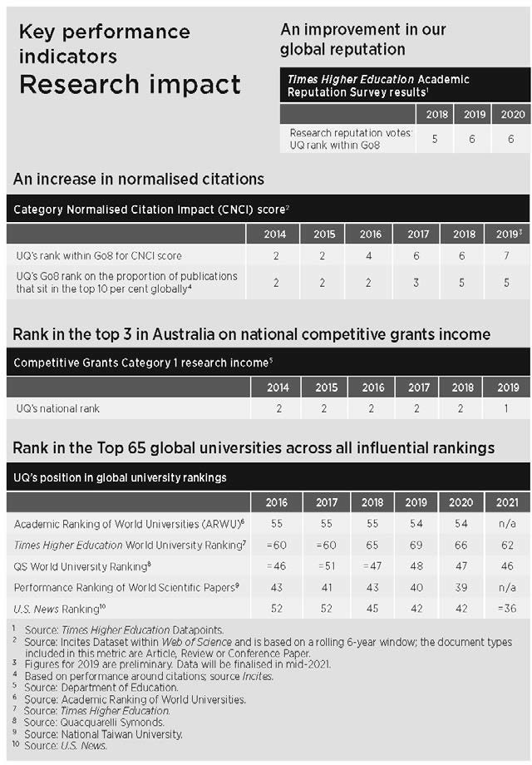
Build a One UQ approach to acquiring, maintaining and
utilising research infrastructure.
Research infrastructure and project management framework
Following the establishment of the Central Research Platforms in 2018; and a Project Governance and Management Framework in 2019; governance, assurance, monitoring
and oversight of UQ’s infrastructure portfolio was further effected in 2020. The main achievement was the presentation of a Plant Growth CRP proposal, and the continued work on drafting industry engagement plans.

Related initiatives for 2.1 | page
3.1 IMB@UQ Centre of Excellence and Innovation | 27
5.2 IT governance | 34

Actively encourage internal collaboration between researchers from different disciplines and organisational units.
Research Week
Although Research Week and the associated Research Capability Showcase were cancelled in 2020 because of the pandemic, several opportunities normally provided to celebrate and connect UQ researchers and showcase their research achievements continued. Highlights included UQ's involvement in the launch of the Engagement Australia Excellence Awards, the continuation of UQ Industry
Connect, and the hosting in virtual format of the UQ Three Minute Thesis competition.

Global Change Institute (GCI)
The Global Change Institute is a transdisciplinary institute that brings together researchers from across the University to work with industry,
government and the community to tackle global grand challenges. The Global Change Research Network (GCRN) program was launched and received 27 applications from across UQ's faculties and institutes. Four GCRNs were awarded and a further 7 have been identified as ‘pipeline GCRNs’. In 2020, a new GCI Director was recruited.

Related initiatives for 2.2 | page
1.4 Science Precinct | 21
3.4 CX program | 28
4.3 Co-leveraging to build research capacity and capability | 30

Actively pursue strategic and high-quality international collaborations in research and education.
The University of Queensland – Indian Institute of Technology Delhi Academy of Research (UQIDAR)
UQ and the Indian Institute of Technology Delhi (IIT-D) are working together to develop a substantial transnational collaborative research program with the flagship initiative of a joint-PhD program.
During 2020, work was impacted by the pandemic, which resulted in delays in student commencements. However, business development activities and the establishment of industry partnerships
have continued to progress, following the appointment of a new CEO in July. By January 2021, student numbers will reach 50 students.

UQ–University of Exeter (QUEX Institute) The Universities of Queensland and Exeter continued to grow their existing partnership through the QUEX Institute (QUEX). QUEX aims to strengthen research and industry collaboration, and to influence public policy. Since 2018, QUEX has enrolled 29 joint PhD scholars, launched 26 grant schemes, and held 2 international symposia and one virtual symposium. The collaboration has secured
$24 million in external funding and published 34 joint publications. In 2021, QUEX will focus on 3 interdisciplinary themes: healthy living, global environmental futures, and digital worlds and disruptive technologies.

Related initiatives for 2.3 | page
2.2 Global Change Institute | 24
2.4 Research partnerships | 24
3.1 Partnerships Framework | 27
6.3 Enhancing capability | 37

Actively encourage researchers to partner with industry, government and the community both within Australia and internationally.
Research partnerships
Through the challenges of the pandemic period, UQ continued to work with our established industry partners and to forge new relationships. Overall, the number
of agreements through the Research Partnerships Office was more than 4,300 in 2020, approximately 10 per cent higher than the 2019 total of 3,952, and significantly higher than 2018's 3,569.
The COVID-19 vaccine project sponsored by the Coalition for Epidemic Preparedness Innovations, with funding support from the Queensland and Australian Governments, was a highlight of the year. In addition to government support, more than 2,500 individual major and smaller donors supported this multiparty collaboration involving over 70 industry and research partners in Australia and across the globe. Regrettably, production of the vaccine will not be going beyond Phase 1 trials.

UQ Industry 4.0 TestLab
In partnership with Siemens Australia and the Federal Government, the UQ
Industry 4.0 Energy TestLab was launched in November with the aim of enhancing global knowledge on electricity networks. This facility is part of a national network of 5 other Australian university Industry 4.0 TestLabs, each with a different focus area.

UQ Industry Connect
Following its launch in 2019, this new initiative proceeded with a range of virtual events with partners in 2020. Its goal was to create a pathway for forming strategic industry-UQ partnerships by ensuring that industry has access to a simple, coordinated entry point to support collaboration discussions and interaction with UQ’s
wide range of expertise and infrastructure. Four streams were created: Engagement, Capability, Innovation and Leadership. As a result of these workshops, a Memorandum of Understanding was signed with Infosys and a research agreement with Stanwell.

RESEARCH IMPACT

Dow Centre partnership
Throughout 2020, the UQ Dow Centre continued to make strong progress in delivering innovative and scalable solutions toward a more sustainable future. The Centre participated in collaborative research projects with the Future Fuels CRC, the Flexible Printed Batteries CRC-P, the
Fight Food Waste CRC and the Andlinger Center for Energy and the Environment at Princeton University. The UQ Dow Centre continues to refine its mission and focus on significantly impacting sustainability and the economy through key research themes of energy transitions, low-carbon energy and materials, and the circular economy.

Cooperative Research Centre on Transformations in Mining Economies
A national consortium led by UQ and the University of Western Australia secured $30 million from the Australian Government
to help regional communities transition to sustainable futures after their local mines close. The funding forms part of a total 10- year investment of $135.4 million supporting mining communities to create sustainable community and development opportunities. The consortium formed a Cooperative Research Centre on Transformations in Mining Economies (CRC-TiME) with hubs
in both Queensland and WA, and with 75 partners including BHP, Rio Tinto, Deswik, Decipher, the State Governments of WA, Queensland and the Northern Territory, as well as researchers from 8 universities and the CSIRO.

Related initiatives for 2.4 | page
1.1 Entrepreneurship Strategy | 18
2.3 UQIDAR, QUEX | 24
4.6 Western Civilisation | 32
6.2 New opportunities | 37

Develop a more consistent approach to higher degree by research (HDR) training with a focus on ensuring students
build research, transferable and professional skills.
In a challenging year with closed borders and restricted people movement, the
UQ Graduate School maintained HDR commencements at 912 candidates (95 per cent of expected target) and supported over 800 conferrals.

HDR industry placements
HDR placements adapted quickly to new ways of working as a result of the
COVID-19 pandemic. A shift was made to enable remote placements, to ensure the many HDR candidates who undertook international or interstate placements were not disadvantaged. Despite the additional hurdles, the Graduate School organised more than 55 placement opportunities.
Placements were undertaken within government, industry and the not-for-profit sectors and provided HDR candidates with an opportunity to further develop and translate their transferable skills.

Career Development Framework (CDF) The CDF saw more than 98 topics offered in 173 workshops in 2020. With the onset of COVID-19, all workshops were shifted to an online format, and attendance tripled in most cases. As at October 2020, 6,300 attendees had participated in CDF workshops, a 40 per cent increase over
the full year of 2019, and had maintained a satisfaction rate of 94 per cent.

Three Minute Thesis (3MT)
The 3MT competition continued to grow, with a record number of more than 300 PhD students competing at UQ alone, and many more at over 900 institutions worldwide.
UQ’s 3MT was strongly contested in 2020, its thirteenth year of competition. Emma Schimke from the School of Health and Rehabilitation Sciences won with her presentation, To sleep or not to sleep.

Invest in the development of systems and processes for the storage and publication of research data, including the
capability for this to benefit future researchers.
UQ Research Data Manager (UQRDM) UQRDM provides researchers and HDR students with integrated research data storage to securely store, share, re-use, collaborate on, and manage their projects’ research data. A major milestone was achieved by allowing researchers to publish datasets directly to UQ eSpace from within RDM, facilitating the transition from working data to published data.
In 2020, 3,901 researchers used RDM for the first time; 4,703 new records were created; 5,531 terabytes of data was stored in RDM; UQ researchers collaborated with more than 1,200 external collaborators through RDM; and the Library held 35 RDM training sessions.

UQ Research Management System 2020 saw further development of MyResearch (formerly known as the Research Management System, or RMS),
which will provide UQ with an enterprise- wide, integrated research management solution. Being researcher-centric and project-based, it will enable a holistic view of research project management, administration and compliance across the research lifecycle at UQ. The ethics component of MyResearch is due for release at the end of January 2021. Work
on MyResearch Projects, the second stage of implementation, progressed in 2020. MyResearch Projects is on track for delivery in early 2022.

Management of research and consultancy In May 2020, a new suite of policies, procedures and processes was implemented to better manage risks relating to consultancies, secondary employment
and internal work. This includes improved financial management of costing and pricing relating to research and consultancy activities. This policy framework complements work undertaken in 2018
and 2019 relating to contract research and grants financial management and the implementation of MyBalance, the research budget management system.
This is also an important foundation for further improvements in the management of the research lifecycle through the implementation of a new research management system during 2020/2021.

Related initiatives for 2.6 | page
5.1 Disclosure and management of interests | 33
5.3 Research Management Business Transformation program | 34

Develop flexible models to effectively utilise the institution’s intellectual property.
UniQuest
UQ was ranked number one within the Group of Eight universities in the 2020 Survey of Commercialisation Outcomes from Public Research (SCOPR) in measures for the amount of commercialisation revenue received, the number of active startups and the value of equity held by UniQuest in startups formed from UQ intellectual property (IP).
UQ’s innovative technologies continued to attract significant global interest in 2020:
- Startup company Inflazome Ltd was acquired by multinational pharmaceutical company Roche in September in the largest deal for a spinout company from an Australian university, with an upfront payment of €380M (AU$617M) plus additional development and regulatory milestone payments. Inflazome is developing potential treatments for a broad range of inflammatory diseases, including inflammatory bowel disease and Parkinson’s disease, based on
IP developed by UQ researchers in collaboration with Trinity College Dublin.
- Startup company Vaxxas will partner with the US Government to test its
high-density microarray patch (HD-MAP) needle-free vaccine delivery technology for pandemic influenza, receiving
$30 million from the Biomedical Advanced Research and Development Authority. With the support of the Queensland Government, the company will establish a facility at Brisbane’s Northshore Hamilton for the manufacture of products, ensuring that the UQ research continues to be developed
in Brisbane. A long-term partnership with Merck & Co Inc has seen the global pharmaceutical company investing $18 million in Vaxxas in a combination of equity funding and option fees.
- In the first 9 months of 2020, UQ’s other startups attracted over $27 million in investment to advance their technologies towards the market, bringing the cumulative total raised since 1984 to $776 million.
- The Queensland Emory Drug Discovery Initiative, operated and managed by UniQuest, progressed its pipeline of drug discovery projects based on
innovative UQ research, and was awarded competitive funding from the Medical Research Futures Fund to advance the projects in cancer and neurodegeneration to commercialisation.
JKTech
As the technology transfer company for the University’s Sustainable Minerals Institute (SMI), JKTech supplies innovative products and services to the global resources industry – including specialist technical consulting in mining, geometallurgy and processing; laboratory services and analysis; professional development and technical training services; and test equipment and simulation software products.
During 2020, a key achievement was the integration of JKTech and SMI’s Julius Kruttschnitt Mineral Research Centre (JKMRC) under one management structure. This approach will strengthen the mining value chain and will maintain the critical linkages between research and consulting in order to drive innovation and ensure
that clients receive the benefits of new research and expertise in technology-based solutions.
Despite the challenges that materialised as a result of the COVID-19 travel restrictions, JKTech continued to engage with industry partners by providing services remotely
as well as remaining connected with the more than 12,000 mining professionals who attended or viewed webinars produced by the combined JKTech, SMI, JKMRC group.

University of Queensland Press (UQP) Quentin Bryce Award
Established in association with UQ, UQP launched a new annual $5,000 prize in February, the UQP Quentin Bryce Award. Bestowed on a book on UQP's list that celebrates women's lives or promotes gender equality, the inaugural winner was Throat, a poetry collection written by Ellen van Neervan.

Citizen science
To increase awareness of the Institute for Molecular Bioscience's scientific endeavours, work began in 2020 on the development of 2 apps: the Cane toad challenge and Soils for science. Both were launched for general community use during the year and have been widely taken up across the state.

Related initiatives for 2.7 | Page
5.1 Disclosure and management of interests | 33
6.5 University of Queensland Press (UQP) | 38

Building engaged and strategic partnerships with a broad range of local and global networks

Engaging and collaborating with the community, industry, government and other research innovators is critical to UQ’s capacity to meet the rapidly changing needs of society. We aim to enhance our approach to external engagement with a partnership framework, customer relationship management system, deeper international connections, diverse income sources and ongoing commercialisation interests.

Build a centralised resource to support, develop and manage
significant partnerships guided by a clear partnership framework.
UQ Industry Partnerships Framework The UQ Industry Partnerships Framework seeks to support engagement with industry partners external to UQ, with the aim of deriving and delivering maximum
impact across research, commercialisation, innovation, teaching and learning, and engagement. The term 'industry' applies to an expanding range of external partners including private industry, industry associations, not-for-profits, foundations, and many other sectors of the economy.
The framework is intended to support all UQ units to facilitate successful engagement with UQ's industry partners, with an emphasis on strategic-level partnerships earmarked for central coordination. It aims to ensure industry–partner interactions
are approached in a coordinated, timely and responsive manner, thus cultivating mutually beneficial relationships in support of the University's objectives to pursue 'partnered innovation' and 'collaborative partnerships to connect and co-create', as outlined in the UQ Strategic Plan 2018–2021. Despite some delays due to pandemic- related budget restrictions, the framework and responsibilities were further clarified during 2020, and development of reporting mechanisms commenced.
Research partnership model
The research partnership model has been very successful in supporting UQ to lift its performance in securing industry funding. During 2020, considerable work was undertaken to build capacity, particularly in security industry research income.
Innovation brokers were recruited and these roles located within the Global Change Institute, and the staggered recruitment
of key staff to support the research partnerships contract administration model was completed. Work will continue during 2021.

IBM@UQ Centre of Excellence and Innovation
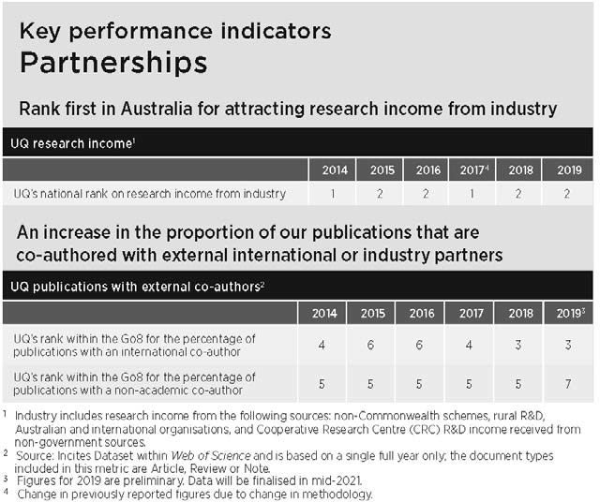
In September, IBM announced the launch of a new collaboration with UQ to address data challenges impacting health, manufacturing and environmental research. Tackling issues associated with significant growth in the amount of data being collected, organised and stored for research purposes, the Centre will also provide a range of new data storage and computer hardware platforms to UQ's Research Computing Centre for experimentation and evaluation.

Related initiatives for 3.1 | Page
1.1 Entrepreneurship Strategy | 18
1.4 Science Precinct | 21
2.2 Global Change Institute | 24
2.6 UQRDM | 25

Strengthen and grow international research collaborations to ensure we leverage the breadth of our research to make significant contributions to global research activity.
In 2019, UQ researchers published 11,262 papers, with 6,380 (57 per cent) having an international co-author – the top 10 source countries being the US, UK, China,
Germany, Canada, France, the Netherlands, New Zealand, Spain and Japan.

International research partnerships
In 2020, UQ ensured that our partnership with the Indian Institute of Technology,
Delhi (IITD) was strongly supported from a research and industry partnership perspective. To this end, UQ explored industry partnerships with companies
and organisations including RenewPower, Infosys, Wipro, Bosch, TCS and Boeing, and with funding bodies like the Indian Department of Biotechnology and Indian Council of Social Science Research.
Advanced-stage funding has been proposed to all. UQ also nurtured flagship partnerships with the University of Exeter, Technical University Munich (TUM) and Wenzhou Medical University.

Global Development Impact Plan
UQ has one of the leading university development groups working across Africa, South and West Asia, South–East Asia and the Pacific. Providing development expertise and program management leadership, UQ International Development (UQID) builds the capacity of people, organisations and governments to achieve key development goals. In 2020, work progressed on the development of a whole-of-UQ Global Development Impact Plan, which will
seek to expand the University's work in the development sector, to promote our expertise, and to profile our impact. The Plan will ensure a One UQ approach to engaging with development projects and
ensure that we can leverage the capabilities across UQ and collectively advance UQ's activities and reputation in the international development space.

Related initiatives for 3.2 | Page
2.3 UQIDAR, QUEX | 24
2.4 Research partnerships | 24
4.1 Indigenous engagement | 29
6.1 International students | 37
6.3 Enhancing capability | 37

Develop a University-wide and consistent approach to external and internal messaging and representation.
Brand refresh project
In late 2018, UQ launched a new brand to modernise its identity, support best practice principles and bring greater consistency across the organisation, which had historically been dominated by a proliferation of sub-brands, many of
which bore no resemblance to the parent organisation. In line with the UQ Strategic Plan 2018–2021, the brand refresh adopted a One UQ approach, to convey the University's brand and tone of voice in a consistent, compelling and contemporary way to all stakeholders. A significant program of work was completed throughout 2019, requiring whole-of-enterprise engagement. 2020 saw the continued rollout of the masterbrand across the University, with a focus on providing individual units and controlled entities (UQ Sport and UQ Health Care)
with bespoke rebranding assistance, and integrating brand-compliant templates with digital asset management tools.

Rankings strategy
A Rankings Strategy Steering Group was established in 2020 to develop a strategy to support UQ’s aspiration to remain a top-
ranking global university. Three pillars of work were identified: Governance and leadership (Organisational design and expertise); Reputation enhancement; and Academic performance. While the work associated with the development of the strategy will continue into 2021, a number of key reputation enhancement initiatives have already been introduced to ensure UQ’s position in the
key global rankings are either sustained or improved in the interim.

Communication, marketing and student recruitment review
A review of how the communication, marketing and recruitment functions could better strategically support UQ's priorities was delayed in the first half of 2020, but recommenced in the last quarter of the year with workstreams established and stakeholder engagement underway.

Improve the management of future-student enquiries and communications with key
partners, alumni and the broader community.
Customer Experience (CX) program
The multi-year CX program involves a suite of initiatives designed to enhance UQ’s digital and CX capability. The Future Students stream is well advanced, including delivery of a new Future Student website and support extended to include higher degree by research and postgraduate coursework offerings. The Customer Relationship Management (CRM) implementation was delayed due to COVID-19 and budget constraints; however, work resumed at
the end of 2020 with procurement for an implementation partner underway.

Domestic future student marketing and recruitment strategy
A whole of UQ integrated marketing and recruitment strategy was implemented in 2019 to address the smaller cohort of Queensland year 12 students entering university in 2020. This initiative was designed to drive an increase in market share among Queensland school leavers, with a focus on maximising enrolments. The Semester 1, 2020 domestic intake was strong, with UQ achieving a 2 per cent increase in market share among
undergraduate Queensland school leavers with entry scores in the range considered for UQ programs. Semester 2 admissions also increased, although this was a much smaller intake for UQ due to limited program offerings. It must be acknowledged that this is in part due to counter-cyclical demand due to the pandemic and associated economic recession, but early indicators suggest this impact will continue into 2021.

Related initiative for 3.3 | Page
3.4 CX program | 28

Committing to activities that attract, support and retain a diverse and inclusive community of high-achieving staff and students

UQ owes its growing global reputation and successes to the strengths and achievements of all staff and students, and attracting people from a broad mix of backgrounds ensures a
wide variety of perspectives and experiences. In 2020, UQ continued to address the barriers facing women in academia, people from culturally and linguistically diverse backgrounds, Aboriginal and Torres Strait Islander peoples, people with disability, members of the LGBTIAQ+ community, and students from disadvantaged and remote backgrounds.

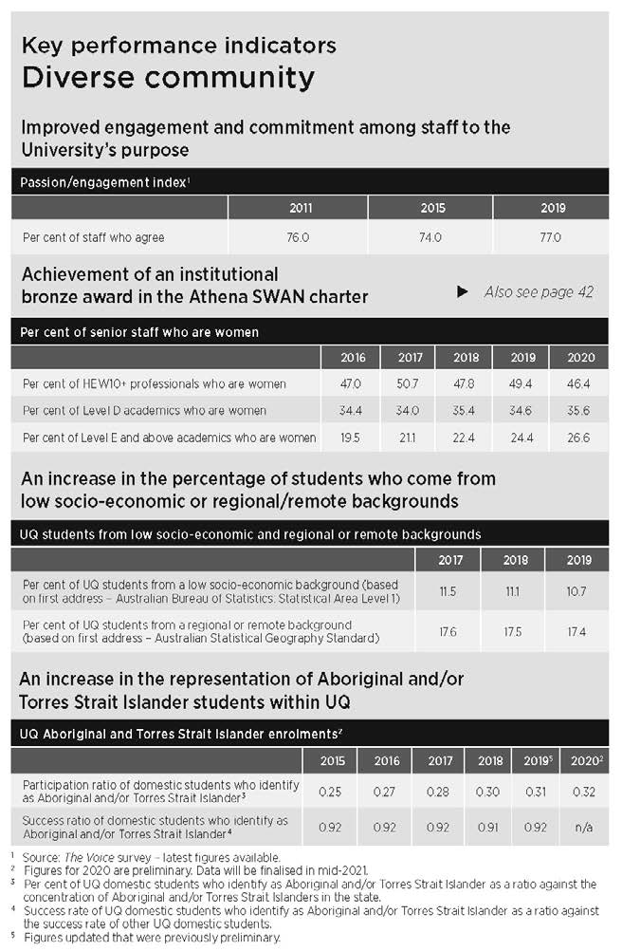
Develop and implement a Reconciliation Action Plan (RAP) that ensures UQ builds respectful relationships and opportunities between Aboriginal and Torres Strait Islander peoples and the broader Australian community.
UQ's RAP (Innovate) was launched in late 2018 and the years since have been spent delivering on the commitments made.

Indigenous engagement
During 2020, the focus for UQ's (Innovate)
RAP shifted to greater engagement with those areas of the UQ community
responsible for ensuring the completion of actions and deliverables within assigned timeframes. A Reconciliation Action
Plan Overview Committee (RAPOC) was established and began meeting monthly. Work also started on UQ's first formal cycle of reporting to Reconciliation Australia, although the 'National Barometer' reporting was deferred until 2021. The Office of
the Pro-Vice-Chancellor (Indigenous Engagement) (PVC(IE)) commenced work with Governance and Risk to develop an entry in the Policy and Procedures Library around Indigenous protocols; and an Indigenising Curriculum Working Party was established as a subcommittee of
the Teaching and Learning Committee to support the project. Planning also
commenced towards the next iteration of UQ's RAP, due to be implemented in 2023.
Working in partnership with the Office of the PVC(IE), the Graduate School continued to fund the Aboriginal and Torres Strait Islander Scholarship, seeing further growth in the cohort to reach 42 (up from 12 in 2017).

THE UNIVERSITY OF QUEENSLAND ANNUAL REPORT 2020 29

Cultural competency training
In 2020, funding was secured to rollout a cultural competency training program for UQ staff. The training package was
launched, including an online module that will sit as part of UQ's standard suite of compulsory training, along with workshops for priority staff. Virtual and face-to-face delivery of the cultural competency training will continue throughout 2021.

Aboriginal and Torres Strait Islander Research and Innovation Strategy
The UQ Aboriginal and Torres Strait Islander Research and Innovation Strategy was developed in 2020 with broad input from across the UQ community, and will be launched in early 2021. The Strategy sets a framework for UQ to excel as a national and international leader in Aboriginal and Torres Strait Islander research and innovation, and to support career progression for Aboriginal and Torres Strait Islander researchers.

UQ Library Reconciliation implementation The Library commenced a broad implementation plan for the RAP in
2020 with the appointment of a project
coordinator and graduate trainee. This initiative will extend to encompass the visibility of collections and
acknowledgement of research data, events and exhibitions, and ongoing work to support embedding Indigenous knowledge in the curriculum.

NAIDOC
The third UQ NAIDOC Festival was held online and on all 3 campuses in August, and featured several Aboriginal and Torres Strait Islander performers, artists and dancers; art, weaving and lolly-making workshops; exhibitions; virtual tours, and an academic program of discussions and panels. In November, a range of cultural heritage discussions, exhibitions and tours was
held as well as a book swap. Both events acknowledged the theme, Always was, always will be, and recognised that First Nations people have occupied and cared for this continent for more than 65,000 years.

Related initiative for 4.1 | Page
1.5 Vibrant campuses | 20

Significantly improve the gender and cultural balance within the workforce at all levels, within all disciplines and organisational areas.
Women comprise 56 per cent of UQ's workforce but remain under-represented in senior academic and professonal positions. The University is making gradual progress towards gender parity, with the number
of female academics in very senior roles steadily increasing – from 19.5 per cent in 2016 to 26.6 per cent in 2020.

AWEI Silver Employer Award
Following an annual audit of all LGBTIAQ+ inclusion work undertaken in the previous year, UQ was awarded Silver Employer status in the Australian Workplace Equality Index (AWEI), a national LGBTIAQ+ inclusion benchmarking process led by Pride in Diversity. As well as hosting several events to raise awareness of LGBTIAQ+ days of significance, UQ ran Ally workshops, trained senior managers on LGBTIAQ+ inclusion, and developed and updated several organisational policies and procedures to
be more inclusive of UQ’s sex, gender and sexuality-diverse communities, including the UQ guide to LGBTIAQ+ recruitment and UQ guide to inclusive language documents. In addition, the UQ Ally Network grew from 476 in 2019 to 640 staff in 2020, and now represents almost 9 per cent of the UQ staff cohort (FTE).

Gender equity in STEMM
In 2020, the UQ Gender Steering Committee (GSC) worked on a range of activities aimed to improve gender equity and to implement the UQ SAGE Athena SWAN Action Plan.
This included becoming a STEM Decadal Plan Champion, introducing the Merle Pledge (to substantially improve women's representation in public and professional forums), staff entry and exit survey
data collection, staff video testimonials, commencement of the Cultural Inclusion Council, and improved annual equity, diversity and inclusion training. The GSC also carefully monitored the impact of COVID-19 on women and STEMM women in particular. The early–mid career research (EMCR@UQ) network worked to advocate for early–mid career researchers at UQ, undertaking research and producing a roadmap for progress. The Women in
science podcast also successfully raised the profile of STEMM women at UQ through the promotion of women's career stories.
Related initiatives for 4.2 | Page
2.7 UQP Quentin Bryce Award | 26
UQ’s Human Resources: Gender | 42

Invest in the capacity of our research workforce by prioritising the development of our high- performing early-career and middle-career academics.
Researcher development program
A research leadership staff development initiative was developed in 2020 to build leadership capacity and competency within the Research portfolio, initially with the senior leadership team and then building frameworks to cascade these learnings
and foster positive culture throughout the portfolio. Framework development is
underway but was significantly slowed due to the pandemic driving focus elsewhere.

Co-leveraging to build research capacity and capability
The University continued to build research capacity and capability through investing in a range of competitive funding opportunities, including:
- ARC Laureate, Future and Discovery Early Career Researcher Award Fellowships Scheme, established to leverage investment and incentivise continued commitment towards attracting and retaining quality researchers at UQ
- Advance Queensland Industry Research Fellowships Scheme, leveraged funding into the Queensland State Government Fellowships scheme to support UQ’s ambition to build industry relationships and invest in partnered research for innovation and impact for Queensland
- UQ Amplify and Amplify Women's Academic Research Equity (AWARE), to proactively support the recruitment, retention and career development of externally funded early- and mid-career fellows through providing fixed-term contracts and lessening the impact of parental leave
- UQ–Universities Australia/DAAD Australia-Germany Joint Research Cooperation Scheme, to foster research collaboration of the highest quality between Australia and Germany
- UQ's Student Employability Centre's Summer and Winter Research Programs. Through 605 engagements, 573 students were supported in 2020 to gain valuable research experience alongside UQ academics.
- The UQ Foundation Research Excellence Awards, One UQ Research Investment Scheme and UQ Early Career Researcher Grants Scheme were temporarily put on hold due to the pandemic.

Related initiative for 4.3 | Page
2020 Honour roll | 8

DIVERSE COMMUNITY

Improve the mechanisms for assessing, developing, recognising, rewarding and improving high performance
among academic and professional staff, with a focus on performance in areas of strategic importance.
People, Planning, Performance (P3) UQ’s current Strategic Plan commits the University to developing and improving academic staff performance. To achieve this objective, the P3 project developed
Individual Activity Profiles (IAPs) to provide academic staff with data about their performance across a range of indicators.
In 2020, IAPs became available for use in appraisals and other performance conversations. Towards the end of 2020, there was a first release of dashboards
designed for organisational areas to assist the decision-making of Heads of School, Executive Deans and Institute Directors. Throughout 2020, the P3 project team was engaged in a re-design of the academic performance appraisal process for release in the new human capital management system in mid-2021. Its aim is to support better and more effective performance conversations across the University.

HEA Fellowships
HEA Fellowship provides a measure of success in teaching that is recognised internationally. Since joining the HEA Fellowship program in 2017, UQ has now accredited more than 325 HEA Fellows. During the second half of 2020, new pathways to professional learning were designed to help teaching staff navigate professional learning opportunities available. Recognition of teaching expertise through the HEA Fellowship will be further consolidated through the provision of online resources such as the HEA@UQ Commons. UQ’s accredited HEA Fellowship program awarded 65 Fellowships in 2020 to professional and academic staff.

Teaching awards and Teaching Innovation Grants
UQ’s Awards for Excellence in Teaching and Learning were postponed in early 2020.
However, given the importance of continuing to recognise the University’s excellent teachers, expressions of interest were called for Teaching Excellence, Program Awards and Citations mid year. Engagement remained strong with a total of 40 expressions of interest (compared with 42 in 2019), of which 17 were invited to full submission. Selection of the awards is ongoing and 2020’s recipients of UQ Awards for Excellence in Teaching and Learning will be announced on 15 March 2021.
The University’s internal preparation for applications to the Australian Awards for
University Teaching was unimpeded and nominations were submitted in September. Results are expected to be announced by Universities Australia in February 2021.
In order to provide both current and recently awarded (late 2019) projects with an opportunity to proceed as proposed, a Teaching Innovation Grant round was not held in 2020.

Related initiative for 4.4 | Page
UQ’s Human Resources: Gender | 42
2020 Honour roll | 8

Significantly increase the representation of students from under-represented backgrounds, including those from rural, regional and interstate locations as well as those facing socio- economic disadvantage.
The University adopted several measures to increase the number of students from under-represented backgrounds; however, the rate of domestic students from a
low-SES background dropped from 12.2 per cent in 2016 to 10.7 per cent in 2019. Similarly, the number of domestic students from a regional/remote background dropped from 17.8 per cent to 17.4 per cent in the same period.

Create Change Scholarship Match
For many talented students, the cost of attending university prevents them from pursuing their higher education goals. To inspire donors to support these aspiring students in greater numbers, UQ established the Create Change Scholarship Match, committing up to $15 million over the
course of 2019–2020 to match donations of $50,000 or more, dollar for dollar, when directed towards the creation of financial need-based endowed scholarships. To date, 136 scholarship fund commitments have been made to establish matched scholarships at UQ.

Young Achievers Program
The Young Achievers Program celebrated its 12th year of operation in 2020 and in December saw its 153rd graduate from UQ. The program has welcomed more than 1,200 students since 2009, 264 of whom are
studying at UQ and a further 230 progressing through the high school component of the program. 50 UQ students are recruited every year as voluntary mentors to support Young Achievers. Through the generous support
of donors, each Young Achiever student receives a $7,000 scholarship per year for up to 4 years during their studies at UQ. QTAC and college application fees are also paid.
Student accommodation is supported via
scholarships from private accommodation providers, UQ residential colleges and donors. The Young Achievers Program is run in 60 state schools across Queensland, most of which are located in regional and remote locations. Participating students must demonstrate academic potential
and leadership qualities, as well as being financially disadvantaged, first in family, or identifying as Indigenous or from the Torres Strait.

Culturally and Linguistically Diverse (CALD) student support
As part of the Student Strategy, in 2020 the CALD working party completed its report, and implementation of the recommendations commenced, having been reframed to reflect available resourcing.

Outreach
In 2020, UQ’s Outreach and Engagement teams met and connected with schools, community and state government throughout Central, North and Far North Queensland; Wide Bay Burnett; and
the Darling Downs regions to promote opportunities at UQ, including ATSIS Unit services, outreach and engagement events, and activities and programs such as InspireU and the Young Achievers Program. As a result of COVID, the teams adapted and engaged with schools, community and key stakeholders using Zoom, Microsoft Teams and virtual workshops, and by conducting a webinar for Q&A series. Although a different form of engagement, it was received well and had positive feedback with the general consensus: “it allowed us to stay connected”. The scope of UQ’s general outreach engagement program extends to low-
SES, regional and remote cohorts through the Queensland Widening Participation Consortium. Consortium-coordinated school outreach activities involved UQ working with a cluster of local low-SES schools, focusing on activities with Year 6 to 12 students – including demystification and awareness-raising, on-campus experiences, curriculum enrichment, career development, and information on access, scholarships
and financial support. The pandemic also restricted these activities.

InspireU
Now in its seventh year of operation, InspireU is a tertiary aspiration-building program for Aboriginal and Torres Strait Islander secondary school students. The program involves a series of residential camps themed around the professional disciplines of Engineering, STEM, Health Sciences, Business, Law and Education, and has had more than 600 participants since its inception. However, because of the pandemic, no camps were held in 2020.

Student retention
Following the rearticulation of its student retention initiatives in 2019, UQ continued its focus on the learning data analytics-based Early Recognition System to help students at risk of attrition. Retention rates improved from 82.88 per cent in 2015 to 83.83 per cent in 2019. Student withdrawal rates in 2020 were generally higher than in 2019.
Withdrawals increased in Semester 2, 2020 with 2.59 per cent of students withdrawing without academic penalty from all courses, compared to 1.01 per cent in Semester
2, 2019. It is likely that at least a portion of this increase can be attributed to the
challenges faced by students as a result of the pandemic, coupled with an extended due date to withdraw without academic penalty in recognition of this.

Student Success Program
In July 2020, immediately before Semester 2, UQ ran a 3-week Student Success Program to retain and support international students directly impacted by the COVID-19 pandemic. New and returning international UQ students were provided with a suite of activities to prepare them for academic and employability success in 2020 and beyond. The program was split into 2 streams, with commencing students engaged in the Academic stream, and returning students in the Employability stream. The program saw a total of 521 student registrations across both streams with 113 (33 per cent) attending 80 per cent or more of all academic sessions, and 73 (41 per cent) completing 80 per cent or more of the employability activities.

Regional Medical Pathway
In 2020, UQ partnered with CQUniversity Australia, Wide Bay Hospital and Health Service, and Central Queensland Hospital and Health Service to instigate the delivery of a Regional Medical Pathway program. Talks continued throughout the year to launch the program that will see students complete a 3-year Bachelor of Medical Science (Pathway to Medicine) course with CQUniversity, before moving into UQ’s
4-year MD program. Planned to commence from Semester 1, 2022, students will complete both education programs locally in Bundaberg or Rockhampton, meaning aspiring doctors will no longer have to leave the regions to complete their studies.

Related initiative for 4.5 | Page
4.1 Indigenous engagement | 29

Attract and develop a high- achieving cohort of students through enriched learning
and personal development experiences.
UQ attracted 40.3 per cent of OP1–5 first preferences in 2020 and was first in the state for OP1–12s. In 2019, UQ also retained
83.8 per cent of commencing domestic bachelors, the highest rate in Queensland.

Mobility and leadership opportunities Despite the impacts of the pandemic, many mobility and leadership opportunities were provided to students, including:
- Student-Staff Partnerships Representation and Voice
- Mentoring programs such as Get Set, Virtual Village – UQ Mates and UQ Chats
- Peer writing mentor program
- Volunteering
- Student–Staff Partnership projects
- Summer in Queensland program leaders and volunteers
- Student Success Program
- Employability award
- Summer and Winter Research programs
- Careers workshops
- Virtual and domestic internship programs
- Student advisory groups (for programs
– e.g. health promotion, international students, Student–Staff Partnerships, student employability)
- Student casual employment (safety stewards, student concierge, UQLife student casuals – event staff, student engagement student casuals – marketing and communication, student relations network, couch crew for UQ Life’s From the couch).
Ventures
At UQ, Ventures reflects the entrepreneurial spirit of our community, providing a suite
of entrepreneurial programs, networking opportunities, 24/7 secure space, and mentoring to enable students to think and act like entrepreneurs – from idea generation through to market validation, and from launching a startup or social enterprise to scaling it up.
A key objective of the UQ Entrepreneurship Strategy is to embed entrepreneurial learning across all disciplines, and to continue deepening engagement with local and global partners.
Highlights for the year included the launch of the inaugural Ventures Industry Challenge, Virtual Hackathon and remote global Startup Adventures, as well as the ilab Accelerator program, which provides
intensive support for entrepreneurs to grow a startup or social enterprise. To enhance
student success, Ventures delivered all programs online, enabling participation of students and guest speakers located locally and globally. UQ's Chief Student Entrepreneur, Ventures’ Entrepreneurs-in-
Residences and the Ventures team were also available to provide support and inspiration.

Indigenous Student Leadership program This project focuses on a number of existing and new activities for a leadership program for Indigenous students at UQ.
The program's centrepiece was planned to include a 2-day leadership conference, but this was postponed in 2020 due to
COVID-19. Despite the pandemic, Indigenous Summer and Winter research program intakes were delivered, and work continued on additional elements such as financial support for students to attend leadership and professional development events, internship and mentoring opportunities, and career planning services.

Liveris Academy for Innovation and Leadership
In 2020, this newly created academy appointed its inaugural Director, Professor Peta Ashworth OAM; welcomed its second cohort of Liveris Academy Scholars; and held inaugural Winter and Summer intensive programs – welcoming a number of distinguished speakers including business leaders from IBM, Mastercard, Unilever, McKinsey, the International Trade Union Confederation, as well as the Academy’s Founding Donor, Andrew N Liveris AO. Scholars undertook training to develop skills in leadership, cognitive agility, innovation,
emotional intelligence, and entrepreneurship. 2021 will see rapid expansion in the growth and impact of the Academy, and the opening of the Academy’s new home in the Andrew
N. Liveris Building.

New major in Western Civilisation funded by the Ramsay Centre
Following the signing of an Agreement with the Ramsay Centre for Western Civilisation in 2019, an extended major in Western Civilisation was introduced in the Bachelor of Advanced Humanities (Honours) and the Bachelor of Humanities/Bachelor of Laws (Honours) programs in 2020. Seven specialist teaching staff and 2 professional staff were appointed to the University’s Centre for Western Civilisation, directed by Professor Alastair Blanchard (who holds the Paul Eliadis Chair of Classics). The Agreement provides generous funding for 30 Ramsay Scholars a year and for at least the next 5 years.

Related initiatives for 4.6 | Page
1.5 Student Complex | 20
3.3 Rankings strategy | 28
3.4 CX program | 28

Review of activities

Building an agile, responsive and efficient university operation

UQ is committed to ensuring that our operations and professional services are responsive to the needs of the University, built on a One UQ approach that drives service improvements and creates efficiencies – particularly in the student administration area. Streamlining and automating business processes, and building professional, advisory and technical skills in our workforce are key priorities.

Proactively build the capacity and capability of our workforce to achieve our strategic goals.
Enhancing business processes and systems During 2020, undergraduate program rules were extensively reviewed and realigned
to the new Program Design policy, a key
component of the Program Architecture 2 initiative.
Operationally, a pilot for the centralisation of assessment of postgraduate coursework applications was implemented, further recommendations relating to student disciplinary proceedings were implemented, and the Library adopted evidence-based methodologies to review processes and deliver improved services for students and greater strategic value from Library special collections.
A social experiment with a service robot was also trialled in conjunction with a Business, Economics and Law Doctor of Philosophy candidate.
Enhancing UQ policies and procedures UQ continued the review of its policies and procedures in 2020 to ensure clarity of objectives, roles, responsibilities and accountabilities. Processes were also implemented to ensure both new policies and procedures, and amendments to existing policies and procedures, have adequate regard to the principles for the protection of freedom of speech and
academic freedom, and are compatible with human rights.
The major review of internal research policies and procedures continued in 2020, resulting in new and revised university documents in the domains of intellectual property, research management, human and animal ethics, and clinical trials. Work also began on a review of policies and procedures relating to open access, research data management, which will be finalised
in 2021.

Disclosure and management of interests In line with changing public expectations around the need for transparency and good governance, UQ developed a suite of new policies and tools to manage and align the interests of individual staff members to
the good of the University as a whole. For managers to have line of sight over the activities of UQ staff, the University released new policies, procedures, and disclosure tools in 2020 covering the following: Conflicts of interest; Secondary employment; Sensitive research; and Foreign influence.
Consistent with UQ policy and State and Commonwealth legislative obligations, eligible staff are required to complete one or more of the 4 online tools. A high-level working group, chaired by the Provost, was also formed to manage the responses flowing through from the disclosure
processes. Feedback from other universities in Australia indicates that UQ’s approach to these complex issues is now sector-leading.

Clinical trials management
This project involved a review of resources and improvement of clinical trials management. This includes the provision of proper training (Good Clinical Practice) to those UQ researchers/clinicians conducting clinical trials, and aims to ensure that UQ can account accurately for all clinical trials in its purview and can monitor accordingly in order to meet all legislative requirements.
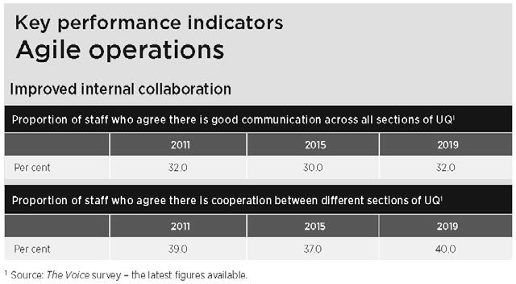
During 2020, a website was established that provided resources for researchers, a Clinical Trials Risk Register was established, a register of approvals for human research studies (including clinical trials) was established
to support insurance coverage, and a new Clinical Trials Procedure was drafted in consultation with a range of stakeholders and then published in December 2020.

Related initiatives for 5.1 | Page
1.2 Student Strategy | 19
1.6 Program Architecture 2 | 22
1.7 UQ2U blended learning | 22
2.1 Research infrastructure | 23
6.5 Sustainable budgeting | 38
Human Resources | 39

Enhance IT governance to ensure that UQ’s information technology aligns with the University’s strategy and priorities, appropriately considers risk and provides maximum value.
IT governance
The University has an IT Governance Framework that ensures that the IT function is optimised for both risk and resources, and is aligned to support the University’s priorities. During 2020, the University's IT governance was further matured by:
- developing change management 'heat maps' that look at the level of change being placed on the University through IT initiatives
- improving the capture and oversight of benefits realisation for IT investments
- developing a roadmap for software compliance improvements
- strengthening disaster recovery and business continuity for key systems
- developing a design authority framework and technical leadership framework that will guide how the University will design and implement new systems
- drafting the IT procurement framework that will enable efficient and effective procurement of a key procurement category for the University
- releasing a new enterprise IT strategy for the University that underwent significant consultation to provide a sound approach for the University's virtual environment over the next 3 years
- drafting a cyber security strategy that will guide how UQ will invest to protect itself against cyber security risks
- releasing new IT standards that target effective operations and risk reduction.
IT Capital Investment Plan
During 2020, work was undertaken to identify a suite of projects to maintain and enhance the University's information and communication technology infrastructure. Priority was given to projects that support the Student Strategy, research and cyber security, with delivery scheduled for 2021. This initiative will also cover network upgrades (including 100Gbps network to Gatton) and continued business process digitisation.
Related initiatives for 5.2 | Page
3.4 CX program | 28
Information systems and recordkeeping | 49

Simplify, streamline, standardise and automate administrative process and work flows across the University.
Accounts payable and accounts receivable automation (APARA)
The APARA project’s primary objective is to centralise, standardise, streamline and automate Accounts Payable and Accounts Receivable processes at UQ. During 2020, work on this project focused on completing the automation of the invoice processing within accounts payable, with an end-of- year target for at least 75 per cent of UQ supplier invoices auto-validated and paid.

Contract and grants financial management During 2020, UQ Finance focused its attention on automating and streamlining existing processes, including investigating supply chains, producing regular financial reports, and enhancing management reporting to aid decision-making.
HR transformation
Human Resources is currently redesigning how it supports UQ, with the aim of making it easier to find HR information online, and to find the right person to talk to at the right time. During 2020, Workday was selected
as the new Human Capital Management Solution. Analysis of business processes, system functionality and integration with other systems commenced, but
implementation of the system was delayed due to the pandemic. This system will replace manual or paper-based activities with simplified and automated workflows for quicker and more consistent service delivery. Other expected benefits include:
- simplified business processing and authorisations; reduced manual processes with minimal duplication; an easily accessible, improved user interface; and a comprehensive, single and accurate view of employees
- high-quality, trusted data supplied in real time
- support for a high-performance culture and future growth, promoting a diverse culture and enabling employees to take control of their career pathways through consistency of recruitment, onboarding and staff development, and direct access for individuals and leaders to the right information to perform in their role.
Research Management Business Transformation program
The Research Management Business Transformation (RMBT) Program encompasses a broad range of targeted projects designed to streamline, enhance and support research, researchers and research training through the provision of new digital solutions.
A 2-phase review of the program was completed during 2020. The Higher Degrees by Research Enhancement project saw a staged rollout of features commencing in late 2020, while the Research Infrastructure Management System was also implemented in the first round of facilities. Research
Data Manager is now fully embedded, and incorporates the Digital Research Notebooks functionality.

Related initiatives for 5.3 | Page
2.1 Research infrastructure | 23
6.5 Capital reporting | 38

Review our delivery model for student services and administration to maximise effectiveness and efficiency and enhance the student experience.
Student administration – digitisation and automation
The student administration digitisation and automation stream of work continued to make progress in enhancing business processes for students. By December
2020, the Business Enhancement team had delivered 19 digitised UniTask forms (some with multiple versions) and 16 significant system enhancements. More than 140,000 student requests have been successfully processed to date, with 77,000 in 2020.
The team also led the development of multiple Robotics Process Automation (RPA) solutions which have achieved estimated savings of 70 person-days in 2020 alone.
These included multiple activities in response to COVID-19, such as mass enrolment and grade changes, as well as bulk change updates to student system configuration, and an integration which allows for full automation of the majority of transcript requests from past and current students.
The team is working towards an automation solution to facilitate the tracking and administration around the Academic Integrity Module completion from 2021. Automation work associated with the student system, including the implementation of Digital Badges and Completion Certificates for shorter-form credential students, was also carried out.

Space management policy
Following the finalisation of the Location Analytics project in 2019, the Space Optimisation Working Group continued developing and implementing best practice office space policy in 2020. This included a range of projects connected with COVID-19, a teaching space requirement prediction tool, a new Archibus module to manage laboratory space, testing of people-counter technologies and the development of an Agile workplace prototype.
Outdoor event space
The University also operated an outdoor event space to provide a flexible and
COVID-safe environment for faculty and unit staff and student groups to host events.

UQ Spaces and new UQMaps
The 2019 UQ Spaces proof-of-concept aimed to identify how UQ might deliver natural-language interfaces to the UQ community, such as using conversational inquiries to find suitable study spots. Based on feedback that students prefer traditional app user interfaces (e.g. tap, scroll, swipe, type), UQ worked to develop a replacement for both UQNav and UQMaps, where availability insights as well as granular navigation capabilities could be provided.
A new UQMaps will replace the existing UQNav and UQMap apps in Semester 1, 2021, providing directions to any room on campus as well as live insights into
library, parking and open-access computer availability. Further enhancements are also scheduled for the new year.

ModWest
A $17.6 million temporary modular teaching facility opened in August 2020 near the UQ Art Museum at St Lucia in response to the request from schools and faculties for more large-scale, interactive learning areas. The collaborative learning spaces comprise 2 x 78-capacity rooms, 3 x 120-capacity rooms and 2 x 150-capacity rooms that can be combined to form larger rooms, and incorporate the most advanced audiovisual platform in Australia. Co-developed by UQ
to meet the modern demands of availability and supportability, the platform builds on the advantages of cloud technologies, and significantly reduces the technology required in lecterns, placing UQ at the forefront of innovation to meet the current and future demands of teaching. The facility will be
in place for 6 years while plans for more permanent teaching and learning facilities are developed.
Supporting students facing hardship With lockdowns applied across the state because of the pandemic, many students – particularly international – lost both social contact and part-time employment, and found themselves facing severe economic and personal hardship. In an effort to alleviate this, UQ students and staff made more than 24,000 'care calls' to affected students; and UQ staff, students and volunteers distributed 28,000 meals. The UQ and State Government Emergency
Support Fund paid out more than $1 million in grants to more than 600 students.

Related initiatives for 5.4 | Page
1.1 Entrepreneurship Strategy | 18
1.2 Learning spaces | 19
1.5 Student Complex, Vibrant campuses | 20, 21
1.6 Program Architecture 2 | 22
2.5 HDR industry placements | 25
3.4 CX program | 28
4.5 Create Change Scholarship Match | 31

Review of activities

Diversifying our income streams and managing our resources to establish a sustainable financial base

Competing in a world market where government funding is declining in relative terms, UQ needs to achieve a more sustainable financial base to pursue our strategic agenda. We are doing this by carefully considering all expenditure before outlay, increasing non- government research funding from industry and international sources, boosting income
from philanthropy, and improving our management of costs with a stable financial budget.

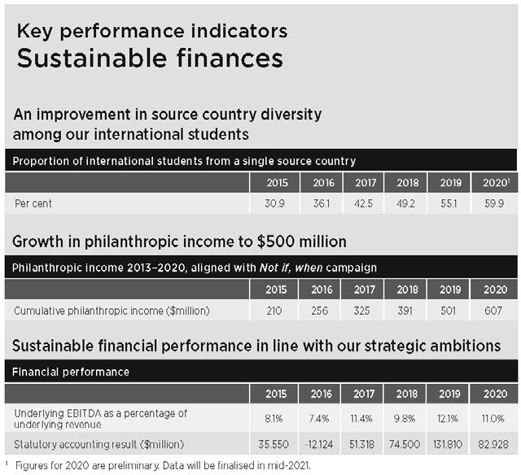
Increase our international student revenue.
With the ban on overseas travel due to the pandemic, the number of international students dropped in 2020, resulting in a reduction in revenue that is expected to continue for some years.

Lead acquisition for diversity
The UQ Strategic Plan 2018–2021 identifies the need for UQ to diversify its income stream as a key strategic focus area.
International students have traditionally been largely drawn to business and commerce programs, and students from China have dominated the overall
international mix. Recruiting students from a diverse range of countries is critically important for the University to also achieve its strategic objective of building cultural diversity in classrooms, which provides
for a richer educational experience for all students. The Lead Acquisition for Diversity strategy takes advantage of a
number of untapped data sources across the University to build a digital profile of our target audiences across the globe, and to develop and execute an informed digital acquisition strategy aimed at improving the geographic distribution of student enquiries. While progress during 2020 was heavily impacted by the pandemic, digital campaign activity shifted to profiling UQ’s thought leadership and research outcomes in relation to COVID-19. This activity drove
new visitation to UQ websites and increased brand awareness for UQ globally. Other market-specific campaign activity aimed at lead acquisition ran in India, Singapore, USA, and Indonesia.

International students
UQ continued to make progress on our long-term priority to increase enrolments from diversity markets. UQ's commitment to India continued throughout 2020
with a strong pipeline resulting from the previous 3-year investment in brand- building initiatives. The India-based team developed deeper relationships with agents (professional development opportunities while in lockdown), implemented a schools strategy (virtual workshops and engagement with schools), and developed a wholesale partnership strategy. Despite the strong pipeline, COVID-19 significantly impacted
the conversion of students from India (particularly for Semester 2, 2020) due to a resistance towards online learning. This was a common theme across many of UQ’s diversity markets, with students preferring to wait for face-to-face learning rather than study online.
With many countries constrained by movement restrictions due to the pandemic, many education systems worldwide shifted to online delivery. International high school and institutional partner engagement across key diversity markets was amplified
through online webinars delivered by faculty academics. These sessions will build the pipeline for future intakes. Scholarships targeting students from diversity markets were also released for Semester 2, 2020.
Related initiative for 6.1 | Page
3.4 CX program | 28

Increase research funding from industry.
New opportunities
UQ is currently exploring sector-focused partnerships at scale, pursuing partnerships that span multiple faculties and institutes.
In 2020, work was ongoing in developing partnerships with Stanwell, Siemens, Stryker, Infosys, IBM, ANSTO and other partners. The partnership with IIT-Delhi solidified with a few strong industry partnering opportunities emerging, including with Renew Power and Google India Labs.

Related initiatives for 6.2 | Page
2.4 Research partnerships | 24
3.2 International research partnerships | 28

Increase research funding from international sources.
By September 2020, UQ had received $264 million of international funding from its 944 research agreements with partners
in 52 countries, the top 10 of which were the US, UK, China, Switzerland, Japan, Germany, France, Canada, Brazil and New Zealand.

Enhancing capability and performance in international research funding
Following the establishment in 2018 of a specialist team for international competitive funding, a rate was successfully negotiated with the US Federal Government so that UQ can now claim 47 per cent indirect cost recovery, rather than 10 per cent, on all Federal Government Agency applications.
Since acceptance in early 2020, UQ generated a further $500,000 of indirect cost recovery gain on 5 grant applications that would otherwise not have been able to be achieved. Education and training programs were undertaken with UQ researchers so
that an unprecedented number of UQ-led bids are currently being prepared for the National Institutes of Health within the year – an indication of the increased confidence of UQ researchers applying to US competitive granting agencies.

Build philanthropic support through a dedicated campaign.
More people donated to the University in 2020 than in any other year.

Philanthropic support
2020 was the final year of the Not If, When – the Campaign to Create Change comprehensive philanthropic campaign. At the close of the year, the campaign's target was exceeded, raising a total of
$607,092,568 from 16,643 donors.
In 2020, $101,968,745 was raised in partnership with 4,683 donors – the most donors in a single year at UQ.

UQ ChangeMakers
In August, UQ launched its first global alumni program, ChangeMakers. Made for alumni by alumni, ChangeMakers aims to provide opportunities to leverage the power of the UQ alumni community –
through alumni-to-alumni (A2A) mentoring, volunteering opportunities, and access to flagship events presented by alumni leaders and academic experts that cover world issues. In 2020, 48,551 alumni engaged with the University, more than any year prior.

Related initiative for 6.4 | Page
4.6 Western Civilisation | 32
5.4 Student hardship fund | 35

Related initiative for 6.3 | Page
2.3 UQIDAR/QUEX | 24

Manage our resources through a capital asset plan and sustainable budgeting.
Sustainable budgeting also included sustainable actions, which reduced costs to both the environment and the bottom line. Around 90 per cent of the University's funding comes from 5 key areas: tuition fees, Commonwealth education funding, research funding, consultancy fees and commercial revenue.

Capital reporting
During 2020, the University introduced an enhanced capital management process and reporting framework. This initiative
facilitates an enhanced capital management process and summary, providing a holistic understanding of all major capital programs (current and pipeline), comparison to budget and high-level view of capital decisions.

UQ Solar Farm
All major construction works for this project are now complete, with stages 1 and 2 (32 megawatts each) having been connected to the grid. Power generation commenced and will follow a 3-stage ‘ramped’ process to full output. The Warwick Solar Farm was
officially opened on 17 July 2020 by Minister for Natural Resources, Mines and Energy Anthony Lynham; Vice-Chancellor Professor Peter Høj AC; and Minister for State Development, Tourism and Innovation Kate Jones – enabling UQ to become the first major university in the world to offset 100 per cent of its electricity use with renewable power produced from its own assets once fully commissioned. The output will be about 160GWh per year, the equivalent of powering more than 25,000 households.
Master of Sustainable Energy students were the first of many students to benefit from seeing renewable energy assets up close and working hands-on with UQ's own data.

Tesla Powerpack battery
In January, UQ commenced operation of a $2 million battery storage system to help the University achieve its energy-
neutral goals, generate revenue and hedge against electricity price volatility. With the energy equivalent of 500,000 standard AA batteries, the system uses an automated algorithm for optimising charging and discharging, developed in-house by UQ. Performance throughout 2020 indicates that the battery will pay for itself in less than the 8 years originally forecast.
Student recruitment
In order to mitigate the anticipated 15 per cent reduction in demand among domestic students for an undergraduate
university place in 2020 (as a result of the introduction of Prep in 2007), an integrated marketing and recruitment strategy was implemented to coordinate all efforts across the University. The results of this concerted effort were pleasing, with UQ increasing
its overall market share – driven largely by an increase in market share among both Queensland and interstate school leavers.
The 2019 review of international admissions processes and procedures recommended several changes, which commenced during 2020. A briefing document was prepared for review by UQ's Information Technology Service, and a proposal outlining what technology can be uplifted, adapted or changed is expected to be completed early in 2021.
Discussions continued around the future of pathways programs, and the operating models for UQ College and the Institute of Continuing and TESOL Education, which were impacted heavily by both uncertainty around Australian Government policies
and the pandemic during 2020. An options paper articulating various operating models will drive further discussions into 2021.

University of Queensland Press (UQP)
In 2020, a new strategic plan was produced to position UQP as a sector-leading independent publishing house with the objectives of transforming Australians through literature, connecting readers with diverse Australian stories, championing Aboriginal and Torres Strait Islander authors, delivering artistic and creative excellence, and providing strong organisational leadership. During the year, the focus was on delivering outstanding engagement for the University including producing a new website, launching a new membership program and industry-leading Indigenous Placement Program, hosting a publicity event for the inaugural UQP Quentin Bryce Award, partnering with UQ Advancement
to launch the monthly UQ Book Club, establishing the inaugural UQP Writing Fellowship, launching the UQP Sustainability Committee, and establishing a framework for collaboration with UQ's Aboriginal and Torres Strait Islander Studies Unit. UQP authors also won a record number of literary prizes in 2020.
UQ art collection conservation Funding was withdrawn for this project in 2020 due to pandemic funding
impacts; however, assuming the supply of
philanthropic sources and the availability of specialist conservators, work may resume in 2021.
Reuse and recycling station
The University partnered with the UQ Union Environment Collective to host a new recycling station for students and staff.
Designed as a receptacle for hard-to-recycle household items that can’t be recycled though home recycling bins, the facility caters for small e-waste, soft plastic, mobile phones, batteries, ink cartridges, oral care products, eye glasses, stationery items, paper, and CDs and DVDs.

Hydrogen buses
In partnership with the Queensland Government, UQ will add 2 hydrogen fuel cell coach-style buses to its fleet by 2022, expected to be the first of their kind in the state. The buses' emissions are expected to be 60–70 per cent lower than those of the diesel-powered intercampus shuttle buses they will replace, cutting about 100
tonnes of carbon dioxide emissions per year. The hydrogen will be produced through electrolysis, using renewable power from the University's Gatton solar farm.

Related initiatives for 6.5 | Page
Honour roll | 8
2.1 Research infrastructure | 22
2.7 UQP Quentin Bryce Award | 26
Financial information | 50

Summary of

Human resources

We fuel success through a positive and supportive culture that attracts and retains high- quality staff in diverse, inclusive, welcoming, safe and progressive workplaces. We design engaging learning experiences and recognise high performance and innovation; and we endorse sound business decisions and streamlined processes that incorporate change management knowledge and capability across the business.

University staff

Recruitment and selection
UQ externally advertised 1,228 jobs for 2020 and placed 492 academic and 736 professional staff positions, along with an additional 890 direct appointments. The University received 29,104 applications. The primary medium for recruitment was the UQ Jobs e-recruitment website, with several externally hosted recruitment websites also used extensively, particularly SEEK, LinkedIn and Global Academy Jobs. From 31 March 2019 to 31 March 2020,
the University’s continuing and fixed- term workforce increased to 7,208 FTE, with a retention rate of 91.88 per cent
and a separation rate of 8.12 per cent for 'continuing' staff members in 2020.
All new recruits were invited to attend a formal induction program in addition to on- the-job orientation.
The Recruitment Services team was selected as a finalist for Best use of technology and Employer of choice (>1000 employees) in the 2020 Australian HR Awards, and Most courageous team in the 2020 Leadership HQ Awards.
The Aboriginal and Torres Strait Islander Employment Strategy continued to be widely promoted by Human Resources. In 2020, 6 graduates were recruited into the Vice-Chancellor's Aboriginal and Torres Strait Islander (Indigenous) Graduate Program,
7 candidates into the Professional Entry Pathways (PEP) Program, and 3 candidates into the Academic Pathways Program. From the 2019 program, 11 of the 21 were retained post-Pathways Program. UQ now employs 97 staff members of Aboriginal and Torres Strait Islander descent.
The table below shows University staff numbers as at 31 March 2020.

Remuneration and benefits
In the 2019/20 financial year, more than 20,000 ATO Income Statements were issued via the ATO's new Single Touch Payroll – myGov system, with overall payroll, superannuation, payroll tax and ATO outgoings of just over $1 billion.

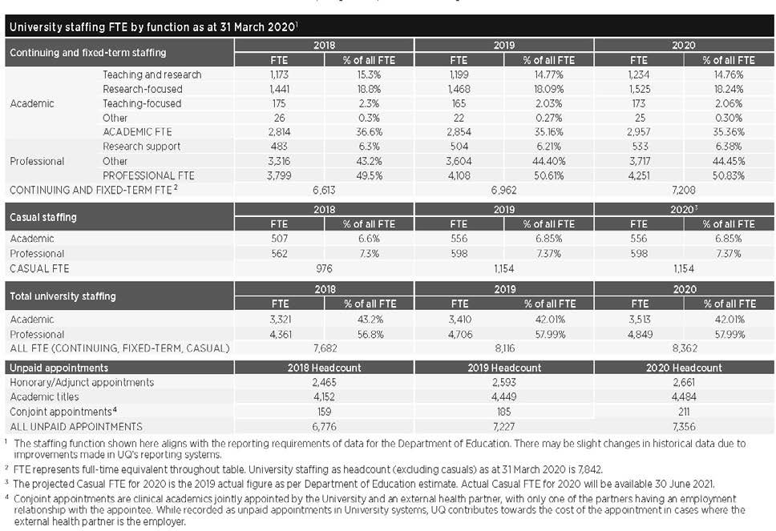

Academic promotions
During the year, 184 academic staff members were promoted, comprising 46 promotions to Level B, 57 to Level C, 50 to Level D and 31 to Level E.

Voluntary Separation Scheme
In 2020, the University chose to implement a Voluntary Separation Scheme (VSS) that allowed eligible staff to voluntarily register an Expression of Interest (EOI) in entering into a separation agreement with UQ.
All continuing academic and professional staff with more than one year of continuous service were eligible to apply. However, some staff members, such as fixed-term
or casual staff and those who had already tendered their resignation, were ineligible.
Access to a VSS payment was at the University’s discretion and all EOIs were confidential and reviewed by a small panel of senior executives.
The scheme attracted strong interest from academic and professional staff across the University. A large majority who registered an EOI were approved and subsequently entered into an arrangement to cease employment under the VSS. Most staff accepting a VSS ceased their continuing employment with the University on or before 31 December 2020.

Staff support
The Workplace Psychologist within the HR team continued to provide general
assistance, referrals and case management support to staff members with, or at risk of having, mental health issues. Where possible, assistance was also provided in managing the rehabilitation and return
to work of staff with non-mental health injury or illness (not covered by a work injury management claim). Due to the impacts of the pandemic, more staff than usual required support. Eighty-four staff were case-managed via rehabilitation and return-to-work activities, short-term assistance in responding to work and personal issues, crisis management and support for their management. Wellbeing checks were provided to staff in line with
the UQ Mental Health Strategy (2018–2020). Due to workplace change, the Workplace Psychologist helped coordinate and develop support strategies for 2 large areas within the University.
The importance of the Employee Assistance Program (provided by Best You by Benestar) was highlighted by its increased usage in periods of stress and
change relating to the COVID-19 pandemic. The March and June quarters showed
10.2 and 10.4 per cent usage respectively, a significant increase when compared
to the December 2019 quarter (8.7 per cent). By September 2020, the usage level stabilised to 8.3 per cent. The Employee Assistance Program continues to represent ongoing proactive early help-seeking by staff, protecting their mental health and promoting wellbeing. UQ's usage remained above the education industry rate of between 2.9 and 3.5 per cent between the December 2019 quarter and the September 2020 quarters. The chief presenting issues continued to be for mental health and personal relationships, mainly for personal rather than work-related reasons.
The University’s accredited Mental Health First Aid program continued via Zoom in 2020, with 13 courses offered for all UQ staff. During 2020, 141 staff completed mental health first aid accreditations, with 123 staff completing the 2-day standard accreditation, and 18 completing the
3-yearly accreditation refresher.

UQ Mental Health Strategy
The delivery and implementation of the UQ Mental Health Strategy (2018–2020) action plan for staff continued throughout 2020, with funding approved to continue implementation until July 2021. Staff initiatives spanning the areas of mental health prevention, early intervention and support that were delivered under the strategy in 2020 included:
- Growth and development of the newly established UQ Mental Health Champion Network. Initiatives promoting enhanced network capability and development with Champion Induction sessions, monthly Community of Practice meetings, Peer Support sessions, and networking opportunities were provided with the staff network increasing by more than
40 per cent to 70 staff. Mental health champions delivered many local mental health initiatives supporting wider UQ mental health events and campaigns,
in addition to providing direct mental health support and referral assistance to students and staff during what was a challenging year for many, due to COVID-19 and its associated mental health impacts
- Support of various work areas in promoting mental health and the development of local mental health action plans for areas with more mentally and emotionally demanding roles
- Delivery of UQ-wide mental health awareness events and campaigns to promote a positive mental health culture and to reduce stigma. These included panel discussion events, seminars and online resources for Men’s Health Week, Carers Week, R U OK? Day and Mental Health Week
- The launch of the new Parents and carers at work program in October during Carers Week, providing all UQ staff with access to webinars and podcasts promoting life, work and career wellbeing topics relevant not only to parents and carers but to all UQ staff and managers
- Development and redesign of the staff mental health webpages including new COVID-19 Mental Health Resources
and other mental health wellbeing and support-related pages
- Development and delivery of a range of new online and face-to-face staff
development programs such as Mentally healthy work for leaders, Promoting mentally healthy work and Healthy minds.

Organisational and leadership development
In line with UQ’s Strategic Plan 2018–2021, a strong focus continues to be placed on supporting staff development activities.
Despite the significant resourcing and logistical impacts of the COVID-19 pandemic on the delivery of the Staff Development program, 690 courses were delivered
to 7,624 UQ staff and affiliates in 2020. Equivalent numbers for 2019 were 781 courses and 7,859 staff respectively. There continues to be a strong appetite for mental health first aid training courses and diversity-related programs such as the UQ Ally training, both of which were strongly attended.
The Career progression for women and Career advancement for senior academic women programs continued to support academic women to gain promotion. Of the past participants in the Career progression for women program, 4 people applied
and all were promoted to Level D; and from the Career advancement for senior academic women program, 11 participants applied for professorial promotion, with 7 achieving promotion to level E and 4 being unsuccessful in 2020.
Significant support was also provided to teams across the University to facilitate strategic planning sessions, promote team culture development, and support organisational change.

HUMAN RESOURCES

UQ Awards for Excellence
For 6 consecutive years, the University has hosted an annual UQ Awards for Excellence program, with nominations increasing
each year. In 2020, 222 individual and team nominations were received, which included more than 900 staff. In order to formally recognise the significant efforts of staff during the pandemic, a new one- off category, Response to COVID-19, was
introduced, which received 109 nominations. Across the 6 categories, 190 staff members received an award or commendation
(6 team and 7 individual winners, 14 team and 14 individual commendations).
By acknowledging and celebrating the achievements and behaviours of staff across all levels of the University, regardless of position, the Awards reflect and support UQ's values.

2020 UQ Awards for Excellence winners Innovation
Dr Aneesha Bakharia
Molecular Clamp Vaccine Team
Service
Lisa Kennedy
Life Course Professional Centre
Community, Diversity and Inclusion
Associate Professor Rhonda Faragher
Student-Staff Partnerships Team
Mental and Physical Health, Safety and Wellness
Guinness World Record Mindfulness (Student Life) Team
Leadership
Jennifer Karlson
Warwick Solar Farm Project Team
Response to COVID-19
Andrea Strachan Professor James Ward
COVID-19 Data Analytics Team

Workplace relations
The Workplace Relations team continued to deliver and provide significant and strategic advice, representation and advocacy throughout 2020 on a range of matters predominantly relating to organisational change and restructuring, business transfers, disputes, performance and conduct. In addition, the team continued to provide general workplace relations advice, internal consultancy services, and advocacy before external tribunals and courts on a range of employment issues and matters.
A number of change processes across UQ organisational units were also supported, including the organisational restructure of ICTE administrative staff, the restructure of the School of Architecture and the restructure of UQ Library, as well as ongoing support and assistance provided for the impact of COVID-19 on university operations.
Workplace Relations continued to support the implementation of UQ’s 2018–2021 Enterprise Agreement, including delivering education and staff development sessions to UQ staff on its key changes. Work is currently underway on the next round of enterprise bargaining negotiations prior to the end of May 2021.
The work of the Human Resources Policy and Strategy team in streamlining and enhancing all existing human resources policies and procedures was also supported, with tools and templates to enable the development of new high-quality, principle- based policies and procedures being provided.

Workforce planning and performance during COVID-19
As the Government’s restrictions on social activity tightened, by the end of March 2020, most classes were made available online, and most staff were required to work from home for an indefinite period. Weeks of intense planning were spent to ensure that UQ students and staff quickly grew accustomed to studying and working from home, using Zoom’s videoconferencing platform and other supporting technologies.
From March through to July (and beyond), 6,700 staff shifted to working from home, while 1,300 staff remained on campus to maintain grounds, facilities, and research integrity and continuity.
Where work in particular areas of the University diminished because of the pandemic, staff were redeployed to other areas through a skill exchange program, UQ Marketplace, and/or participated in special projects such as delivering hampers to isolated and disadvantaged students.
On 29 May, UQ issued a roadmap for a safe return to campus and staff progressively returned to campus work life in line with government restrictions and health protocols.

HR response to COVID-19
The Workplace Relations team, HR policy team, Workplace Psychologist and Mental Health Coordinator all contributed subject matter expertise to the Executive and key stakeholders in developing the University’s HR COVID-19 response, as well as providing extensive support material for staff. This ensured UQ's approach was consistent with our employment obligations, the Mental Health Strategy and the sector-wide response. This work was undertaken during
a time of complex and fast-moving changes to Australia’s industrial landscape.

HR policy and strategy
The Policy team reviewed more than 160 documents in the Policy and Procedures Library (PPL) as part of implementing the Streamlining and Enhancing Policies and Procedures (SEPP) management program, rationalising the existing 62 policies down to approximately 25. All
policies are now drafted, and consultation with key stakeholders to finalise these drafts continues as required. To date, the Senate has reviewed Diversity, Equity and Inclusive Behaviours Policy, and associated procedures have been approved. The drafted HR policy suite is being further refined to complement and support the configuration and implementation of
the Human Capital Management System (HCMS).

Workplace diversity and inclusion In 2020, the Workplace Diversity and Inclusion (WDI) team delivered a number
of significant outcomes in support of UQ’s
commitment to building a safe, respectful and inclusive environment for all members of the UQ community. The most significant of these was a recent change which enables the Chairs of all Strategic Diversity and Inclusion Committees to attend UQ’s Senate Sub-Committee for Equity, Diversity and Inclusion, promoting greater cross-university sharing and a more intersectional approach to diversity and inclusion matters.

Aboriginal and Torres Strait Islander staff UQ is on track to achieving the Aboriginal and Torres Strait Islander staff FTE representation targets outlined in UQ’s Enterprise Agreement. Key deliverables in the Aboriginal and Torres Strait Islander portfolio include The Deadly Post, a new newsletter that shares information, stories, events and employment opportunities for Aboriginal and Torres Islander (Indigenous) staff; implementation of the Academic

Pathways Program, which has resulted in the appointment of several new academic
staff members; and ongoing implementation of the Professional Pathways programs, including the Vice-Chancellor's Indigenous Graduate Program, which have resulted in doubling the representation of Aboriginal and Torres Strait Islander staff over the past few years.
Other activities included enhanced professional development programs for Indigenous staff, including fee-waived opportunities to undertake a MicroMasters with the School of Business; networking events and activities, both virtual and non- virtual, in support of the Aboriginal and Torres Strait Islander Staff network; and refreshed recruitment collateral, which aligns with UQ’s Reconciliation artwork and situates UQ as a safe, welcoming and inclusive community for Aboriginal and Torres Strait Islander staff. New guides supporting supervisors of Aboriginal and Torres Strait Islander staff and outlining further measures to enhance their representation in UQ roles will be released shortly.
The WDI team also introduced measures that allow external Aboriginal and/or Torres Strait Islander people to apply for ‘Internal Only’ roles, and exempt Aboriginal and Torres Strait Islander staff and positions from UQ’s ongoing recruitment controls, enabling staff who have progressed through any Indigenous Pathway Program to be directly appointed to a suitable role during or at the conclusion of their Pathway Program.

Gender
In support of UQ’s commitment to the SAGE Pilot of Athena SWAN, WDI and UQ’s Gender Steering Committee coordinated and implemented a range of programs and activities, including Promoting Women fellowships, which have demonstrated
improved promotion outcomes for attendees in terms of timeframes for promotion and success rates; delivery of the Merle Pledge, an initiative designed to substantially improve women's representation in public and professonal forums, and which is likely to become a national movement supporting women’s representation on panels, speaking events and other conference activities; and the first annual report and faculty report cards of progress against achievement of SAGE Athena SWAN goals.
Pay equity was another focus in 2020, with the development of 2 new guides addressing mechanisms for improving pay equity within organisations – both of which garnered national interest.
Disability
Excellent progress was made in the area of disability employment, with achievements including a highly successful trial of a
new fund to support any additional travel support needed by staff with disability (its ongoing implementation was interrupted by COVID-19); the delivery and update of the refreshed Disability masterclass and Managing diverse teams training; forging a new partnership with Autism Queensland’s EmployABLE project; and the development of policy and procedures to support staff
with a disability and reasonable adjustments in the workplace.

Cultural inclusion
WDI convened the inaugural meeting of the UQ Staff Cultural Inclusion Council early in the year, after which the Council met quarterly. In addition, WDI worked alongside the Council to hold focus-group discussions with more than 40 culturally and linguistically diverse (CALD) staff from 23 countries/regions – including Aboriginal and Torres Strait Islanders – to inform the key priorities and objectives in delivering
UQ’s first CALD Staff Inclusion Strategy (due to commence implementation in 2021). The Warm Welcome program continued to be
a successful and valued service provided to incoming international staff prior to a temporary hiatus as a result of COVID- related restrictions.

See CALD student support | 31
LGBTIAQ+
LGBTIAQ+ was another focus for WDI in 2020. Key achievements included the highly successful Wear it purple event, which was supported by UQ’s senior executive, Senate members and the wider UQ community. UQ again achieved Silver status in the national Australian Workplace Equality Awards, which were more competitive in 2020 than usual. UQ also introduced an internal Ally Award, acknowledging the significant efforts and support provided to the LGBTIAQ+ community through UQ’s nationally recognised Ally program.

Sexual misconduct
On 16 December, UQ officially launched its Strategic framework and action plan for sexual misconduct and response, which set out UQ's commitment to striving for safe and respectful learning, working and research environments for all members of the UQ community.

Work/life balance
The UQ Wellness Program aims to boost staff psychological and physical wellbeing through a range of lifestyle and community engagement activities. During 2020, the pandemic brought a number of challenges; however, it was essential to continue to provide health and wellbeing options to the UQ community, while also following COVID-19 health protocols. Offerings included, but were not limited to, the following initiatives:

Staff influenza vaccination program and innovative wellness options
The staff flu program participation increased by approximately 7 per cent in 2020, with 6,065 staff members and HDR students receiving the vaccination (compared to 5,700 in 2019). Being adaptable and flexible was essential during 2020 and led to the development of online Yoga and Pilates classes, plus a range of online resources
to help staff manage during COVID-19, including Surviving home-schooling, Working from home arrangements, Webinar fatigue and Pandemic fatigue.

Australasian University Health Challenge and Wellness challenges
Seventeen universities across Australia and New Zealand participated in the second
- week walking challenge, which attracted more than 2,100 participants (197 from UQ).
More than 1,000 participants in 76 teams participated in a 6-week community health challenge designed to help people stay connected and keep moving during working from home arrangements.
Based on the principles of positive psychology, 7- and 14-day 'challenges' to promote physical, social and emotional wellbeing were held in 2020. A popular initiative, it saw 1,041 staff and students participating. Evaluation showed that the challenge helped participants make ongoing and sustainable behavioural changes to enhance wellbeing.

Psychological wellbeing seminars
UQ Wellness provides a broad range of health and wellbeing seminars annually on topics like mental fitness, enhancing
personal wellbeing, positive coping, healthy communication and stress management.
In 2020, sessions focused on supporting people during the COVID-19 crisis. More than 1,490 people participated in seminars such as Let's get real (about burnout, self- compassion, difficult conversations and emotional regulation), Nutrition, Navigating the change, Mindfulness, Managing aches and pains, Work/life balance, Mental health in uncertain times, The truth about sugar, Women's health and Men's health.

Our governance

The governing body of the University is the Senate, as constituted by the University of Queensland Act 1998.

University governing body
Senate has 22 members, comprising official members, appointed members, elected members and additional members.
Members serve a 4-year term, except student members who serve for 2 years. The 34th Senate began its term on 1 January 2018 and will expire on 31 December 2021.
Senate met 8 times during 2020.
On 1 July, Professor Bronwyn Lea filled the vacancy of academic staff member created by the resignation of Associate Professor Tony Roberts on 30 June; student member Gabrielle Starr commenced on 4 August, filling the casual vacancy created by Drew Pavlou; and, following the retirement of Vice-Chancellor and President Professor Peter Høj AC on 31 July 2020, Professor Deborah Terry AO joined the Senate on
3 August 2020.
The University complies with the Voluntary Code of Best Practice for the Governance of Australian Public Universities.

Senate membership
Official members
- Chancellor Peter N Varghese AO, BA (Hons), H.DLitt Qld (leads the University’s governing body, the Senate)
- Vice-Chancellor and President, Professor Deborah Terry AO, BA (Hons) ANU, PhD ANU, FASSA, FAPS
– President of the Academic Board, Professor Peter Adams, BSc (Hons), BComm, PhD Qld

Members appointed by the Governor-In- Council
- Julieanne Alroe, BEc Qld, GAICD
- Timothy B Crommelin, BCom Qld, AdvMgmtProg Hawaii, FSIA
- Philip Hennessy AO, BBusAcc QUT
- Jamie Merrick, BA, MSc
- Grant Murdoch, BCom, MCom Cant, FCA, FAICD
- Adjunct Professor Dr Sally Pitkin AO, LLB, LLM QUT, PhD Qld, FAICD
- Cecile Wake, BEcon, LLB (Hons) Qld,
ExecDevptProg Wharton
- [Vacancy]

Elected members
- One member of the Academic Board, Professor Greg Hainge, BA (Hons), MA, PhD Nott, GCELead Qld, FAHA, SFHEA
- One member of the full-time or part- time academic staff of the University, Professor Bronwyn Lea, BA, MA, PhD Qld, FQA
- One member of the full-time or part-time general staff of the University, Rebecca Hurst, BA (Hons) Griffith
- One postgraduate student, Richard Lee, BA, BEd (MidYsSch) Qld, JP (Qual)
– One undergraduate student, Gabrielle Starr, BSc Qld (studying Dentistry)
Three (elected) graduates of the University
- Associate Professor Douglas Cavaye, MBBS Qld, FRACS
- Adjunct Professor Dimity Dornan AO, DipSpTh, BSpTh, PhD Qld, HonDUniv USQ, FSPAA, FTSE, CpSp, LSLS Cert AVT
– Elliott Johnson, BCom/BEcon Qld

Appointed by Senate
- Anne Cross AM, BSocWk, MSocWk Qld, FAICD
- Deputy Chancellor Tonianne Dwyer, BJuris (Hons), LLB (Hons) UWA, GAICD (acts as Chancellor in the absence of
the Chancellor, or if the office of the Chancellor is vacant)
- Michelle Tredenick, BSc Qld, FAICD.

Senate achievements
In 2020, UQ Senate:
- under the Seal of the University, conferred 14,242 awards* to 13,017 students – including 737 PhD candidates
- unanimously agreed to appoint Professor Deborah Terry AO as the University’s Vice-Chancellor and President from 3 August 2020, in terms of Section 32 of the University of Queensland Act 1998
- approved the principles for the protection of freedom of speech and academic freedom
- undertook an extensive, external review of the Senate: the Governance Committee will oversee the implementation of the report and report back to the Senate
- invited 6 nominees to accept honorary doctorates and one to receive a Gatton Gold Medal.

* This figure includes dual degrees as 2 awards because 2 testamurs are produced 'under the Seal of the University'. It also includes a subset of programs that are not considered federal government-reported awards – hence the variation from the Key Statistics table on page 15.

Senate Committee memberships
Senate Advancement Committee
- Timothy Crommelin (Chair)
- Peter N Varghese AO
- Professor Peter Høj AC /Professor Deborah Terry AO
- Professor Aidan Byrne
- Associate Professor Douglas Cavaye
- Adjunct Professor Dimity Dornan AO
- Jennifer Karlson
- Dr Catherine Lawrence
- Rongyu Li
– Gabrielle Starr
Senate Campus Infrastructure Committee
- Tonianne Dwyer (Chair)
- Peter N Varghese AO
- Professor Peter Høj AC /Professor Deborah Terry AO
- Professor Peter Adams
- Julieanne Alroe
- Philip Hennessy AO
- Malcolm Middleton OAM
- Cecile Wake
Senate Discipline Appeals Committee
- Adjunct Professor Dr Sally Pitkin AO
(Chair)
- Grant Murdoch
- Professor Peter Adams
- 2 students
Senate Committee for Equity, Diversity and the Status of Women
- Julieanne Alroe (Chair)
- Anne Cross AM
- Adjunct Professor Dimity Dornan AO
- Rebecca Hurst
- Professor Peter Høj AC /Professor Deborah Terry AO
- Professor Aidan Byrne
Senate Finance Committee
- Philip Hennessy AO (Chair)
- Peter N Varghese AO
- Professor Peter Høj AC /Professor Deborah Terry AO
- Professor Peter Adams
- Timothy Crommelin
- Tonianne Dwyer
- Grant Murdoch
- Associate Professor Tony Roberts / Professor Bronwyn Lea
- Cecile Wake
- President UQU or nominee
Senate Governance Committee
- Peter N Varghese AO (Chair)
- Professor Peter Høj AC /Professor Deborah Terry AO
- Professor Peter Adams
- Tonianne Dwyer
- Professor Greg Hainge
- Philip Hennessy AO
- Grant Murdoch
Senate Honorary Awards Committee
- Peter N Varghese AO (Chair)
- Professor Peter Høj AC /Professor Deborah Terry AO
- Professor Peter Adams
- Julieanne Alroe
- Tonianne Dwyer
- Adjunct Professor Dr Sally Pitkin AO
Senate Remuneration Committee
- Peter N Varghese AO (Chair)
- Anne Cross AM
- Tonianne Dwyer
- Philip Hennessy AO
- Professor Peter Høj AC/Professor Deborah Terry AO
Senate Risk and Audit Committee
- Grant Murdoch (Chair)
- Peter N Varghese AO
- Professor Peter Adams
- Anne Cross AM
- Philip Hennessy AO
- Elliott Johnson
- Michelle Tredenick
Senate Student Appeals Committee
- Professor Joanne Wright (Chair)
- Professor Peter Adams
- Professor Greg Hainge
- Professor Bronwyn Lea
- Director, Student Support Services
- President (UQU) or nominee
- Student appointed by Senate after consultation with President UQU
- 3 members of the academic staff nominated by DVC (Academic)

Financial reporting
The financial statements are general purpose financial reports prepared in accordance with prescribed requirements. The University of Queensland is a statutory body and is audited by the Queensland Audit Office.
See also: about.uq.edu.au/annual-reports.

See also | page
UQ basis of authority/functions | 10

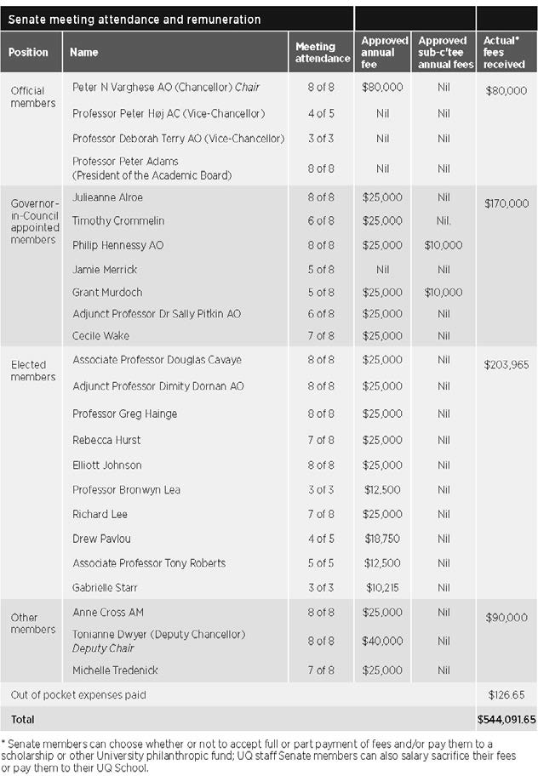
Executive management
While the Chancellor and Deputy Chancellor lead the University Senate, the Vice- Chancellor and President is the University’s Chief Executive Officer, responsible to Senate for overall strategic planning, finance and external affairs direction.
Until 17 August 2020, the Vice-Chancellor and President was supported by the Vice- Chancellor’s Committee, consisting of:
  - Provost and Senior Vice-President
  - Deputy Vice-Chancellor (Academic)
  - Deputy Vice-Chancellor (External Engagement)
  - Deputy Vice-Chancellor (Research)
  - Chief Operating Officer.

On 18 August 2020, the senior management group that provided input to strategic and operational planning was disestablished.
From that date, the Vice-Chancellor and President was supported by an expanded Senior Executive Team comprising:
  - Provost and Senior Vice-President
  - Deputy Vice-Chancellor (Academic)
  - Deputy Vice-Chancellor (External Engagement)
  - Deputy Vice-Chancellor (Research and Innovation)
  - Chief Operating Officer
  - Executive Dean, Faculty of Business, Economics and Law
  - Executive Dean, Faculty of Engineering, Architecture and Information Technology
  - Executive Dean, Faculty of Health and Behavioural Sciences
  - Executive Dean, Faculty of Humanities and Social Sciences
  - Executive Dean, Faculty of Medicine
  - Executive Dean, Faculty of Science
  - Director, Queensland Brain Institute (representing the research institutes).

The Senior Executive Team has responsibility for advising the Vice- Chancellor on planning, directing and controlling the activities of the University.

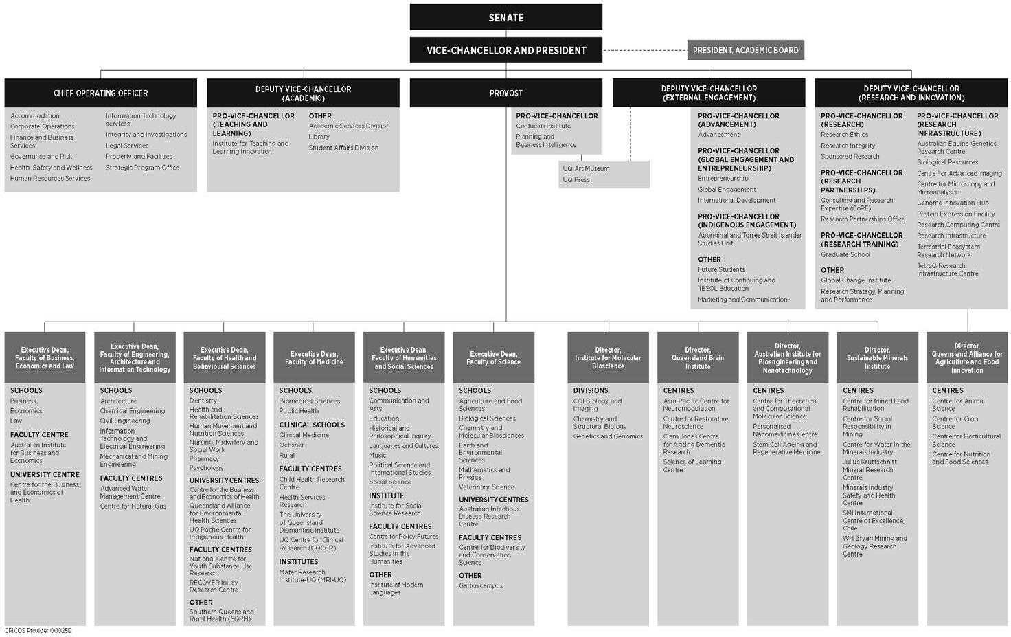
Organisational structure / lines of responsibility
GOVERNANCE
46 THE UNIVERSITY OF QUEENSLAND ANNUAL REPORT 2020
As at October 2020
Issued by the Office of the Chief Operating Officer
uq.edu.au/about/docs/org-chart

Public Sector Ethics
In terms of its obligations under the Public Sector Ethics Act 1994, the University
has a Code of Conduct that sets out the expectations for University staff in relation to professional conduct. All continuing and fixed-term staff are required to complete an assessable online course to learn how the Code of Conduct applies to them; casual staff are also strongly encouraged to complete the course.
The training is consistent with the University’s obligations under the Public Sector Ethics Act 1994, which requires the University to provide appropriate
education about public sector ethics. Given the high profile of the Code of Conduct, administrative procedures and management practices across the University reflect the objectives and requirements set out. It is also referenced in position descriptions
and offers of appointment, forms part of employee induction programs, and is incorporated into relevant training and development programs.

Risk management
The University has a Senate Risk and Audit Committee that assists Senate in discharging its risk management, and internal compliance and control oversight responsibilities.
The role of this committee is to oversee the University’s governance, risk and compliance frameworks, including policies, procedures, information systems, and systems of internal control surrounding key financial and operational processes. The Committee also provides oversight of the leadership and direction in terms of organisational culture and ethical behaviour.
The Committee receives advice and assurance from senior management and Internal Audit across the following functions and activities:
- Enterprise Risk
- Occupational Health and Safety
- Governance
- Compliance
- Integrity and Investigations
- Research Integrity.

All members of the Senate Risk and Audit Committee are appointed by Senate. The Committee met 4 times during 2020 and the members were:
- Grant Murdoch, BCom Cant, MCom Cant, FCA, FAlCD (Chair)
- Professor Peter Adams, BSc (Hons), BComm, PhD Qld
- Anne Cross AM, BSocWk, MSocWk Qld, FAICD, FIML
- Philip Hennessy AO, BBusAcc QUT (as Chair of Finance Committee)
- Elliott Johnson, BCom/BEcon Qld
- Michelle Tredenick, BSc Qld, FAICD
- Peter N Varghese AO, BA (Hons) Qld, H.DLitt Qld (Chancellor, ex officio).
No members were remunerated for their attendance apart from Grant Murdoch, who received $10,000 in his role as Chair.
UQ’s key risk management governance instruments are the Senate-approved Risk Appetite Statement and the Enterprise Risk Management Framework.
The Enterprise Risk Management Framework is built on and supported by 5 ‘pillars’:
- Senate’s expectations and risk appetite
- Management/leadership commitment and support for risk management function, organisational culture and relationships
- External compliance obligations relating to risk management
- Risk management objectives, strategies, delegated authority and accountabilities
- Risk management resources, plans, processes and activities.

The University has adopted a ‘3 lines’ assurance model as part of its governance, risk and compliance frameworks.
During 2020, the Committee provided direction and oversaw the following:
- Risk Appetite Statement (RAS): Updates were proposed for this and the related Risk Matrix.
- COVID-19-related risk assessments, mitigations and reporting: These comprised:
  - impact assessments including the impact on UQ’s risk capacity
  - crisis response organisational and governance structure
  - crisis management strategy and protocols
  - crisis response focus areas and actions•UQ’s recovery strategy.
- Top risks: Reporting continued on the University’s top academic and non- academic risks, considering the COVID-19 expected impact and related changes in the external environment, and progress reporting on the implementation of proposed new risk treatments.
- Emerging risks: UQ’s key emerging risks were reported, including those risks that have not yet occurred but are at an early stage of becoming known and/or are expected to grow greatly in significance.
- Specific risk exposures: Based on specific requests from management and/or
the Senate Risk and Audit Committee, comprehensive risk assessments were undertaken and reports provided on specific risk exposures. Examples of such requests included risks associated with research collaborations with partners based in foreign countries, and the governance and management of major projects such as the Human Capital Management System.

GOVERNANCE

  - Key Risk Indicators (KRIs): These were identified for monitoring our performance against each Risk Appetite Statement, including an assessment of the status of the current KRI level against the RAS, as well as the KRI’s development trend over time. Relevant strategic KPI metrics and targets were also cross-referenced to the RAS.
  - Health, safety and wellness: To strengthen the governance structures and functions related to health, safety and wellness management, 3 additional safety dedicated senior management risk committee meetings were scheduled
in 2020.
  - Research Integrity: In 2020, work focused on strengthening management of
conflict of interest, including consultancy, secondary employment and internal work, and foreign influence.
  - Cybersecurity: There was a continued focus on cybersecurity risk management, in particular on strengthening the University’s controls framework to mitigate this high-risk exposure.

The Senate Risk and Audit Committee has operated effectively as per its charter and had due regard to Treasury’s Audit Committee Guidelines.

Integrity and Investigations Unit The Integrity and Investigations Unit is responsible for the management and
conduct of investigations into breaches
of policies, activities directed against the University and/or its people, misuse of public money and public interest
disclosures. The Unit also leads the delivery of misconduct prevention strategies, including training, information and advice.
The Associate Director, Investigations and Integrity, reports administratively to the Chief Operating Officer and has direct access to the Vice-Chancellor and President, the Provost and Senior Vice-President, Chair
  - Senate Risk and Audit Committee, and Chancellor, as required.

Internal Audit
The Internal Audit function adds value by assisting Senate and University management to effectively execute their responsibilities by providing assurance on the effectiveness of governance, risk management and internal controls.
Internal Audit also assesses and provides assurance on the quality of financial, managerial and operating information, and whether resources are acquired economically, used efficiently and managed effectively.
Internal Audit operates under an Internal Audit Charter, last reviewed and approved by the Senate Risk and Audit Committee in November 2020. As per this Charter, the Internal Audit function is independent of management and, as such, has no direct responsibilities for, or authority over, any of the activities it audits.
Internal Audit functionally reports to the Senate Risk and Audit Committee and has direct access to the Vice-Chancellor and President, Chair – Senate Risk and Audit Committee, Chair – Vice-Chancellor’s Risk and Compliance Committee, and Chancellor.
Internal Audit activities take into account applicable legislative requirements, such as the University of Queensland Act 1998, the Financial Accountability Act 2009, Financial and Performance Management Standard 2019 and Tertiary Education Quality and Standards Agency Act 2011 (TEQSA Act). Internal Audit activities also consider the Queensland Treasury Audit Committee Guidelines 2020.
An annual risk-based planning process is undertaken in consultation with management and the Annual Audit Plan is approved by the Senate Risk and Audit Committee.
During 2020, the completion of the annual audit plan was impacted by COVID-19.
Nevertheless, Internal Audit was able to complete 12 engagements across the University, including assurance services, grant certifications, advisory services and the ongoing review of several large programs and projects.

Human rights
The Human Rights Act 2019 commenced on 1 January 2020, with the main objectives being to:
- protect and promote human rights
- help build a culture in the Queensland public sector that respects and promotes human rights
- help promote a dialogue about the nature, meaning and scope of human rights.

The University is committed to ensuring all decisions and actions taken are compatible with human rights. During 2020, the University conducted information sessions with the Senior Executive Team and Human Resources Leadership Team, and also implemented new processes to ensure any new or revised policies and procedures are compatible with human rights.
UQ received 2 complaints during 2020 that raised human rights concerns.
These matters currently remain under consideration.

Information systems and recordkeeping
The University continues to promote compliance with the Public Records Act 2002, Information Standard 18 (2018) and the ISO27001 information security management system.
In 2020, UQ made key system improvements to recordkeeping, information management, and security and information systems to support University objectives and priorities, including:
  - Class Sign-on that enables students to select class preferences to better balance work/life commitments – 86 per cent received their first preference
  - Curriculum management system (JAC) to provide an integrated digital tool-set that enables staff to collaborate in the creation, management and evolution of a comprehensive curriculum
  - BlackBoard learning management system enhancements to support the University's pivot to dual-mode teaching and onlline assessment.
UQ continued work delivering components of the Information Governance and Management Framework, encapsulating the whole of University’s strategic intent for information governance. The Framework underpins the Information Management
Policy released late 2019. Activities included:
  - thorough assessment of UQ’s data and information legislative obligations
  - comprehensive threat analysis of UQ’s data and information
  - development and communication of a Data Handling Procedure, outlining the minimum requirements via controls and mitigation strategies to safeguard UQ’s data and information throughout all phases of the information lifecycle
  - development and communication of a Research Data Governance Operating Model, outlining the data governance and management expectations and decision rights for research data
  - consolidation of various instruments to support information accountability,
including the placement of recordkeeping and records lifecycle management under the broader and inclusive information governance program
  - delivery of a data awareness campaign aimed at increasing the data literacy of all UQ stakeholders.
UQ also conducted a comprehensive cyber security improvement program that:
- delivered a cyber security awareness campaign, which decreased information security risk through changed behaviour
- further deployed multi-factor authentication (MFA) and increased applications requiring MFA, which resulted in over 25,000 accounts now being protected
- enabled contemporary high-quality firewalls and data protection solutions
- implemented secure online password recovery processes that include security questions for staff and student accounts
- piloted the Security Operations Centre Service delivered by AARNet for the university sector
- improved the security of staff computers by implementing drive encryption, automatic screen-locks, and improved management of local administrative accounts.

Other improvements included:
- continuing work in recordkeeping best practice, which featured:
- compiling a comprehensive list of the Universities Systems of Record
- introducing a central electronic ‘Vault’ for all UQ executed contracts
- introducing a review and approval process for all documents
- going through the offices of the Vice- Chancellor and the Provost
- developing an extensive online training program in the use of TRIM for record-keeping from basic to advanced users
- positioning recordkeeping as part of Project Planning
- continuing the application of the records disposal freeze on any records that are, or may be relevant to, allegations of child sexual abuse and all vulnerable persons, following recommendations of the Royal Commission.

External scrutiny
No significant findings or issues about The University of Queensland were identified by a State entity in 2020.
As part of its audit plan, the Crime and Corruption Commission (CCC) audited the measures in place by a selection of
Queensland universities to mitigate research fraud. Audit results were published in May 2020, and the University is working with the CCC to implement the recommendations from that report.

Summary of

Financial information

As per the financial statements, the University recorded a consolidated surplus of
$108.7m for 2020. This compares to a consolidated surplus of $127.8m in 2019.

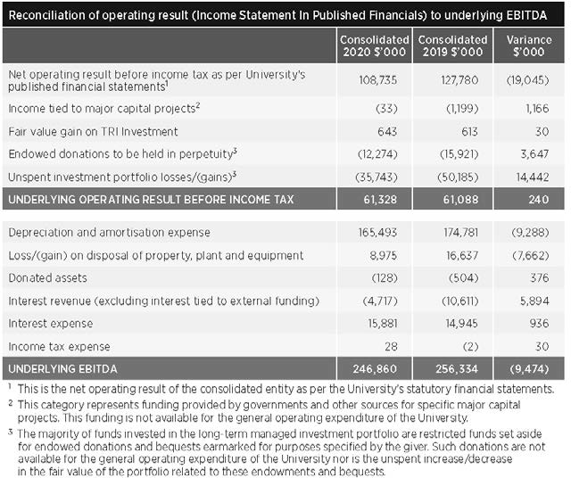
While the financial statements reflect a true and fair view of the financial position of the University and its consolidated entities in accordance with the applicable accounting standards, the University believes that
the more relevant financial result is the underlying consolidated EBITDA (earnings before interest, tax, depreciation and amortisation). This represents the total funding available for debt servicing, major capital projects, and operational property, plant and equipment.
A breakdown of the items adjusted for as part of the underlying consolidated EBITDA is contained in the table at right.

University finances

Underlying EBITDA
The underlying consolidated EBITDA moved from a surplus of $256.3m in 2019 to a surplus of $246.9m in 2020. While the surplus of the 2 years was similar, both
revenue and expenditure were affected due to COVID-19.

Underlying income
The University’s underlying consolidated income decreased by $13.6m (or 0.6 per cent). This can be attributed to:
  - An increase in the combined funding through the Commonwealth Grant Scheme (CGS), the Higher Education Loan Program (HELP), and HELP student contributions of $7.6m (or 1.5 per cent). The number of Commonwealth-funded students fell by 1.1 per cent from 25,624 EFTSL in 2019 to 25,338 in 2020.
  - A decrease in course fees and charges of
$28.2m (or 4.0 per cent). The number of full-fee paying domestic and international students fell by 2.6 per cent from 17,975 EFTSL in 2019 to 17,506 EFTSL in 2020.
This revenue stream decreased by a higher rate because of a 12.5 per cent rebate provided to students unable to travel to Australia given the COVID-19- related restrictions and hence, studied offshore.
  - An increase in research block grant funding of $1.2m (or 0.7 per cent) as the University’s share of total research
funding across higher education providers remained steady.
  - An increase in tied research, scholarship and other major project revenue of $4.8m (or 1.1 per cent). As the underlying result does not recognise such revenue until it
is expended, this rise is due to a related increase in expenditure.
  - An increase in investment revenue of
$15.5m. This gain relates to an increase in the fair value of investments (excluding the portion related to endowments) during the year and proceeds from
the sale of investments held by the University’s commercialisation entity, UniQuest.
- An increase in scholarship and donation revenue (excluding endowments) of
$8.7m (or 24.0 per cent).
- A decrease in royalty and licence fee revenue of $7.7m (or 19.8 per cent) largely due to a reduction in Gardasil royalties during the year.
- A decrease in the remaining revenue categories of $15.5m (or 8.3 per cent) largely due to COVID-19-related factors and government restrictions which reduced on-campus activity. Specific areas where revenue declined included student accommodation, parking fees, gym and sport fees, field trips and activities, conference registrations, executive education, Customs House dining, and contract work.

Underlying expenditure
The University’s underlying consolidated expenditure decreased by $4.2m (or 0.2 per cent). This can be attributed to:
- An increase in employee expenses of
$84.7m (or 7.5 per cent). This was largely driven by the following movements within the parent entity:
  - a 1.3 per cent rise in the average number of full-time equivalent (FTE) permanent staff
  - a 15.0 per cent decline in the average number of FTE casual staff
  - salary rate increases of 2.0 per cent that occurred on 1 January 2020
in accordance with the University’s Enterprise Bargaining Agreement
  - $67.4m in costs associated with a Voluntary Separation Scheme (VSS) for eligible staff who left the University in late 2020.
- An increase in non-employee expenditure on tied research, scholarship and other major project income of $2.2m (or 1.2 per cent).
- A decrease in non-research travel, staff development and entertainment expenses of $39.1m (or 84.9 per cent)
due to COVID-19-related travel and dining restrictions.
- A decrease in repairs and maintenance expenses of $13.5m (or 17.2 per cent) due to a deferral of certain projects given the decline in total revenue.
- A decrease in the remaining expenditure categories of $38.5m (or 8.7 per cent).
Much of this related to the reduced on-campus activity with a reduction in expenses including commission
payments, consultants and professional fees, consumables, motor vehicle costs, trading purchases, electricity, printing and stationery, and advertising and promotion.

Capital expenditure
The University has continued to invest in major infrastructure. The total amount capitalised on property, plant and equipment, and intangibles during 2020 was $192.0m (2019: $311.7m).
Major capital projects in 2020 included the construction of a new chemical engineering building, student residences building and teaching building, and the development of a new Human Capital Management System.

FINANCIAL STATEMENTS

Investment Portfolio
Background
The University maintains 2 long-term managed investment portfolios – the UQ Investment Fund and the UQ Socially Responsible Investment (SRI) Green Fund. These portfolios serve two purposes.
Firstly, they hold endowments received by the University over the past century.
The principal amount of the endowment is invested in perpetuity and the investment earnings are used to support a particular purpose (e.g. scholarships, prizes, chairs) consistent with the donor's intent.
Secondly, they hold a portion of annual operating surpluses generated by the University in recent years. This is known as the UQ Future Fund and the funds are invested in the long-term to provide for
  - a stream of investment earnings that can be used for innovative or strategically important teaching and learning activities,
and/or (2) a reserve to draw upon to absorb a large, unexpected financial shock.

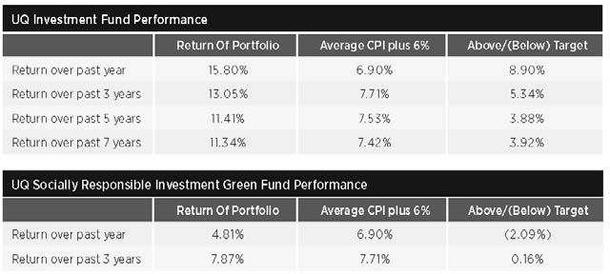
UQ Investment Fund
The UQ Investment Fund is managed by external specialist fund managers who are required to operate within designated asset allocation benchmarks. Each has
responsibilities for investments in cash and fixed interest, listed property, Australian shares, overseas shares, tactical asset allocation, and private equity. The balance at 31 December 2020 is $707.1m. Of this total, $323.8m relates to endowments and
$383.3m relates to the UQ Future Fund.
The investment strategy of the UQ Investment Fund is to achieve a long-term return (net of all fund manager fees) of the Consumer Price Index plus an additional
6 per cent over rolling 7-year periods. As at 31 December 2020, the fund had produced a one-year return of 15.8 per cent and a 7-year return of 11.3 per cent per annum (meeting its target).

UQ Socially Responsible Investment (SRI) Green Fund
The UQ SRI Green Fund offers an alternative to donors providing endowments. The fund will not invest in companies involved with tobacco, armaments, gaming or pornography as they are not deemed socially responsible investments. Further, the fund will not invest in companies excluded from the FTSE All- World ex Fossil Fuels Index.
The fund managers are required to operate within designated asset allocation benchmarks and each has responsibilities for investments in cash and fixed interest and Australian shares. The balance at 31 December 2020 is $4.5m.
The investment strategy of the UQ Investment Fund is to achieve a long-term return (net of all fund manager fees) of the Consumer Price Index plus an additional 6 per cent over rolling 7-year periods. As at 31 December 2020, the produced had produced a one-year return of 4.8 per cent. A 7-year return is not yet available as the fund was first established in 2016.

CFO Statement
In preparing the financial statements, the UQ Chief Financial Officer has fulfilled the reporting responsibilities as required by the Financial Accountability Act 2009. He has provided the accountable officer with a statement that the financial internal controls of the University were operating efficiently, effectively and economically in accordance with section 57 of the Financial and Performance Management Standard 2019.

Annual Financial statements are available online at about.uq.edu.au/annual-reports

Glossary

3MT Three Minute Thesis
AIBN Australian Institute for Bioengineering and Nanotechnology
AMA Australian Medical Association
ANZSCDB Australia and New Zealand Society for Cell and Developmental Biology
APARA Accounts payable and accounts receivable automation
ARC Australian Research Council
ARWU Academic Ranking of World Universities
AskUs Library service providing help with searching, accessing resources, referencing and IT queries
ATO Australian Taxation Office
ATSE Australian Academy of Technology and Engineering
ATSIS Unit Aboriginal and Torres Strait Islander Studies Unit
AWA Australian Water Association
AWEI Australian Workplace Equality Index BEL Business, Economics and Law (Faculty of) CALD Culturally and Linguistically Diverse CBD Central Business District
CCC Crime and Corruption Commission
CDF/L Career Development Framework/Learning
CEO Chief Executive Officer
CEPI Coalition for Epidemic Preparedness Innovations
CFO Chief Financial Officer
CRC Cooperative Research Centre
CRM Customer relationship management system
CSIRO Commonwealth Scientific and Industrial Research Organisation
CX Customer Experience program
CWTS Centre for Science and Technology Studies
EBITDA Earnings before interest, tax, depreciation and amortisation
edX—an online learning destination and MOOC provider, offering high-quality courses from the world’s best universities and institutions to learners everywhere
EFTSL Equivalent full-time student load

ERA Excellence in Research in Australia
FEE-HELP—a federal government loan scheme that assists eligible fee-paying students to pay all or part of their tuition fees
FTE Full-time equivalent
FTSE Financial Times Stock Exchange
GCI Global Change Institute
Go8 Group of Eight—a coalition of leading Australian universities intensive in research and comprehensive in general and professional education
HCMS Human Capital Management Solution
HDR Higher degree by research—PhD, MPhil, DBiotech, DVCSc
HEA Higher Education Academy, a fellowship scheme to recognise outstanding teaching
HECS–HELP Higher Education Contribution Scheme–Higher Education Loan Program
HEW Higher Education Worker (professional staff classification level)
HR Human Resources
IITD Indian Institute of Technology–Delhi
IMB Institute for Molecular Bioscience
InspireU—a tertiary aspiration-building program for Aboriginal and Torres Strait Islander secondary students, involving a series of residential camps
IP Intellectual property
IT Information Technology
ITaLI Institute of Teaching and Learning Innovation JKMRC Julius Kruttschnitt Mineral Research Centre KPI Key performance indicator
KRI Key risk indicator
LGBTIAQ+ Lesbian, gay, bisexual, transgender, intersex, asexual and queer/questioning
MOOC Massive Open Online Course
MW Megawatt
NAIDOC National Aborigines and Islanders Day Observance Committee
NHMRC National Health and Medical Research Council
ORCID—an alphanumeric code to uniquely identify scientific and other academic authors and contributors

P3 People, Planning, Performance project
PA2 Program Architecture project
PVC(IE) Pro-Vice-Chancellor (Indigenous Engagement)
QAAFI Queensland Alliance for Agriculture and Food Innovation
QBI Queensland Brain Institute
QS Quacquarelli Symonds (World University Rankings)
QTAC Queensland Tertiary Admissions Centre QUEX Queensland University/Exeter University RAP Reconciliation Action Plan
RAS Risk Appetite Statement
RCPCH Royal College of Paediatrics and Child Health
SAGE Science in Australia Gender Equity
SMI Sustainable Minerals Institute
STEM/STEMM Science, technology, engineering and mathematics/and medicine
SWAN Scientific Women's Academic Network
TESOL Teaching English to Speakers of Other Languages
The Act University of Queensland Act 1998
TRI Translational Research Institute
Triple P UQ-developed Positive Parenting Program
UQ The University of Queensland
UQ Ally—UQ staff who provide safe, welcoming and inclusive space for sexuality-diverse people
UQIDAR Partnership between UQ and Indian Institute of Technology Delhi Academy of Research
UQP University of Queensland Press
UQRDM UQ Research Data Manager UQ2U—blended learning experience for students UQU University of Queensland Union
UQx—UQ’s participation in edX, developing MOOCs, researching online learning, and collaborating with partner institutes
WA Western Australia
WDI Workplace diversity and inclusion
WIL Work-integrated learning
YAP Young Achievers Program

126 THE UNIVERSITY OF QUEENSLAND ANNUAL REPORT 2020

Qualifications/Honorifics
Aberd Aberdeen, AC Companion of the Order of Australia, Adel Adelaide, AdvMgmtProg
Advanced Management Program, ALF Australian Laureate Fellowship, AM Member of the Order of Australia, ANU Australian National University, AO Officer of the Order of Australia, Auck Auckland, BA Bachelor of Arts, BBus (Comn) Bachelor of Business (Communication), BBusAcc Bachelor of Business (Accountancy), BCAE Brisbane College of Advanced Education, BCom Bachelor of Commerce, BComm Bachelor of Communication, BEc/BEcon Bachelor of Economics, BEd Bachelor of Education, BHMS Bachelor of Human Movement Studies, BJuris (Hons) Bachelor
of Jurisprudence (Honours), BSc Bachelor of Science, BSocWk Bachelor of Social Work, BSpTh Bachelor of Speech Therapy, Cant Canterbury, CCB Creative Connections Brisbane, CertIV (TAE) Certificate 4 in Training and Assessment, CertIV (CC) Certificate 4 in Community Culture, CFRE Certified Fund Raising Executive, CpSp Certified Practising Speech Pathologist, CQU Central Queensland University, DipSpTh Diploma of Speech Therapy, DipT (Sec) Diploma of Teaching (Secondary), DLitt Doctor of Letters, DPhil Doctor of Philosophy, DSc Doctor of Science, DUniv (Honoris Causa) Doctor of the University (honorary degree), Ed Education, ExecDevptProg Executive Development Program, FAA Fellow, Australian Academy of Science, FAHA Fellow, Australian Academy of the Humanities, FAICD Fellow, Australian Institute of Company Directors, FAIESEP Fellow, International Association for Physical Education in Higher Education, FAPS Fellow, Australian Psychological Society, FASMF Fellow, Sports Medicine Australia, FASSA Fellow, Academy of the Social Sciences in Australia, FCA Financial Counselling Australia, FESSA Fellow,

Exercise and Sports Science Australia, FNAI (US) Fellow, National Academy of Inventors (USA), FNAK Fellow, National Academy of Kinesiology (USA), FQA/FQAAS Fellow, Queensland Academy of Arts and Sciences, FRACP Fellow of the Royal Australasian College of Physicians, FRACS Fellow of the Royal Australasian College of Surgeons, FRSC Fellow of the Royal Society of Chemistry, FSIA Fellow of the Securities Institute of Australia, FSPAA Fellow, Speech Pathology Australia,
FTSE Fellow of the Australian Academy of Technological Sciences and Engineering, GAICD Graduate Member of the Australian Institute of Company Directors, GCELead Graduate Certificate in Leadership, Grad Dip Graduate Diploma, GradDipTeach(Sec) Graduate Diploma of Teaching (Secondary), GTC Gladstone Training College, H/ Hon Honorary, Harv Harvard, Hons Honours, JP Justice of the Peace, LLB Bachelor of Laws, LLM Master of Laws, LSLS Cert AVT Listening and Spoken Language Specialist Certified Auditory- Verbal Therapist, MA Master of Arts, MBA Master of Business Administration, MBBS Bachelor of Medicine/Bachelor of Surgery, MCom Master of Commerce, MD Doctor of Medicine, MDP Master of Development Practice, MEd Master of Education, MEdSt Master of Education Studies, Melb Melbourne, MidYsSch Middle Years Schooling,
MIT Massachusetts Institute of Technology, MLitt Master of Letters, MPhil Master of Philosophy, MSc Master of Science, MSocWk Master of Social
Work, Nott Nottingham, PhD Doctor of Philosophy, Qld Queensland, QUT Queensland University of Technology, S.Aust South Australia, SFHEA Senior Fellow Higher Education Academy, Tas Tasmania, UK United Kingdom, UNSW University of New South Wales, USA United States of America,
USQ University of Southern Queensland, UWA
University of Western Australia

ANNUAL REPORT 2020
The University of Queensland uq.edu.au

