The University of Queensland
2022

ANNUAL REPORT

22 February 2023

The Honourable Grace Grace MP
Minister for Education, Minister for Industrial Relations and Minister for Racing
PO Box 15033
CITY EAST QLD 4002

Dear Minister

I am pleased to submit for presentation to the Parliament the Annual Report 2022 and financial statements for The University of Queensland. I certify that this Annual Report complies with:
- the prescribed requirements of the Financial Accountability Act 2009 and the Financial and Performance Management Standard 2019
- the detailed requirements set out in the Annual report requirements for Queensland Government agencies, May 2022.
A checklist outlining the annual reporting requirements can be found at https://www.uq.edu.au/about/organisation/policies-procedures- guidelines/annual-reports.

Yours sincerely
Peter N Varghese AO
Chancellor, The University of Queensland

Acknowledgement of Country
We acknowledge the Traditional Owners and their custodianship of the lands on which our University stands. We pay
our respects to their Ancestors and descendants, who continue cultural and spiritual connections to Country.
We recognise their valuable contributions to Australian and global society.

Public availability note
This report, as at 31 December 2022, was produced by Marketing and Communication, The University of Queensland, Brisbane, Queensland 4072 Australia; and is available online at https://www.uq.edu.au/about/ organisation/policies-procedures-guidelines/ annual-reports, or by calling +61 7 3365 2479 or emailing publications@uq.edu.au.
The following information is available online at https://www.uq.edu.au/about/
organisation/policies-procedures-guidelines/ annual-reports and on the Queensland Government Open Data website at https://www.data.qld.gov.au/
- Consultancies
- Overseas travel.

Interpreter service statement

The University of Queensland (UQ) is committed to providing accessible services to people from all culturally and linguistically diverse backgrounds. If you have difficulty understanding this 2022 Annual Report, please contact UQ’s Institute of Modern Languages on +61 7 3346 8200 to arrange for an interpreter to effectively communicate this report to you.

Feedback
If you have any suggestions about how we can improve this report, please complete the feedback form at https://www.uq.edu. au/about/organisation/policies-procedures- guidelines/annual-reports.
ISSN 1837-6592 (print)
ISSN 1837-6606 (online)
CRICOS Provider Number 00025B TEQSA Provider Number PRV12080
© (The University of Queensland) 2023

Contents

Vice-Chancellor and President’s review 4
  - Year in summary 6
  - 2022 Honour roll 10
Role and functions 14
  - Basis of authority; Controlled entities; Mission; Vision; Values 14
  - Queensland Public Service values; Operating environment 15
  - Key statistics 17
Operational performance 18
  - Government objectives for the community; UQ objectives and performance indicators 18
  - Measures of success 1. Learning and student experience 20
  - Measures of success 2. Research and innovation 23
  - Measures of success 3. Enriching our communities 25
  - Measures of success 4. Our global profile 27
  - Measures of success 5. Our people 29
  - Measures of success 6. Securing our future 31
Human resources 33
  - Workforce profile 33
  - Workforce planning and performance 34
  - Health, safety and wellness 36
Governance 38
  - University governing body 38
  - Executive management 40
  - Organisation chart 41
  - Public Sector Ethics; Freedom of speech and academic freedom 42
  - Risk management 43
  - Information systems and recordkeeping; Human rights; External scrutiny 44
Financial information 45
Glossary 49
Annual Financial Statements are available online at https://www.about.uq.edu.au/annual-reports

Vice-Chancellor and President’s review

The University of Queensland (UQ) withstood multiple challenges in 2022 to consolidate its position as one of Australia’s leading universities – and among the top 50 universities globally.

After a difficult and disrupted start, 2022 developed into a year in which the University repeatedly and successfully pursued its mission of
delivering for the public good through excellence in education, research, and community engagement.
I am proud to say that we made real progress in the implementation of a number of the strategic priorities this year – the first year of our new 4-year Strategic Plan – while also broadening the University’s societal impact in a range of areas.

A difficult start to the year
As the first widespread wave of COVID-19 transmission took hold in Queensland in early 2022, the University encouraged most staff to work from home for the first
6 weeks of the year. Staff and students started returning to campus in large numbers in mid-February, just in time for the start of the academic year.
However, the sense of normality was short- lived as a severe weather event inundated South East Queensland in late February, causing major flooding across multiple UQ sites, including our St Lucia and Gatton campuses. This led to the closure of all UQ sites across South East Queensland for a week and resulted in a one-week pause to teaching in Semester 1.
Through this challenging time, our staff aided nearly 2,000 students who had no power at home – and also found emergency accommodation for 370 students who simply couldn’t return
home due to flooding. Meanwhile, teams worked around the clock to protect vital infrastructure and manage the flood recovery and clean-up process.

Learning and student experience
In total, we enrolled 55,014 students across 392 educational programs in 2022.
We graduated 13,860 students.
Although there was some softening of demand for higher education
among domestic students as Australia experienced strong economic growth and labour shortages across a range of industries, UQ remained the state’s most
sought-after destination for high-achieving school leavers.
With the gradual reopening of Australia’s international border (starting in late 2021), international students started to return to Queensland to study with us on campus.
However, some international students could not travel to Australia due to some ongoing impacts of the pandemic. For this reason, we continued to teach in dual mode (both on campus and online) throughout 2022.

Research and innovation
As a leading Australian research-intensive university, UQ is committed to the generation of knowledge through excellence in discovery science and fundamental research, as well as translating our research into progressive ideas, better services, and products that benefit society.
Some 3,846 active research projects were underway across UQ in 2022 – and we continued to invest in impactful research across a wide variety of fields by approving 1,081 new projects this year.
Many of these projects are seeking to address global challenges, such as climate change and energy transition, food and water security, biodiversity conservation, and disease prevention and treatment.
The University’s research community continues to excel on the global stage, with 42 UQ researchers included on the 2022 Clarivate Highly Cited Researchers list.
According to this prestigious global survey of research excellence, UQ now has more highly cited researchers than any other Australian university.
Among the many highlights of this year, UQ secured $50 million in May under the Federal Government’s Trailblazer Universities Program to establish a new Food and Beverage Accelerator (FaBA) to nurture innovation in Australia’s agricultural, food and beverage sector.
UQ is also a partner in another successful Trailblazer program – the Resources Technology and Critical Minerals hub, led by Curtin University.
In November, the Australian Research Council (ARC) announced that UQ had secured $105 million in funding to establish 3 new Centres of Excellence
focused on Indigenous Futures, Quantum Biotechnology, and Green Electrochemical Transformation of Carbon Dioxide. These 3 Centres will work in close collaboration with non-government organisations, government, industry, and university partners as they seek to find solutions to intractable societal challenges.
In December, we signed a partnership agreement with the Queensland Government, Griffith University, and global healthcare company Sanofi to establish a significant new mRNA vaccine research facility in Brisbane. Known as the Translational Science Hub, the $280
million facility will link our local researchers with Sanofi mRNA Centres of Excellence in France and the United States.

At the very end of the year, we also announced 2 separate trials of UQ- developed medical innovations. The first involved a proof-of-concept trial for a
re-engineered version of the innovative molecular clamp vaccine platform,
and the second was a safety trial for a pioneering ultrasound device that has been developed to improve the treatment of Alzheimer’s disease.

Enriching our communities
Beyond the direct impact of our education and research programs, UQ is committed to enriching communities – both locally and globally – by spreading understanding, raising awareness, disseminating culture, building capacity, creating opportunities, and connecting people.
A major highlight of this year was the August launch of a new UQ initiative called ‘The Queensland Commitment’. The strategic intent of The Queensland Commitment is to provide a more level playing field when it comes to accessing a university education, by removing many of the personal, financial, and geographic barriers that might deter Queensland students from studying at UQ.
This is our pledge to disrupt education disadvantage by improving our pathway programs and growing our philanthropic endowment fund, so that we can provide many more needs-based scholarships for future generations of Queensland students.

Building for the future
In early 2022, we opened 2 substantial new buildings at our St Lucia campus. The Andrew N. Liveris Building was officially opened in April, as a purpose- built home for the School of Chemical Engineering. In May, we officially opened Kev Carmody House, our new student residential building (although the inaugural cohort of over 600 students took up residence earlier in the year).
In other developments at St Lucia, we opened a new restaurant and events venue in Alumni Court; commenced construction of a new Plant Growth Facility; began a major renewal project of the UQ Lake and surrounds, including the construction of a new amphitheatre; and started a project to restore the Avalon Theatre. We also confirmed that the Union Complex will keep its village-
style design and, where possible, existing elements including the Schonell Theatre, Forum and Union Building (building 21A) will be retained.
After a major restoration, we officially opened UQ Brisbane City in August. This heritage-listed building at 308 Queen Street has rapidly become a popular hub where our staff, students and alumni can connect with one another and engage with UQ’s many government, industry and community partners.

Thank you
Despite the challenges we faced early this year, 2022 has been a year of significant achievement and progress for the University. The improvement in our performance and impact this year is due to the collective efforts of our staff working across UQ’s faculties, schools, research institutes and centres, administrative and service divisions.
I would like to express my sincere gratitude to all of our staff, our senior executive team, and members of
the University Senate, including our Chancellor, Peter N Varghese AO.
Thank you for your hard work, your commitment to our mission, and your dedication to serving the broader UQ community. It’s an honour to work alongside you.
I look forward to building on our many successes and achievements in 2023, and beyond.

Professor Deborah Terry AO
Vice-Chancellor and President

Year in summary

January
- UQ offers 3,735 tertiary places to future students in the major January offer round, bringing the Semester 1 offers total to 11,049
- UQ receives $28.8 million in ARC 2022 Discovery and Linkage schemes
- Three UQ research projects are awarded National Health and Medical Research Council (NHMRC)
Development grants
- UQ researchers discover how to unlock ways to fight Listeria infections, and how differences in brain structure are linked to chronic pain
- UQ Art Museum receives carbon- neutral certification for Oceanic Thinking exhibition
- UQ teams with Aurizon to research how rail network carbon emissions can be reduced

February
- Ready to Teach Week is held for UQ teaching staff
- UQ researchers discover that eating selenium-rich foods could reverse the cognitive effects of stroke; feeling connected to nature may be genetic; unique birds have disappeared from 69% of Australia; and diseased male livers undergo sex change to self-protect
- UQ and Australian National University researchers find that cat-transferred diseases cause 8,500 hospitalisations per year
- Patina at Alumni Court restaurant opens at UQ St Lucia
- UQ Ally Network establishes new scholarships for future LGBTQIA+ students
- UQ researchers determine cattle age through tail-hair analysis

March
- UQ South East Queensland locations close temporarily due to floods, with all teaching paused for a week
- Six UQ projects receive $3.2 million in 2021 ARC Linkage Projects scheme (Round 2)
- UQ researchers find links between endometriosis and ovarian cancer, enabling identification of potential drug targets; identify a molecule essential for regulating the repair of damaged nerves; develop lithium-ion technology that could prevent flat batteries; discover a new gene that could extinguish fear-related memories for people with post-traumatic stress disorder; and find evidence that screen time adversely affects teen mental health
- Moderna selects UQ as a partner to research and develop vaccines for future global health threats
- Partnering with Jamie’s Ministry of Food, UQ Wellbeing offers free 5-week online cooking classes to all UQ staff and students
- School of Education launches 3 new shorter form credentials for upskilling teachers
- UQ Employability Week is held
- The 27th Ancient History Day is held at UQ St Lucia
- UQ Wellbeing launches UQ Active & Thriving 4-week fitness challenge
- UQP and UQ Alumni Friends donate books to flood-damaged Lismore Library
- Malaysian High Commissioner thanks UQ for its support of Malaysian students during the floods
- Queensland startup company Eclipse wins iLab Accelerator Pitch Night for production of synthetic lactoferrin for baby formula

April
  - Clean Up Australia Day events are held
  - UQ Regional Roadshow to Toowoomba is held
  - Carpe Futurum, a youth forum to influence UQ’s future research agenda, is held at the Global Change Institute
  - Schneider Electric buys UQ-initiated IT- based sensor technology startup, Aurtra
  - UQ researchers find non-English research is often overlooked or not published; develop data dashboard to track political advertising spending; find genetic link between childhood and adulthood anxiety and depression; develop wireless neuro- stimulator for managing neurological
disorders; develop microbiopsy device to take tissue samples; develop app to protect bird species worldwide; and find that better patient care is needed after strokes
  - Andrew N. Liveris building officially opens
  - UQ, National Rugby League, Queensland Rugby League, Triple P and Central Queensland University launch Play Well program for children in Junior Rugby League
  - UQ, James Cook University (JCU) and Curtin University share in $242 million Resources Technology and Critical Minerals Trailblazer project
  - Queensland Aphasia Research Centre opens at UQ Herston
  - UQ Alumni Book Fair is held, raising more than $129,000 for student scholarships and researchers
May
- Anywhere Festival is held at UQ St Lucia
- UQ develops The future world of work
  - an immersive digital experience edX course
- UQ and Queensland University of Technology (QUT) researchers develop Threatened Species app
- UQ ranks sixth in world for WARPit, the furniture and equipment reuse program
- 2 UQx MOOCs rank in world's top 25
- UQ receives $50 million funding from the Australian Government Universities'
Trailblazer funding to lead FaBA project
- UQ researchers develop environmentally friendly spray to kill crop-killing whiteflies; discover the health benefits of people changing their minds; and reveal the history of the Great Barrier Reef's 8,000-year history of climate change
- Ignite Innovation Showcase 2022 is held
- UQ Pulse Chamber Orchestra participates in Opera Queensland's Festival of Outback Opera
- UQ Reconciliation Garden opens at Herston to acknowledge Indigenous heritage and flora
- School of Music launches new record label, Corella Recordings
- UQ hosts Native American Indigenous Studies Association conference
- Kev Carmody House is officially opened

June
- UQ researchers discover bodybuilders risk developing muscle dysmorphia; obesity reduces age for knee replacement surgery; ocean floors could be a source of critical minerals for use in renewable energy; superworms can eat polystyrene; coffee is safe during pregnancy; female world leaders saw fewer COVID deaths in their countries; and humpback whales share songs
- UQ Poche Centre for Indigenous Health, Institute of Urban Indigenous Health and Metro North Health unite to form Research Alliance for Urban Goori Health
- UQ offers telehealth service for rural women with gynaecological cancer
- The Economist ranks UQ's MBA (Master of Business Administration) program number one in Australia
- UQ academic creates first artwork in the world to combine augmented reality game music with places in the community
- Campuses on Country: UQ Aboriginal and Torres Strait Islander Design Framework is launched
- UQ ranks 50th in QS World University Rankings

July
  - UQ promotes national NAIDOC Week
  - Ready to Teach and Ready to Tutor Weeks are held for UQ academic staff
  - UQ Gatton celebrates 125th anniversary
  - UQ researchers identify gut bacteria strains that could help prevent bowel cancer; develop a method for protecting sheep from flystrike; note
that high-intensity exercise can stave off dementia; and determine that doing things for others is key to finding meaning in life
  - UQ Regional Roadshow to Warwick and Gatton is held
  - UQ hosts 14 graduation ceremonies for 5,358 students
  - ARC awards UQ 3 major grants to establish the ARC Training Centre for Environmental and Agricultural
Solutions to Antimicrobial Resistance, the ARC Research Hub to Advance Timber for Australia’s Future Built Environment, and the ARC Research Hub for Advanced Manufacture of Targeted Radiopharmaceuticals
  - The Institute for Molecular Bioscience (IMB) and UniQuest announce that drug candidate from K'gari spider is licensed to Brisbane startup, Infensa Bioscience
  - UQ invests $50 million to support Health Research Accelerator (HERA) program
  - UniQuest secures $3 million MRFF funding for 4 biomedical startups
  - Feeney Way opens at St Lucia, honouring the extraordinary philanthropists Chuck and Helga Feeney’s contribution to UQ and more broadly
  - UQ–IITD (Indian Institute of Technology Delhi) Research Academy enrols its 100th student
  - UQ wins Pacific Pathways to Brisbane 2032 – Pacific Sports Program bid

August
- Deadly Noize concert is held at UQ St Lucia as part of UQ NAIDOC Week
- Great Court Race, Wear it Purple Day and UQ Sustainability Week are held
- Open Day/Back to UQ days at St Lucia and Gatton attract around 20,000 in- person and 1,000 online visitors
- Premier Annastacia Palasczuk officially opens UQ Brisbane City, 308 Queen Street, and launches The Queensland Commitment
- UQ Regional Roadshow visits Moreton Bay and Redlands, Roma, and Chinchilla
- ARC Centre of Excellence for Plant Success in Nature and Agriculture, ARC Industrial Training Centre for Bioplastics and Biocomposites, and ARC Centre of Excellence for Innovations in Peptide and Protein Science launch at UQ
- UQ researchers discover COVID-19 pandemic had a greater financial and psychological impact on women
- Ian Frazer Centre for Children's Immunotherapy Research opens
- 4th National Indigenous Art Triennial opens at UQ Art Museum
- UQ improves its position in the Shanghai Rankings ARWU to 47

September
- UQ Research and Innovation Week is held
- Pfizer acquires UQ-developed ResApp technology for $180 million
- UQ collaborates with several universities to create WildObs wildlife tracking system
- NHMRC awards 7 UQ researchers funding for research projects including
$2.5 million to establish Centre of Research Excellence for Urban Indigenous Health
- UQ researchers develop molecule chip manufacturing technology for use in medicines, vaccines and energy storage; discover that 'designer' compost could be used commercially; develop a tool to measure properties of lasers for better performance; find that online reporting of minor crime
makes people feel less safe; COVID-19 affects heart tissue; crowded housing contributes to poor Indigenous health; metal compounds could cure drug- resistant fungal infections; and positive reporting on social media promotes teen drug and alcohol use
- US Department of Defense provides UQ with funding for melanoma research
- 15th UQ–Latin American Colloquium is held at St Lucia
- UQ Regional Roadshow to Townsville is held
- R U OK? Day is held at UQ campuses
- Yunan Ye wins UQ's 3MT Final

October
  - Sartorius partners with UQ's Advanced Biomanufacturing Nucleic Acid facility (BASE) facility to improve the manufacturing process of nucleic acid products
  - UQ hosts fourth Giving Day, UQ Wellbeing Festival, BLOOM Festival and Courting the Greats
  - UQ improves its position in the Times Higher Education World University Ranking to 53
  - UQ researchers find water fluoridation is safe for children; baby boomers and young adults are most affected by housing shortage; genetics affects height; disadvantaged children may miss meals in rural childcare centres; wild animals can thrive alongside humans; whale song has meaning; cattle methane emission could be
substantially cut; 'ice' use is increasing across Queensland
  - UQ hosts TropAg agricultural conference
  - UQ Regional Roadshow to Sunshine Coast is held
  - Queensland Government announces that global medical technology group Stryker will establish its first Australian research and development facility in Queensland, with support from the Queensland Government, UQ and QUT
  - NHMRC awards UQ $2.84 million in grants to research in fields of hearing loss and intellectual disability

November
- Teaching and Learning Week is held with the theme of Learning for life and attracts 1,162 participants
- UQ Regional Roadshows to Bundaberg and the Gold Coast are held
- UQ Art Museum hosts Ceremony: First Nations languages lecture and panel discussion
- UQ researchers discover possible treatment for COVID-induced brain disease; microplastics can carry viruses; pregnancies lower risk of endometrial cancer; sleep apnoea increases risk of dementia; pets are a proxy for human health; cyclists plan routes to reduce traffic stress; biting mosquitoes are attracted by person's smell; genome sequencing could curb hospital infections; employers discriminate against applicants with non-standard accents
- Queensland Digital Health Centre (ODHeC) is launched
- The Queensland Commitment philanthropic match is launched
- UQ celebrates Women's Entrepreneurship Day and announces LeadHers winners
- UQ announces proof-of-concept human trial for its second-generation molecular clamp vaccine
- UniQuest startup Cassowary Pharma begins work on hyper- targeted pain medication
- ARC awards UQ 3 Centres of Excellence worth $105 million: Quantum Biology, Indigenous Futures, and Green Electrochemical Transformation of Carbon Dioxide
- UQ hosts first ever Blak market at St Lucia
- UQ is awarded $4.3 million in National Soil Carbon Innovation Challenge
- Former PM Malcolm Turnbull AC delivers 2022 POLSIS lecture
- ARC Training Centre for Information Resilience is launched at UQ St Lucia
- UQ Diamantina Institute renamed the Frazer Institute in honour of Emeritus Professor Ian Frazer AC FRS
- 42 UQ researchers make Clarivate's Highly Cited Researchers list

December
- UQ Thanks You celebrations are held to acknowledge staff
- 8,516 students graduate from UQ at 23 graduation ceremonies, bringing total for the year to 13,860 graduates at 37 ceremonies
- UQ, Sanofi, Queensland Government and Griffith University become partners in new global hub for mRNA vaccines, the Translational Science Hub
- QAAFI partners with the German Research Foundation, DFG, to establish the International Research Training Group for researching genetic improvements in cereal and pulse crops
- Sashing ceremony for Aboriginal and Torres Strait Islander students is held
- Inaugural Indigenous 3MT competition is held, won by Amy Thomson
- UQ researchers discover that Queenslanders cannot assess their intoxication levels; face masks reduce decision-making skills; male turtles are still in sufficient numbers to reproduce; kicking penalty goals in soccer can
be improved; a needle-free malaria detection tool could save hundreds of thousands of lives annually; nasal mucous transplants may help those with chronic nose infections
- ARC approves 51 UQ Discovery projects worth more than $25 million
- Safety trial for Alzheimer's ultrasound treatment begins in Brisbane
- QEM Ltd commences partnership with UQ on critical minerals project
- 'Topping-out' ceremony is held for new Plant Growth Facility at UQ
- The Institute for Social Science Research becomes consortium partner in the National Centre for Place-Based Collaboration
- 31 UQ researchers and research teams receive NHMRC grants.

2022 Honour roll

Fellowships
Learned Academies
  - Professor Jason Roberts, Professor Di Yu (AAHMS); Professor Clint Bracknell,
Professor Deborah Brown, Professor Felicity Meakins, Peter N Varghese AO (Honorary) (AHA), Professor Bronwyn Fredericks, Professor Janet McColl-Kennedy, Professor Brad Sherman, Adjunct Associate Professor Monica Cuskelly (ASSA)
ARC Future Fellows
  - Associate Professor Victor Anggono, Professor Antje Blumenthal, Dr Joel Carpenter, Associate Professor Coral Gartner, Associate Professor Lee Hickey, Dr Ruth Knibbe, Associate Professor Timothy Mercer, Dr Conan Wang, Dr Loic Yengo, Dr Rowan Young
ARC Laureates
  - Professor Karen Thorpe, Professor Matt Trau
2022 Churchill Fellowship
  - Dr Liz Brogden, Associate Professor Marc Ruitenberg
2022 Advance Queensland Industry Research Fellowships
  - Dr Sebastian Hoerning, Dr Xia Huang, Dr Christopher McMillan, Dr Christopher
O'Brien, Dr Anne Sawyer, Dr Mehdi Serati, Dr Anton Van Der Vegt, Dr Ruizhi Zhong, Dr Guohun Zhu
2022 Higher Education Academy (HEA) Fellows
Principal Fellow
  - Professor Karen Benson
Senior Fellows
  - Belinda Benes, Associate Professor Ian Hardy, Associate Professor Judith Mair, Associate Professor Katie Makar

Awards
2021 Australian Awards for University Teaching (AAUT)
  - Citations for Outstanding Contributions to Student Learning: Dr Roma Forbes, Dr
Cle-Anne Gabriel, Dr Sara Herke, Associate Professor Ian MacKenzie, Dr Michael Thai
2022 AAIA Awards
  - The University of Queensland Global Sustainability Lab for Sustainability & Environmental Solution of the Year
2022 AIA Queensland Architecture Awards
  - Andrew N. Liveris building (Queensland Medallion, Jennifer Taylor Award forEducational Architecture, Karl Langer Award for Urban Design, Interior Architecture State Award)
  - UQ Gatton Heart and entry (Urban Design Award)
2022 AIA Regional Architecture Awards (Queensland)
  - Andrew N. Liveris building (John Dalton Award for Building of the Year;Educational Architecture; Interior Architecture; and Urban Design commendations)
  - Kev Carmody House (Residential Architecture commendation)
  - UQ Gatton Heart and entry (commendation)
2022 Australasian Green Gown Awards
  - The University of Queensland (Next generation learning and skills for UQ carbon literacy program)
2022 Australian Financial Review Higher Education Awards – Research Commercialisation Award
  - UniQuest (Pure Battery Technologies)
2022 Australian HR Awards
  - The University of Queensland (Best use of technology)
2022 Australian Workplace Equality Index (Gold) Award
  - The University of Queensland
2022 Bionics Queensland Awards
  - Professor Susannah Tye and team at QBI (Bionic Neurotech and AI) for Intelligent closed loop neuromodulation project
2022 Clarivate Analytics Highly Cited Researchers*
  - Professor Christine Beveridge, ProfessorBhesh Bhandari, Associate Professor Mark Blaskovich, Professor Wendy J Brown, Dr Mark S Butler, Professor Matthew Cooper, Professor Thomas Davis, Professor Elizabeth Eakin, Professor David P Fairlie, Dr Alize J Ferrari, Professor Richard Fuller, Professor Juergen Goetz, Professor Wayne D Hall, Professor Ben J Hayes, Professor Genevieve N Healy, Professor Philip Hugenholtz (2 categories), Emeritus Professor Sritawat Kitipornchai, Professor Jeffrey Lipman, Professor Catherine Lovelock, Professor John J McGrath, Professor Peter Mumby, Professor John M Pandolfi, Dr Donovan Parks, Professor David L Paterson (2 categories), Professor Hugh Possingham, Dr Christian Rinke, Professor Jason A Roberts, Emeritus Professor Michael
S Roberts, Professor Avril Robertson, Honorary Professor James Scott, Honorary Professor Gene Tyson,Professor Peter
M Visscher, Professor Lianzhou Wang, Dr Peng Wang,Professor James EM Watson, Professor Harvey A Whiteford, Professor Naomi Wray, Professor Yusuke
Yamauchi (2 categories), Professor Zhiguo Yuan, Professor George Zhao, Professor Zhonghua Zhu, Emeritus Professor Jin Zou
[* With 45 HiCi awards, this places UQ first in Australia and equal 22nd in the world.]
2022 Council for Advancement and Support of Education (CASE) Awards
  - Silver Circle of Excellence Award (Special Events In-person – Single Day Events) for UQ Young Alumni Party with a Purpose
2022 Engagement Australia Awards
  - The University of Queensland (UQ ChangeMakers initiative) for Excellence in Student and Alumni Engagement
  - The University of Queensland (Danielle Harvey, UQ Art Museum) for Outstanding Leadership in Engagement
2022 EventsAir Award
  - The University of Queensland (Best use of onsite technology in Asia–Pacific region) for UQ Open Day 2022)
2022 Gallery and Museum Achievement Award
  - UQ Art Museum (Sustainability for carbon-neutral certification) for Oceanic Thinking exhibition
2022 Great Court Race champions
  - Zane Vozvoteca (Men's)
  - Cara Feain-Ryan (Women's)
  - Emmanuel College (Men's college relay)
  - King's College (Women's college relay)
  - Lachlan Kennedy (Men's 70m sprint)
  - Emily Omahen (Women's 70m sprint)
  - AIBN (Staff relay)
  - UQ Athletics Club (Clubs relay)
2022 NHMRC Investigator Grants
Emerging Leadership Level 1
  - Dr Samuel Chan, Dr Nigel Lee, Dr Lisa McHugh, Dr Fabian Rehm, Dr Jie Tang, Dr Emma Thomas, Dr Julie Wixey
Emerging Leadership Level 2
  - Dr Samuel Robinson, Professor Amanda Ullman
Leadership Level 1
  - Dr Jacob Gratten, Associate Professor Timothy Mercer, Professor Irina Vetter
Leadership Level 2
  - Professor Brett Collins, Professor David Evans, Professor Nadine Foster, Professor Claire Rickard, Professor Michele Sterling
2022 Queensland Greats
  - Emeritus Professor Dr Stuart Pegg AM, Else Shepherd AM

2022 The Australian top researchers
Top 5 research institutions for 10 top challenges
    - The University of Queensland (Food and agriculture; Indigenous research; Medical technology and devices; Quantum tech; Climate change)
Top 10 entrepreneurial universities
    - The University of Queensland
Research field leaders
    - The University of Queensland (Audiology, speech and language pathology; Biodiversity and conservation biology; Biomedical technology; Biotechnology; Combustion and propulsion; Dentistry; Dermatology; Dispersion chemistry; Ecology; Family studies; Food science and technology; Genetics and genomics; Gynaecology and obstetrics; Health and medical sciences (general); Life sciences and earth sciences (general); Medical informatics; Metallurgy; Microbiology; Natural medicines and medicinal plants;
Organic chemistry; Palaeontology; Plant pathology; Public policy and administration; Remote sensing; Social psychology; Social sciences (general); Sociology; Spectroscopy and molecular physics; Sustainable development; Tourism and hospitality; Toxicology; Water supply and treatment)
    - Professor Bhesh Bhandari (Food science and technology)
    - Professor Bhagirath Singh Chauhan (Pest control and pesticides; Plant pathology)
    - Adjunct Professor Adele Green (Dermatology)
    - Dr Maxime Cordeil (Computer graphics)
    - Professor Brian Head (Public policy and administration)
    - Professor Philip Hugenholtz (Biotechnology; Microbiology)
    - Associate Professor Md Shahriar Hossain (Organic chemistry)
    - Professor Sašo Ivanovski (Dentistry)
    - ProfessorJolanda Jetten (Social psychology; Social sciences (general))
    - Associate Professor Alina Morawska (Family studies)
    - Professor David Paterson (Communicable diseases)
    - Adjunct Associate Professor Francisco Perales Perez (Sociology)
    - Professor Brent Ritchie (Tourism and hospitality)
    - Dr Anthony Romilio (Palaeontology)
    - Dr Fred Roosta (Mathematical optimisation)
    - Professor Michael Smart (Aviation and aerospace engineering)
    - Professor Anthony Smith (Medical informatics)
    - Professor Peter Visscher (Genetics and genomics)
    - Dr James Watson (Biodiversity and conservation biology)
    - Dr Subhan Zein (English language and literature)

2022 UQP Literary Awards
- 2021/2022 The Story Prize SpotlightAward
  - Born into this
- 2022 Australian Book Industry Awards – Dropbear (Small Publishers' Adult Book of the Year), The edge of thirteen (Small Publishers' Children's Book of the Year), UQP (Small Publisher of the Year)
- 2022 CBCA Book of the Year: older readers (honour books) – How to repaint a life
- 2022 CBCA Notables List – How to repaint a life, Henry Hamlet’s heart, Footprints on the moon, Mina and the whole wide world, My brother Ben, The edge of thirteen,
Fozia and the quest of Prince Zal
- 2022 NSW Premier's Literary Awards – Dark as last night (Christina Stead Prize for Fiction), My brother Ben (Patricia Wrightson Prize for Children's Literature)
- 2022 NT Chief Minister's Book Awards – Peace crimes (Non-fiction)
- 2022 Prime Minister's Literary Awards
  - Mina and the whole wide world (Children's literature)
- 2022 Queensland Literary Awards – Another day in the colony (Courier-Mail People's Choice Queensland Book of the Year), Dark as last night (UniSQ Steele Rudd Award for a short story collection)
- 2022 Quentin Bryce Award – The burnished sun
- 2022 Speech Pathology Australia's Book of the Year (5–8 years) – My brother Ben
- 2022 Stella Prize – Dropbear
- 2022 Victorian Premier's Literary Awards –
Smokehouse, Trigger warning
- 2022 Voss Literary Prize – After story

2022 Victorian Water R&D Excellence Award
- The University of Queensland with Melbourne Water, University of Melbourne and Ektimo (Real greenhouse gas emission measurement and reporting for real reductions as we move toward net zero)
2023 DECRA Awards
- Dr Seth Cheetham, Dr Peng Chen, Dr Tong Chen, Dr Itia Favre-Bulle, Dr Lachlan Harris, Dr Jessica Harrison, Dr Andrew Letten, Dr Rijia Lin, Dr Haijiao Lu, Dr Cheneal Puljevic, Dr Sally Staton, Dr Julian Steele, Dr Elizabeth Strakosch, Dr Xianyu Wang, Dr Miao Xu, Dr Zhe Yang, Dr Cheng Zhang
Individual Prizes
- Michael Aird: 2022 RAI Photographic Studies Award
- Adjunct Professor David Allan: Medal of the Order of Australia
- Dr Matilde Balbi: 2021 Early-Stage Bionics Innovation Award
- Phillip Barnett: 2022 AUCSO Officer of the Year
- Emily Bates: 2022 AFLW Best and Fairest
- Sarah Beetson: 2022 Superstar of STEM
- Dr Max Brierty: 2023 SLQ Memory Award
- Ella Ceolin: Central Queensland 30 under 30 Most Influential List 2021
- Dr Gary Chan: 2022 Queensland Young Tall Poppy of the Year Award
- Jessica Cockerill: 2021 AILASA prize for Best honours dissertation
- Honorary Professor Kay Crossley: Member of the Order of Australia
- Drew Min Su Cylinder: 2022 International Visualise your thesis competition winner
- Dr Ali Dehghan-Manshadi: MTPConnect REDI Fellow
- Emeritus Professor the Honourable Justice Sarah Derrington: Member of the Order of Australia
- Professor Heather Douglas: Member of the Order of Australia
- Lawton Elliot: 2022 ICMJ Beef Judging team award, Retail Cut and Saleable Item Identification team award, Overall Questions Individual Overall Champion
- Dr Michael Foley: Member of the Order of Australia
- Emeritus Professor Shu Fukai: Member of the Order of Australia
- Professor Ian Frazer AC: Grand Hamdan International Award – Infectious Diseases;
Prince Mahidol Award 2022
- Professor Bronwyn Fredericks: 2022 National NAIDOC Education Award
- Adjunct Associate Professor Fiona Gardiner AC: 2022 AIA Paula Whitman Leadership in Gender Equity Prize
- Adjunct Associate Professor Steven Hambleton AM: Member of the Order of Australia
- Professor Alexander Haslam: Member of the Order of Australia
- Professor Anita Heiss: Member of theOrder of Australia, NSW Premier's Literary Awards 2022 Indigenous Writers' Prize
- Professor Louise Hickson: Member of the Order of Australia
- Professor Ove Hoegh-Guldberg: 2022 Gulbenkian Prize for Humanity
- Lorelle Holland: 2022 Douglas and Lola Douglas Scholarship in Medical Science
- Dr Jingwei Hou: 2022 Queensland Young Tall Poppy Award
- Jeremy Hunt: 2022 Brisbane Young Citizen of the Year
- Isaac Irons: 2022 Walkley Award for Investigative Journalism
- Associate Professor Anna Johnston: 2023 SLQ Memory Award
- Dr Margaret Kay: Member of the Order of Australia
- Dr Larisa Labzin: 2022 Queensland Young Tall Poppy Award
- Professor Barbara Leggett: Member of the Order of Australia

  - Associate Professor Peter Lewis: 2022 Universitas 21 Health Sciences Teaching Excellence Award
  - Nick Loughan: 2022 ICMJ Beef Judging team award, Retail Cut and Saleable Item Identification team award
  - Brooke Maddison: 2021 UQP Writing Mentorship
  - Dr Christopher McMillan: Top 20 Australian researcher under 40
  - Professor Felicity Meakins: LSA Kenneth L Hale Award
  - Professor Flavio M Menezes: WWL Top 16 Australia and New Zealand 2022 Competition Economist
  - Professor Gita Mishra: 2022 RANZCOG Excellence in Women's Health Award
  - Dr Sally Mortlock: 2022 LSQ Rose-Anne Kelso Commemorative Award
  - Mallika Mukherji: 2022 GradConnection/ Australian Financial Review's Top 100 Future Leader: Coles Award
  - Hannah Musco: 2022 Dr Jian Zhou Memorial Scholarship
  - Dr Carmen Parter: 2021 Emerging Voices in Indigenous Scholarship/Researcher International Award; 2022 Indigenous Inquiries Circle Award
  - Dr Benjamin Pope: 2022 Queensland Young Tall Poppy Award
  - Isabella Reynolds: 2022 AIA Student Prize for the Advancement of Architecture
  - Dr Reuben Rideaux: Top 20 Australian researcher under 40
  - Professor Jason Roberts: 2021 SHPA Fred J Boyd Award
  - Professor Kate Schroder: 2022 LSQ QIMR Berghofer Woman of Influence Award
  - Dr Felix Septianto: 2022 ASSA Paul Bourke Award for Early Career Research
  - Dr Sonia Shah: 2022 Queensland Young Tall Poppy Award
  - Fahim Sultanbawa: 2022 GradConnection/ Australian Financial Review's Top 100 Future Leader: Westpac Award
  - Professor Margaret Turner: Member of the Order of Australia
  - Samuel Turner: 2022 ICMJ Beef Judging team award, Retail Cut and Saleable Item Identification team award
  - Dr Roger Varela: 2021 ISBD Samuel Gershon Junior Investigator Award
  - Dr Adam Walker: 2021 Novartis Institutes for Biomedical Research Global Scholar
  - Dr Cong Wang: 2021 Nanostring Young Investigator Brain Tank Neuroscience Edition Prize
  - Dr Michael Westaway: 2023 SLQ Memory Award
  - Dr Keane Wheeler: 2022 AAS Aboriginal and Torres Strait Islander Scientist Award; 2022 LSQ Merck Life Science Rural and Regional Service Award
  - Dr Jane Wilson: Officer of the Order of Australia
  - Dr Beck Wise: 2022 AAH Humanities Travelling Fellowship
- Emeritus Professor Linda Worrall: Member of the Order of Australia
- Professor Naomi Wray: ISPG Ming Tsuang Lifetime Achievement Award
- Dr Chloe Yap: 2022 CSL Florey Next Gen Award
- Katie Yap: 2022 Freedman Classical Fellowship
- Dr Loic Yengo: 2022 AAS Ruth Stephens Gani Medal
- Her Excellency the Honourable Dr Jeannette Young PSM: Member of the Order of Australia
- Dr Sobia Zafar: 2022 LeadHers Community Award
- Katja Zapf: 2022 ICMJ Individual Overall Champion; Beef Judging team award, Retail Cut and Saleable ItemIdentification team award
- Mingxuan Zhou: 2022 Leadhers Student Award

International scholarships
2022 Rhodes Scholar
- Tahlia Smith, BIntSt (Hons), DipLang
2022 Fulbright Scholars
- Adam Hines, Dr Lachlan Jones, Dr Honor Magon, Isaac Tucker, Emily Westwood
2022 New Colombo Plan Scholars
- Luwalhati Arraiza, Alexandra Butler, Daniel Dunn, Sophie James, Jennifer Min
2022 Sir John Monash Scholars
- Milan Gandhi, LLB (Hons), Natalie Meiklejohn, BSc (Hons), Sophie Rose, BA (Hons)
2022 École Normale Supérieure Scholar
- Sophie Coombs
2022 Ramsay Postgraduate Scholars
- John de Bhal, Genia Hill, William Holbrook, Melanie Kilby
2023 Rhodes Scholar
- Josephine Auer, BAdvFinEc (Hons)

National scholarships
2022 AgriFutures Horizon Scholars
- Lachlan Bryant, Laura Carniel, Sarah Hamblin
2022 AIS Athlete Education Scholars
- Claire Colwill (hockey), Ria Thompson (rowing)
2022 NHMRC Postgraduate Scholars
- Lorelle Holland, Katie Lee; Drs Prianka Puri, Tanya Ross
2022 Westpac Scholars
- Darcy Douglas, Kyle Leden, Ben Scott, Tariq Soliman, Ashley Wakely, Nyakuoy Yak (Future Leaders)
2023 NHMRC Postgraduate Scholars
- Georgia Carstensen; Drs Karen Liddle, Natacha Omer

Commonwealth Games medallists
- Blake Cochrane - SB8 100m Breaststroke (bronze)
- Claire Colwill - Hockey (silver)
- Elizabeth Dekkers - 200m Butterfly (gold)
- Jack Ireland - S14 200m Freestyle (bronze)

UQ Awards
2022 UQ Alumni Awards
UQ Alumnus of the Year
- Dr Graham Colditz
UQ Graduate of the Year
- Lillian Rangiah
Vice-Chancellor’s Alumni Excellence Awards
- Leeanne Bond
- Brett Clark
- Dr Rolf Gomes
- Debbie Kilroy OAM
- Dr William Yang
Distinguished Young Alumni Awards
- Daniel George
- Bianca Goebel
- Dr William Hawker
- Isabella Higgins
- Sophie Yao
International Alumnus of the Year
- Dr Alue Dohong
Indigenous Community Impact Awards
- Georgia Birks
- Will Davis OAM
Colleges’ UQ Alumni Award
- Dr Robert McLeay
UQ Gatton Gold Medal
- John Ziro

UQ Sport Awards
UQ Sportswoman of the Year:
- Rachael Watson OAM
UQ Sportsman of the Year:
- Thomas Neill
UQ Blues Awards:
- Jack Clayton
- Claire Colwill
- Felicity Cradick
- Lizzy Dekkers
- Mac Grealey
- Cara Feain-Ryan
- Emily Meaney
- Harrison Vig

UQ Honorary Awards
UQ Honorary Doctorates
- Richard Bell
- Kev Carmody
- Adjunct Professor Robert Christiansen
- Chuck and Helga Feeney
- Professor Peter Høj AC
- Adjunct Professor John McKenna KC
- The Honourable Justice Anthe Philippides SC
- Dr Ian Poiner FTSE
UQ RH Roe Award
- Emeritus Professor Fred D'Agostino

2022 UQ Staff Awards for Excellence
  - Emily Tan – Innovation
  - UQ Mobility as a Service team –
Innovation
  - Dr Hasan Hasan – Service
  - Anthropology Museum team – Community
  - Dr Dino Willox – Diversity and Inclusion
  - Jennie Trinder – Mental and Physical Health, Safety and Wellness
  - Wellbeing, Engagement and Research Culture project – Mental and Physical Health, Safety and Wellness
  - Associate Professor Paul Harpur –
Leadership
  - Caroline Williams – Leadership
  - Early- and mid-career researchers (EMCR)@UQ Committee – Leadership
  - Library Aboriginal and Torres Strait Islander Initiatives team – Reconciliation
  - James Fowler – Ally
2022 UQ Awards for Excellence in Higher Degree by Research (HDR)
  - Associate Professor Fiona Barlow –HDR supervision
  - Associate Professor Michael Barras – HDR industry adviser
  - Associate Professor Shihu Hu and Dr Eloise Larsen – promoting industry engagement in graduate research
  - Dr Darren Korbie – HDR supervision (letter of commendation)
  - Dr Paola Lerdini – HDR emerging adviser
  - Professor Marina Reeves – graduate research leadership
2022 UQ Foundation Research Excellence Awards
  - Dr Jingwei Hou, Faculty of Engineering,
Architecture and Information Technology
  - Dr Aideen McInerney-Leo, Faculty of Medicine
  - Dr Felix Septianto, Faculty of Business,
Economics and Law
  - Dr Sonia Shah, Institute for Molecular Bioscience
  - Dr Hao Song, Australian Institute for Bioengineering and Nanotechnology
  - Dr Sarah Wallace, Faculty of Health and Behavioural Sciences
  - Dr Renee Zahnow, Faculty of Humanities and Social Sciences
2022 UQ Research Partnership and Translation Awards
- Associate Professor Justine Bell-James –
research impact
- BHP Foundation – UQ corporate philanthropy
- Dr Cassandra Chapman – innovative partnerships
- Associate Professors Liza Forbes and Kym Runge – innovative partnerships
- Professor Daniel Franks – research impact
- Associate Professor Sumaira Hasnain –
UniQuest commercialisation impact
- Dr Nina Lansbury and Professor Paul Memmott AO – Indigenous research and innovation partnerships
- Dr David Muller – partnership excellence
- Professor Alan Rowan – Indigenous research and innovation partnerships
- Professor Tapan Saha – partnership excellence

2022 UQ Teaching and Learning Awards
Awards for Teaching Excellence
- Associate Professor Ann Black
- Dr Suja Pillai
Commendations for Teaching Excellence
- Dr Peter Walters
- Dr Ryan Williams
Awards for Programs that Enhance Learning
- Work and Research in Applied Psychology team:
Dr Mazlan Maskor
Dr Natasha Matthews Jordan Reutas
Commendations for Programs that Enhance Learning
- CaLD Lab team: Dr Seb Dianati
Associate Professor Noriko Iwashita
Franciele Spinelli
- Digital Dental team: Dr Jessica Zachar Dr Sobia Zafar
Citations for Outstanding Contributions to Student Learning
- Associate Professor Lisa Hall
- Associate Professor Elizabeth Krenske
- Associate Professor Peter Lewis
- Associate Professor Sabine Matook
- Associate Professor Christine Slade
- Higher Ed Heroes Podcast team: Anthony Frangi
Dr Sebastian Kaempf
Associate Professor Alastair Stark
- Urban Design Challenge team: Cathryn Chatburn
Dr Sebastian Darchen
Professor Steven Kenway Dr Paola Leardini Mojtaba Moravej
Diana Navarro
Associate Professor Ilje Pikkar
Commendations for Outstanding Contributions to Student Learning
- Dr Obaid Hamid
- Associate Professor Shuang Liu
- Dr Miriam Moeller
- Dr Freyr Patterson
- Tarli Young
UQ Teaching Innovation grants
- Professor Deborah Brown and Dr Peter Ellerton
- Dr Seb Dianati
- Professor Gwendolyn Lawrie
- Dr Sharlene Leroy-Dyer
- Dr Iulia Oancea
- Dr Chamith Wijenayake
- Associate Professor Helen Wozniak

Role and functions

Basis of authority
The University is a body corporate governed by the University of Queensland Act 1998, as amended (the ‘Act’). The University was founded in 1910.

Functions
The University:
- disseminates knowledge and promotes scholarship
- provides education at university standard
- provides facilities for and encourages study and research
- encourages the advancement and development of knowledge and its application
- provides courses of study or instruction (at levels of achievement Senate considers appropriate) to meet community needs
- confers higher education awards
- provides facilities and resources for the wellbeing of staff, students and others taking courses at the University
- exploits commercially, for the University’s benefit, university facilities and resources such as study, research or knowledge belonging
to the University (or their practical applications), whether alone or with someone else
- performs other functions given to the University under the Act or another Act.

Powers
The University has powers outlined more fully in the Act.

Controlled entities
In accordance with the University of Queensland Act 1998, the University has established controlled entities that further the University’s educational and research aims.
They are included as part of the consolidated result in the University’s annual financial statements.
At 31 December 2022, the University operated the following controlled entities:
UQ Holdings Group JKTech Pty Ltd UniQuest Pty Ltd
UQ College Limited
UQ Health Care Limited UQ Holdings Pty Ltd UQ Sport Limited
UQ Residences Limited

University Controlled Trusts
UQ Foundation Trust

UQ Investment Trust Group UQ Investment Trust IMBCom Pty Ltd
UniQuest Group
Carsinosa Pty Ltd
Cassowary Pharmaceuticals Pty Ltd Frontier Inflammasome Therapeutics Pty Ltd Jetra Therapeutics Pty Ltd
Liperate Therapeutics Pty Ltd Neo-Rehab Pty Ltd Symbiosis Group Pty Ltd
JKTech Group
SMI-ICE-CHILE SpA

Other Controlled Entities
UQ Jakarta Office Pty Ltd.

Our mission
Our core purpose is to deliver for the public good through excellence in education, research and engagement with our communities and partners: local, national and global.

Our vision
UQ’s Strategic Plan 2022–2025 outlines our objectives to achieve our vision of knowledge leadership for a better world.

Our values
What we strive for
Creativity
We apply our creativity as a way of seeking progress. We value new ideas, seek fresh perspectives and pursue game-changing innovations and opportunities.
Excellence
We strive for excellence in everything we do. We apply the highest standards to our work to achieve the greatest impact for the benefit of communities everywhere.

Central to what we do
Truth
Truth is central to all that we do as a university. We seek truth through our focus on the advancement and
dissemination of knowledge, and our deep commitment to academic freedom and freedom of expression.

FUNCTIONS

Our operating environment

How we work together
Integrity
We always act with integrity. As stewards of the University’s resources and reputation, we are honest, ethical and principled.
Courage
We are courageous in our decision making. We are ambitious, bold and agile. We demonstrate moral courage, so that we are always guided by a sense of what is right.
Respect and inclusivity
We provide a caring, inclusive and empowering environment for all. We engage respectfully with one another and promote the value that our diversity brings to our whole community.

Queensland Public Service (QPS) values
The 6 UQ values align well with the 5 QPS values, which encourage creativity, diversity, accountability and collaboration:
- Customers first ≈ Integrity
Know your customers; deliver what matters; make decisions with empathy
- Ideas into action ≈ Creativity
Challenge the norm and suggest solutions; encourage and embrace new ideas; work across boundaries
- Unleash potential ≈ Excellence
Expect greatness; lead and set clear expectations; seek, provide and act on feedback
- Be courageous ≈ Truth, Courage
Own your actions, successes and mistakes; take calculated risks; act with transparency
- Empower people ≈ Respect and inclusivity
Lead, empower and trust; play to everyone's strengths; develop yourself and those around you.

Statutory obligations
The University of Queensland Act 1998 outlines UQ’s many functions and general powers, including its primary function, 'to disseminate knowledge and promote scholarship'.
And our mission, as defined in the UQ Strategic Plan 2022–2025, is 'to deliver for the public good through excellence in education, research and engagement
with our communities and partners: local, national and global'.
As a University, we have a long and proud history of delivering on this purpose.
From an initial intake of 83 students in 1911, UQ has grown to the point that we enrolled more than 55,000 students in 2022. Over the past 111 years, more than 318,600 students have graduated from UQ and our research has contributed new knowledge and innovation across a diverse range of disciplines.

Nature and range of operations
UQ is a comprehensive university offering study and research opportunities across 6 faculties and 8 internationally acclaimed research institutes with specialised expertise in neuroscience, molecular bioscience, bioengineering and nanotechnology, agriculture and food innovation, sustainable minerals, medical science, and social science. We currently offer 392 programs and 3,140 courses including tertiary preparation, non-award, diploma, undergraduate, postgraduate coursework and higher degree by research.

Opportunities and challenges
The University operates in a complex and dynamic global environment. Over the past few years, the landscape
of higher education in Australia has been rapidly evolving – impacted by
COVID-19, geopolitical issues, economic factors and the Australian Government’s greater emphasis on employment outcomes, national priorities and research commercialisation.
During 2022, the COVID-19 pandemic continued to impact the higher education sector and, while there have been signs of recovery following the re-opening
of Australia’s international border to
international students on 15 December 2021, the sector is yet to fully recover.
Demand for higher education reduced during 2022, after growth in 2021. Some international students continued to face barriers travelling to Australia due to lockdowns, travel restrictions and limited commercial flights. Student visa processing delays also had an effect.
To enable international students to study at UQ, staff again delivered teaching in
dual mode to cater for both on-campus and offshore students.
Demand among domestic students softened in 2022, with the greatest drop among non- school leavers. This follows a significant spike during the pandemic, related to economic uncertainty. With strengthening economic conditions and unemployment declining to levels not seen in decades, it
is likely that potential university applicants chose to work rather than study in 2022. However, within this environment of softening demand, UQ was able to grow its market share of undergraduate applications.
Economic, geopolitical and environmental factors – including February’s floods in South East Queensland – affected the operations of higher education institutions during 2022. Rising costs, inflation and supply chain issues necessitated continued fiscal restraint at UQ. This has required the re-evaluation and prioritisation of capital needs, and a targeted focus on value- generating initiatives to both grow revenue and improve effectiveness and efficiency.
The election of a new federal government in May 2022 signalled a reset for the sector. The government has an ambitious reform agenda, with several reviews established in 2022 including the Australian Universities Accord process, which aims to build
a long-term plan for Australia’s higher education system; and the ARC Review, which is considering the broad governance and focus of the ARC within the national research system so it can meet current and future needs. A renewed focus on educational equity was exemplified by the government’s one-off investment in 20,000
additional Commonwealth-supported places for students commencing in 2023 and 2024, of which UQ received 379. We are looking forward to working with the government
to help develop a higher education and research sector that best meets Australia's future economic and social needs.

15
Page 15

FUNCTIONS

In summary, operational challenges in the coming years include:
- rebuilding our international student demand and diversifying our international source markets in
a competitive environment as governments around the world recognise the substantial impact international students have on the economy and workforce
- maintaining our reputation as a university of choice in the local market
- diversifying research income to meet the true costs of the research enterprise and respond to the increasingly competitive research funding environment
- responding to the changes in pedagogical delivery methods and student expectations with increased demand for scaffolded, blended, and digital learning experiences and assessment
- ensuring the University’s contribution to the public good is recognised through our teaching, innovation, and collaboration with partners
- maintaining our campuses and facilities in the context of continued demands for the rejuvenation of teaching and research spaces and technologies
- addressing the need to continuously invest in core enterprise, IT and cyber- security systems.
Considerable opportunities for the future include:
- translating and commercialising our exceptional research and innovation capabilities to help build a more resilient, knowledge-based economy – and to contribute innovative solutions to our shared global challenges
- offering lifelong learning opportunities for education, training, upskilling and knowledge-sharing – in Australia and internationally
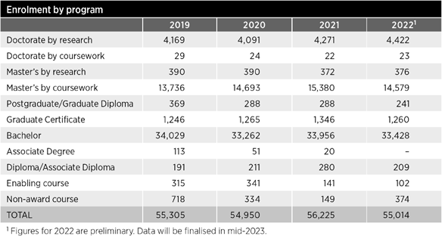
- creating long-term solutions for educational inequality in Queensland and embedding 2-way partnerships with Queensland communities through the UQ Queensland Commitment
- actively participating in the Australian Universities Accord process to help develop a sustainable university sector that can meet Australia's current and future needs
- continuing to build our cultural capital and reputation as a trusted, collaborative and solutions-focused partner committed to enriching our community
- harnessing the innovation, leadership and creativity of our talented and diverse workforce.

Key initiatives
See our Measures of success on pages 20–32.

Looking ahead
The global higher education outlook for 2023 continues to be uncertain and challenged by a number of external
factors including the ongoing impacts of COVID-19, geopolitics and the economy. We will need to be adaptive and responsive as we continue to navigate this period of unprecedented change. In this context, we must provide leadership in education, research and innovation, and leverage the foundational work completed during the first year of the Strategic Plan 2022–2025.
We are committed to working with our many partners – across government, industry, academia and community organisations – to respond to emerging societal, economic and workforce changes. We are well placed to meet changing expectations in a rapidly changing world. However, to support our aspirations of broadening our societal impact, we will need to continue to grow our research funding, increase the enrolment of higher degree research students, grow our research base, and maintain first-class infrastructure and resources.
We are focused on empowering researchers to excel broadly and contribute collaboratively to our strategic agenda, strengthening our research systems,
and maturing our proactive approach to developing strategic partnerships.
We must also continue to adopt a student- centric focus that positions our graduates for future success. Our priorities in
this area include building capability in our digital and physical environments;
continuing to enhance student connection, enrichment and wellbeing; refreshing curriculum, assessment and pedagogies; expanding educational partnerships;
and maturing lifelong learning and postgraduate opportunities.
Through The Queensland Commitment, we will focus on growing UQ’s endowment fund to enable all students who seek to study at UQ – regardless of personal, financial or geographic barriers – to pursue their passion.
We will continue to diversify our funding through greater philanthropic endeavours and industry partnerships, and seek opportunities for further efficiency
across UQ’s operations so that we are in a position to maximise investment in our teaching, research, community engagement and global impact.
Our success as a university is determined by our ability to attract and retain highly talented, committed people who are leaders in their field. For this reason, we are intent on embedding a supportive and inclusive culture built around UQ’s values, where the many talents, passions and perspectives of our staff and alumni are encouraged and nurtured.

Key statistics

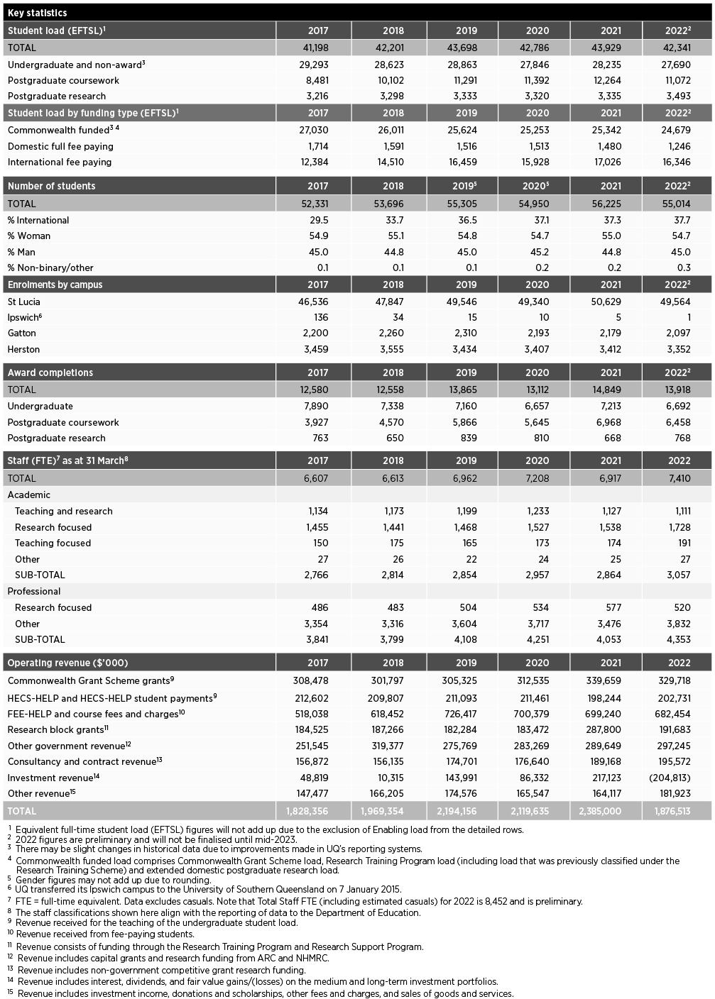

Operational performance

Government objectives for the community
With the underpinning principles of integrity, accountability and consultation, which are applied to the activities outlined in this report, UQ contributes
to the Queensland Government’s broad objectives for the community:
- Good jobs
- Better services
- Great lifestyle.
With a commitment to delivering for the public good, our research excellence and focus on providing quality education and experiences, UQ contributes directly to good jobs, better services and great lifestyle. UQ does this by ensuring Queenslanders have the skills they
need to find meaningful jobs and set up pathways for the future. This includes supporting careers in frontline services such as health and education as well as key industries for Queensland such as infrastructure, agriculture, resources and tourism; developing small business opportunities through entrepreneurship and adaptability; and creating impactful
solutions to protect the health and natural environment of our state.

Our objectives and performance indicators
By 2032, our objective is for UQ to be known as a university that:
- delivers highly sought-after graduates, who are prepared for future success through rich and broad educational experiences
- leads as a premier provider of high- quality postgraduate and lifelong learning opportunities
- leverages the breadth and depth of its research capabilities and vibrant precincts to address the world's most pressing challenges
- is a trusted and agile partner widely regarded as a leader in entrepreneurship, knowledge exchange and commercialisation
- has an extensive global reach in education and research with a strong commitment to capacity building in the Indo-Pacific
- breaks down barriers to education through The Queensland Commitment
- is values-led, deeply committed to delivering for the public good and supporting our people, leading reconciliation, and embracing different life experiences and perspectives.
UQ's strategic priorities have been developed around 3 domains that reflect the core purpose of the University:
- Learning and student experience
- Research and innovation
- Enriching our communities.

Underpinning our domains, our 3 fundamental enablers will support our ambitions to deliver on our core purpose.
- Our global profile
- Our people
- Securing our future.

We use a range of strategies to achieve our objective, with specific measures of success (or key performance indicators) for each domain and enabler, as outlined in the table on page 19.
To successfully achieve our strategic objectives, we support the delivery of strategic initiatives and plans with
adequate risk management plans. For example, key risk mitigation strategies responding to the highly volatile external environment include:
- recruitment and retention strategies to maintain a highly respected workforce
- innovative approaches to teaching, learning and research
- development and nurturing of partnerships to realise mutual benefits in research, teaching and learning
- robust financial management that includes diversifying our international student profile and implementing lifelong learning growth opportunities.

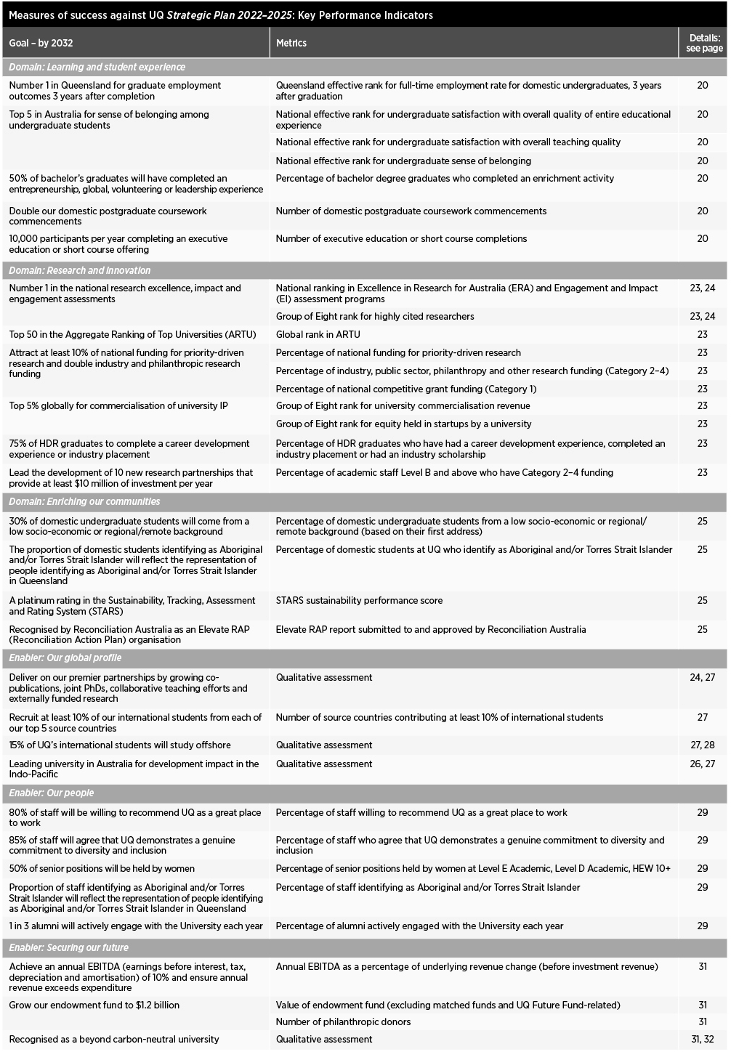

Measures of success

Learning and student experience

At UQ, we offer rich and varied educational experiences designed to foster a sense of belonging, while equipping our students to be leaders within their field with the agility to thrive in a global environment.

Key performance indicators Experiential curriculum
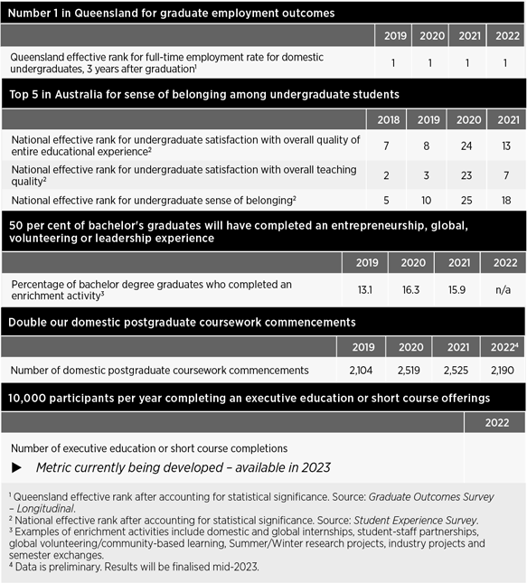
At UQ, we aim to provide an experiential
curriculum with local and global partners that inspires students and extends their capabilities to thrive in a global environment.
How we are achieving this
In 2022, we offered 392 programs, 3,140 courses and 16 shorter form credentials, some of which included global experiences. We also began investigating transnational education schemes to provide more diversity in our student experience. A
new electronic workplace assessment platform was trialled in 2 schools, and rural and remote placements for our students continued to be supported through our partnerships with industry and communities.
Related achievements and initiatives
- In 2021, more than 12,471 domestic coursework students undertook a work- integrated learning course, representing 38.2% of the student population, which was up from 33.5% in 2018.
- The Doctor of Medicine program was reaccredited for the first student cohort in January 2023, and plans were made for its full incorporation into all Regional Medical Pathway programs by 2026.
- The Southern Queensland Rural Health Extended Rural Experiences Framework, a collaboration with industry to channel students into supported, high-quality, extended placements in regional, rural and remote areas in nursing, midwifery, and allied health professions, was active in 2022.
- Work continued on the creation of a student-led Healthy Families clinic at Meadowbrook and a Musculoskeletal Clinic in the proposed Health and Recreation Precinct at UQ St Lucia.
- The Global Change Scholars Program continued to attract outstanding, multidisciplinary PhD candidates, who also collaborated on a project and pitch with a real end-user in industry.

- Seven new programs and one exit award were introduced in 2022 for commencement between 2023 and 2025, with another 12 programs discontinued and one suspended.

- See also
Offshore offerings pg 28

Dental Medicine

Epidemiology (32 unit)

Law (exit award)

Criminology and Criminal Justice / Arts

Student enrichment and employability development
We are developing opportunities that give students an edge in local and global networks through experiences that foster leadership, entrepreneurship, civic duty and digital literacy, among other critical capabilities.
How we are achieving this
We developed and launched a new landing page on the Future Students website, focused around the #GetTheEdge campaign that had attracted positive feedback. Following a successful pilot,
New programs approved in 2022
Doctor
MyCareerAdvisor was launched across the whole student cohort within the virtual learning platform, Blackboard. HDR students and early-career researchers undertook more industry placements and internships with key partners, resulting in a 10% increase in work-related experiences compared with the previous year. We
Masters
Bioengineering (Professional)
Public Health (32 unit)
Graduate Certificate
also enabled more than 1,450 students to participate in 1,500 experiences to enhance their employability, including short-term global studies and semester exchanges, national and international conferences, student–staff partnerships, industry projects, and internships.
Criminology and Criminal Justice
Bachelors
Related achievements and initiatives
Computer Science / Economics
  - 271 students participated in 94 student– staff partnership projects during the year, ensuring that programs, courses and supports were inclusive of diverse student voices.
  - 1,752 students engaged with the MyCareerAdvisor digital platform, enabling them to evidence their development and empowering them to #GetTheEdge.
  - In partnership with UQU, we supported more than 250 active and engaged student groups, including direct support from the Faculty
of Engineering, Architecture, and Information Technology (EAIT) for UQ Space and UQ Racing, providing support for students to enhance
their leadership capabilities through diverse experiences.
  - HDR industry placement hosts included the Queensland Academy of Sport, Suncorp Bank, Rio Tinto, Queensland Health and many more.
  - UQ Ventures delivered over 191 programs and 43 events during 2022, engaging with more than 7,600 students. Events ranged from entrepreneurial pop-up sessions in various course programs, to flagship activities in design thinking, entrepreneurial mindsets and startup acceleration.

- See also
Experiential curriculum pg 20

Digital experience
We are evolving a digital and personalised experience that meets changing
student and industry expectations and incorporates leading-edge pedagogies, assessment and analytics.
How we are achieving this
Our focus is on enhancing online digital capabilities and face-to-face innovation in our educational programs to meet the needs of our students. We refined our Digital Teaching Quality Standards and enhanced our professional learning
offerings to support best-practice teaching. We developed supporting resources, including 20 open textbooks currently in production, self-paced learning modules for advanced literature searching, and legal research essentials. We refreshed a suite of digital course offerings to increase accessibility and standards across pedagogy, curriculum, and assessment
in 22 schools and all 6 faculties. We also continued to enhance assessment
practices through the development of the UQ Assessment Action Plan.
Related achievements and initiatives
- We introduced access to virtual resources including self-navigated tours to farms and agricultural sites for agriculture students to see industry concepts in action.
- We published a new course for teaching staff, Awareness of digital accessibility.
- We conducted an audit of the technology- rich spaces available for students.
- We reviewed and established new governance committees to oversee investment in future digital infrastructure.
- The Sustainable Minerals Institute (SMI) offered Global Minerals Industry Risk Management courses as short form credentials; and several faculties identified a range of courses suitable for offering as short form credentials, e.g. Indigenous Cultural Heritage.
- We identified a number of programs that could be delivered fully online, including the Bachelor of Exercise and Nutrition Sciences and the Bachelor of Psychological Science (Honours).

Sense of belonging
We are fostering a sense of belonging and wellbeing for all learners, enriched by our vibrant campus cultures, rich residential options, world-class sporting facilities and highly valued student services.
How we are achieving this
We delivered a rolling orientation program in Semester 1 to welcome back students and build a sense of belonging. The program incorporated traditionally popular offerings such as library tours and training sessions, as well as new engagement events such as faculty expos, an international student breakfast, Connect Week welcome barbecue, and new 'Get to know your Library' sessions at St Lucia and Gatton. Service ambassadors were employed, the Student Central Service Delivery Model was introduced, and queuing software and footfall counters were installed. We also progressed a range of new built environment projects and embedded Course Insights activities in Ready to Teach Week activities.
Website resources to support academic staff were published as well.
Related achievements and initiatives
  - We created a Reconciliation Garden at Herston and green spaces at St Lucia.
  - We signed a relationship framework with the UQ residential colleges.

- See also
Lifelong learning this page
Capital infrastructure pg 32

Lifelong learning
We aim to launch a professional academy to deliver market-responsive programs and credentials for postgraduate and lifelong learning, supported by our landmark UQ Brisbane City and new online platforms.
How we are achieving this
UQ Brisbane City opened at 308 Queen Street in August as a place for staff, alumni, students and the broader
community to meet, exchange ideas, and engage with industry and government. It also served as a centre for professional growth, learning and connection, featuring a suite of continual professional development and short course offerings.
We began investigating how to diversify our program offerings, including expansion into short courses and micro- credentialled programs, the creation of work-based learning opportunities through industry engagement, and unbundling programs and services so students
can access 'just-in-time' education at affordable prices. We also considered how best to design governance structures, product offerings, pricing and branding
to position UQ as a leading provider of postgraduate and lifelong learning.
Related achievements and initiatives
- The Faculty of Science developed a Science Product Development
Framework to guide market research in advance of any new product development, particularly postgraduate coursework and 'stackable' shorter form credentials such as science teaching credits articulating to the Master of Educational Studies.
- In Semester 2, we trialled 47 individual fully online programs at graduate certificate, graduate diploma and master's level through the Open Universities Australia scheme – attracting interest from more than 300 prospective students.
- Potential partnership models were reviewed, based on analysis of the online program manager market.
- We designed a business case process for the development of new programs and short courses.
- We defined a product catalogue and developed a new website for short courses that will launch in early 2023.

Measures of success
2. Research and innovation

Through our commitment to conducting world-leading discovery research and collaborating with our partners to translate our research discoveries, we seek to not only create new knowledge but share it in ways that enrich our communities, our economy and the environment.

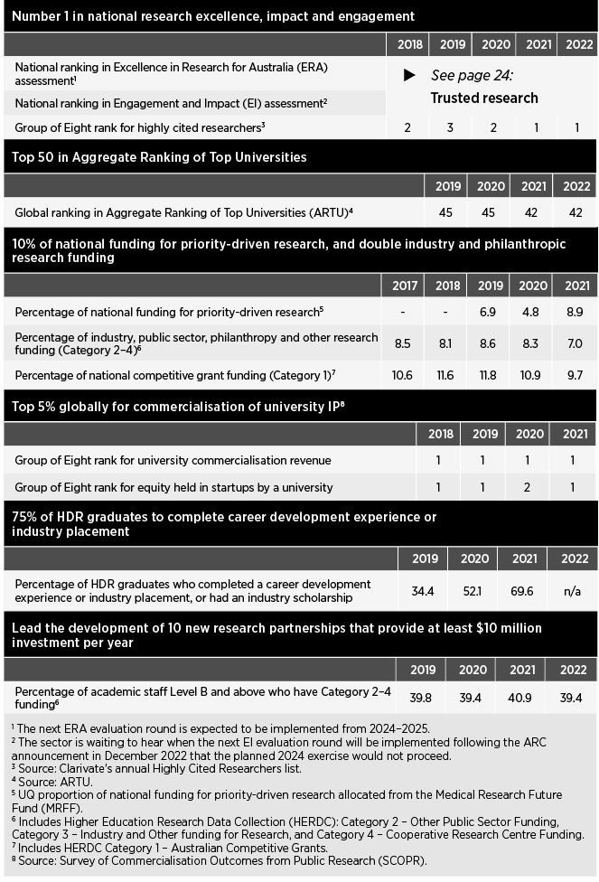
Key performance indicators Research roadmap for
mission-driven research
We are implementing a research roadmap to ensure the ongoing excellence of our world-class research capabilities, facilities and collaborative networks. We aim to connect the strengths and leadership of our comprehensive discipline profile to deliver mission-driven research that is aligned with industry, government and community priorities.
How we are achieving this
2022 saw the first draft of the UQ Research Roadmap produced, aligning with the University's key research priorities.
Work also began on the development of an integrated, whole-of-UQ research
marketing and communications strategy, with qualitative market research completed during the year. We expect to launch the Roadmap in 2023.

Related achievements and initiatives
  - We received ARC funding to establish 3 Centres of Excellence – in Quantum Biotechnology, Indigenous Futures, and Green Electrochemical Transformation of Carbon Dioxide – making us the host of more Centres of Excellence than any other Australian university.
  - We launched the HERA scheme, a major Vice-Chancellor's Strategic Initiative over 7 years, with the first appointees commencing in September 2022.
  - We secured $50 million in May under the Federal Government’s Trailblazer Universities Program to establish a new Food and Beverage Accelerator to nurture innovation in Australia’s agricultural, food and beverage sector. UQ is also a partner in another successful Trailblazer program – the Resources Technology and Critical Minerals hub, led by Curtin University.

  - See also
Capital infrastructure pg 32

Partnerships
Our goal is to foster mutually beneficial partnerships for research translation and commercialisation at scale, to create positive impact for our communities, the environment and economy.
How we are achieving this
In preparing to develop a new partnerships and translation strategy, we implemented a Research Partnerships Review that
saw both a Community of Practice and a Pipeline of Projects and Partners through the UQ Commercialisation Action Plan established during the year. This will feed into the Research Roadmap implementation as well as the convening of a cross- organisational partnership community.
Related achievements and initiatives
- UQ signed a partnership agreement with the Queensland Government, Griffith University and global healthcare company Sanofi to establish a significant new mRNA vaccine research facility in Brisbane.
- The Queensland Alliance for Agriculture and Food Innovation QAAFI) partnered with the German Research Foundation DFG to establish the International Research Training Group for researching genetic improvements in cereal and pulse crops.
- The Australian Institute for Bioengineering and Nanotechnology (AIBN) successfully launched Australia's first Advanced Biomanufacturing Nucleic Acid facility (BASE), a joint initiative with the National Biologics Facility and Protein Expression Facility, and supported by Therapeutics Innovation Australia.

Research community
We support the development of our research community, including professional staff and HDR students, empowering them to thrive and excel in the evolving research and innovation ecosystem.
How we are achieving this
Work began on implementing a Researcher Development Framework to empower
and support diverse career pathways for academics and professional staff. This included the development of the UQ Spark – Industry Engagement Skills program for Level B and C academics.
Related achievements and initiatives
- We continued to improve the Career Development Framework.
- We provided system and community of practice support for HDR student engagement with industry placements.
- IMB rolled out Stage 2 of its Global Challenges HDR cohort program, attracting 25 PhD (Doctor of Philosophy) candidates to work on at least 5 industry- focused research projects.
- SMI developed bespoke training, a professional certificate, online courses, contracted and public workshops, and regular webinars for its stakeholders.
- The Faculty of Medicine developed a clinician–researcher guide, support mechanisms for research-focused academics and HDR supervisors
  - including an online 'toolbox' for community engagement – and an internship for research-focused staff.
- The PhD stipend will increase to
$32,192 from 1 January 2023.

Trusted research
We aim to ensure our research policies, practices and systems uphold our strong institutional commitment to trusted research and innovation.
How we are achieving this Organisation-wide planning and preparations for the ERA assessment
exercise began during the year for the
next round, which will likely take place in 2024–2025. In the latest ERA assessment in 2018, we were assessed in 98 4-digit Fields of Research, with 100% rated at world standard or above. UQ was rated above world standard in more specialised fields of research than any other Australian university. Preparations did not commence on the EI assessment as the ARC announced in December that the 2024 exercise would not proceed.
Related achievements and initiatives
- 51 UQ researchers and research teams received grants (to commence in 2023) totalling $25 million under the ARC Discovery Projects scheme, the second highest number nationally.
- Our Interdisciplinary Tobacco Endgame Research Network received a $5 million grant under the NHMRC's Synergy scheme to help reduce smoking.
- In order to meet security obligations when working on defence-related research projects, we applied for institutional membership of the Defense Industry Security program.
- QAAFI staff completed the GRDC- funded Sorghum pre-breeding with the transfer of germplasm project to the satisfaction of commercial partners.
- The Faculty of Science continued

  - Global medical technology group Stryker
to monitor and manage regulatory

will establish its first Australian research and development facility in Queensland, with support from the Queensland Government, UQ and QUT.
  - The Queensland Brain Institute (QBI) signed a research Memorandum of Understanding with the University
of Washington.
  - We appointed an Executive Director (Research Partnerships) to advance research partnerships with industry.
  - QAAFI's TropAg conference was held in October/November as a vehicle for collaboration and engagement.
- See also
Student enrichment and employability development pg 21
Queensland Commitment pg 25
Reconciliation and
Indigenous excellence pg 25
Innovation precincts pg 32
compliance with research protocols, including a review of the equine unit and closure of the piggery at UQ Gatton.
– Work continued on systems upgrades to bolster the University's research infrastructure, including rolling out the Research Infrastructure Management System 2 and preparing for the MyResearch Projects system.

Measures of success
3. Enriching our communities

We seek to enrich communities here in Queensland, and around the world.
Our commitments to leading reconciliation, global development and capacity building; broadening access to education; and leveraging our research impact to strengthen the economy demonstrate just some of the ways in which we will deliver for the public good.

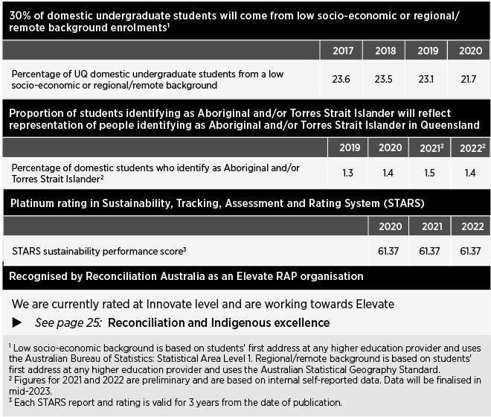
Key performance indicators

- We delivered the InspireU Program, bringing Aboriginal and Torres Strait Islander high school students from across the state for a week-long camp at St Lucia.
- We grew the Young Achievers Program, which supports the tertiary study and career aspirations of senior secondary school students from disadvantaged backgrounds by engaging and mentoring them throughout their academic journey and beyond.
- We strengthened the UQ College Foundation Year program to provide a direct pathway into the University for undergraduate international students.
- We delivered a Breakfast Club webinar series to strengthen knowledge and university pathway options.
- We established a new Government Relations office within the University.
- We established a research working group to promote and support high- quality health research for rural communities, including allied health placements at Chinchilla and St George.

The Queensland Commitment
Through our Queensland Commitment, we are broadening access to higher education, and working in partnership to address our state’s priorities, including those relating to the health workforce and economic diversification.
How we are achieving this
The Queensland Commitment was officially launched in August to break down the personal, financial and geographical barriers facing students aspiring to study at UQ. The core focus of the pledge is on increasing philanthropic funding to provide sustainable, needs- based scholarships for future scholars, particularly those from regional, remote or low socio-economic backgrounds,

as well as Aboriginal and Torres Strait Islander students. Other initiatives include expanded pathway programs, extensive regional and rural outreach, and accommodation support. We aim to strengthen our engagement with core educational, health, industry and arts partners throughout the state, to deliver transformative change.
Related achievements and initiatives
- We conducted Regional Roadshows across the state to discover more ways UQ can foster the growth, health and prosperity of communities across Queensland.
- We invited alumni and the broader community to support the ambitions of The Queensland Commitment by volunteering with UQ, sharing their
stories, or becoming a UQ ambassador.
- See also
Experiential curriculum pg 20
Philanthropic investment pg 32

Reconciliation and Indigenous excellence
Our aim is for Reconciliation to be business as usual through the successful development and implementation of our Stretch Reconciliation Action Plan (RAP), and we support the continued development of Indigenous excellence as defined by Indigenous peoples, in collaboration with the broader UQ community.
How we are achieving this
With the 2019–2022 Innovate Reconciliation Action Plan (RAP) successfully implemented, work began on developing the 2023–2026 Stretch RAP, further embedding reconciliation in the day-to-day business of the University.

We also established an Aboriginal and Torres Strait Islander Collections and Services team to identify and catalogue Indigenous knowledge held in the Library and to create open educational resources, as well as starting to Indigenise the curriculum.
Related achievements and initiatives
- UQ will be hosting the first ever Indigenous-led ARC Centre of Excellence – Indigenous Futures – using Indigenous knowledge to transform the life chances of
Indigenous Australians and enhance understanding of the complex nature of intergenerational inequity.
- We launched Campuses on Countries: Aboriginal and Torres Strait Islander Design Framework in June
to incorporate Indigenous design principles for UQ's physical spaces and built environment.
- Through the Ventures Strong Spirit program, we increased the participation of female-identifying First Nations persons in UQ entrepreneurial activities.
- We grew the number of Aboriginal and Torres Strait Islander scholarships to 20, thanks to several high-profile sponsors.
- In September, we held the third Aboriginal and Torres Strait Islander Research and Innovation Forum, focusing on Indigenous health and wellbeing.
- Work began on implementing the AIATSIS Code of Ethics for Aboriginal and Torres Strait Islander Research and we continued to implement the Aboriginal and Torres Strait Islander Research and Innovation Strategy.
- Along with cultural awareness training, QBI offered Indigenous summer scholarships and cultural experiences.
- 100% of the profit made from sales of RAP merchandise was committed to

Indo–Pacific
Our goal is to harness UQ’s expertise to support Australia’s commitment to capacity building across the Indo-Pacific.
How we are achieving this
Following the launch of the UQ Global Development Impact Plan 2021–2025, we secured a range of contracts for the design and delivery of tailored short course programs, customised graduate certificate courses and long-term development initiatives in South Asia, Mongolia, Bangladesh, Sri Lanka, Vietnam, Indonesia, Thailand, Papua New Guinea (PNG) and the Pacific. In addition,
the Global Development Hub hosted its Global Development Dialogue 2022 event – Strengthening partnerships with the Pacific – with UQ academic and professional staff engaging with Pacific counterparts in the areas of development practice, government and industry engagement, research collaboration, and teaching.
Related achievements and initiatives
- We secured 21 new development projects, bringing the total value of projects under management of UQ's International Development unit to $23.1 million. A range of short courses and development projects were delivered for Indonesia, Vietnam, Sri Lanka, Vietnam, Bangladesh, PNG, the Pacific and ASEAN region.
- We delivered the Department of Foreign Affairs and Trade/UQ co-hosted Pacific Telecommunications Security Expert Forum in November, bringing together telecommunications and cyber security experts from UQ and the Pacific to address existing challenges and future opportunities to guide future investments and initiatives in the critical technologies and cyber security sectors in the Pacific.
- The Faculty of Science continued to pursue external funding to implement training in environment and agriculture in Indonesia.
across the 4 pillars of teaching and research, engagement, operations, and planning and administration. The Strategy is fully aligned with the UN Sustainable Development Goals. We established a Project Control Group to drive implementation of the Sustainability Strategy, with several working parties responsible for developing action plans for key commitment areas. In 2021, we achieved a high silver STARS rating, with a score of 61.37, and are now actively working towards gold level (65 points) before February 2024 when the current rating expires.
Related achievements and initiatives
- Through the UQ Sustainability Office, we created low-carbon guidelines for managing events, and progressed WellLab initiatives to enhance wellbeing.

Public debate
We aim to nourish intellectual vitality through inclusive access to debates and public lectures, cultural events, and UQ’s museums and libraries.
How we are achieving this
We extended access to our facilities, bringing the community onto campus through an extended program of in-person and digital events such as Back to UQ Day, UQ Alumni Book Fair and the ChangeMakers series, among others. In particular, we profiled the role of the arts (visual arts, music, writing, drama, museums) in connecting the University to the broader community.
Related achievements and initiatives
- We held more than 50 public lectures, discussions and debates during the year.
- We conducted Strategic Roundtable discussions with community leaders across the state, as part of our Regional Roadshows, to gain insights into the key regional challenges and opportunities.
- In May, Music and Country was held in the UQ Centre with didgeridoo player and composer William Barton joining the UQ Symphony Orchestra to create Bush Fire Requiem.
- In the Anthropology Museum, the

Aboriginal and Torres Strait Islander
Kirrenderri, Heart of the Channel Country

student scholarships.
  - The Faculty of Medicine increased the
  - See also
Partnerships pg 24
exhibition provided Mikhaka perspectives, recent archaeological discoveries, as well
as historic and contemporary photographs

number of Indigenous staff members in the Faculty by 25% in 2022.
and artefacts.
- The Herston campus increased its visitor

  - New Indigenous health modules were incorporated into HLTH1000, a mandatory course for all Faculty of Health and Behavioural Sciences (HABS) students.
  - The Faculty of Science began designing a VET Certificate in Cultural Heritage Management that would be open to all students.

  - See also
Partnerships pg 24

UN Sustainable Development Goals
We support and promote the UN Sustainable Development Goals in research, teaching, external engagement and campus operations.
How we are achieving this
In 2022, UQ became a formal signatory to the SDSN University Commitment to the United Nations Sustainable Development Goals.
This commitment builds on our sustainability record in research, teaching, engagement and campus operations. The UQ Sustainability Strategy was also published, laying a strong
rate with several functions and lectures hosted in the Mayne events space.
- UQ Gatton held its 125th anniversary celebrations in July, attracting hundreds of visitors to the campus.
- The Vice-Chancellor's Concert series continued at the Queensland Performing Arts Centre.

- See also
Year in summary pg 6
Lifelong learning pg 22
International partnerships pg 27

foundation as we progress its implementation

Measures of success
4. Our global profile

It is implicit in our vision, ‘knowledge leadership for a better world’, that UQ seeks to have a global impact. In collaboration with a range of international partners, we offer our students a global educational experience, undertake development initiatives and research that has international impact, and deliver a UQ education to learners from broad and diverse backgrounds.

Key performance indicators
Grow co-publications, joint PhDs, collaborative teaching and externally funded research
  - See page 28: QUEX and UQ–IITD

15% of UQ's international students will study offshore
  - See page 28: Offshore offerings

Be a leading university in Australia for development impact in the Indo-Pacific
  - See page 26: Indo-Pacific

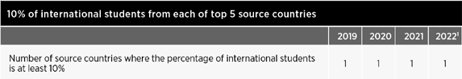

International partnerships
Our goal is to strengthen the University’s global impact through our network of premier international partnerships to build scale and impact across both research and education.
How we are achieving this
In 2022, we visited several countries as part of the Global Engagement Senior Executive Mission schedule, with trips to the UK, India, Vietnam and Indonesia, and specific partner visits in a number of other priority countries. In 2023, we will again expand our post-pandemic engagement including key
international research collaborations in South America through SMI–ICE–Chile, and visits to strategic partners including IITD (India), Technical University of Munich (Germany), UNESP (Brazil), SUSTech (China), DTU (Denmark), Exeter University (UK), UBC (Canada) and Emory University (USA).
Related achievements and initiatives
- We supported teaching, research and student experience at UQ through our growing international philanthropic partnerships.
- The Future Students International unit participated in 801 recruitment events in 33 countries, in both virtual and physical modes, hosted by UQ and other agencies and partner institutions. In addition, we maintained our market presence and engaged with key stakeholders through international travel to over 21 countries.
- We welcomed 365 commencing students from key international partners under a Global Connect Scholarship scheme to build student diversity.
- UQ Ventures partnered with the Vietnam Institute for Science, Technology and Innovation to develop a business model for an Innovation Centre in Hanoi. The institutions collaborated with support from the Australian Government’s Aus4Innovation Program, delivered by CSIRO. This collaboration increased UQ’s engagement with the Vietnamese Ministry of Science and Technology and is planned to continue in 2023, with a delegation visiting Queensland.

  - Australia Awards South Asia and Mongolia – Foundational Skills for Change Agents – International Development welcomed 195
participants from 8 countries for the online program as a pre-cursor to formal study programs at Australian universities including UQ.
  - UQ delivered the Twinning Partnership Program to 'Strengthen Primary Health Care in Ethiopia' funded by the Gates Foundation through the American International Health Alliance (AIHA).
UQ School of Public Health academics travelled to Ethiopia to contribute to capacity building of the Institute of Primary Health Care in order to achieve recognition as a collaborating centre for the World Health Organization.
  - Senator The Honourable Penny Wong launched the Mekong Australia
Partnership Short-term Awards program in Bangkok, a collaboration between UQ and Chulalongkorn University.
  - We hosted the TIME (Top International Managers in Engineering) General Assembly to elevate the University's profile in the engineering sector.
  - Through UQ's enabling partnerships scheme, we established 2 new program articulations for a small number of nursing and pharmacy students, which may be extended in 2023.

- See also
Public debate pg 26
QUEX and UQ–IITD this page
Alumni engagement pg 30

QUEX and UQ–IITD
We aim to broaden the scope and impact of our partnerships with the University
of Exeter and the Indian Institute of Technology Delhi (IITD).
How we are achieving this
We met in-person with staff from the IITD and the University of Exeter to strengthen the partnerships and explore ways to expand collaboration further. The joint initiatives are paving the way for students, researchers, and industry to partner on projects addressing some of the most pressing global challenges.
Related achievements and initiatives
- The Vice-Chancellor led a Senior Executive Mission to the UK – the first senior international mission since the start of the pandemic – including collaboration with the Universitas 21 network and University of Exeter (and QUEX Institute).
- In August, the UQ–IITD Academy of Research celebrated its 100th PhD student enrolment.
- The Faculty of Science continued to support the development of the QUEX joint master's program as well as a number of international articulation programs.

Offshore offerings
We plan to establish targeted offshore offerings in order to expand our reach and diversify our international student cohort.
How we are achieving this
Working with Austrade, and Trade and Investment Queensland, we are exploring transnational education
opportunities with strategic institutional partners in key markets.
Related achievements and initiatives With support from the Australia-Japan Foundation, UQ Ventures successfully
delivered the entrepreneurial-mindset
'Discovery’ program to 10 high schools in Japan.
- The QLabs program, delivered by Future Students and Ventures, provides a Virtual Incubator program for Indian high schools over a 4-month suite of activities. The program engaged with 78 schools and 650 participants from more than 30 cities in India.

- See also
International partnerships pg 27

UQ College
We plan to expand our UQ College pathway offerings and global scholarship programs to provide access to a UQ education for a diverse range of high- achieving international students.
How we are achieving this
The merger of ICTE (Institute of Continuing and TESOL Education) and UQ College
in 2021 consolidated the delivery of all UQ pathway programs, further enhancing the international and domestic student experience, maximising collaboration opportunities, and streamlining pathways for students into UQ.
In 2022, UQ College delivered the UQ Foundation Program, Tertiary Preparation Program, pathway ELICOS courses, and several Vocational Education and Training courses. In August, TEQSA approved CRICOS registration for UQ College for
7 years. UQ College is working closely with TEQSA to transition all courses to its own CRICOS provider number for delivery in 2023 and beyond.
Related achievements and initiatives
- Student Services extended its wellbeing and pastoral care support to include UQ College students.
- UQ welcomed 15 Vinacomin staff to commence a 22-week customised English and Mining Management program delivered by UQ College and SMI.
Student mobility programs We aim to deliver a suite of innovative student mobility programs, including
virtual experiences and global classrooms, to develop global perspectives and enhance graduate outcomes.
How we are achieving this
We continued to develop a full suite of curricular, co-curricular, and extracurricular opportunities for students to engage with global opportunities and international context. This included physical as well as virtual opportunities, with more than 430 different experiences commenced during 2022.
Related achievements and initiatives
- We expanded the Startup AdVentures program to incorporate new global entrepreneurship experiences, including to Singapore, San Francisco and Vietnam.
- Across the whole of UQ, more than 250 students undertook a global mobility experience (60% virtual) – including international virtual experiences for those studying offshore.

Measures of success

5. Our people

Our success as a university is determined by our ability to attract and retain highly talented, committed people who are leaders in their field. For this reason, we are intent on embedding a supportive and inclusive culture built around UQ’s values, where the many talents, passions and perspectives of our staff and alumni are encouraged and nurtured.

Key performance indicators
- We delivered a UQ-wide Pulse survey to map our workplace culture – with a 74% completion rate (including casual staff)
- We worked on an Academic Enhancement Program that will commence from Semester 2, 2023.
- The APD process went live.
- We hosted UQ Thanks You events at our 3 campuses to acknowledge contributions of our staff.

- See also
Development opportunities pg 30
Organisational design pg 35

Inclusive culture
We are nurturing a supportive and inclusive culture that aligns with the University’s values, celebrates diversity, and drives excellence.
How we are achieving this
In 2022, we released new Annual Performance and Development (APD) process, policy and training packages; continued our strong commitment to gender equality through the UQ SAGE Athena SWAN Action Plan; continued to embed intersectionality across a number of Workplace Diversity and Inclusion (WDI) committees, councils and networks; provided strategic direction and a planning

network for LGBTQIA+ inclusion efforts; continued commitments to ensuring persons with disability are afforded equal opportunities to participate in, excel
and be part of the University community through our Disability Action Plan; and supported the inclusion of culturally
and linguistically diverse staff with the development of an action plan, endorsed by the University Senior Executive Team (USET) and the Senate Committee for Equity, Diversity and Inclusion.
Related achievements and initiatives
- We achieved gold accreditation in the Australian Workplace Equality Index awards, placing UQ in the top 10% of employers in Australia.

Leadership capabilities
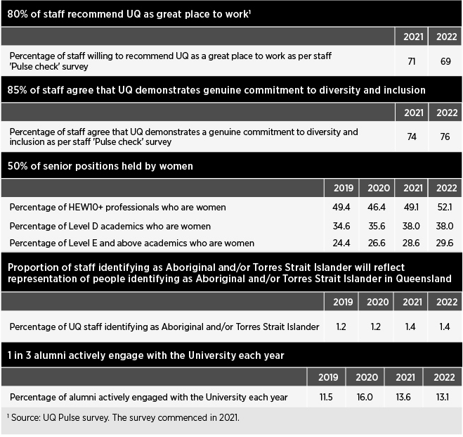
We wish to develop the leadership capabilities of our staff in order to empower decision-making and support innovation.
How we are achieving this
In 2022, we finalised the UQ Leadership capability framework and provided an
in-principle endorsement for a 4-level leadership development framework, containing 5 programs. Of these 5 programs, 2 were piloted this year: Leadership in practice (targeted at new leaders within 2 years of commencing a leadership role) and Learning to lead (targeted at aspiring leaders not yet in a formal leadership role).The Leading UQ flagship program – aimed at Heads of School, Deputy Heads of School, and HEW levels 9 and above – and the
specific development program for Heads of School, Heads up, are both currently in final design stages.
Related achievements and initiatives
  - Support was provided to teams across the University to facilitate strategic planning sessions, promote team culture development, and support organisational change.

Development opportunities
We are investing in our staff through development opportunities and providing meaningful feedback to support their career aspirations and to recognise the diverse ways in which they demonstrate excellence.
How we are achieving this
During the year, we began embedding APD, a new performance framework and criteria for academic performance into our processes for probations, confirmations, and promotions; and also revised the Academic staff special studies program (the new Academic Enabler Program). We relaunched the annual performance discussion process
for academic, professional and executive staff, including additional learning being designed and delivered with the aim of supporting our people to effectively lean into or lead this process.
Related achievements and initiatives
    - In 2022, Workday Learning recorded more than 74,000 course completions (digital and instructor-led training).
    - HR's Learning and Development team produced periodical newsletters that were used to update content creators and learning partners on improvements and changes in Workday Learning.
    - Equivalencies were created for several courses in Workday, with a focus on continuous improvement to functionality.
    - For the eighth consecutive year, we hosted the annual UQ Awards for Excellence program, receiving nominations for 425 staff (including 50 teams) and bestowing 119 staff members with individual or team awards or commendations.
    - As part of implementing APD, approximately 2,500 staff engaged directly in APD information sessions; 1,800 trained in development sessions; and 485 completed online modules.
    - New guides, engagement sessions, policies and procedures, websites, webinars, video content and resources were developed for
the launch of the end-to-end APD process for staff, with 4 separate learning offerings being designed and deployed during the year.
- To help reduce staff stress, SMI employed a physiotherapist to deliver breathing, sleeping and movement workshops.
- HABS developed a suite of activities and resources to support and empower early career academics.
- We held an Early-career Researcher Symposium for Life Sciences in May.
- We redesigned the professional learning program to address a broad range of teaching and learning development for teaching staff.

- See also
2022 Honour roll pg 10

Career pathways
We are developing and strengthening career pathways and roles that support our strategic priorities in digital education, industry engagement, and research translation.
How we are achieving this
After reviewing the academic employment categories and supporting professional staff roles, 2022 saw us establish Industry Professor and Industry Affiliate roles to support education, research translation and deeper connections with industry.
Related achievements and initiatives
- EAIT created several academic positions to appoint staff with strong industry experience.
- The Faculty of Medicine reviewed all teaching roles with the aim of balancing workloads and steering career pathways, particularly for academic title holders.

- See also
Research community pg 24

Alumni engagement
We aim to deliver alumni engagement programs that build affinity, connection and partnership to extend the value of the UQ experience and strengthen our community.
How we are achieving this
In July, we launched the global ChangeMakers Platform, an online community that builds on the UQ ChangeMakers program, for alumni to connect, provide or seek mentoring
support; volunteer in a local chapter or alumni board; share job opportunities; and host or attend meet-ups and flagship events around the world. It also offers business discounts, networking opportunities and access to special- interest groups, and provides general news about the University's activities and achievements. For the first time this year, the program included a Back to UQ
reunion as part of the St Lucia Open Day, offering free talks, tours, meet-ups and sunset drinks for UQ alumni.
Related achievements and initiatives
- The 2022 UQ Alumni Book Fair welcomed 4,393 people to the St Lucia campus, raising $129,098 for UQ student scholarships and researchers.
- The Faculty of Business, Economics and Law developed a suite of programs to encourage creative engagement with its alumni community including a Commerce Alumni celebration, Finance roundtable series, and a faculty-wide volunteer thank-you event.

- See also
Lifelong learning pg 22
Public debate pg 26
Philanthropic investment pg 32

Securing our future
Measures of success

To achieve our mission of ‘delivering for the public good’, we need to first ensure that UQ is securely positioned for the future. That involves diversifying the University’s revenue base, building an endowment fund, and investing purposefully in the infrastructure, systems, people and partnerships that will enrich the student experience and broaden the impact of our research.

Key performance indicators

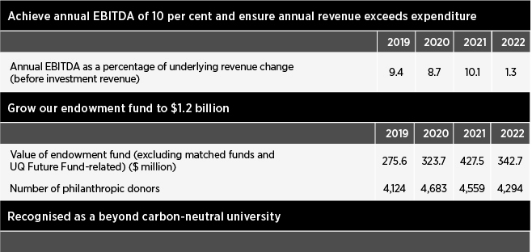

  - See page 32: Streamline operations

Diversified revenue base
We aim to diversify and increase our revenue base by increasing domestic postgraduate enrolments, recruiting students from a broader range of international markets, and attracting greater investment in translating our research.
How we are achieving this
By implementing a new operating model within the International Admissions team, we were able to sharpen our focus on enhancing efficiencies, and effectively managing business continuity and compliance risks. We saw improved and specialised service models for diverse priority markets and maintained an immigration risk rating of one or below. These efforts, including a refinement of the University’s recruitment strategy, resulted in a 7.5 percentage point increase in the proportion of commencing international students coming from diverse markets between 2021 and 2022.
The University is successfully targeting commercial development contracts to secure customised training programs and long-term global development projects, which bring direct revenue through a range of donors and funders including the Department of Foreign Affairs and Trade,
the New Zealand Ministry of Foreign Affairs and Trade, and the private sector.
Related achievements and initiatives
- In the domestic space, we achieved 93% of the combined undergraduate and postgraduate student admission target.
- We achieved 111% of the 2022 international student admission target, with 41.6% of commencing international students from diversity markets.

Capital infrastructure
We will invest in capital infrastructure and digital capabilities to enhance our vibrant and sustainable campuses, and meet growing expectations for digital engagement, online delivery and improved efficiency.
How we are achieving this
We invested significantly in the capital and digital space in 2022.
Related achievements and initiatives
  - Work began on the Research Infrastructure and Investment Strategy, with plans developed for clinical trials and minerals characterisation.

Innovation precincts
We aim to accelerate and grow innovation precincts that support collaboration with industry, community and government, and enable shared access to state-of-the-art research facilities.
How we are achieving this Development of a new Precinct Plan for the Long Pocket site is in progress,
driven by a vision statement for the
establishment of a Sustainable Futures Innovation Precinct.
Related achievements and initiatives
- Planning commenced for new precincts for Science, and Health and Recreation.

Philanthropic investment
Our goal is to attract philanthropic investment to support our commitment to delivering greater access to education and research impact, with a focus on building an endowment fund.
How we are achieving this
We partner with individuals and organisations to create impact through philanthropic investment in research, teaching, and community enrichment. We aspire to grow our endowment fund, enabling our donors to create impact in perpetuity. In 2022, we set a stretch goal to exceed $80 million in philanthropic funds raised, supported by trusted

  - We created a designated space for
and responsive relationship building.

civil engineering students, as well as upgrading much of EAIT's teaching
- See also
Partnerships pg 24
A focus on building UQ's endowment fund remains critical in an increasingly

and informal learning spaces.
  - Restoration of the Avalon Theatre
unpredictable environment for universities,
and in response to growing need from

began mid-year.
  - Construction of a UQ Plant Growth Facility continued throughout the year, with an anticipated completion date of September 2023.
  - The UQ Amphitheatre and Lake Renewal project began at St Lucia to create a self-sustaining ecosystem to offer both habitat for wildlife, and more opportunities for people to enjoy the area.
  - We registered 60 buildings as part of the Queensland Government's Safer Buildings Program and work
commenced to replace the facades on many of them.
  - A new recreation space located between Hood Street and Services Road, St Lucia, was opened for the UQ community to enjoy.
  - Patina Restaurant at Alumni Court opened to the public in February.
  - Work began on developing a physical learning environments roadmap that included a teaching space quality audit, and a benchmarking survey.

Streamline operations
We are streamlining our operations by reducing duplication and ensuring the effectiveness of our governance structures and approval processes.
How we are achieving this
As part of the technology master planning process, detailed roadmaps for the University will be built as part of the operationalisation process to identify key themes, technologies sequencing, and forecasted investment in a longer-term cycle.
UQ also aims to become a beyond carbon- neutral university by reducing energy consumption and investing in carbon offsets to achieve this goal long-term.
Related achievements and initiatives
- We launched Uber for Business UQ-wide.
- The Faculty of Science established assessment communities of practice to improve the quality, effectiveness and integrity of its systems, processes and communication of assessment procedures.
both students and researchers.
Related achievements and initiatives
- Our fourth annual Giving Day in October attracted 1,381 donors, who collectively donated more than
$730,000 to support more than 30 causes across the University.
- In November 2022, we officially announced The Queensland Commitment Match, through which the University doubled gifts of $50,000 or more directed to endowed, need- based scholarships.

- See also
Alumni engagement pg 30

  - See also

Digital experience pg 21
Lifelong learning pg 22
  - See also
UN Sustainable

Development Goals pg 26

Summary of

Human resources

The Human Resources (HR) division is integral to driving UQ's values and culture. By attracting high-quality staff and supporting them in diverse, inclusive, welcoming, safe and progressive workplaces, we create teams that are creative and impactful.
We support a foundation of integrity and respect, in the pursuit of knowledge leadership for a better world through the entire employee lifecycle. HR delivers key services in talent acquisition and onboarding, staff and client engagement, learning, recognition, support for personal growth, capability development, process efficiency and career development.

Workforce profile

Workforce size
In 2022, UQ’s continuing and fixed-term workforce increased to 7,410 FTE with a retention rate of 95.55% for ‘continuing’ staff members.

Recruitment and selection
From 1 January to 31 December 2022, UQ advertised more than 1,900 jobs and placed 500+ academic and 1,400+ professional staff positions, along with an additional 1,350+ direct appointments. The University received more than 52,000 applications.

Academic promotions
During the year, 221 academic staff members were promoted, comprising 68 promotions to Level B, 74 to Level C, 52 to Level D and 27 to Level E.
The table below shows University staff numbers as at 31 March 2022.

2022 saw the formalisation of the in-house

Executive Search function within UQ, focused on sourcing talent directly through the use of targeted campaigns, networking, market mapping and direct market sourcing. The team successfully placed a number of high-profile roles, resulting in considerable cost savings for the University.
- See also
Our people pg 29

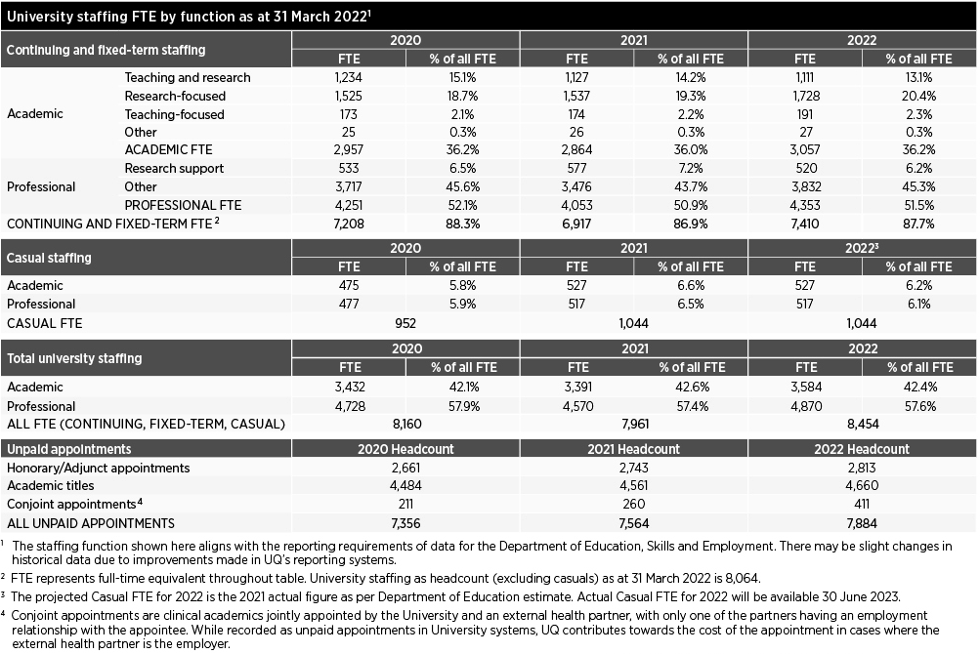

Workforce planning and performance

HR organisation
In 2022, the HR Division slightly amended its organisational structure into 6 areas:
- HR Client Partnering
- Organisational Culture and Capability
- Rewards and Remuneration
- Workplace Relations
- HR Governance, Transformation and Strategy
- People Services, including Talent Acquisition, Employee Services and Payroll.

Staff support
During the year, UQ's Workplace Psychologist moved to the Health, Safety and Wellness team, where they continued to provide support to staff members;
and the Employee Assistance Program (provided by PeopleSense from November) offered counselling as required.
UQ Mental Health Strategy
UQ remained committed to mental health and wellbeing throughout 2022, supporting several initiatives including
awareness events, and staff development and training sessions, and provided a range of online support material.

  - See also
Health, safety and wellness pg 36

Diverse workforce
The WDI team continued to embed intersectionality across all of its activities, facilitated through greater engagement with faculty, school and institute Equity, Diversity and Inclusion Committees, and regular meetings with the Chairs of the Strategic Diversity Committees, such
as the Ally Action Committee, Disability Inclusion Group (DIG), Gender Steering Committee, Age Friendly Committee and the Cultural Inclusion Council (CIC). The team also continued to support the Discrimination and Harassment Contact
Officer network, as well as developing and piloting a new training module on bullying and harassment.
In addition, WDI reviewed sexual misconduct reporting processes and began working with key stakeholders on better ways of working between areas, as well as several other agreed actions to improve education and support for staff.

Gender Equity:
UQ Athena SWAN Action Plan 2021–2022
We continued our strong commitment to gender equity with the completion of many of the actions required for the
Athena SWAN Bronze Action Plan. We are currently working towards silver accreditation. As part of the next steps on the UQ pathway, 5 key priority areas were selected and barriers identified to measure progress and impact against.
Specifically, the focus will be on addressing barriers for women across UQ in recruitment, progression, promotion and retention. Actions will continue on women's representation in leadership, narrowing of the gender pay gap, flexible work, and the ‘leaky pipeline’ for academic women.
Key achievements during the year included: – UQ further reduced the gender pay
gap. In 2021, the organisation-wide average gap was 16.3%, down from 18.1% in 2020, and the gap continued to narrow throughout 2022.
- Promoting women fellowships saw an increased number of recipients, with 26 women receiving fellowships. Furthermore, a dedicated program was provided with additional support workshops including Self-reflection: Learning from your experiences, Writing with a purpose, Effective communication skills and Influence and leadership.
- The Thriving for an academic edge program supporting Level B female academics was launched to develop leadership skills and to encourage a strategic approach be taken for their career growth.
- We produced reports for the staff entry and exit surveys. These surveys were instrumental in measuring attraction and retention data, seeking to find out why women are attracted to work at UQ and why they may leave.
- Following the development of a 2021 guide to increasing under-represented staff through targeted recruitment
and retention measures, several work areas pursued the targeted recruitment of women or gender-diverse staff
to boost the participation of under- represented groups.
- UQ is drawing closer to its target of 50:50 ratio of women and men in leadership positions.
LGBTQIA+ inclusion
The UQ Ally Action Plan 2019–2022 provides strategic direction and a planning framework for LGBTQIA+ inclusion efforts at UQ and establishes priorities for UQ’s Ally Action Committee (AAC). This plan
is the third iteration and builds on the work achieved in previous years. The Plan is also informed by Pride in Diversity and feeds into UQ’s annual submission to the Australian Workplace Equality Index (AWEI) to ensure planning reflects national best practices. The plan’s vision is for UQ to be a national leader for the inclusion, respect and support of gender, sex and sexuality diversity in education and employment.
In 2022, UQ was recognised with a Gold Employer ranking in the 2022 AWEI,
the definitive national benchmark for LGBTQIA+ inclusion in the workplace, and which places UQ in the top 10% of employers in Australia.
UQ Ally workshops continued to be one of UQ’s most popular Staff Development
workshops, with sessions regularly having waiting lists. This year, we also held local workshops for the UQ Art Museum and the Gatton campus.
The 920-strong Ally Network and the WDI team planned and celebrated key dates of significance such as Wear It Purple Day; International Day Against Homophobia, Biphobia, Intersexism and Transphobia; and Intersex Awareness Day. UQ also flew the Rainbow Progress flag on most key dates in the LGBTQIA+ calendar, as well as the Transgender flag during Transgender Day of Visibility and Transgender Awareness Week. The Ally
network held a stall at UQ Market Day and the New Staff Expo to increase visibility.
This year the WDI team, together with the AAC, created the monthly newsletter Equali(tea) for the Ally Network to advise about events, research and allyship.
Disability inclusion
The UQ Disability Action Plan 2018–2021, extended to 2022, constitutes formal recognition of UQ’s commitment to ensuring persons with disability are afforded equal opportunities to participate in, excel and be part of the University community. The next iteration will launch in early 2023.
The DIG monitors the effectiveness of the Plan through the annual reporting process.
In 2022, UQ:
- participated in the Australian Network of Disability Access and Inclusion index, for the first time

  - provided bespoke training on disability inclusion to the HR Client Partnering team through the WDI team
  - conducted focus groups for staff with disability to identify shared experiences and objectives from UQ’s disability inclusion efforts
  - led a working group made up of key stakeholders across the University on Universal Design in Learning
  - trained stakeholders on how to perform a physical audit of University spaces.
Culturally and linguistically diverse (CALD) inclusion
UQ has made a strategic commitment to support the inclusion of CALD staff. Endorsed by USET and the Senate Committee on Equity, Diversity and
Inclusion, the CALD Staff Inclusion Action Plan outlines concrete actions that UQ will take to improve inclusion. This includes auditing existing support (e.g. career progression, mental health etc.) and also implementing new initiatives.
The UQ CIC formed working groups to support the delivery of specific actions scheduled for Phase 1 of the Action Plan to address the following objectives:
  - investigate a process and implement measures for all decision-making about CALD inclusion at UQ, which ensures consultation is sought from the CIC in accordance with its Terms of Reference
  - revisit the Staff Grievance Process to ensure it is culturally inclusive and does not exclude anyone, including those with language barriers
  - determine whether current mental health and wellbeing support at UQ is inclusive of CALD staff, recognising that they may face challenges in accessing support, have unique perspectives
on help-seeking behaviour, and may require new or tailored services – particularly those who experience intersecting forms of marginalisation
  - conduct an audit of existing UQ support, resources and training focused on CALD inclusion
  - investigate systemic barriers that hinder long-term planning and progression of CALD staff at UQ
  - investigate how to ensure and support academic staff to provide a high level of English language support to students.
Another initiative to support staff coming from overseas (including CALD staff) is the Warm Welcome Program, which pairs incoming UQ staff from overseas with existing staff to provide them with relevant support to settle into life in Brisbane. Since its relaunch in mid- 2022, 26 UQ staff have expressed interest
in becoming welcomers and 6 incoming
UQ staff are interested in participating in the program. Six matches were made this year. The program also received interest from different schools and faculties at UQ.
Aboriginal and Torres Strait Islander peoples inclusion
Our Strategic Plan sets a target for the proportion of staff at UQ identifying as Aboriginal and/or Torres Strait Islander to reflect the proportion in Queensland, currently 4.6%. At 31 March 2022, the number of staff identifying as Aboriginal
and/or Torres Strait Islander (fixed-term and continuing) at UQ was 107 FTE (1.4%).
In 2019, we launched the Aboriginal and Torres Strait Islander Employment Strategy 2019–2022 in support of our inaugural Innovate RAP. We continued aiming to deliver on these commitments during 2022.
Key programs and activities included: – UQ’s Vice-Chancellor's Indigenous
Graduate Program had an intake of 6 participants for 2022. Since first being offered in 2019, this program has provided a formal induction, cultural immersion opportunities, and personal and professional development such as conferences and industry networking.
- UQ’s Indigenous Professional Entry Pathways Program pilot program was launched in 2019, offering candidates a position in a generalist field relevant to their career aspirations. The program has experienced positive results in terms of ongoing retention within UQ. In 2022, UQ continued to provide professional entry pathways opportunities through evergreen expression of interest job advertisements for Aboriginal and Torres Strait Islander peoples.
- In 2022, the UQ School of Business offered 4 positions in the Indigenous Academic Pathways program (IAP). The IAP program offered candidates a flexible, supportive and tailored program to build their academic career at UQ.
- UQ's Pro-Vice-Chancellor (Indigenous Engagement), together with Indigenous Employment, hosted 5 Indigenous staff network events this year, providing an opportunity for new and existing staff to connect and network across UQ. Three events were held at UQ St Lucia with 2 other gatherings occurring in separate locations.

- See also Reconciliation and
Indigenous excellence pg 25
Inclusive culture pg 29

Service delivery and continuous improvement
Following the successful implementation of Workday in 2021, we were able to track more than one million transactions in the first year. 2022 saw a focus on continuous improvement of the system, with more than 500 enhancements and 2 major Workday releases made. Key
improvements included developing reports and dashboards, enabling employee- initiated changes to work patterns, and simplifying the casual appointment process. Since go-live, business processes have already become 60% faster for job requisitions and job changes.
HR supported UQ staff with more than 8,000 enquiries per month on a range of topics, approximately 70% of which were resolved by our frontline response team, AskHR.

Enterprise Agreement negotiations
UQ remains committed to prioritising a new Enterprise Agreement. Negotiating in good faith will continue with the unions.

Payroll and compliance
Backpay, including interest and superannuation, was paid to current casual academic staff impacted by a clerical error. The University continues to make every effort to contact former casual academic staff to complete this process.

Organisational design
During the year, we conducted a full review of the flexible work policy and procedures to enable more agility in the way staff perform their work for UQ. This policy was developed in response to the changing needs of the workforce
post-global pandemic and aims to provide guidance around the principles and considerations for UQ and staff.

Health, safety and wellness
In line with the University's Health, Safety and Wellness Strategy 2022–2026, the key focus areas for Health, Safety and Wellness (HSW) at UQ are:
- Enhancing wellness and community
- Empowering culture and capability
- Quality risk management
- Integrated systems and decision-making
- Beyond compliance.
Focusing on these strategic priorities will take UQ beyond compliance, embed health and safety in our operations and decision-making, enhance the wellness of all in our community, and increase our
safety capability. Key HSW activities and achievements in 2022 included:
- exceeding the health and safety performance requirement for organisations that self-insure for workers’ compensation, through completion of a third-party audit against the National Self-Insurers OHS Management Systems Audit Tool (NAT) submitted to the Office of Industrial Relations (OIR). The NAT is a full systems audit and valuable lead indicator that can be used by UQ and OIR in assessing occupational health and safety performance
- implementing a CO₂ (carbon dioxide) monitoring program as a means
to evaluate the effectiveness of ventilation to UQ indoor spaces, which continued as part of the UQ COVID-19 risk management program – with 1,624 indoor spaces monitored within 85 buildings across UQ campuses and sites
- implementing a new risk management process for time-sensitive chemicals
- implementing a new UQ Substance Management Plan for medicines and poisons, and related approvals
- reviewing the University’s health and safety risk register, and top health and safety enterprise risks
- continuing support for building the capability of staff and students, with 56,136 completions of 26 online safety training modules and 1,036 attendees at instructor-led HSW professional development training
- successfully conducting the internal HSW audit program with 3 organisational OHS management systems audits, 6 risk factor audits, and an audit of corrective actions implemented
- holding the UQ Wellness Festival, and health and safety events in October
to coincide with Queensland Mental Health Week and the national Safe Work Month, attracting around 2,500 attendees across 3 UQ campuses
- auditing and certifying new facilities to conduct work with (i) genetically modified organisms as
authorised by the Office of the Gene Technology Regulator or (ii) imported biological material as required by
the Commonwealth Department of Agriculture, Fisheries and Forestry
- assisting researchers and supporting the UQ Institutional Biosafety Committee and subcommittee to assess 137 applications for work with genetically modified organisms or high- risk biological material
- continuing to promote and support staff health and wellbeing through UQ Wellness, the University's staff wellness program, using an
evidence-informed approach across the 4 key areas of lifestyle factors, psychological health, physical health, and organisational engagement
- continuing to provide specialist HSW services to faculties and institutes
- commencing implementation of a best- practice respirator fit-testing program for UQ staff and students at risk of exposure to airborne contaminants
- addressing the potential risk of Japanese Encephalitis Virus to staff and students, and identifying measures to minimise staff/students in high-risk work environments being bitten by mosquitos. Clinics were organised
at St Lucia and Gatton to provide for more than 100 workers who were recommended to receive the vaccine
- delivering an early intervention injury prevention workstation assessment program with in-person assessments and provision of an online computer workstation self-assessment tool
- continuing to focus on proactive risk management and a strong
reporting culture, with 2,804 new risk assessments created and approved, and 1,446 incident and hazard reports via UQSafe.
In 2022, UQ made 18 notifications to regulators and was issued one improvement notice.

UQ’s workers’ compensation function
All aspects of the University’s workers’ compensation operations are managed by the Work Injury Management team in the HSW division, according to the provisions of the regulatory licence issued under the Queensland Workers’ Compensation and Rehabilitation Act 2003. These operations include managing statutory injury claims and personal injury litigation claims, and managing the rehabilitation and return to work of injured workers. The University also manages the workers’ compensation risk of 7 of its controlled corporate entities. 2022 achievements were many:
- The workers’ compensation regulator completed its self-insurance claims management audit, with the final report concluding that UQ had demonstrated that it meets the legislative criteria to hold a self-insurance licence, had satisfied
the conditions of the licence for its claims administration and rehabilitation
management, and had provided adequate resources, systems and procedures for the management of claims.
- The Work Injury Management team assisted more than 116 injured workers in 2022, with 98 accepted claims (62 work-related, 36 journey-related). The University received 4 damages claims during the year. Claims involved a range of injuries including orthopaedic, neurological and psychological. The average time to evaluate and admit a claim was 3.4 days in 2022, compared to the Scheme average of 9.4 days.
- UQ continued to maintain a high level of customer service to injured workers, with emphasis on early intervention, efficient claims, and medical management, combined with an effective rehabilitation program to return injured workers to full employment. In 2022, 99% of workers who lodged a claim were successfully returned to work (excluding retirees), with the claim resolved.
- UQ Residences Limited was added to the workers’ compensation self-
insurance licence in February 2022 and an application was made to remove Leximancer Pty Ltd from the licence following its sale in November 2022.
- The workers' compensation regulator continues to assess UQ as 'low
risk' across all 11 assessed criteria necessary to keep its self-insurance licence for workers’ compensation. These criteria include resources and systems, legislative compliance, licence compliance, privacy, business relationship, compliance with regulatory standards, perception of stakeholders, and workplace health and safety.

Work/life balance
UQ aims to promote a positive balance between healthy work and a healthy life through the provision of a variety of health and wellbeing opportunities and
programs. In 2022, initiatives delivered via the UQ Wellness program included:
- the staff influenza vaccination program, which provided 5,641 vaccinations to staff and HDR students across multiple campuses
- provision of on-site walk-in COVID-19 vaccination clinics for UQ community and family members
- several physical activity challenges, including:
  - Push-up for mental health challenge, where 40 UQ teams completed a total of 477,098 push-ups across 24 days in June
  - Australasian University Health Challenge – a 6-week community health challenge where UQ competed against 18 other Australian and New Zealand universities; UQ participants completed a total of 71,190,397 steps during the 6-week period
- 1,096 free health check appointments being offered to staff across multiple campuses, with clinics conducted for skin checks and heart health, as well as back and posture assessments
- a broad range of health and wellbeing programs – including nutrition support, mindfulness activities, mental health week and RU OK? day initiatives, Men’s Health Week virtual series, and Women’s Health Week activities. More than 1,300 staff and students participated in these programs during 2022
- recruiting 39 staff volunteer 'Wellness Ambassadors' and 43 'Mental Health Champions' to support health and wellbeing in local areas
- providing workplace and team-based support through wellbeing sessions on topics such as sleep and stress, as well as personal and workplace wellbeing
- facilitating programs and resources to increase awareness of work-related factors that may compromise the health and wellbeing of staff
- promoting access to gyms and pool facilities across Queensland – with an additional 20 added in 2022 – through the UQ Fitness Passport program.

Our governance
The governing body of the University is the Senate, as constituted by the University of Queensland Act 1998.

University governing body
Senate has 22 members, comprising official members, appointed members, elected members and additional members.
Members serve a 4-year term, except for the President of the Academic Board and student members, who serve for a minimum of 2 years. The 35th Senate began its term on 1 January 2022.
Senate met 6 times during 2022.
The University complies with the Voluntary Code of Best Practice for the Governance of Australian Public Universities.

Senate membership
Official members
- Chancellor Peter N Varghese AO, BA (Hons), H.DLitt Qld (leads the
University’s governing body, the Senate)
- Vice-Chancellor and President, Professor Deborah Terry AO, BA (Hons), PhD ANU, H.LLD Aberd, FASSA, FQA
- President of the Academic Board, Professor Craig Franklin, BSc (Hons), PhD Cant
Members appointed by the Governor-
In-Council
- Julieanne Alroe, BEc Qld, GAICD
- Charmaine Chalmers, BCom, BEc, MIEF, CA, GAICD
- Philip Hennessy AO, BBusAcc QUT
- Rob Jones, BCom Qld, ICAAZ, FSIA
- Grant Murdoch, BCom, MCom Cant, FCA, FAICD
- Adjunct Professor Dr Sally Pitkin AO,
LLB, LLM QUT, PhD Qld, FAICD
- Cecile Wake, BEcon, LLB (Hons) Qld,
ExecDevptProg Wharton
- [Vacancy]
Elected members
- One member of the Academic Board, Professor Greg Hainge, BA (Hons), MA, PhD Nott, GCELead Qld, FAHA, SFHEA
- One member of the full-time or part- time academic staff of the University, Professor Kristen Lyons, BEnvSc,
BSc (Hons), PhD Qld
- One member of the full-time or part- time general staff of the University, Dr Dino Willox, BA (Hons), MA, PhD,
Cardiff, PFHEA
- One postgraduate student, Richard Lee, BA, BEd (MidYsSch), MEdSt Qld, JP (Qual)
- One undergraduate student, Emily Scott, JP (Qual)
Three (elected) graduates of the University
- Sallyanne Atkinson AO, BA Qld,
HonDUniv Griffith, ACU
- Dr Lee Duffield, BA, BEdSt, GDipJ
Qld, MA Syd, PhD JCU
- Dr Mellissa Naidoo, BSc (Hons), MBBS Qld, CHIA, ACHSM, FRACMA, GAICD
Appointed by Senate
- Anne Cross AM, BSocWk, MSocWk
Qld, FAICD
- Deputy Chancellor Tonianne Dwyer, BJuris (Hons), LLB (Hons) UWA, GAICD (acts as Chancellor in the absence of the Chancellor, or if the office of the Chancellor is vacant)
- His Honour Judge Nathan Jarro, LLB, BBus QUT.

Senate achievements
In 2022, UQ Senate:
  - under the Seal of the University, conferred 14,939 awards* to 13,860 students – including 708 PhD candidates
  - affirmed its support for the Uluru Statement as a historic contribution to understanding the business of national reconciliation
  - approved UQ's budget for 2022 and budget for 2023–2025
  - invited 8 nominees to accept honorary doctorates and one for the newly established RH Roe Award
  - introduced a standalone Freedom of Speech and Academic Freedom Policy
  - adopted the Australian Universities Vice-Chancellor and Senior Staff Remuneration Code
  - approved the TEQSA and CRICOS Renewal of Registration for submission
  - reviewed the University's Top Risks
  - established the 35th Senate Scholarship Fund, aligned with The Queensland Commitment, to support students facing financial hardship
  - approved the Colleges Framework.
* This figure includes dual degrees as 2 awards because 2 testamurs are produced 'under the Seal of the University'. It also includes a subset of programs that are not considered federal government-reported awards – hence the variation from the Key Statistics table on page 17.

Senate Committee memberships
Senate Advancement and Community Engagement Committee
- Sallyanne Atkinson AO (Chair)
- Professor Aidan Byrne
- Lee Duffield
- Rob Jones
- Jennifer Karlson
- Dr Catherine Lawrence
- Dr Mellissa Naidoo
- Emily Scott
- Professor Deborah Terry AO
- Peter N Varghese AO
Senate Campus Infrastructure Committee
- Tonianne Dwyer (Chair)
- Julieanne Alroe
- Professor Craig Franklin
- Philip Hennessy AO
- Richard Lee
- Malcolm Middleton OAM
- Professor Deborah Terry AO
- Peter N Varghese AO
- Cecile Wake
Senate Committee for Equity, Diversity and Inclusion
- Anne Cross AM (Chair)
- Professor Aidan Byrne/Professor Pauline Ford (from November)
- Professor Bronwyn Fredericks
- Dr Dee Gibbon CSC OAM / Declan Hughes (from September)
- His Honour Judge Nathan Jarro
- Professor Kristen Lyons
- Professor Doune Macdonald
- Emily Scott
- Professor Deborah Terry AO

Senate Finance Committee
  - Philip Hennessy AO (Chair)
  - Julieanne Alroe
  - Tonianne Dwyer
  - Professor Craig Franklin
  - Grant Murdoch
  - Dr Mellissa Naidoo
  - Professor Deborah Terry AO
  - Peter N Varghese AO
  - Cecile Wake
  - Dr Dino Willox
  - President UQU or nominee
Senate Investment Sub-Committee
  - Timothy Crommelin (Chair)
  - Julieanne Alroe
  - Tonianne Dwyer
  - David Goffage
  - Philip Hennessy AO
  - Professor Deborah Terry AO
Senate Governance Committee
  - Peter N Varghese AO (Chair)
  - Tonianne Dwyer
  - Professor Craig Franklin
  - Professor Greg Hainge
  - Philip Hennessy AO
  - Grant Murdoch
  - Adjunct Professor Dr Sally Pitkin AO
  - Professor Deborah Terry AO
Senate Honorary Awards Committee
  - Peter N Varghese AO (Chair)
  - Julieanne Alroe
  - Sallyanne Atkinson AO
  - Tonianne Dwyer
  - Professor Craig Franklin
  - Adjunct Professor Dr Sally Pitkin AO
  - Professor Deborah Terry AO

Senate Remuneration Committee
    - Peter N Varghese AO (Chair)
    - Anne Cross AM
    - Tonianne Dwyer
    - Philip Hennessy AO
    - Adjunct Professor Dr Sally Pitkin AO
    - Professor Deborah Terry AO
Senate Risk and Audit Committee
    - Grant Murdoch (Chair)
    - Charmaine Chalmers
    - Anne Cross AM
    - Professor Craig Franklin
    - Philip Hennessy AO
    - Rob Jones
    - Peter N Varghese AO

Financial reporting
The financial statements are general purpose financial reports prepared in accordance with prescribed requirements. The University of Queensland is a statutory body and is audited by the Queensland Audit Office.
See also: https://www.uq.edu.au/about/ organisation/policies-procedures- guidelines/annual-reports.

- See also
UQ basis of authority/functions pg 14

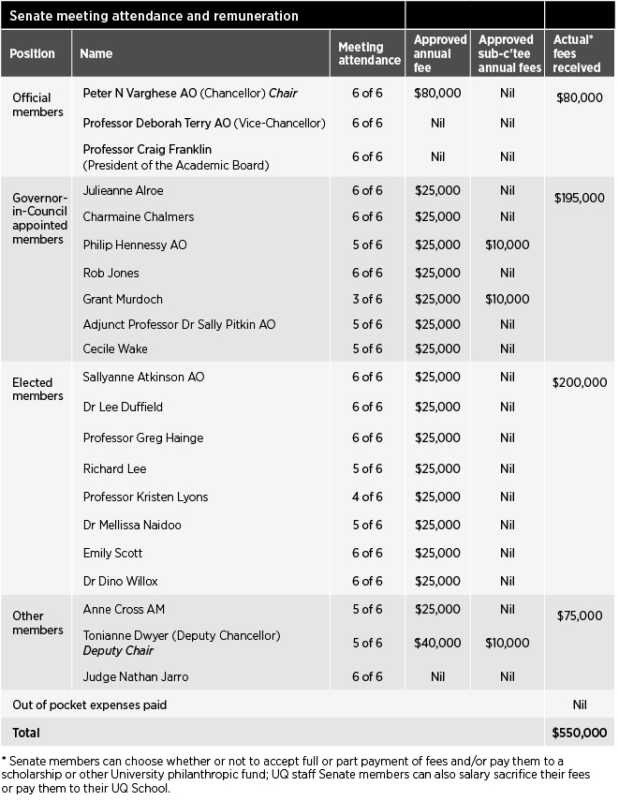
Executive management
While the Chancellor and Deputy Chancellor lead the University Senate, the Vice-Chancellor and President is the University’s Chief Executive Officer, responsible to Senate for overall strategic planning, finance and external affairs direction.
The Vice-Chancellor and President was supported in 2022 by the Senior Executive Team comprising:
- Provost and Senior Vice-President
- Deputy Vice-Chancellor (Academic)
- Deputy Vice-Chancellor (Global Engagement)
- Deputy Vice-Chancellor (Research and Innovation)
- Chief Operating Officer
- Executive Dean, Faculty of Business,
Economics and Law
- Executive Dean, Faculty of Engineering, Architecture and Information Technology
- Executive Dean, Faculty of Health and Behavioural Sciences
- Executive Dean, Faculty of Humanities and Social Sciences
- Executive Dean, Faculty of Medicine
- Executive Dean, Faculty of Science
- Institute Director, AIBN (representing the research institutes).

The Senior Executive Team has responsibility for advising the Vice- Chancellor on whole-of-university management, strategic direction, budget setting, oversight of risk and assurance, and organisational culture.

Organisational structure / lines of responsibility
As at November 2022
Issued by the Office of the Chief Operating Officer https://www.uq.edu.au/about/files/5643/org-chart.pdf
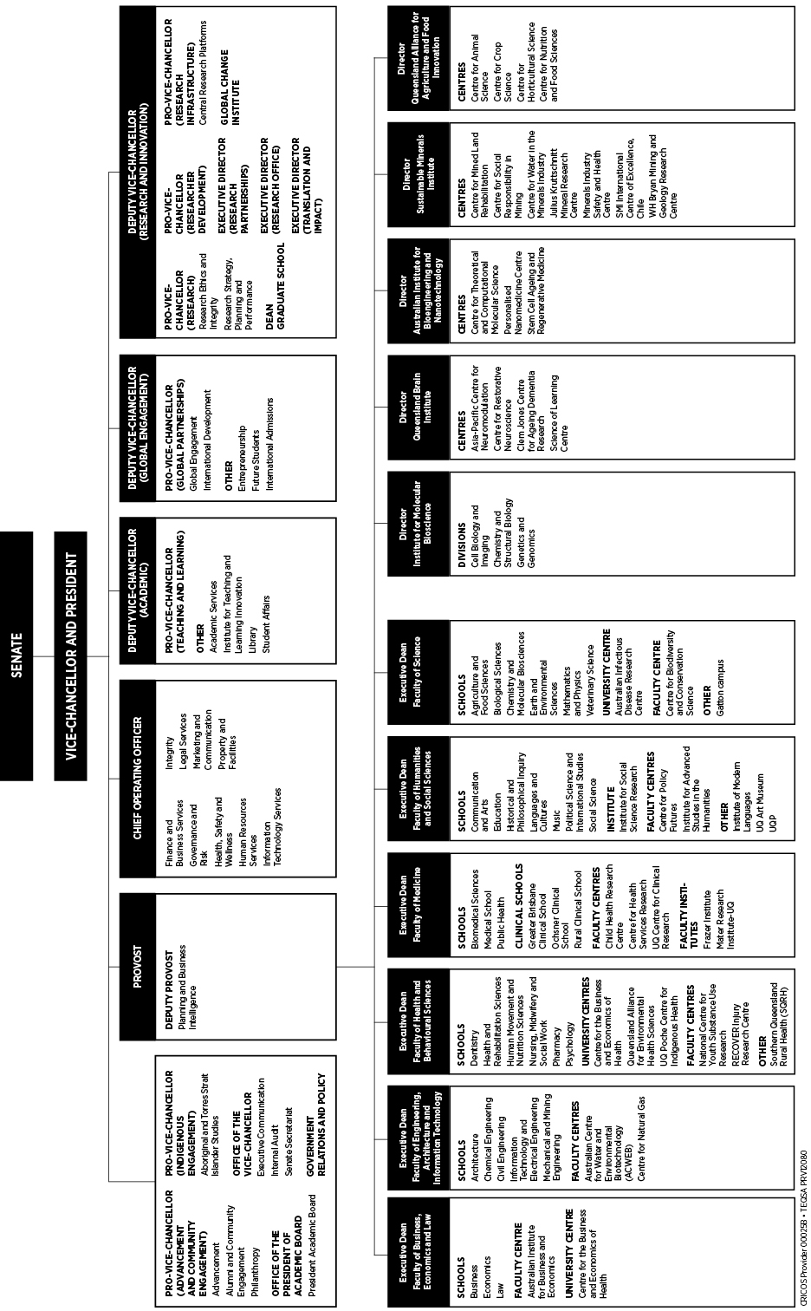

Public Sector Ethics
In 2022, the University reviewed and implemented a new Staff Code of Conduct, which aligns with the Public Sector Ethics Act 1994, UQ’s Model Code for the Protection of Freedom of Speech and Academic Freedom, and the
requirements under the Human Rights Act 2019. The new Staff Code of Conduct sets out the expectations for university staff in relation to professional conduct.
A revised version of our mandatory online course, aligned to the new Staff Code of Conduct, was developed during the year and launched in December. Completion of the Staff Code of Conduct module remains mandatory for all continuing, fixed-term and casual staff.
The revised online training is consistent with the University’s obligations under the Public Sector Ethics Act 1994, which requires the University to provide appropriate education about public sector ethics. Given the high profile of
the Staff Code of Conduct, administrative procedures and management practices across the University reflect the objectives and requirements set out. It is also referenced in position descriptions and offers of appointment, forms part of employee induction programs, and is incorporated into relevant training and development programs.

Freedom of speech and academic freedom*
On 30 November 2022, the University Senate approved a new, standalone Academic Freedom and Freedom of Speech policy, ensuring visibility of the University’s commitment to the Principles.
Prior to the establishment of the standalone policy, the University had adopted a Model Code for the Protection of Freedom of Speech and Academic Freedom, which was embedded in the University’s Governance and Management Framework.
In the drafting of policies and procedures, UQ has regard for the adopted Principles for the Protection of Freedom of Speech and Academic Freedom.
The policies intersecting most closely with the Principles were reviewed to ensure consistency with the University’s commitment to the protection of freedom of speech and academic freedom.
During the year, UQ supported a culture committed to freedom of speech and academic freedom.
All proposed policy amendments were reviewed to ensure they give effect to the commitment to the Principles for the Protection of Freedom of Speech and Academic Freedom. Throughout the policy review process, advice was offered to policy reviewers about opportunities to strengthen provisions related to the Principles, and amendments were
requested in cases where a risk was identified that may restrict freedom of speech or academic freedom at UQ. A statement from this process of review accompanied all policies that were submitted for approval.
As part of the process for reviewing policies for alignment with the Principles, a range of feedback was provided to policy owners for consideration prior to approval. As an example, amendments were made to the Grants, Prizes and Scholarships Policy to note that when entering any agreement supporting an Award, UQ will protect freedom of speech, academic freedom, and institutional independence by ensuring that all Awards are consistent with its values, priorities and policies.
Students are represented on university committees that consider business associated with student experience.
Students are also represented on the Academic Board, where there is discussion on matters associated with freedom of speech and academic freedom.
The governing body is not aware of any matters of concern regarding freedom of speech or academic freedom in 2022.
Qualitative responses in staff and student surveys were closely monitored to ensure that any issues regarding freedom of speech and academic freedom could be identified and acted upon.
* This attestation statement is made pursuant to a University Chancellor’s Council decision in 2021 to encourage universities to make annual attestation statements. The template was adopted by the UQ Senate in 2021.

Risk management
The University has a Senate Risk and Audit Committee that assists Senate in discharging its risk management, and internal compliance and control oversight responsibilities.
The role of this committee is to oversee the University’s governance, risk and compliance frameworks, including policies, procedures, information systems, and systems of internal control surrounding key financial and operational processes. The Committee also provides oversight of the leadership and direction in terms of organisational culture and ethical behaviour.
The Committee receives advice and assurance from senior management and Internal Audit across the following functions and activities:
- Enterprise Risk
- Occupational Health and Safety
- Governance
- Compliance
- Integrity and Investigations
- Research Integrity.
All members of the Senate Risk and Audit Committee are appointed by Senate. The Committee met 4 times during 2022.
No members were remunerated for their attendance apart from Grant Murdoch, who received $10,000 in his role as Chair.
UQ’s key risk management governance instruments are the Senate-approved Risk
During 2022, the Committee provided direction and oversaw the following:
- Top risks: Continued reporting on the University’s top risks, considering changes in both the
internal and external environment, and progress reporting on the implementation of proposed new risk treatments took place.
- Emerging and existing risk developments: Reporting of significant emerging and existing risk developments took place, including deep dives of specific risk exposures.
- Significant programs and projects: A high-level performance summary report of UQ’s most significant programs and projects highlighting status of the overall program or project and specific project aspects,
e.g. project budget, schedule, scope, resources etc, was prepared.
- Health, safety and wellness: In addition to reviewing regular reports, Senate also received an annual report on occupational health and safety matters and their management for reference.
- Cybersecurity: There was a continued focus on cybersecurity risk management, in particular on strengthening the University’s
controls framework to mitigate this high-risk exposure.
The Senate Risk and Audit Committee has operated effectively as per its charter and had due regard to Treasury’s Audit Committee Guidelines.

Internal Audit
The Internal Audit function adds value by assisting Senate and University management to effectively execute their responsibilities by providing assurance on the effectiveness of governance, risk management and internal controls.
Internal Audit also assesses and provides assurance on the quality of financial, managerial and operating information, and whether resources are acquired economically, used efficiently and managed effectively.
Internal Audit operates under an Internal Audit Charter, last reviewed and approved by the Senate Risk and Audit Committee in November 2022. As per this Charter, the Internal Audit function is independent of management and, as such, has no direct responsibilities for, or authority over, any of the activities it audits.
Internal Audit reports functionally to the Senate Risk and Audit Committee and administratively to the Chief Operating Officer, and has direct access to the Vice-Chancellor and President, the Chair – Senate Risk and Audit Committee, and the Chancellor.
Internal Audit activities take into account applicable legislative requirements, such as the University of Queensland Act 1998, the Financial Accountability Act 2009, Financial and Performance Management Standard 2019 and Tertiary Education Quality and Standards Agency Act 2011 (TEQSA Act). Internal Audit activities also consider the Queensland Treasury Audit

Appetite Statement and the Enterprise
Committee Guidelines 2020. The

Risk Management Framework.
The Enterprise Risk Management
  - See also
Senate Committee membership pg 39
University’s Internal Audit activity conforms with the International Standards
for the Professional Practice of Internal

Framework is built on and supported by
5 ‘pillars’:
Auditing and The Institute of Internal Auditors’ Code of Ethics.

- Senate’s expectations and risk appetite
- Management/leadership commitment and support for risk management function, organisational culture and relationships
- External compliance obligations relating to risk management
- Risk management objectives, strategies, delegated authority and accountabilities
- Risk management resources, plans, processes and activities.
The University has adopted a ‘3 lines’ assurance model as part of its governance, risk and compliance frameworks.

Integrity Unit
The Integrity Unit is responsible for the management and conduct of
investigations into breaches of policies, including allegations of corrupt conduct, activities directed against the University and/or its people, misuse of public money and public interest disclosures. The Unit also leads the delivery of misconduct prevention strategies, including training, information and advice.
The Director, Integrity Unit, reports administratively to the Chief Operating Officer and has direct access to the Vice- Chancellor and President, the Provost and Senior Vice-President, the Chair – Senate Risk and Audit Committee, and the Chancellor, as required.
An annual risk-based planning process is undertaken in consultation with management, and the Annual Internal Audit Plan is approved by the Senate Risk and Audit Committee. During 2022, Internal Audit completed 14 engagements across the University, including assurance reviews, grant certifications, advisory services and the ongoing review of several large programs and projects.

Information systems and recordkeeping
The University continues to promote compliance with the Public Records Act 2002, Information Standard 18 (2018) and the ISO27001 information security management system.
In 2022, UQ made key system improvements to recordkeeping, information management, and security and information systems to support University objectives and priorities, including:
- The next phase of the Human Capital Management System (human resources) transformation began, focusing on implementing modern, integrated payroll and time and attendance capabilities. This will enhance the consistency and accuracy of key staff and pay- related information, and allow the
decommissioning of legacy systems.
- A new customer relationship management platform was implemented, enabling more effective communications with prospective students and the decommissioning of legacy solutions.
- Multi-factor authentication was applied to all student user accounts, adding an important layer of security to key University systems.
- A 5-year Technology Master Plan was developed to ensure UQ’s investment in information systems is considered and coordinated at an enterprise level and aligns with and enables UQ’s Strategic Plan. The consultative plan will be submitted for approval in 2023.
UQ continued to deliver components of the Information Governance and
Management Framework, encapsulating the whole of the University’s strategic intent for information governance.
Activities included:
- The University’s Information Governance and Management Framework and Information Management Policy are undergoing a comprehensive review to ensure legislative alignment, clarify roles and responsibilities, clarify connections
with records management, incorporate principles of data ethics and further streamline the framework. These aspects will now enter a consultation phase before being submitted for approval in 2023.
- Data awareness campaigns and staff development training are continuing. These aim to increase the data literacy of all UQ stakeholders
- A structured data scoping process is being implemented as part of the governance of IT projects with data requirements.
- Domain-specific data governance operating models are being finalised, outlining specific data governance and management expectations and decision rights for data within both the research and teaching and learning information domains.
- The data governance program is being transitioned to an ongoing operational team within the Information Technology Services division.
- A new Keeping Records at UQ procedure was developed. It focuses on the key systems of record keeping. The procedure has been implemented across the University, including through the delivery of awareness sessions for staff and business areas on the new procedure.
UQ also conducted a comprehensive cyber security improvement program that:
- continued delivering a cyber security awareness campaign, aiming to reduce information security risks through changed behaviour. This included implementation of a new cyber security training platform
- enhanced protections from malicious phishing through implementing a 'report a phish' button in Outlook and a friendly phishing campaign
- extended detection and response (XDR) capability to provide security enhancements across prevention, detection, investigation, and response domains
- commenced implementation of UQ processes to meet requirements under the Security of Critical Infrastructure Act 2018, including in relation to registering critical assets, notifying suppliers dealing with UQ’s business critical data, and reporting cyber security incidents
- transitioned the cyber security program to an ongoing operational team under a new Director of Cyber Security, combining teams responsible for security architecture, cyber security operations, cyber risk and assurance, cyber culture and security improvements projects.

Human rights
The Human Rights Act 2019 has been in operation since 1 January 2020, with its main objectives being to:
- protect and promote human rights
- help build a culture in the Queensland public sector that respects and promotes human rights
- help promote a dialogue about the nature, meaning and scope of human rights.
The University is committed to ensuring all decisions and actions taken are compatible with human rights. During 2022, the University continued to embed processes to ensure new or revised policies and procedures were compatible with human rights. Further decision- making training and resources were made available to UQ staff, which included tailored training in making decisions consistent with human rights.
UQ received no human rights complaints in 2022. Of the 2 complaints that raised human rights concerns in 2020, one matter was settled and discontinued in 2021, while the other was dismissed in 2022.

External scrutiny
No significant findings or issues about The University of Queensland were identified by a State entity in 2022.

Summary of

Financial information

As per the financial statements, the University recorded a consolidated deficit of $310.8 million in 2022. This compares to a consolidated surplus of $341.9 million in 2021.

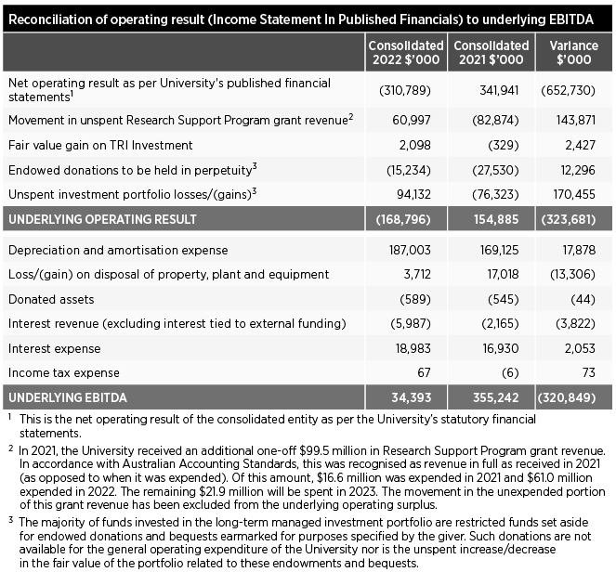
The significant difference when comparing the 2 years (a decrease of $652.7 million) is largely due to:
- A $430.0 million movement in investment revenue. In 2021, the University recorded investment revenue of $220.7 million as rising global stock markets created positive returns for the medium and long-term portfolios. In 2022, the University recorded an investment loss of
$209.3 million due to the change in market conditions resulting in global stock markets falling.
- A $143.9 million timing difference related to the one-off additional Commonwealth Government Research Support Program revenue. In 2021,
$99.5 million in revenue was received and $16.6 million expended (creating a surplus of $82.9m). In 2022, no additional revenue was received and
$61.0 million was expended (creating a deficit of $61.0m). The remaining
$21.9 million will be expended in 2023.
While the financial statements reflect a true and fair view of the financial position of the University and its
consolidated entities in accordance with the applicable accounting standards, the more informative financial result is the 'underlying consolidated EBITDA'
(earnings before interest, tax, depreciation and amortisation).
The underlying consolidated EBITDA represents the total annual funding available for major capital and infrastructure projects, operational plant and equipment, debt servicing, and contributions to the UQ Future Fund.
A breakdown of the items adjusted for as part of the underlying consolidated
EBITDA is contained in the Reconciliation of Operating Result to Underlying EBITDA table on this page above right.
Reconciliation of operating result (Income Statement In Published Financials) to underlying

University finances

Underlying consolidated EBITDA
The underlying consolidated EBITDA was a surplus of $34.4 million in 2022. This compares to a surplus of
$355.2 million in 2021.

Underlying tuition revenue
The University’s underlying tuition revenue decreased by $11.5 million (or 0.9 per cent). This can be attributed to:
- A decrease in the combined funding through the Commonwealth Grant Scheme (CGS), HECS-HELP, and HELP student contributions of $4.1 million (or 0.8 per cent). The number of Commonwealth-funded students fell by 2.6 per cent from 25,342 EFTSL in 2021 to 24,679 in 2022.
- A decrease in course fees and charges, and FEE-HELP of $7.4 million (or 1.1 per cent). The number of full- fee-paying domestic and international students fell by 4.9 per cent from 18,506 EFTSL in 2021 to 17,592
EFTSL in 2022. This decline was offset by fee increases and a lower per cent of students receiving a 12.5 per cent rebate provided to those studying offshore (the result of COVID-19- related travel restrictions).

Underlying other revenue (excluding investment revenue)
The University’s underlying other revenue (excluding investment revenue) increased by $115.0 million (or 13.3 per cent). This can be attributed to:
- An increase in research block grant funding of $47.7 million (or 23.3 per cent). The increase is largely due to an additional $44.4 million in expenditure related to the one-off additional Commonwealth Government Research Support Program revenue received in 2021.
- An increase in tied research, scholarship and other major project revenue of $14.3m (or 3.2 per cent). As the result does not recognise such revenue until expended, this increase is due to a related increase in expenditure.
- An increase in royalty and licence fee revenue of $11.0 million (or 30.2 per cent) due to an increase in Gardasil royalties.
- An increase in student residential fee revenue of $10.8 million due to the opening of the 610-bed Kev Carmody House on the St Lucia campus in 2022.
- An increase in Warwick Solar Farm electricity revenue of $5.7 million due to higher generation and power prices.
- An increase in insurance proceeds revenue of $5.3 million due to claims relating to floods in February 2022.
- An increase in the remaining revenue categories of $20.2 million (or 11.5 per cent). With fewer COVID-19 related restrictions in 2022, revenue increased in areas including consultancy fees, contract work, conference registrations, rental charges, and Patina dining.

Underlying consolidated investment revenue
The University’s underlying investment revenue decreased by $262.5 million
- a loss of $121.3 million in 2022 compared to a gain of $141.2 million in 2021. This can be attributed to:
- A decrease in the unrealised returns on the long-term investment portfolio (excluding unspent endowment earnings) of $195.7 million. The annual return of the UQ Investment Fund was a loss of 19.14 per cent in 2022 compared to a gain of 23.74 per cent in 2021.
- A decrease in the unrealised returns on the medium-term investment portfolio of $34.0 million. The annual return was a loss of 6.40 per cent in 2022 compared to a gain of 11.69 per cent in 2021.
- A decrease in the returns on investments in commercialisation entities of $8.5 million.
- A decrease in remaining investment revenue of $24.3 million. This was largely due to a decline in value of the investment in IDP Education, which was sold in 2022.

Underlying employee expenditure
The University’s underlying employee expenditure increased by $55.1 million (or 4.6 per cent). This can be attributed to:
- A 5.5 per cent increase in the average number of full-time equivalent (FTE) permanent staff. Half of the increase was related to staff funded by the extra research block grant funding (received in 2021).
- Salary rate increases of 2.0 per cent in January 2022, and 3.0 per cent in December 2022.
- The above increases were slightly offset by a reduction in employee provisions with staff, in addition to their current year entitlements, using annual leave and long service leave accrued in prior years.

Underlying other expenditure
The University’s underlying other expenditure increased by $106.7 million (or 15.3 per cent). This can be attributed to:
- An increase in non-employee expenditure on tied research, scholarship and other major project revenue, and the one-off additional Commonwealth Government Research Support Program revenue of $19.8 million (or 10.4 per cent).
- An increase in utilities and insurance expenses of $23.4 million (or 60.3 per cent) largely due to an increase in electricity costs.
- An increase in travel and hospitality expenses (excluding the portion covered by tied funding) of $14.8 million (or 208.5 per cent) largely due to the opening of state and international borders following the COVID-19 pandemic.
- An increase in commercialisation supply and services expenses of $11.0 million (or 163.2 per cent) due to increased royalty and licence fee revenue, and increased commercialisation and consultancy work.
- An increase in repairs and maintenance expenses of $5.3 million (or 6.9 per cent), largely due to works associated with the University’s facade replacement program.
- An increase in scholarship expenses (excluding the portion covered by tied funding) of $5.2 million (or 6.4 per cent) largely due to an increase in research stipends.
- An increase in the remaining expenditure categories of $27.2 million (or 9.2 per cent). Categories with an increase in expenditure included computing software and licences, digital library collections, student support, teaching/research consumables, trading purchases, and operating costs for the new Kev Carmody House.

Capital expenditure
The University continued to invest in major infrastructure. The total amount capitalised on property, plant and equipment, and intangibles during 2022 was $138.3 million (2021: $239.5 million).
Major capital projects in 2022 included the refurbishment of 308 Queen Street (The Atrium), the construction of the new Plant Growth Facility, and the renewal of the UQ lake.

FINANCE

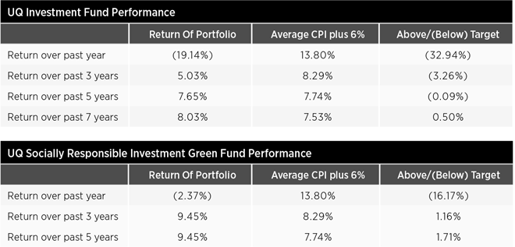

Investment Portfolio
Background
The University maintains 2 long-term managed investment portfolios – the UQ Investment Fund and the UQ Socially Responsible Investment (SRI) Green Fund. These portfolios serve 2 purposes.
First, they hold endowments received by the University over the past century. The principal amount of the endowment is invested in perpetuity and the investment earnings are used to support a particular purpose (e.g. scholarships, prizes, chairs) consistent with the donor's intent.
Second, they hold a portion of annual operating surpluses generated by the University in recent years. This is known as the UQ Future Fund and the funds are invested in the long-term to provide for
(1) a stream of investment earnings that can be used for innovative or strategically important teaching and learning activities, and/or (2) a reserve to draw upon to absorb a large financial shock.

UQ Investment Fund
The UQ Investment Fund is managed by external fund managers, who are required to operate within designated asset allocation benchmarks. Each has responsibilities for investments in cash and fixed interest, listed property, Australian shares, overseas shares, tactical asset allocation, and private
equity. The balance at 31 December 2022 was $803.2 million. Of this total, $342.7 million relates to endowments and $460.5 million relates to the UQ Future Fund.
The investment strategy of the UQ Investment Fund is to achieve a long-term return (net of all fund manager fees) of the Consumer Price Index plus an additional 6 per cent over rolling 7-year periods.
CFO Statement
In preparing the financial statements, the UQ Chief Financial Officer
(CFO) has fulfilled the reporting responsibilities as required by the Financial Accountability Act 2009. They have provided the accountable officer with a statement that the financial internal controls of the University were operating efficiently, effectively and economically in accordance with section 57 of
the Financial and Performance Management Standard 2019.
As at 31 December 2022, the fund had produced a one-year loss of 19.14 per cent and a 7-year return of 8.03 per cent per annum.
The UQ Investment Fund has no direct investments in fossil fuel companies. The University regularly monitors the composition of investments managed by external fund managers and ensures fossil fuel companies do not form a material part of the total investment.

UQ Socially Responsible Investment (SRI) Green Fund
The UQ SRI Green Fund offers an alternative to donors providing
endowments who are looking for socially responsible investments. The fund
will not invest in companies involved with tobacco, armaments, gaming or pornography as they are not deemed
socially responsible investments. Further, the fund will not invest in companies excluded from the FTSE All-World ex Fossil Fuels Index.
The fund managers are required to operate within designated asset allocation benchmarks and each has responsibilities for investments in cash and fixed-interest and Australian shares. The balance at 31 December 2022 was $5.6 million.
The investment strategy of the UQ SRI Green Fund is to achieve a long-term return (net of all fund manager fees) of the Consumer Price Index plus an additional 6 per cent over rolling 7-year periods.
As at 31 December 2022, the fund had produced a one-year loss of 2.37 per cent. A 7-year return is not yet available as the fund was first established in 2016.

Annual Financial statements are
available online at https://www.about.uq.edu.au/annual-reports

Glossary

3MT Three Minute Thesis
AAC Ally Action Committee
AAH Australian Academy of the Humanities
AAHMS Australian Academy of Health and Medical Science
AAIA Australian Information Industry Association
AAS Australian Academy of Science
AAUT Australian Awards for University Teaching AFLW Australian Rules Football League Women's AHA Australian Academy of the Humanities
AIA Australian Institute of Architects
AIATSIS Australian Institute of Aboriginal and Torres Strait Islander Studies
AIBN Australian Institute for Bioengineering and Nanotechnology
AILASA Association of Iberian and Latin American Studies of Australasia
AAH Australian Academy of the Humanities APD Annual Performance and Development ARC Australian Research Council
ARTU Aggregate Ranking of Top Universities ARWU Academic Ranking of World Universities ASEAN Association of Southeast Asian Nations ASSA Academy of Social Sciences in Australia
AUCSO Association of University Chief Security Officers
AWEI Australian Workplace Equality Index
CALD Cultural and linguistic diversity
CASE Council for the Advancement and Support of Education
CBCA Children's Book Council of Australia
CFO Chief Financial Officer
CIC Cultural Inclusion Council
CRICOS Commonwealth Register of Institutions and Courses for Overseas Students
CSIRO Commonwealth Scientific and Industrial Research Organisation
DECRA Discovery Early Career Researcher Award
DIG Disability Inclusion Group
DTU Technical University of Denmark
EAIT Engineering, Architecture and Information Technology (Faculty of)
EBITDA Earnings before interest, tax, depreciation and amortisation
edX – an online learning destination and MOOC provider, offering high-quality courses from the world's best universities and institutions to learners everywhere
EFTSL Equivalent full-time student load
EI Engagement and Impact
ELICOS English Language Intensive Courses for Overseas Students
ERA Excellence in Research in Australia FaBA Food and Beverage Accelerator Project FTE Full-time equivalent
GRDC Grains Research and Development Corporation
HABS Health and Behavioural Sciences (Faculty of)
HCMS Human Capital Management Solution
HDR Higher degree by research – PhD, MPhil, DBiotech, DVCSc
HEA Higher Education Academy, a fellowship scheme to recognise outstanding teaching
HERA Health Research Accelerator
HERDC Higher Education Research Data Collection
HR Human Resources
HSW Health, Safety and Wellness IAP Indigenous Academic Pathways ICMJ Intercollegiate Meat Judging
IITD Indian Institute of Technology Delhi
IMB Institute for Molecular Bioscience
ISBD International Society for Bipolar Disorders ISPG International Society of Psychiatric Genetics IT Information Technology
LGBTQIA+ Lesbian, gay, bisexual, transgender, queer/questioning, intersex and asexual
LSQ Life Sciences Queensland
MOOC Massive Open Online Course
mRNA Messenger RNA – a type of vaccine
NAIDOC National Aborigines and Islanders Day Observance Committee
NAT National Self-Insurers OHS Management Systems Audit Tool
NHMRC National Health and Medical Research Council
OHS Occupational Health and Safety
OIR Office of Industrial Relations
pg page
PNG Papua New Guinea
POLSIS Political Science and International Studies
PTSD Post-traumatic stress disorder
QAAFI Queensland Alliance for Agriculture and Food Innovation
QBI Queensland Brain Institute QPS Queensland Public Service QS Quacquarelli Symonds
QUEX Queensland University/Exeter University
R&D Research and Development
RAI Royal Anthropological Institute
RANZCOG Royal Australian and New Zealand College of Obstetricians and Gynaecologists
RAP Reconciliation Action Plan
REDI Researcher Exchange and Development within Industry
RTP Research Training Program
SAGE Science in Australia Gender Equity
SHPA Society of Hospital Pharmacists of Australia
SLQ State Library of Queensland SMI Sustainable Minerals Institute SRI Socially Responsible Investment
STARS Sustainability, Tracking, Assessment and Rating System
STEM/STEMM Science, technology, engineering and mathematics/and medicine
SUSTech Southern University of Technology
SWAN Scientific Women's Academic Network
TEQSATertiary Education Quality and Standards Agency
The Act University of Queensland Act 1998
Triple P Positive Parenting Program UBC University of British Columbia UK United Kingdom
UN United Nations
UNESP São Paulo State University UniSQ University of Southern Queensland UQ The University of Queensland
UQU University of Queensland Union USET University Senior Executive Team WDI Workplace Diversity and Inclusion WIL Work-integrated learning

Qualifications/Honorifics
Aberd Aberdeen, AC Companion of the Order of Australia, ACHSM Australasian College of Health Service Management, ACU Australian Catholic University, AdvMgmtProg Advanced Management Program, AM Member of the Order of Australia,
ANU Australian National University, AO Officer of the Order of Australia, BA Bachelor of Arts, BBus Bachelor of Business, BBusAcc Bachelor of Business (Accountancy), BCom Bachelor
of Commerce, BCom Bachelor of Commerce, BEc/BEcon Bachelor of Economics, BEdSt Bachelor of Education Studies, BEnvSc Bachelor of Environmental Science, BIntSt Bachelor of International Studies, BJuris (Hons) Bachelor
of Jurisprudence (Honours), BSc Bachelor of Science, BSocWk Bachelor of Social Work, CA Chartered Accountant, Cant Canterbury, CHIA Certified Health Informatician Australasia, CSC Conspicuous Service Cross, DipLang Diploma of Languages, DLitt Doctor of Letters, DUniv
(Honoris Causa) Doctor of the University (honorary degree), ExecDevptProg Executive Development Program, FAHA Fellow, Australian Academy of
the Humanities, FAICD Fellow, Australian Institute of Company Directors, FASSA Fellow, Academy of the Social Sciences in Australia, FCA Financial
Counselling Australia, FRACMA Fellow of the Royal Australasian College of Medical Administrators, FSIA Fellow of the Securities Institute of Australia, FTSE Fellow of the Australian Academy of Technological Sciences and Engineering, GAICD Graduate Member of the Australian Institute of Company Directors, GCELead Graduate Certificate in Leadership, GDipJ Graduate Diploma in Journalism, H/Hon Honorary, Hons Honours, ICAAZ Institute of Chartered Accountants Zimbabwe,
JCU James Cook University, JP (Qual) Justice of the Peace (Qualified), KC King's Counsel, LLB Bachelor of Laws, LLD Doctor of Laws, LLM Master of Laws, MA Master of Arts, MBA Master of Business Administration, MBBS Bachelor of Medicine/Bachelor of Surgery, MCom Master of Commerce, MEdSt Master of Education Studies,
MidYsSch Middle Years Schooling, MIEF Master of International Economics and Finance, MSocWk Master of Social Work, Nott Nottingham, OAM Medal of the Order of Australia, PhD Doctor of Philosophy, Qld Queensland, QUT Queensland University of Technology, SC Senior Counsel, SFHEA Senior Fellow Higher Education Academy, Syd Sydney, UWA University of Western Australia

Annual

Financial statements

for The University of Queensland and Controlled Entities for the year ended 31 December 2022

Foreword
The financial statements are general purpose financial reports prepared in accordance with prescribed requirements.
The financial statements comprise the following components:
- Income Statements
- Statements of Comprehensive Income
- Statements of Financial Position
- Statements of Changes in Equity
- Statements of Cash Flows
- Notes to the Financial Statements
- Management Certificate
- Independent Auditor's Report.
Within the above components, the financial statements have been aggregated into the following disclosures:
- University (as an entity in its own right and to which the remainder of this Annual Report refers) – column headed Parent
- Group (University and controlled entities: refer to Note 29 for a listing of these entities) – column headed Consolidated.

Content

Financial Statements
Income statements 49
Statements of Comprehensive Income 50 Statements of Financial Position 51
Statements of Changes in Equity 52
Statements of Cash Flows 54
Notes to the Financial Statements
Accounting Policies  Note 1 Summary of significant accounting policies | 55 | Liabilities  Note 20 Trade and other payables | 85
Revenue |  | Note 21 Borrowings | 86
Note 2 Australian Government |  | Note 22 Provisions | 88
financial assistance | 58 | Note 23 Other liabilities | 89
Note 3 State and local government  financial assistance | 61 | Equity
Note 4 HECS-HELP student |  | Note 24 Reserves | 90

payments 61
Note 5 Fees and charges 62
Note 6 Royalties, trademarks
and licences 63
Note 7 Consultancy and contracts 63
Assets
Note 14 Cash and cash equivalents 68
Note 15 Receivables and
contract assets 69
Note 16 Other financial assets 70
Note 17 Investments accounted
for using the equity method 73
Note 18 Property, plant
and equipment 75
Note 19 Intangible assets 82

Disclosure Notes
Note 25 Reconciliation of operating result after income tax to net cash flows from operating activities 91
Note 26 Commitments 92

Note 8 Other revenue and other income | 64 | Note 27 Related parties  Note 28 Contingencies | 93  94
Note 9 Investment revenue |  | Note 29 Controlled entities | 96
and income | 65 | Note 30 Key management personnel
Expenses |  | disclosures | 97
Note 10 Employee-related expenses | 66 | Note 31 Financial risk management | 100
Note 11 Impairment of assets | 66 | Note 32 Fair value measurements | 104
Note 12 Other expenses | 67 | Note 33 Events occurring after the
Note 13 Remuneration of auditors | 68 | reporting date | 108
 |  | Note 34 Acquittal of Australian
 |  | Government financial assistance | 109
 |  | Management Certificate | 113
 |  | Independent Auditor's Report | 114

To the Senate of The University of Queensland

Report on the audit of the financial report

Opinion
I have audited the accompanying financial report of The University of Queensland (the parent) and its controlled entities (the group).
In my opinion, the financial report:
- gives a true and fair view of the parent's and group's financial position as at
31 December 2022, and their financial performance and cash flows for the year then ended
- complies with the Financial Accountability Act 2009, the Financial and Performance Management Standard 2019, the Australian Charities and Not-for-profits Commission Act 2012, the Australian Charities and Not-for-profits Commission Regulation 2013 and Australian Accounting Standards.
The financial report comprises the statements of financial position as at 31 December 2022, the income statements, statements of comprehensive income, statements of changes in equity and statements of cash flows for the year then ended, notes to the financial statements including summaries of significant accounting policies and other explanatory information, and the management certificate.

Basis for opinion
I conducted my audit in accordance with the Auditor-General Auditing Standards, which incorporate the Australian Auditing Standards. My responsibilities under those standards are further described in the ncial Report section
of my report.
I am independent of the parent and group in accordance with the auditor independence requirements of the Australian Charities and Not-for-profits Commission Act 2012 and with the ethical requirements of the Accounting
APES 110 Code of Ethics for Professional Accountants (the Code) that are relevant to my audit of the financial report in Australia. I have also fulfilled my other ethical responsibilities in accordance with the Code and the Auditor-General Auditing Standards.
I believe that the audit evidence I have obtained is sufficient and appropriate to provide a basis for my opinion.

Key audit matters
Key audit matters are those matters that, in my professional judgement, were of most significance in my audit of the financial report of the current period. I addressed these matters in the context of my audit of the financial report as a whole, and in forming my opinion thereon, and I do not provide a separate opinion on these matters.

Valuation of Property, plant and equipment at current replacement cost ($2.15 billion) Note 18 and 32

Key audit matter How my audit addressed the key audit matter

Buildings (consisting primarily of specialised buildings), infrastructure assets and land improvements were material to the University of Queensland at balance date.
Assets, valued at $2.15 billion, were measured using the current replacement cost method that comprises:
gross replacement cost, less accumulated depreciation.
The university performs comprehensive revaluations of all of its buildings, infrastructure assets and land improvements every four years, or whenever a material variation is expected to have occurred, with desktop valuations conducted in the intervening period.
In making these judgements, the university engaged an external valuation expert to perform a comprehensive valuation in 2019. Indexation has been applied for the 2020, 2021 and 2022 balances.
The university derived the gross replacement cost of its buildings, infrastructure assets and land improvements at balance date through using unit prices that required significant judgements for:
identifying the components of buildings with separately identifiable replacement costs
identifying the components of assets that are replaced at different times in the asset lifecycle
developing a unit rate for each of these components, including:
estimating the current cost for a modern substitute (including locality factors and on-costs), expressed as a rate per unit (e.g. $/square metre)
identifying whether the existing assets contain obsolescence or less utility compared to the modern substitute, and if so estimating the adjustment to the unit rate required to reflect this difference.
The measurement of accumulated depreciation involved significant judgements for forecasting the remaining useful lives of asset components. The significant judgements required for gross replacement cost and useful lives are also significant for calculating annual depreciation expense.
Our audit procedures included, but were not limited to: In a previous year when a comprehensive valuation was conducted:
Assessing the competence, capability and objectivity of the valuation specialist.
valuation process.
Obtaining an understanding of the methodology used and assessing the design, integrity and appropriateness using common industry practices.
On a sample basis, evaluating the relevance, completeness, and accuracy of source data used to derive unit rates for the:
modern substitute
adjustment for excess quality or obsolescence.
In the current year when indexation was applied:
Assessing the competence, capability and objectivity of the valuation specialist.
w of the valuation process.
Evaluating the reasonableness of the indices used against other publicly available information about movements in values for replacement costs of similar assets.
Assessing the ongoing reasonableness of the asset useful lives by:
useful lives
assessing the appropriateness of useful lives where assets were disposed of prior to the end of their useful lives
reviewing assets with an inconsistent relationship between condition and remaining life.
Performing reasonableness tests to confirm depreciation accounting policies and industry standards.

Valuation of restricted land ($254.75 million) Note 18 and 32

Key audit matter How my audit addressed the key audit matter

was measured at fair value using the market approach. The university performs a comprehensive revaluation of its land every four years, or whenever a material variation is expected to have occurred, with desktop valuations conducted in the intervening period. A comprehensive valuation was conducted in 2019 by an external valuation specialist. Indexation has been applied for the 2020, 2021 and 2022 balances.
Significant judgement was used in arriving at the market value impact from the restrictions on the

comparing the market value of similar land and applying judgement in assessing the fair value of the restricted use land assets of the university.
My audit procedures included, but were not limited to:
In a previous year when a comprehensive valuation was conducted:
as the valuation process.
obtaining an understanding of the methodology used and assessing the design, integrity and appropriateness using common industry practices.
assessing the competence, capability and objectivity of the external valuation specialist.
for a sample of land parcels, evaluating the reasonableness of the market value impact resulting from the restrictions on use.
In the current year when indexation was applied:
evaluating the reasonableness of the indices used against other publicly available information about movements in values for replacement costs of similar assets.

Responsibilities of the entity for the financial report
The Senate is responsible for the preparation of the financial report that gives a true and fair view in accordance with the Financial Accountability Act 2009, the Financial and Performance Management Standard 2019, the Australian Charities and Not-for-profits Commission Act 2012, the Australian Charities and Not-for-profits Commission Regulation 2013 and Australian Accounting Standards, and for such internal control as the Senate determines is necessary to enable the preparation of the financial report that is free from material misstatement, whether due to fraud or error.
The Senate is also responsible for assessing the parent's and group's ability to continue as a going concern, disclosing, as applicable, matters relating to going concern and using the going concern basis of accounting unless it is intended to abolish the parent or group or to otherwise cease operations.

responsibilities for the audit of the financial report
My objectives are to obtain reasonable assurance about whether the financial report as a whole is free from material misstatement, whether due to fraud or error, and to issue an cludes my opinion. Reasonable assurance is a high level of assurance, but is not a guarantee that an audit conducted in accordance with the Australian Auditing Standards will always detect a material misstatement when it exists. Misstatements can arise from fraud or error and are considered material if, individually or in aggregate, they could reasonably be expected to influence the economic decisions of users taken on the basis of this financial report.

As part of an audit in accordance with the Australian Auditing Standards, I exercise professional judgement and maintain professional scepticism throughout the audit. I also:
Identify and assess the risks of material misstatement of the financial report, whether due to fraud or error, design and perform audit procedures responsive to those risks, and obtain audit evidence that is sufficient and appropriate to provide a basis for my opinion. The risk of not detecting a material misstatement resulting from fraud is higher than for one resulting from error, as fraud may involve collusion, forgery, intentional omissions, misrepresentations, or the override of internal control.
Obtain an understanding of internal control relevant to the audit in order to design audit procedures that are appropriate in the circumstances. This is not done for the purpose of expressing an opinion on the effectiveness of the internal controls, but allows me to express an opinion on compliance with prescribed requirements.
Evaluate the appropriateness of accounting policies used and the reasonableness of accounting estimates and related disclosures made by the group.
Conclude on the appropriateness of the parent's and group's use of the going concern basis of accounting and, based on the audit evidence obtained, whether a material uncertainty exists related to events or conditions that may cast significant doubt on the parent's or group's ability to continue as a going concern. If I conclude that a material
disclosures in the financial report or, if such disclosures are inadequate, to modify my opinion. I base my conclusions on the audit evidence obtained up to the date of my
the parent or group to
cease to continue as a going concern.
Evaluate the overall presentation, structure and content of the financial report, including the disclosures, and whether the financial report represents the underlying transactions and events in a manner that achieves fair presentation.
Obtain sufficient appropriate audit evidence regarding the financial information of the entities or business activities within the group to express an opinion on the financial report. I am responsible for the direction, supervision and performance of the audit of the group. I remain solely responsible for my audit opinion.
I communicate with the Senate regarding, among other matters, the planned scope and timing of the audit and significant audit findings, including any significant deficiencies in internal control that I identify during my audit.
From the matters communicated with the Senate, I determine those matters that were of most significance in the audit of the financial report of the current period and are therefore
precludes public disclosure about the matter or when, in extremely rare circumstances, I determine that a matter should not be communicated in my report because the adverse consequences of doing so would reasonably be expected to outweigh the public interest benefits of such communication.

Report on other legal and regulatory requirements Statement
In accordance with s.40 of the Auditor-General Act 2009, for the year ended 31 December 2022:
- I received all the information and explanations I required.
- I consider that, the prescribed requirements in relation to the establishment and keeping of accounts were complied with in all material respects.

Prescribed requirements scope
The prescribed requirements for the establishment and keeping of accounts are contained in the Financial Accountability Act 2009, any other Act and the Financial and Performance Management Standard 2019. The applicable requirements include those for keeping financial
ances to
enable the preparation of a true and fair financial report.

24 February 2023

Michelle Reardon Queensland Audit Office
as delegate of the Auditor-General Brisbane

ANNUAL REPORT 2022
The University of Queensland https://www.uq.edu.au
Page 50

