The University of Queensland
2021

Annual Report

23 February 2022

The Honourable Grace Grace MP
Minister for Education, Minister for Industrial Relations and Minister for Racing PO Box 15033
CITY EAST QLD 4002

Dear Minister
I am pleased to submit for presentation to the Parliament the Annual Report 2021 and financial statements for The University of Queensland.
I certify that this Annual Report complies with:
- the prescribed requirements of the Financial Accountability Act 2009
- and the Financial and Performance Management Standard 2019
- the detailed requirements set out in the Annual report requirements
- for Queensland Government agencies, June 2021.

A checklist outlining the annual reporting requirements can be found at about.uq.edu.au/annual-reports.
Yours sincerely
(signed) Peter N Varghese AO
Chancellor, The University of Queensland

Acknowledgement of Country
We acknowledge the Traditional Owners and their custodianship of the lands on which our University stands. We pay our respects to their Ancestors and descendants, who continue cultural and spiritual connections to Country. We recognise their valuable contributions to Australian and global society.

Public availability note
This report, as at 31 December 2021, was produced by Marketing and Communication, The University of Queensland, Brisbane, Queensland 4072 Australia; and is available online at about.uq.edu.au/annual-reports, or by calling +61 7 3365 2479 or emailing publications@uq.edu.au.
The following information is available online at about.uq.edu.au/organisation/policies-procedures-guidelines/annual-reports and on the Queensland Government Open Data website at data.qld.gov.au:
- Consultancies
- Overseas travel.

Interpreter service statement
The University of Queensland (UQ) is committed to providing accessible services to people from all culturally and linguistically diverse backgrounds. If you have difficulty understanding this 2021 Annual Report, please contact UQ’s Institute of Modern Languages on +61 7 3346 8200 to arrange for an interpreter to effectively communicate this report to you.

Feedback
If you have any suggestions about how we can improve this report, please complete the feedback form at about.uq.edu.au/organisation/policies- procedures-guidelines/annual-reports.
ISSN 1837-6592 (print)
ISSN 1837-6606 (online)
CRICOS Provider Number 00025B
© (The University of Queensland) 2022

Contents
Vice-Chancellor and President’s review 4
  - Year in summary 6
  - 2021 Honour roll 8
Role and functions 12
  - Basis of authority; Controlled entities; Mission; Vision 12
  - UQ values; Queensland Public Service values; Operating environment 13
  - Key statistics 15
Operational performance 16
- Government objectives for the community; UQ objectives and performance indicators 16
- Review of activities — Student experience 18
- Review of activities — Research impact 21
- Review of activities — Partnerships 23
- Review of activities — Diverse community 25
- Review of activities — Agile operations 28
- Review of activities — Sustainable finances 30
Human resources 32
- HR overview 32
- University staff 33
Governance 36
- University governing body 36
- Executive management 38
- Organisation chart 39
- Public Sector Ethics; Freedom of speech and academic freedom 40
- Risk management 41
- Information systems and recordkeeping; Human rights; External scrutiny 43
Financial information Only available in PDF or printed format
Annual Financial Statements Only available in PDF or printed format
Glossary 120

Vice-Chancellor and President’s review
2021 was a pivotal year for the University. Our community showed remarkable resilience in the face of disruption, while at the same time developing a new Strategic Plan that sets out how UQ will deliver for the public good in the pandemic recovery phase.

For the second consecutive year, the COVID-19 pandemic cast a shadow over the operations of the University. While Queensland remained largely virus-free for most of the year because of the successful application of a clear public health approach, the uncertainty created by restrictions and border closures meant that it was a challenging year for many people in our community.
However, despite these disruptions, our staff and students persevered – as we delivered on our commitment to serving the public good through excellence in education, research and engagement with our communities and partners.
As a measure of our overall impact in 2021, UQ continued to perform strongly across most global rankings of universities. In the Aggregate Ranking of Top Universities (which combines the results of several leading ranking systems), UQ ranked 42nd in the world, and second in Australia.

Learning and student experience
In spite of the ongoing challenges created by the pandemic, we enrolled a record number of students this year – 56,278 students in total across all programs. This is 1.7 per cent higher than the pre-pandemic 2019 enrolments.
A significant factor underpinning this stronger than expected enrolment figure was the successful shift to online learning.
With international borders closed until the very end of the year, almost one-third of UQ coursework students progressed with their studies purely online, including around 12,000 international students who studied with us from offshore.
Graduations were postponed in July, which meant that we held a record 27 graduation ceremonies in December 2021. In total, 6,890 students graduated from the University over a period of just 10 days.
Importantly, our graduates are leaving UQ with the knowledge and skills they need to make a meaningful contribution to the workplace, and to society.
According to the 2021 Graduate Outcomes Survey, UQ is the leading university in Queensland for undergraduate outcomes when it comes to the employment rates of our alumni 3 years after they graduate.
The excellence of our teaching was once again recognised at the 2020 Australian Awards for University Teaching (AAUT) in February. Four UQ academics received AAUT awards, with Associate Professor Jack Wang, from the School of Chemistry and Molecular Biosciences, being named Australian University Teacher of the Year.

Research and innovation
As one of Australia’s leading research-intensive universities, UQ is committed to the generation of new knowledge through excellence in discovery science and fundamental research, as well as translating our research into progressive ideas, better services, and new products for the benefit of society.
This year, the University received an additional one-off contribution of $99.5 million to sustain our research, as part of the Federal Government’s Research Support Program. Initially announced in the October 2020 Federal Budget, the extra funding was allocated during the year to fund strategic research projects and research infrastructure, and to support the recruitment and retention of early- and mid- career researchers.
The University continued to support the research pipeline with the approval of 967 new research projects throughout the year.
Over the course of 2021, some 3,842 active research projects were underway across UQ, with many seeking solutions to pressing challenges such as climate change, food and water security, biodiversity conservation, and the prevention and treatment of disease.
Our research is continuing to have a global impact, with 40 UQ researchers being included on the 2021 Clarivate Analytics Highly Cited Researchers list across 44 fields of research – up from 34 on the 2020 list.
Among the many highlights of this year, the University received funding support in April to establish a new R&D facility that is focused on developing high-purity mRNA vaccines and cancer therapies.
In July, we were awarded funding by the Australian Research Council (ARC) to establish a new Industrial Transformation Training Centre in Bioplastics and Biocomposites.
Then, in November, we launched the ARC Research Hub for Sustainable Crop Protection, which is committed to boosting agricultural productivity through the development of innovative products that help fight pests and prevent disease in crops.
Also in November, we received funding under the Strategic University Reform Fund to establish the Agri-Food Innovation Alliance, with the aim of collaborating with local industry to bring interesting new food products to market.

Enriching our communities
Beyond the direct impact of our education and research programs, UQ is committed to enriching communities by spreading understanding, raising awareness, disseminating culture, building capacity and connecting people.

In 2021, we launched a number of new plans, programs and activities that exemplify our approach to acting responsibly and sustainably, at the same time as enriching the communities in which we’re embedded – both here in Queensland, and around the world.
The University’s leadership team participated in a Regional Roadshow in the second half of the year, where we consulted with community leaders on opportunities to broaden UQ’s impact in regional Queensland. The Roadshow visited Toowoomba, the Gold Coast, the Wide Bay region and the Sunshine Coast in late 2021 – and we are planning to visit communities in Far North Queensland in 2022.
We also launched two new Regional Medical Pathway programs for training doctors in the Wide Bay/Central Queensland and Darling Downs/South West Queensland, in an effort to improve access to health care in regional communities by developing a home-grown medical workforce.
We continued the important work of implementing our Reconciliation Action Plan (RAP). In May, we launched the UQ RAP Network, which provides opportunities for staff and students to participate in cultural learning activities and engage in reconciliation initiatives.
And in June, we launched our new Global Development Impact Plan, which aims to position UQ as the go-to Australian institution for international development expertise and impact. This Plan focuses on marshalling the breadth of expertise that exists within UQ to help build the capacity of people to contribute to the sustainable development of their own local communities and nations.

Building for the future
We celebrated the completion of a new landmark at our St Lucia campus in the second half of 2021, with the opening of the 11-storey Andrew N. Liveris Building.
We also officially named the new 16-storey student residences building at St Lucia after Aboriginal singer/songwriter and UQ alumnus Kev Carmody. The very first students are moving into Kev Carmody House for the start of the 2022 academic year.

A new Strategic Plan
The development of the University’s new 4-year Strategic Plan was a major priority throughout the year.
Staff responded enthusiastically to our call for input to the Plan by contributing their ideas and insights to the online ‘Strategy Jam’ conducted over 3 weeks in May and June. We had over 8,000 unique visits to the Strategy Jam website and 1,000 separate contributions from staff.
UQ’s new Strategic Plan 2022–2025 was launched in December, setting out the University’s strategic priorities for the post-pandemic era. The Plan also reframes the University’s values – by identifying the values of truth, creativity, excellence, integrity, courage, respect and inclusivity as our core values.
At a broader level, this new Strategic Plan re-emphasises UQ’s position not only as The University of Queensland but also as the University for Queensland. In this respect, the Plan includes a commitment to establishing a new endowment fund to support talented young Queenslanders to pursue their passion at UQ, regardless of their background or financial circumstances. This is the basis of our new ‘Queensland Commitment’.

Thank you
In summary, despite the many disruptions we faced this year, the University continued to create and share knowledge in service to society
– and make a meaningful contribution to communities everywhere.
The progress we made this year was due to the hard work, agility and perseverance of our staff and students. I would like to sincerely thank each and every one of them for their contribution to the UQ community in 2021.
I would also like to acknowledge the senior executive team and members of the University Senate – including our Chancellor, Peter N Varghese AO – for their strategic advice and support, as well as the passion they all have for broadening the impact of our University.

Professor Deborah Terry AO
Vice-Chancellor and President

Year in summary

January
- UQ researchers develop what could be the first new class of antibiotics in 60 years, based on cannabidiol
- UQ emails offers to 4,073 students, bringing the total prospective students offered places to more than 9,500 – with high market share of ATAR 90+ applicants
- UQ invites Traditional Owners to attend bush tucker workshop at Gatton to consider business opportunities for food
- UQ researchers collaborate with scientists around the world to map more than 690 million celestial objects
- UQ macadamia researchers breed thinner shells for bigger kernels
- UQ commences the Celebration phase of Not If, When – the Campaign to Create Change

February
- UQ researchers discover the possible cause of dementia and that exercise can help prevent it
- UQ researchers link particular asthma subtype with dangerous influenza mutations
- 13,949 graduates from 2020 are given the opportunity to attend 19 graduation ceremonies that had been deferred from previous year due to pandemic
- The $1.5 million 5-year ARC project A deadly solution: Towards an Indigenous-led bushfood industry is launched at UQ Gatton
- $10 million Herston Biofabrication Institute opens at Herston health precinct with UQ as academic partner
- UQ researchers work on developing a chip that can detect early signs of a toxic immune response in cancer or COVID-19 patients
- UQ researchers work on the resuscitation of old antibiotics through the IMB Centre for Superbug Solutions
- UQ researchers discover a link between gut health and mental health
- UQ researchers find that low-calorie sweeteners promote transfer of antibiotic-resistant genes between bacteria
- OCCURRENT AFFAIR: proppaNOW exhibition commences at UQAM

March
- International students show a positive commitment to UQ with
commencements 48.8 per cent higher than expected
- Domestic postgraduate interest increases with integrated campaigns delivered across UQ teams
- UQ student develops technology to enable prosthetic devices to be controlled by artificial intelligence
- QS World University Rankings ranks UQ top Australian university for Sports- related subjects for third year in a row
- UQ and QIMR researchers confirm the safety of sunscreen
- The ‘hidden’ continent of Zealandia is partially mapped by UQ scientists in collaboration with the Schmidt Ocean Institute
- Soils for science citizen science project is launched
- Safe Blues technology is trialled to estimate and control epidemics
- UQ researchers show that body-positive health campaigns are more successful than those with weight stigma messages
- UQ achieves international Silver STARS rating for its sustainability performance

April
- UQ researchers believe that immersive Virtual Reality applications are critical for speech pathologists to treat communication disorders
- UQ Senate approves UQ's first Modern Slavery Statement
- UQ researchers develop i-PATHWAY model to predict future childhood obesity
- UQ researchers find that e-cigarettes may be more effective in helping smokers quit than nicotine replacement therapies
- UQ Alumni Book Fair and Rare Book Auction is held at St Lucia
- QBI scientists determine that deep brain stimulation is effective in treating OCD
- UQ-developed battery is shown to charge phones/cars 70 times faster than lithium-ion batteries
- BASE facility opens at AIBN to produce mRNA vaccines and cancer therapies
- UQ celebrates the conclusion of the 2021 ilab Accelerator program by launching 12 new startups
May
- UQ’s inaugural Scholarships Week is held at Gatton, Herston and St Lucia
- UQ media researchers call for urgent change to whistleblower protection laws
- Parliamentary inquiry supports UQ law professor's proposal for a
multidisciplinary tribunal to manage parenting disputes
- UQ researchers find a new way to reduce scarring by blocking part of the healing process that forms the hard materials found in scar tissue
- Schonell Theatre closes temporarily due to asbestos and safety concerns
- UQ celebrates National Reconciliation Week and launches UQ RAP Network
- Staff consultation process begins for developing UQ's 2022–2025 Strategic Plan
- Former UQ Chancellor Sir Llew Edwards passes away at the age of 85
- Med-tech company and UQ Ventures ilab Accelerator startup, Audeara, is listed on Australian Stock Exchange for
$21 million
- UQ has 49 subjects ranked in world's top 100 (30.6 per cent in top 50) in Shanghai Rankings subject rankings

June
- UQ researchers help develop a needle-free COVID-19 vaccine using Vaxxas patch
- UQ researchers discover 37 per cent global reduction in crime since pandemic
- UQ researchers release report on pandemic-proofing the education system
- UQ Life Course Centre researchers link teen suicidal ideation with bullying
- In partnership with KPMG, UQ researchers find that 72 per cent of people don't trust Artificial Intelligence
- UQ PhD student documents new species of giant prehistoric crocodile, Gunggamarandi maunala
- UQ commemorates Refugee Week
- UQ researchers find caterpillar venom with promise for medicine and pest control
- UQ researchers find that ultrasound can overcome some detrimental effects of ageing and dementia
- DVA partners with UQ to trial Active Choices physical activity support program
- UQ scientists boost avocado production through plant stem-cell technology

July
  - UQ social scientists become first to be awarded Facebook funding for social media research on hate speech
  - Andrew Flannery commences in the role of Chief Operating Officer
  - UQ receives more than $15 million MRFF funding for 9 health research projects
  - In collaboration with WEHI, UQDI researchers identify new-generation anti- cancer drug for medulloblastoma
  - UQ researchers reveal that COVID-19 prevented 4.7 million holidays for Queenslanders, affecting mental health
  - Andrew N. Liveris building is completed
  - QBI researchers discover rare genetic mutation that can cause epilepsy; and refute claim that COVID-19 vaccine enters DNA
  - In association with Victor Chang Cardiac Research Institute, UQ researchers discover that funnel web spider venom may help prevent heart attack damage
  - UQ researchers develop rapid testing kits for both Hendra virus and ovarian cancer
  - UQ is awarded $5 million for ARC Industrial Transformation Training Centre in Bioplastics and Biocomposites
  - UQ study reveals Australia one of only 3 countries globally to exceed 30 per cent female membership of company boards

August
  - UQ Open Day, National Student Volunteer Week, UQ Sustainability Week, HDR Week and NAIDOC Week are held online
  - International student commencements are 32.2 per cent higher than expected
  - ICTE merges with UQ College
  - will.i.am and Andrew Liveris AO deliver UQ community lecture
  - UQU Arts & Culture Festival is held
  - UQ begins Regional Roadshow to celebrate impact of UQ students, alumni and partners on their community
  - UQ researchers discover new pterosaur; the source of healthy sugar in stingless bees' honey; and links between childhood trauma and addiction
  - ARC awards $995,000 to UQ Future Fellow to investigate support for people with disability into work
  - UQ scientists begin researching magic mushrooms for mental health treatments
  - UQ partners with Minderoo Foundation to measure toll of plastic pollution in humans

September
- R U OK? Day is held at UQ campuses
- Rosie Stoke wins UQ's 3MT Final
- Using UQ-developed mapping techniques, the Allen Coral Atlas project officially launches high-resolution coral reef maps
- Pfizer vaccine clinic opens at UQ St Lucia
- UQ Research and Innovation Week is held and includes launch of UQ Aboriginal and Torres Strait Islander Research and Innovation Strategy
- ACRF ACEMID is launched
- UQ announces 'version 2' of COVID-19 vaccine to start clinical trials in 2022
- UQ receives more than $50 million NHMRC funding for 5 Centres of Research Excellence, 2 Partnership Projects and 29 Investigator Grants
- UQ scientists develop antiviral surface spray for added protection against COVID-19
- Kev Carmody House at St Lucia student accommodation opens for 2022 bookings
- Cane toad-busting technology is launched
- Former UQ Deputy Chancellor Emeritus Professor Dr Mary Mahoney AO dies

October
- Workday system is launched to manage UQ's enterprise resource planning and human capital
- Inaugural Deadly Noize concert is held at UQ St Lucia
- UQ hosts 14th Latin American Colloquium, third Giving Day and Courting the Greats
- UQ launches first stops of 'Philanthropy Trail' to recognise UQ's rich history of giving
- UQ researchers develop cheap and efficient solar cells
- In partnership with Motif Foodworks Inc, UQ researchers begin project to improve quality of plant-based 'meat' burgers
- IMB researchers identify Cavin3, a new pathway to target breast cancer
- UQ startup gets $1.3 million international backing for liver disease treatment
- NHMRC funds UQ-led CRE to improve health/economic costs after traffic injuries
- UQ researchers develop unbreakable phone screens, COVID-19 calculators, and bionic shoe insoles
- The new Student Central service centre opens at St Lucia

November
- Teaching and Learning Week is held with the theme of Inclusion and attracts more than 870 participants
- UQ hosts the inaugural UQ-Japan Day
- UQ Thanks You celebrations are held to acknowledge staff
- UQ launches the Frontier Forum, a new space for research-backed conversations on major world developments
- UQ researchers develop national blueprint for screening melanoma; discover microbiome for preventing ear infections; and investigate how electric vehicles are powering the grid
- The UQ Agri-Food Innovation Alliance is established to boost Australian produce
- UQ researchers determine intelligence of octopuses
- UQ partners with Teslascope to develop electric vehicle technology
- Aggregate Ranking of Top Universities (ARTU) ranks UQ 42nd in the world

December
- New members are appointed to the 35th UQ Senate
- 15,628 students graduate from UQ in 2021, and 27 graduation ceremonies are held
- Summer in Queensland program is run for international students
- UQ launches Strategic Plan 2022– 2025
- UQ researchers discover the exercise 'sweet spot' for reversing cognitive decline; and the benefits of ultrasound for inhibiting the development of Alzheimer's disease
- UQ Senate approves revised Student Disciplinary Framework
- UQ researchers link childhood trauma with psychosis, female 'first in family' with mental health issues, and Marvel superhero behaviours with positive ageing outcomes.
- UQ works with Google.org to develop world-first real-time bushfire hazard detection and warning system.
- UQ’s international scholarship suite of 710 scholarships is launched for 2022.
- 110 Queensland students are selected to participate in UQ’s 2022 Young Achievers Program.

2021 Honour roll

Fellowships

Learned Academies
- Professors Theresa Green, Claire Rickard (AAN), Professor Catherine Lovelock (AAS); Professor Alpha Yap (ASCB), Professors Andrew Burton- Jones, Nicole Gillespie (ASSA)

Royal Society
- Professor David Craik FAA, FRS

ARC Future Fellows
- Dr Paul Evans, Dr Simon Haine, Associate Professor Paul Harpur, Dr Jingwei Hou, Dr Markus Muttenthaler, Dr Hongzhi Yin, Dr Magdalena Zych

ARC Laureates
- Professors Rob Parton, Andrew White

2021 Advance Queensland Industry Research Fellowships
- Drs Sebastian Hoerning, Xia Huang, Christopher McMillan, Chris O'Brien, Anne Sawyer, Mehdi Serati, Anton van der Vegt, Ruizhi Zhong, Guohun Zhu

2021 Higher Education Academy Senior Fellows
- Janet Frizzarin, Associate Professor Joerg Henning, Dr Angie Knaggs, Associate Professor Katherine Martell, Associate Professor Sabine Matook, Dr Marloes Nitert Dekker, Professor Shaun O'Leary, Dr Keane Wheeler

2021 NHMRC Fellowships (Level 3)
- Professors Gabrielle Belz, David Craik, David Fairlie, David Hume, Jason Mattingley, Gita Mishra, Ranjeny Thomas

Awards

2020 Australian Awards for University Teaching (AAUT)
- Australian University Teacher of the Year: Associate Professor Jack Wang
- Award for Teaching Excellence (Biological sciences, health and related studies): Associate Professor Jack Wang
- Citations for Outstanding Contributions to Student Learning: Dr Anna Hatton, Dr Michael Bermingham, Professor Matthew Dargusch

2020 Meetings and Events Australia: National Awards
- UQ Open Day Online (Major Event or Festival of the Year and Corporate Event of the Year, Queensland)

2021 Australian Museum Eureka Prizes
- Eureka Prize for Excellence in Interdisciplinary Scientific Research: Professor Felicity Meakins (with Lindell Bromham, Xia Hua, Cassandra Algy)

2021 Australian Road Safety Awards
– Community Programs Award and Founders Award: Queensland Police Service and University of Queensland for Community Engagement with IM-PACT)

2021 Australian Water Association Awards
– Infrastructure Project Innovation Award (Metro): Urban Utilities, Veolia Water Technologies, Fulton Hogan and University of Queensland

2021 Australian Workplace Equality Index (Silver) Award
- The University of Queensland

2021 Bionics Queensland Challenge
- The University of Queensland (Dr Anna Hatton) – Challenge 2 – Bionic Senses

2021 Clarivate Analytics Highly Cited Researchers*
- Professor Christine Beveridge, Professor Bhesh Bhandari, Professor Gregory Brown, Dr Mark S Butler, Professor Matthew Cooper, Professor Elizabeth Eakin, Professor David P Fairlie, Dr
Alize J Ferrari, Professor Richard Fuller, Professor Paul A Gardiner, Professor Juergen Goetz, Professor Wayne D Hall, Professor Ben J Hayes, Professor Genevieve N Healy, Professor Philip Hugenholtz (2 categories), Professor Jeonghun Kim, Emeritus Professor Sritawat Kitipornchai, Professor Carl J Lavie, Professor Catherine Lovelock, Professor Janet McColl-Kennedy, Professor John J McGrath, Professor
Peter Mumby, Professor John M Pandolfi, Dr Donovan Parks, Professor David
L Paterson (2 categories), Professor Hugh Possingham, Dr Christian Rinke, Emeritus Professor Michael S Roberts, Professor Avril Robertson, Professor Kate Schroder, Dr Oscar Venter, Professor Peter M Visscher, Professor Timothy Walsh, Professor Lianzhou Wang, Professor James EM Watson, Professor Harvey A Whiteford, Professor Naomi Wray, Professor Yusuke Yamauchi (2 categories), Professor George Zhao, Emeritus Professor Jin Zou

2021 Council for Advancement and Support of Education (CASE) Awards
- Grand Gold Circle of Excellence Award for Marketing/Campaign/Fundraising for Not If, When – the Campaign to Create Change
- Silver Circle of Excellence Award for Alumni Relations/Alumni Relations Improvement for UQ ChangeMakers
- Bronze Circle of Excellence Award for Advancement Services/Donor Relations and Stewardship for Jacaranda Society

2021 Engagement Australia Award for Excellence in Indigenous Engagement
- The University of Queensland for Enhancing access to specialist health services through the use of telehealth for Indigenous Australians

2021 National Centre for Student Equity in Higher Education Champions for Change Award
- University of Queensland Disability Inclusion Group

2021 NHMRC Fellowships

Emerging Leadership Level 1
- Drs Ibrahim Javed, Aleksandr Kakinen, Janni Leung, Gregore Mielke, Natalie Newton, Jake O'Brien, Lena Oestreich, Jay Rasmussen, Tatiane Yanes, Yannan Yang

Emerging Leadership Level 2
- Associate Professors Yeoungjee Cho, Maree Toombs; Drs Quan Nguyen, Kirsty Short, Nicole Warrington

Leadership Level 1
- Professor Di Yu

Leadership Level 2
- Professors Vicki Flenady, Josephine Forbes, Sailesh Kumar, Jason Roberts, Kate Schroder, Trent Woodruff

2021 Peter Doherty Awards for Excellence in STEMM Education
- UQ Faculty of Science – Partnership Award

2021 Restaurant & Catering Hostplus Awards for Excellence
- Customs House – for Function/ Convention Centre Caterer award and Caterer of the Year (South East Queensland)

2021 Sustainability Tracking, Assessment and Rating System Award
- The University of Queensland (Silver)
2021 The Australian top researchers

Lifetime achievers – Research superstars
- Professor Neal Ashkanasy (Human resources and organisations)
- Professor Sara Dolnicar (Tourism and hospitality)
- Professor Ben Hayes (Animal husbandry)
- Professor Julie Henry (Cognitive science)
- Professor Katie McMahon (Cognitive science)
- Professor Grant Montgomery (Genetics and genomics)
- Professor Yusuke Yamauchi (Materials engineering)
- Professor Zhiguo Yuan (Environmental Sciences)

Research field leaders
- The University of Queensland (Biotechnology; Business, economics and management (general); Dermatology; Diplomacy and international relations; Dispersion chemistry; Emergency management; Family studies; Food science and technology; Genetics and genomics; Gynaecology and obstetrics; Health and medical sciences (general); Life sciences and earth sciences (general); Medicinal chemistry; Microbiology; Nutrition science; Organic chemistry; Paleontology; Spectroscopy and molecular physics; Toxicology; Water supply and treatment**)
- Professor Bhesh Bhandari (Food science and technology)
- Professor Bhagirath Singh Chauhan (Agronomy and crop science; Pest control and pesticides**; Plant pathology**)
- Associate Professor Bryan Fry (Toxicology)
– Adjunct Professor Adele Green (Dermatology)
- Professor Brian Head (Public policy and administration)
- Professor Louise Hickson (Audiology, speech and language pathology)
- Professor Philip Hugenholtz (Microbiology)

  - Dr Ian Marquette (Mathematical physics)
  - Professor Lorraine Mazerolle (Criminology, criminal law and policing)
  - Associate Professor Alina Morawska (Family studies)
  - Professor David Paterson (Communicable diseases)
  - Professor Brent Ritchie (Tourism and hospitality)
  - Professor Peter Visscher** (Genetics and genomics)
  - Professor Peter Walker (Virology)
  - Professor Yusuke Yamauchi (Organic chemistry)
  - Dr Subhan Zein (English language and literature)
  - Professor Xiaofang Zhou (Data mining and analysis)

Early achievers – Rising stars
  - Dr Fiona Charlson (Health and medical sciences)
  - Dr Nik Steffens (Business, economics and management)
  - Dr Loïc Yengo (Health and medical sciences)

2021 Timberbiz Awards
  - Duncan Hossy, William Webster –
Responsible Wood Civil Engineering Prize
– Dylan Francis, Simon Louei – Wood Architecture Design Prize

2021 Universities Australia Marketing, Communications and Development (UAMCD) Awards
  - University of Queensland – for Best proactive communications for Learning through COVID-19

2021 University of Queensland Press (UQP) Literary Awards
  - 2020 ACT Book of the Year Award for
Ghost bird
  - 2021 Australian Book Industry Awards Small publisher of the year
  - 2021 Children's Book Council Notables List
– The heartsong of Wonder Quinn and Zoe, Max and the bicycle bus
  - 2021 Indie Book Awards – Mammoth (Fiction); This one is ours (Young Adult)
  - 2021 NSW Premier's Literary Awards – Book of the Year, Kenneth Slessor Prize for Poetry, and Multicultural NSW Award for Throat
  - 2021 Queensland Literary Awards – Queensland Premier's Award for a work of State Significance for Biting the clouds and USQ Steele Rudd Award for a Short Story Collection for Ordinary Matter
  - 2021 Readings Children's Book Prize for As fast as I can
  - 2021 YABBA Award – Fiction for Years 7–9 for Sick Bay

2022 DECRA Awards
  - Drs Guillermo Badia, Claudia Benham, Timothy Buttsworth, Cassandra Chapman, Stefan Emming, Sarah Grainger, Anthony Harris, Melissa Johnston, Eleonore
Lebre, Tao Liu, Miaoqiang Lyu, Naphak Modhiran, Gunn-Helen Moen, Matthew Reeves, Marten Risius, Felix Septianto, Sarah Sweet, Jie Wang, Xin Wu, Mehmet Yildirimoglu
* With 43 HiCi awards, this places UQ first in Australia and equal 20th globally (with University of Cambridge). This list only includes individuals whose primary affiliation is UQ, not those who list UQ as a secondary affiliation.
** Global leader

Individual Prizes
- Associate Professor Don Barrett AM: Member of the Order of Australia
- Judith Bell AM: Member of the Order of Australia
- Associate Professor Sarah Bennett: Excellence in research on improving law enforcement for women award in 2021 Women in Policing awards
- Odette Best: Fellow of the Australian College of Nursing
- Thomas Bizzell: Schmidt Futures Reimagine Challenge 2020
- Emeritus Professor David Carter AM: Member of the Order of Australia
- Professor Bagirath Chauhan: WSSA Outstanding paper: weed technology award and honorary WSSA member
- Sophie Clacher: ICMJ Commercial Evaluation team award
- Dr Fabio Costa: 2021 Queensland Young Tall Poppy Award
- Professor Tamara Davis: 2021 ASA Robert Ellery Lectureship
- Adjunct Professor Everald Compton AO: Officer of the Order of Australia
– Csilla Demeter: 2021 Fresh Scientist
- Ellen Derbyshire: Australian Financial Review's Top 100 Graduate, BP Commercial Award
- Lawton Elliot: ICMJ Commercial Evaluation team award
- Simon Farley: AIA Queensland Chapter's President's 2021 Prize
- Dr Yaqoot Fatima: 2021 Queensland Young Tall Poppy Award
- Professor Josephine Forbes: 2021 Women in Technology Outstanding Achiever Science Award
- Professor Ian Frazer AC: LSQ Hall of Fame award
- Dr Brian Gabrielli: MRA established investigator award
- Kriti Garg: Australian Financial Review's Top 100 Graduate, BP Commercial Award
- Dr Fleur Garton: 2021 LSQ Rose-Anne Kelso Commemorative award
- Sreya Ghosh: Forbes 30 under 30 Europe List 2021
- Professor Elliot Gilbert: 2021 Australian Neutron Beam Users Group Neutron Award
- Professor Ian Godwin: AGI's Medal of Agriculture 2021
- Eliza Gray: ICMJ overall individual award
- Jessie Harper: 2021 Westpac Future Leaders Scholar
- Associate Professor Paul Harpur: 2021 Blind Australian of the Year
- Médy Hassan OAM: Medal of the Order of Australia
- Duncan Hossy: 2021 Responsible Wood Civil Engineering Prize
- William Isdale: 2021 Holt Prize
- Professor Claire Jackson AM: Member of the Order of Australia
- Honorary Professor John Jell AM: Member of the Order of Australia
- Baden Johns: ICMJ Commercial Evaluation team award
- Dr Laurel Johnson: 2021 Outstanding Woman in Planning award (PIA)
  - Dr Natalie Jones: British Ecological Society's Elton Prize
  - Professor David Jordan: Australian Farmer of the Year Awards 2020–21 Award for Excellence in Agricultural Research
  - Dr Brian Keating: 2020 Crawford Fund Medal
  - Associate Professor Sarah Jane Kelly OAM: Medal of the Order of Australia
  - Samantha King: PSA Professor James Dare Graduate of the Year award
  - Honorary Associate Professor Cecilie Lander AM: Member of the Order of Australia
  - Professor Peter Liesch: 2021 Fellow of the Academy of International Business
  - Adjunct Professor Harvey Lister AM: Member of the Order of Australia
  - Tao Liu: 2021 AWA Student Water Prize
  - Annika Luebbe: 2021 Westpac Future Leaders Scholar
  - Professor John Macarthur: 2021 AIA Neville Quarry Architectural Education Prize
  - Emeritus Professor Tony Makkai AM: Member of the Order of Australia
  - Professor Helene Marsh AO: Officer of the Order of Australia
– Dr Priya Martin: 2021 Interprofessional Global Best Research Award
  - Professor Margaret Mayfield: 2021 Fellow of the Ecological Society of America
  - Dr Aideen McInerney-Leo: 2021 Queensland Young Tall Poppy Award
  - Associate Professor Eve McDonald- Madden: 2021 Fenner Medal (AAS),
  - Professor Paul Memmott AO: Officer of the Order of Australia
  - Professor Flavio M Menezes: WWL Top 15 Australia and New Zealand 2021 Competition Economist
  - Professor Neena Mitter: 2021 LSQ Rural and Regional Service award
  - Dr Samantha Nixon: 2021 FameLab® Australia winner
  - Associate Professor Kazuhiro Nogita: 2021 TMS Research to Industrial Practice Award
  - Kelly Nortje: 2021 AIA Bluescope Glenn Murcutt Student Prize
  - Professor Andreas Obermair: IGCS Excellence in Teaching Award
  - Zhen-Yi Andy Ou: Parkinson's Disease Foundation Fellowship
  - Dr Carmen Parter: 2020 Fellow of the Congress of Aboriginal and Torres Strait Islander Nurses and Midwives
  - Emeritus Professor Lester Peters AO: Officer of the Order of Australia
  - Adjunct Professor Dr Sally Pitkin AO: Officer of the Order of Australia
  - Edgar Poon: PDL Student Grant winner
  - Elizabeth Potter: ICMJ Commercial Evaluation team award
  - Emeritus Professor Cheryl Praeger AC: Companion of the Order of Australia
  - Sasha Purcell: NAIDOC 2021 Scholar of the Year
  - Emeritus Professor Ian Riley AM: Member of the Order of Australia
  - Professor Halina Rubinsztein-Dunlop: The Optical Society’s 2021 CEK Mees Medal and the Australian Institute of Physics 2020 Harrie Massey Medal

    - Adjunct Associate Professor Colin Saltmere AM: Member of the Order of Australia
    - Emeritus Professor Kay Saunders AO: Officer of the Order of Australia
    - Emma Scott: 2020 MIGAS Apprentice
of the Year; 2020 TAFE Engineering and Manufacturing Apprentice of the Year
    - Dr Patrick Silvey: 2021 LSQ McCullough Robertson Industry Excellence award
    - Choon Leng So: Society for Laboratory Automation and Screening 2021 Student Poster award
    - Andrea Strachan: Universitas 21 Overall 2020 Champion in the time of COVID-19
    - Dr Andrew Swayne: 2021 Fresh Scientist
– Professor Matt Sweet: Society of Leukocyte Biology Mentoring Award
    - Associate Professor Maree Toombs: Suicide Prevention Australia's LIFE Impact Award
    - Amy Tran: Australian Financial Review's Top 100 Graduate, Jacobs Engineering Consulting Award
    - Dr Alice Twomey: 2021 Fresh Scientist
    - Scout Wallen: Walkley Awards 2021 WIN News Scholarship
    - Zhiyao Wang: 2021 Australian Water Awards Student Water Prize
    - Adjunct Professor Donald Watson: 2021 AIA Gold Medal
    - Associate Professor Daniel Watterson: CSL Centenary Fellowship
    - William Webster: 2021 Responsible Wood Civil Engineering Prize
    - Dr Keane Wheeler: ESSA Accredited Exercise Scientist of the Year 2020
    - The Honourable Trish White AM: Member of the Order of Australia
    - Sally Wilson: AUIDF Tracy McCabe Future Leader Fellowship
    - Emily Winter: AWC Furious Fiction prize
    - Liva Wood: 2021 BHP Mitsubishi Alliance Girls in Resources Future Leader scholarship
    - Dr Chloe Yap: 2021 Queensland Women in STEM Prize Judges Award
    - Professor Di Yu: 2021 AAHMS Jian Zhou Medal
    - Dr Cheng Zhang: 2021 Fresh Scientist
    - Alvin Zhu: 2021 AIA Student Prize for the Advancement of Architecture
    - Dr Magdalena Zych: Australian Institute of Physics 2020 Ruby Payne-Scott Award

International scholarships

2021 Rhodes Scholar
- Justin Clarke, BE (Hons)

2021 Fulbright Scholars
- Dr Viqar Ahmad, Professor Bradley Carter, Hayley Channer, Dr Jordan Corey, Ivan Diklich-Zelich, Jon Fanning, Kailin Graham, Professor Susan Harris Rimmer, Beth Madsden, Professor Helen Nahrung, Clare Stephens, Andrew Su, Professor Amanda Ullman, Sasha Purcell

2021 Governor Phillip Scholars
- Kye Allan, BA (Hons), Eden Bywater, BA (Hons), Rohan Watt, BA (Hons)/LLB

2021 New Colombo Plan Scholars
- Max Broad, James Cafferky, Adele Greedy-Vogel, Joshua Grice,

2021 Sir John Monash Scholar
- Brett Shannon, MBBS

National scholarships

2021 AgriFutures Horizon Scholars
- Matilda Meppem, Lilly Rehbein, Alyse Wood

2021 Westpac Scholars
- Jessie Harper, Annika Luebbe, Jacob White (Future Leaders)

Tokyo 2020 Olympics/ Paralympics

Gold medals
- Lakeisha Patterson (Women’s S9 400m freestyle swimming), Rachael Watson (Women's S4 50m freestyle swimming)

Silver medals
- Paige Leonhardt (Women’s S14 100m butterfly swimming)

Bronze medals
- Caitlin Cronin (Women’s quad sculls), Thomas Neill (Men’s 4 x 200m freestyle swimming), Ria Thompson (Women’s quad sculls)

UQ Awards
2021 UQ Alumni Awards

Alumni Friends' UQ Alumnus of the Year
- Caroline Frazer AM

Alumni Friends' UQ Graduate of the Year
- Jessie Harper

Vice-Chancellor’s Alumni Excellence Awards
- Allan Davies
- Dr Marguerite Evans-Galea AM
- Simon Hewett
- Dr Daryl Homes OBE
- Amanda Johnston-Pell

Distinguished Young Alumni Awards
- Dr Bonny Cumming
- Dr James Fielding
- Bri Lee
- Dr Bavahuna Manoharan
- Mikhara Ramsing

International Alumnus of the Year
- Dr Ryan Taft

Indigenous Community Impact Award
- Kevin O'Brien

Colleges’ UQ Alumni Award
- Scott Young

UQ Sport Awards
UQ Sportswoman of the Year:
- Natalie Grider
UQ Sportsman of the Year:
- Callum Davies
UQ Blues Awards:
- Ethan Bullemor
- Callum Davies
- Kiera Gazzard
- Natalie Grider
- Harri Jones
- Charli Knott
- Thomas Neill
- Himeka Onoda
- Joseph Ryan
- Mara Stransky-Smith
- Rachael Watson
- Natalie Wright

UQ Honorary Awards

UQ Fellowships
- Yvonne Burns AO
- William (Tony) Lee
- Emeritus Professor Alan Rix
- Emeritus Professor Maree Smith AC

UQ Gatton Gold Medal
- Daniel Kelly AM

UQ Honorary Doctorates
- Professor Megan Davis
- Dr Paul Eliadis AM
- Dr Fiona Foley
- The Hon Justice Andrew Greenwood
- Hugh Lunn
- Trevor St Baker
- Dr Elizabeth Woods OAM

UQ Principal Practitioners 2021
  - Dr Frederico Fialho Teixeira – for
Learning Spaces
  - Dr Lynda Shevellar – for Sense of Belonging

2020 UQ Awards for Excellence in Higher Degree by Research
– Associate Professor Peter Cabot – for
HDR supervision
– Dr Suzanna Fay – for graduate research leadership
– Professor Brenda Gannon – for promoting industry engagement in graduate research
  - Professor Blake McKimmie
  - for HDR supervision (commendation)
  - Associate Professor Chiara Palmieri
  - for HDR emerging adviser
– Associate Professor Elske van de Fliert – for HDR supervision

2021 UQ Awards for Excellence in Higher Degree by Research
– Dr Obaid Hamid – for HDR supervision
(commendation)
  - Professor Paul Mills – for HDR supervision
  - Dr Ben Ross – for graduate research leadership
  - Professor Susanne Schmidt – for HDR supervision
  - Associate Professor Jason Tangen – for promoting industry engagement in graduate research
  - Associate Professor Zuduo Zheng – for
HDR emerging adviser

2021 UQ Foundation Research Excellence Awards
  - Dr Joel Carpenter – Faculty of Engineering, Architecture and Information Technology
  - Dr Gary Chan – Faculty of Health and Behavioural Sciences
  - Dr Loic Yengo Dimbou – Institute for Molecular Bioscience
  - Dr Camille Guillerey – Faculty of Medicine
  - Dr Jody Peters – Faculty of Science
  - Dr Ruirui Qiao – Australian Institute for Bioengineering and Nanotechnology
  - Dr Marnee Shay – Faculty of Humanities and Social Sciences
  - Dr Ya-Yen Sun – Faculty of Business, Economics and Law
  - Dr Susannah Tye – Queensland Brain Institute

2021 UQ Research Partnership and Translation Awards
- Adjunct Professor Dale Chapman – for Indigenous research and innovation partnerships (commendation)
- Professor Sara Dolnicar – for research impact
– Dr Joerg Henning – for research impact
(commendation)
– Professor Leanne Hides – for partnership excellence
– Dr Tim Huelsen – for partnership excellence
- Professor Hamish McGowan – for
research impact (commendation)
- Dr Cristyn Meath – for innovative partnerships (commendation)
– Professor Anthony Smith – for Indigenous research and innovation partnerships
- The Dow Chemical Company – for UQ Corporate Philanthropy
– Professor Ranjeny Thomas – for UniQuest commercialisation impact

2020 UQ Teaching and Learning Awards

Awards for Teaching Excellence
- Associate Professor Saiied Aminossadati
- Associate Professor Nicholas Carah
- Associate Professor Leanne Johnston
- Dr Frances Shapter

Awards for Programs that Enhance Learning
- Student-Staff Partnership Projects Program: Madelaine-Marie Judd
Associate Professor Kelly Matthews
Naima Crisp
Dr Eimar Enright Dr Julia Groening
Yvonne Oberhollenzer Caelan Rafferty Franciele Spinelli

Citations for Outstanding Contributions to Student Learning
- Dr Roma Forbes
- Dr Cle-Anne Gabriel
- Dr Sara Herke
- Associate Professor Ian MacKenzie
- Dr Ben Mitchell
- Dr Michael Thai

Commendations for Outstanding Contributions to Student Learning
- Dr Louise Ainscough
- Dr Leigh Sperka
- Environmental Systems Engineering Team: Associate Professor Kate O'Brien Associate Professor Steven Prat, Dr
Peter Ellerton, Dr Bernadino Virdis Dr
Lisa Bai

UQ Ally Award
- Dr Rebecca Olive

UQ Refugee and Humanitarian Scholar
- Omid Anwary

2021 UQ Teaching and Learning Awards

Awards for Teaching Excellence
- Dr Taylor Dick
- Dr Deanne Gannaway
- Dr Poh Wah Hillock
– Dr Alison Mandrusiak
- Dr Kevin Welsh

Citations for Outstanding Contributions to Student Learning
- Associate Professor Rachel Allavena
- Associate Professor Karen Hughes
- Dr Hassan Khosravi
- Dr Stuart Middleton
- Mark Tanner
– Vulnerability in Medicine Tutorial Program Team:
Dr Michaela Kelly Dr Johanna Lynch
Associate Professor Nancy Sturman Dr Alison Green
Dr Gillian Eastgate Dr Penny Mainstone Kim Wicks

[See also, UQ Staff Excellence Awards
pg 34]

Role and functions

Basis of authority
The University is a body corporate governed by the University of Queensland Act 1998, as amended (the ‘Act’). The University was founded in 1910.

Functions
The University:
- disseminates knowledge and promotes scholarship
- provides education at university standard
- provides facilities for and encourages study and research
- encourages the advancement and development of knowledge and its application
- provides courses of study or instruction (at levels of achievement Senate considers appropriate) to meet community needs
- confers higher education awards
- provides facilities and resources for the wellbeing of staff, students and others taking courses at the University
- exploits commercially, for the University’s benefit, university facilities and resources such as study, research or knowledge belonging
to the University (or their practical applications), whether alone or with someone else
- performs other functions given to the University under the Act or another Act.

Powers
The University has powers outlined more fully in the Act.

Controlled entities
In accordance with the University of Queensland Act 1998, the University has established controlled entities that further the University’s educational and research aims.
They are included as part of the consolidated result in the University’s annual financial statements.
At 31 December 2021, the University operated the following controlled entities:

UQ Holdings Group JKTech Pty Ltd UniQuest Pty Ltd
UQ College Limited
UQ Health Care Limited UQ Holdings Pty Ltd UQ Sport Limited
UQ Residences Limited

University Controlled Trusts
UQ Foundation Trust

UQ Investment Trust Group UQ Investment Trust IMBCom Pty Ltd

UniQuest Group
Dendright Pty Ltd
Jetra Therapeutics Pty Ltd Leximancer Pty Ltd
Neo-Rehab Pty Ltd Symbiosis Group Pty Ltd

JKTech Group
SMI-ICE-CHILE SpA

Other Controlled Entities
UQ Jakarta Office Pty Ltd.

Our mission
UQ positively influences society by engaging in the pursuit of excellence through the creation, preservation, transfer and application of knowledge. UQ helps shape the future by bringing together and developing leaders in their fields to inspire the next generation and to advance ideas that benefit the world. UQ strives for the personal and professional success of its students, staff and alumni.

Our vision
UQ’s Strategic Plan 2018–2021 outlines our objectives to achieve our vision of knowledge leadership for a better world.

Long-term objectives
UQ’s vision has been translated into three long-term objectives:
- Transforming students into game- changing graduates who make outstanding contributions and address complex issues with a global perspective
- Delivering globally significant solutions to challenges by generating new knowledge and partnered innovation
- Developing a diverse community of knowledge seekers and leaders who embody a One UQ culture and use collaborative partnerships to connect and co-create.

Our values

Pursuit of excellence
We strive for excellence, seeking to apply the highest standards to benefit our communities.

Creativity and independent thinking
We welcome new ideas from our staff and students as well as from our alumni and our external partners. We support intellectual freedom, courage and creativity.
We encourage the pursuit of innovation and opportunities.

Honesty and accountability
We act with integrity and professionalism and uphold the highest ethical standards. We are committed to transparency and accountability. Our decisions ensure responsible stewardship of the University’s resources, reputation and values. We
lead by example in all areas, including our approaches to sustainability.

Mutual respect and diversity We promote diversity in the University community – through our people, ideas
and cultures. We create a vibrant, inclusive
environment in which ideas flourish and future generations, regardless of
background, are empowered. We respect our colleagues and work together for shared success.

Supporting our people
We ensure the safety and wellbeing of our people. We create an inclusive
and supportive university community in which achievements are celebrated and rewarded. Our people have the opportunity to enrich their lives and pursue their goals.

Queensland Public Service (QPS) values
The University of Queensland’s values align neatly with the 5 Queensland Public Service values, guiding our behaviour and the way we do business:

Customers first
≈ Supporting our people

Ideas into action
≈ Creativity and independent thinking

Unleash potential
≈ Pursuit of excellence

Be courageous
≈ Honesty and accountability

Empower people
≈ Mutual respect and diversity.

Our operating environment

Statutory obligations
The chief purpose of the University is to provide education, research and innovation at university standard and through doing so, contribute to the public good of our community.
We have been successfully achieving this for more than a century, increasing our student cohort from 83 in 1911 to more than 56,000 in 2021, and graduating more than 307,000 in that time.
Our research has also flourished. In the latest Excellence in Research in Australia (ERA) assessment in 2018,
we were assessed in 98 4-digit Fields of Research, with 100 per cent rated at world standard or above. UQ was rated above world standard in more specialised fields of research than any other Australian university.

Nature and range of operations UQ offers study and research opportunities across one of the widest discipline ranges
in Australia, through our 6 faculties and
8 internationally acclaimed research institutes, with expertise in social sciences, neuroscience, nanotechnology, food innovation, and many more. We currently offer around 390 programs and 3,400 courses including tertiary preparation,
non-award, undergraduate, postgraduate coursework and higher degree by research.

Risks, opportunities and challenges
The University operates in a dynamic global environment. The COVID-19 pandemic again heavily impacted Australia’s higher education sector in 2021, primarily due
to the ongoing closure of Australia’s international borders. This required staff to again deliver teaching in dual mode
throughout the year, catering to on-campus learners as well as online and offshore students, which presented challenges in curriculum design and pedagogy, and in ensuring a sense of belonging among all students both on- and offshore.
Domestically, the university sector faced increased financial pressures, regulatory changes and changing student, industry and government expectations – all of which were brought to the fore in 2021 with the introduction of the Job-ready Graduates Package, a major, new model for Australian higher education funding.
Within this context, UQ quickly responded to position the University to remain
competitive and successful in the longer term. The UQ community worked hard to support international students, who were studying offshore and, as a result, international coursework load at UQ increased by 5 per cent in 2021 compared with pre-pandemic 2019 figures. However, much of this increase was due to students who had deferred in 2020 commencing their studies in 2021, which disguised a softening in new demand.
Operational challenges in the coming years include:
- diversifying research income to meet the true costs of the research enterprise and to respond to an increasingly competitive research funding environment
- responding to the accelerated change in pedagogical delivery methods and post- pandemic student expectations
- maintaining our campuses and facilities with continued demands for the rejuvenation of teaching and research spaces and technologies
- ensuring the University’s contribution to the public good is recognised through our teaching, innovation, and collaboration with partners
- addressing the need to continuously invest in core enterprise, IT and cyber- security systems.
Considerable opportunities for the future include:
- translating and commercialising our exceptional research and innovation capabilities to help build a resilient, knowledge-based economy
- offering lifelong learning opportunities for education, training, upskilling and knowledge-sharing – in Australia and
internationally – with a particular focus on online learning
- implementing world-leading energy reduction strategies and our Sustainability Strategy
- introducing sector-leading initiatives to ensure that we are positioned as an employer of choice.

Environmental factors
As already noted, throughout 2021, the ongoing impact of the COVID-19 pandemic led to continuing uncertainty for students. This, coupled with competitor markets such as the UK, USA and Canada relaxing their border restrictions ahead of Australia, certainly deterred some students from
choosing Australia as their study destination during the year. Australia’s borders reopened to international students in mid-December 2021. Ensuring the return of our students is well managed, and that they can confidently travel between their home country and Australia, will be critical to reclaiming Australia's leading position as a provider of quality international education.

The Australian Government's Job-ready Graduates Package, introduced in 2021, provided a level of funding certainty across the sector. The impact of the changes has been mitigated by the transition fund, which will remain in place until the end of 2023. However, to position UQ for the future, considerable growth in enrolments will be necessary across the intervening years.
Simultaneously, UQ faces disruption arising from social, economic and technological changes, which have been intensified by the ongoing pandemic and necessitate continued fiscal restraint.
The impact of these disruptions on the future workforce was anticipated, through the strong focus on employability and enterprise, as the best means of futureproofing the value of a UQ degree. This is starting to show results, with the 2022 QS Graduate Employability Rankings placing UQ 63rd in the world’s 500 leading universities – first in Queensland and sixth in Australia. Student and industry partnerships, career development learning, and authentic assessment will remain important to ensure strong graduate outcomes in the future, and will remain key strategies at UQ over the coming years.
We have also continued to invest in learning technologies, maintained a significant footprint in edX and further enhanced our Massive Online Open Courses (MOOCs). By mid-December 2021, UQx enrolments had reached 4,228,127, allowing us to increase our exposure to global markets.
Most importantly, through our involvement in edX, UQ has expanded its understanding of how to use online courses to engage students, and gained access to emerging technologies, rich sources of data, and collaborative insights from consortium members. This, in turn, has supported innovation among our academic staff and helped enrich the student learning experience through initiatives such as UQ2U. The ongoing importance of quality flexible delivery is now more critical than ever, particularly as UQ seeks to position itself as a provider of high-quality lifelong learning to meet the changing needs of our alumni and the broader community.
From a research perspective, tight fiscal conditions and government reforms are increasing the competition for funding, making it challenging to meet the ongoing costs of our research and facilities. While UQ benefited from an additional $100 million of Research Support Program funding, representing 10 per cent of the national total, and has been relatively successful in attracting industry funding, there is still a critical need to continue to diversify our research funding sources and partnerships.
These partnerships will be critical to addressing major global challenges, which will mean a reskilling of our research strategy and our research management policies, procedures and systems.

Key initiatives
See our Summary of Activities on pages 18–31.

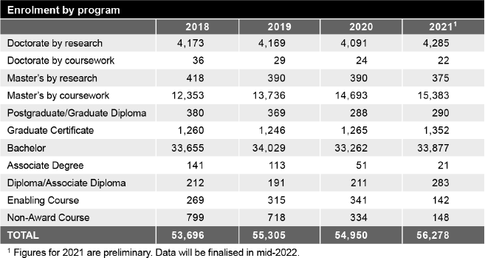

Summary
The landscape of higher education in Australia is rapidly evolving as the Commonwealth places greater emphasis on employment outcomes, national priorities, and an innovation-led approach to our future economy.
The National Innovation and Science Agenda states, 'we need to embrace new ideas in innovation and science, and harness new sources of growth to deliver the next age of economic prosperity in Australia’,* which has major implications for research and research training.
Staff will be an essential part of UQ’s success as we focus on continuing to deliver high-quality service to all members of our UQ community in coming years, and it's critical that we equip our graduates with the transferable skills that will enable them to be leaders across a range of industries.
* education.gov.au/national-innovation-and-science-agenda

Looking ahead
The University has just released its Strategic Plan 2022–2025, which articulates our mission to 'deliver for the public good through excellence in education, research and engagement with our communities and partners, local, national and global'. This reflects UQ’s core mission and highlights our commitment to delivering for the public good, and the connection between UQ and our community and partners. These will be key elements of our direction in the coming 4 years.
The coming year is likely to see the gradual shaping of a post- pandemic economy, and in this context, the University must provide leadership in education, research and innovation.
The competition for high-achieving students continues to increase, so we must also continue to adopt a student-centric focus that positions our graduates for future success. We
will need to diversify the student body, explore new pathway opportunities for international students, and provide globally competitive education and opportunities for domestic students. This will require us to keep considering factors such as location, flexible and digital delivery, and more contemporary program options that ensure our graduates are adaptable and prepared for any future possibilities in their careers.
In 2022, we will continue to improve our research systems and ensure we have a proactive strategic approach to developing partnerships. We must also ensure that, through our higher degree by research programs, we are equipping the next generation of research leaders with the innovation and research capabilities needed to satisfy Australia’s demand for highly skilled labour
and knowledge leadership. The focus on research translation and impact remains critical to our economic recovery from the pandemic, and UQ is committed to working with partners to respond to emerging economic and workforce needs and to contribute to ensuring a sustainable future for our communities.
2022 will also see our focus move to embedding Reconciliation further into the daily operations of UQ, with the goal of preparing to become a Stretch RAP organisation by 2025. Further, through our Queensland Commitment and closer engagement with regional centres – for example, through the delivery of
two end-to-end regional medical education programs – we will demonstrably expand our role as the University for Queensland.
We will continue to diversify our funding through greater philanthropic endeavours, and further develop a university operation that is agile and efficient, and which allows us to direct our resources to ensuring the continued quality of our teaching, research and global impact. Our staff have proven themselves to be dedicated, adaptable and innovative in response to
the challenges of 2021, and we will work to ensure that UQ continues to attract this calibre of talent for the future.

Key statistics

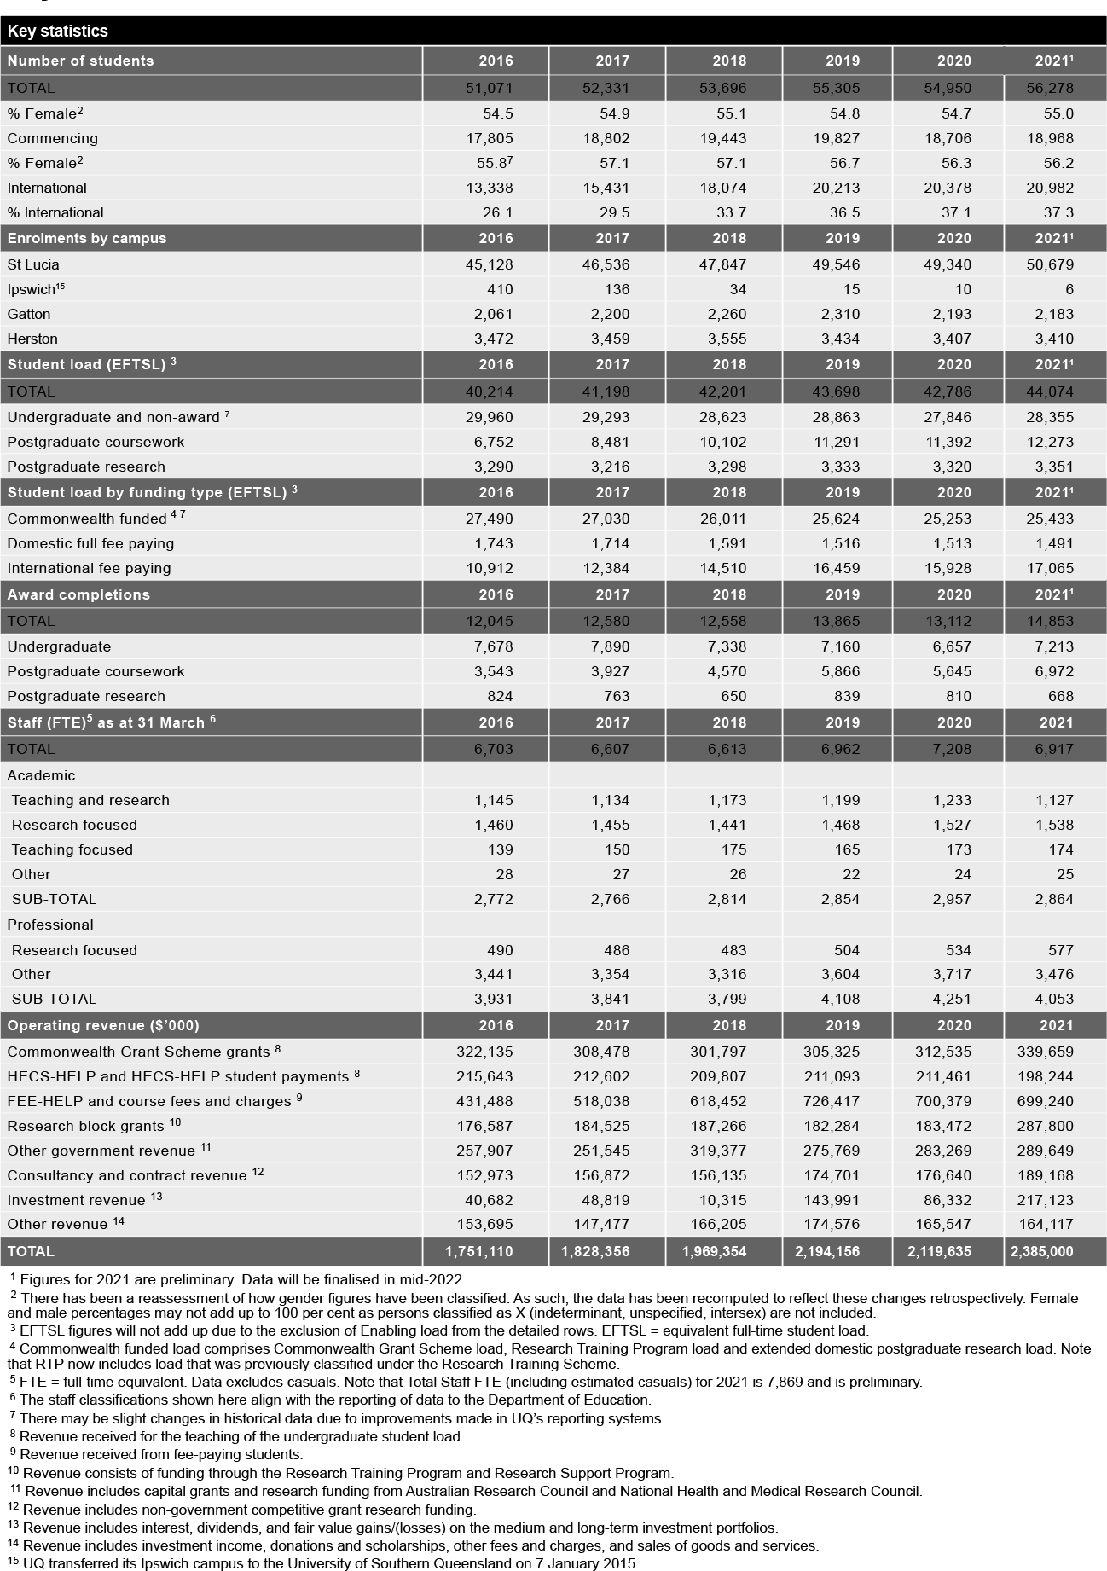

Operational performance

Government objectives for the community
The government’s objectives for the community are built around Unite and Recover – Queensland’s Economic Recovery Plan. With the underpinning principles of integrity, accountability and consultation, which are applied to carry out the activities outlined in this report, UQ contributes to the Queensland Government’s key objectives for the community:
- safeguarding our health
- supporting jobs
- backing small business
- making it for Queensland
- building Queensland
- growing our regions
- investing in skills
- backing our frontline services
- protecting the environment.

UQ contributes directly to investing in skills by ensuring Queenslanders have the skills they need to find meaningful jobs and set up pathways for the future; and both directly and indirectly – through its research and community liaison activities – to advance Queensland's other priorities.

Our objectives and performance indicators
In order to achieve our vision of knowledge leadership for a better world, we require sustained focus and a commitment to our 3 long- term objectives.
To transform students into game-changing graduates who make outstanding contributions and address complex issues with a global perspective, we will go beyond ensuring that we develop graduates who can easily gain employment. UQ’s students are motivated and highly capable: we want to develop an educational experience that maximises our students’ personal and academic development.
We will support them to become enterprising, independent thinkers with the leadership, creativity and problem-solving skills that empower them to create positive change within industry, academia, the workplace, and society more generally.
To deliver globally significant solutions to challenges by generating new knowledge and partnered innovation, we continue to expect that research will be undertaken at the highest academic standard with the highest ethical principles. UQ remains committed to both fundamental and translational research. However, we will be focusing on working with others – both internally through collaborations that cut across disciplinary and organisational boundaries, and externally through partnerships and networks. We will become a hub that brings the best expertise together to creatively solve complex problems through research and innovation. This ethos will also be reflected in our approach to teaching.
To develop a diverse community of knowledge seekers and leaders who embody a One UQ culture and use collaborative partnerships to connect and co-create, we hope to bring together different perspectives and experiences in order to find solutions to global challenges and provide an enriched learning experience. Through a One UQ culture we can create an environment that is inclusive and collaborative, to ensure that we work together in pursuit of our strategic objectives. Universities must reflect wider society – working with and for the broader community. Through collaborative external partnerships we can create the connections and networks necessary to understand the needs of industry, government and the community, and work with others to meet those needs: this applies to both our teaching and research endeavours.
To pursue these objectives, we have developed 6 strategic focus areas, or medium-term goals, to articulate where our efforts will be prioritised throughout the life of the Strategic Plan 2018–2021. This report addresses these 6 areas and provides examples of initiatives adopted to meet them.
- Transforming our student experience through a flexible, integrated and partnered learning environment
- Enhancing our high-quality research by improving our capacity to collaborate to achieve greater impact
- Building engaged and strategic partnerships with a broad range of local and global networks
- Committing to activities that attract, support and retain a diverse and inclusive community of high-achieving staff and students
- Building an agile, responsive and efficient University operation
- Diversifying our income streams and managing our resources to establish a sustainable financial base.
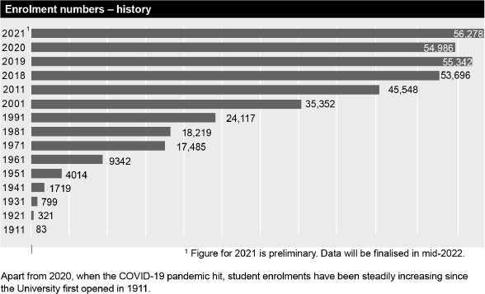

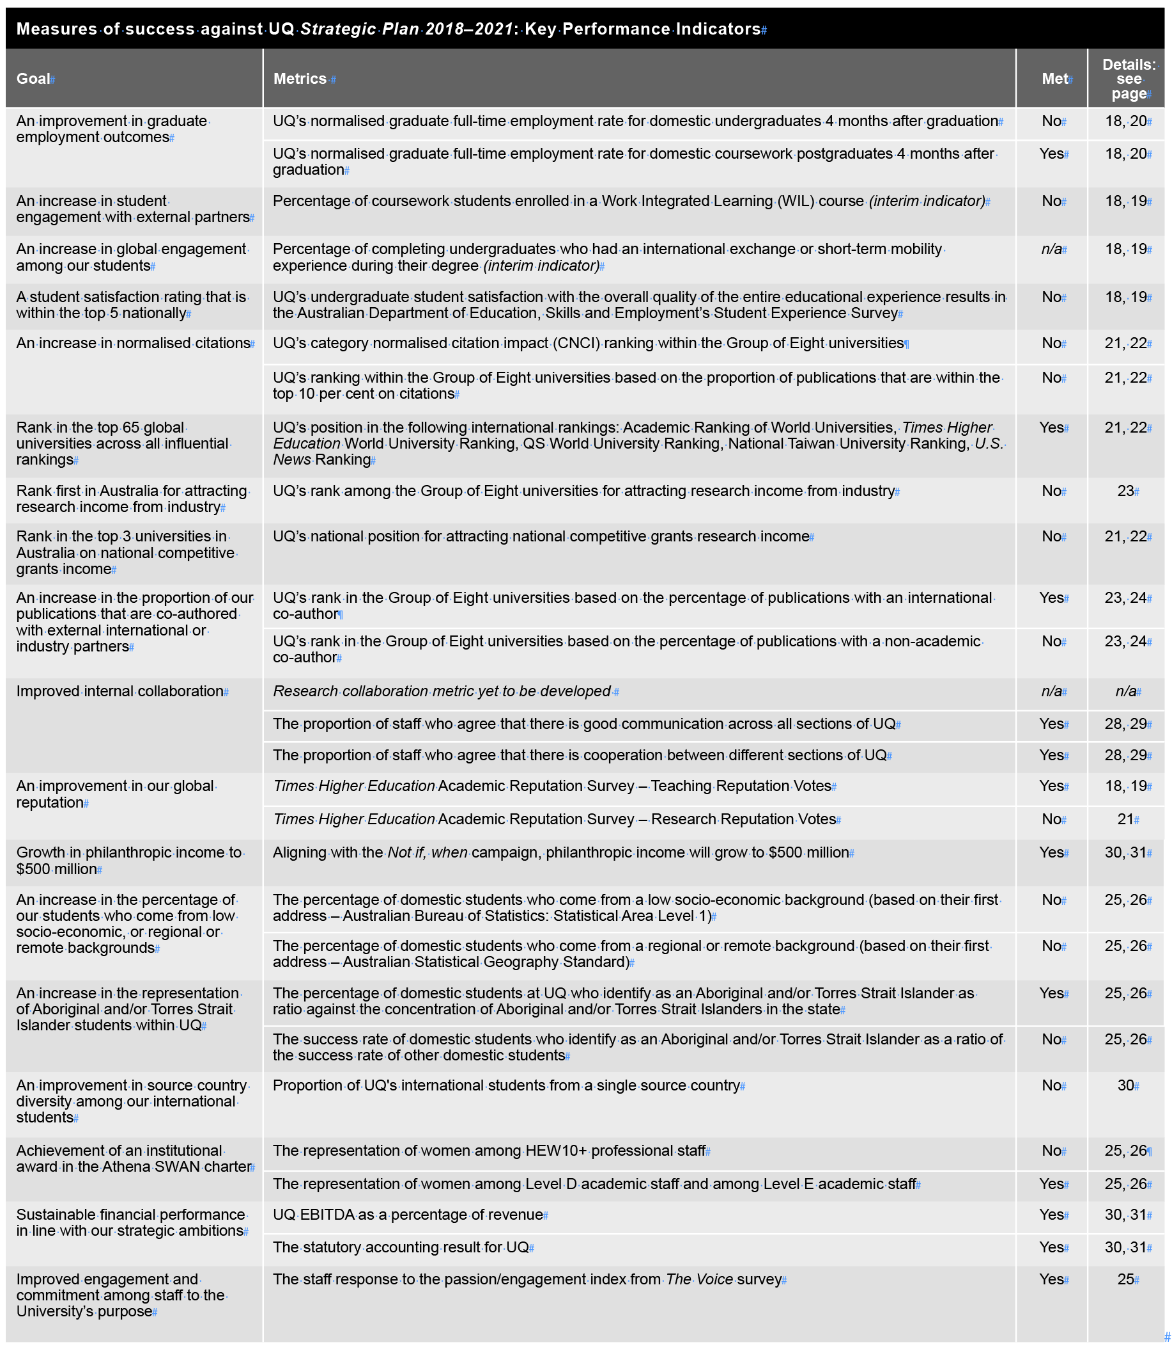

Review of activities

Transforming our student experience through a flexible, integrated and partnered learning environment
UQ is committed to the success of our students and the quality of their educational experience. We will continue to adapt to changing expectations brought about by advances in technology, increased
competition, structural reform of the workforce and economy, and impacts of the COVID-19 pandemic as we prepare our students for an unpredictable future. Shifting our Student Strategy to 'business as usual' was a key priority during the year.

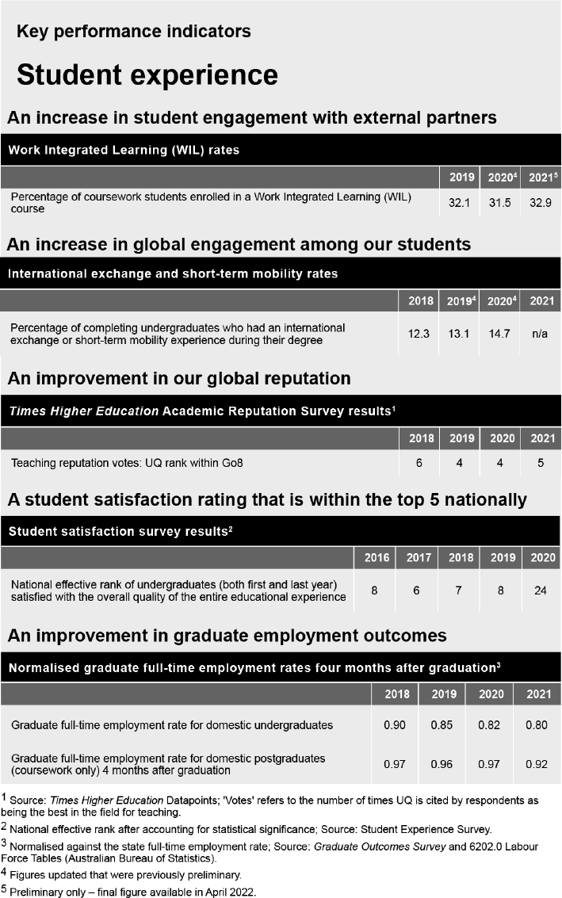

An increase in student engagement with external partners
During 2021, the Faculties continued to progress Work Integrated Learning (WIL) within their curricula. For example, the Faculty of Business, Economics and Law leveraged the recent curriculum review process to ensure that all students commencing an undergraduate program from 2021 would experience WIL opportunities during their studies. The Student Enrichment and Employability Development (SEED) team enabled the efficient management of WIL across the University, as well as the allocation of funding to students experiencing financial hardship as a result of their WIL placement costs. The importance of student engagement with external partners is highlighted by UQ’s commitment to grow the percentage of students enrolled in WIL experiences to 40 per cent by 2024 as part of the University’s response to the new National Priorities and Industry Linkages Funding (NPILF) submission.
The UQ Entrepreneurship Strategy 2018–2022 ensured that more than 260 entrepreneurial activities were offered to students through a range of programs, including through the Advanced ilab Accelerator; the Curiosity, Validate, Social Enterprise, LeadHers, Startup AdVentures, and Ventures Challenge programs; and a range of hackathon and innovation challenges.

Supporting achievements and initiatives
- The Southern Queensland Rural Health (SQRH) Extended Rural Experiences framework was established to develop immersive rural and remote training for students enrolled in nursing and allied health professional programs. During 2021, work was undertaken to support students with an identified interest in rural health in these disciplines to have access to an extended regional placement.
- The Ventures Industry Challenge, focusing on accelerating renewable energy transition, attracted 108 student participants, enabling them to work with industry-defined problems, develop their entrepreneurial capabilities, and deepen connections with UQ’s industry partners – including the UQ Dow Centre for Sustainable Engineering Innovation, Office of the Queensland Chief Scientist, St Baker Energy Innovation Fund, Aurecon and Tritium.
- Due to international border closures, students involved in the UQ Space Project Asteria had to defer the launch of Project Asteria until mid-2022.

An increase in global engagement among our students
Due to travel restrictions, global experiences were offered as virtual opportunities only in 2021, in addition to a broader range of domestic engagement opportunities. In 2021, 209 students took part in a virtual or domestic internship and 374 participated in global, virtual short- term study experiences. This total of 583 domestic and international students compares with 419 the year before.

Supporting achievements and initiatives
- The Liveris Academy welcomed its third cohort of Scholars and extended its online lecture series, featuring high-calibre international speakers, to the broader
- UQ community.
- Two Singapore virtual Startup AdVenture programs were delivered in June and November.
- A new MOOC was developed for release in July 2021 as a resource to support UQ's international students, ACE101x: Academic English, which went on to be ranked in the edX 'Year's top 100' of 2,900 new courses.

An improvement in our global reputation – teaching
The Times Higher Education Academic Reputation Survey is an opinion survey of senior, published academics asked to name up to 15 universities they believe are the best in their field for teaching. UQ's target was to improve its Group of 8 ranking by 2021 and this was achieved, improving from sixth in 2018 to fifth in 2021.

Supporting achievements and initiatives
- In February 2021, UQ topped the nation in the Australian Awards for University Teaching (AAUT) for the second year in a row with Associate Professor Jack Wang winning both the 2020 Australian University Teacher of the Year award and the Award for Teaching Excellence (Biological sciences, health and related studies).
- An Alternative Shorter Form Credentials framework and policy was launched in 2021.
- Several resources and workshops focusing on hybrid teaching were developed, and Professional Learning programs were made available to uplift teaching capabilities in the digital space.
- A joint Master of Global Environmental Futures is currently being developed through the UQ-Exeter Alliance with input from the Faculty of Science. This initiative expands the alliance and builds greater international awareness of UQ's teaching strengths.

A student satisfaction rating within the top 5 nationally
The impact of the COVID-19 pandemic on the student experience was very significant as teaching moved online and many students studied offshore due to border closures. The 2020 Student Experience survey results showed that, nationally, overall satisfaction with the educational experience dropped 10 percentage points (78 to 68 per cent) and at UQ, we saw a drop of 14 percentage points (80 to 66 per cent).
Analysis showed that universities with a concentrated on-campus delivery model were more heavily impacted than universities with well- developed online offerings – which partly explains why satisfaction among UQ students was more pronounced than elsewhere.
In 2021, the COVID-19 pandemic again caused a great deal of disruption to UQ’s educational offerings and student services. Although a range of planned initiatives could not proceed, no disruption to the delivery of teaching occurred and efforts quickly shifted to managing the uncertain circumstances arising from lockdowns, social distancing requirements and border closures.

Supporting achievements and initiatives
- Implementing the UQ Mental Health Strategy was an ongoing priority for managing student and staff wellbeing.
- New and evolving learning models and pedagogies were closely considered and applied as teaching and learning moved online. The Digital Learning Roadmap 2020–2023 assumed greater importance and featured updates to the digital literacy strategic framework as well as a revamp of the Library training course, Digital Essentials.
- In response to the pandemic, some exams transitioned to online with a proctoring service, and revised academic integrity modules became mandatory for all incoming students.
- Work continued on delivering improvements in academic integrity, supporting academic staff in the development of authentic assessment, and piloting Inspera as an option for online invigilation.
- 93 courses were digitally enhanced in 2021, through partnership with the ITaLI digital learning uplift team and School academic and learning design staff.
- The new Student Central service centre opened for business.
- Kev Carmody House, the $94.6 million student accommodation building at St Lucia, was completed and is fully booked for 2022.

An improvement in graduate employment outcomes
According to the 2021 QILT Graduate Outcomes Survey, UQ domestic undergraduates achieved a full-time employment rate of 71.4 per cent 4 months after graduation, compared with 69.2 per cent across all other universities. Three years after graduation the full-time employment rate for UQ’s domestic undergraduates was 92.3 per cent in 2021, the highest result in Queensland (Graduate Outcomes Survey – Longitudinal, 2021).
Between 2018 and 2021, UQ invested almost $12 million in employability initiatives such as Career Development Learning (CDL) and Work Integrated Learning (WIL) services through SEED. This ensured relevant experiential learning, industry connections, and other opportunities including career preparation workshops and careers fairs for more than 10,500 students, which continued in 2021.

Supporting achievements and initiatives
- The Faculty of Medicine completed the major review of its Doctor of Medicine program.
- Employability Week was held in March, which involved a series of workshops, career advice and mentoring sessions, plus networking functions.
- The Student-Staff Partnerships initiative continued to be popular, attracting 421 student partners and 317 staff partners engagements in Projects, and 150 student engagements in representation activities and other student opportunities, capturing 842 student voices.
- The Program Architecture 2 project focused on postgraduate coursework offerings in 2021 to help streamline program structures and embed more flexibility in program delivery. The Business, Economics and Law Faculty also used this opportunity to embed Career Development Learning across all master's programs, extending the work already completed at undergraduate level in earlier years.
- Enrolments in the integrated Bachelor of Engineering (Honours)/Master of Engineering continued to grow. This program incorporates a significant industry-embedded project that enables students to investigate and find solutions to authentic, real-world industry problems. Overwhelmingly positive feedback from industry partners and students confirmed the need to maintain these industry-based experiences, even as the cohort grows.

General activities enabling the transformation of our student experience through a flexible, integrated and partnered learning experience
- UQ Library continued to support online and on-campus teaching and learning, reinventing existing services and delivering new ones. Use of digital resources in 2021 was up from the previous year, with over 18 million resources accessed and 7,075,301 searches performed. Laptop loans continued to be popular, with 590 loans. Work continued on the Aboriginal and Torres Strait Islander initiatives to create a referencing guide, and a cultural audit of theses is currently underway. Six open textbooks were published, with another 15 in
development, and online modules aimed at developing students’ digital, media and information capabilities continued to be developed and are widely viewed.
- Staff and students in the School of Chemical Engineering gradually began occupying the 11-storey Andrew N. Liveris building, which provides innovative learning spaces for users.
- UQLife activities reverted from the mostly online offerings of 2020 to a mix of online and on-site weekly events, experiences and programs designed to keep students engaged. More discipline-based activities and opportunities for the UQ and broader Brisbane communities to connect were delivered. Major events included the BLOOM festival, NAIDOC Festival, the new Deadly Noize music connect, and the Ibis Film Festival.
- Several networking events were held in India and China to enhance the UQ student experience for offshore students.
- The UQ Art Museum commissioned a major Indigenous artwork with the installation of Jennifer Herd's In defence, as part of the proppaNOW exhibition held from February.
- UQ participated in the National Student Safety Survey, formerly known as the Respect. Now. Always. survey.
- The recommendations of the Review of student disciplinary policy and processes including in relation to the management of sexual misconduct complaints at The University of Queensland were fully implemented in preparation for 2022.
- A new Student Code of Conduct was released to replace the former Student Charter.
- The pilot of Inspera was completed and the Teaching and Learning Committee approved it for use as a UQ-wide eAssessment system.
- The fourth UQ Chief Student Entrepreneur was appointed in 2021.
- Twenty-three new programs were introduced in 2021 for commencement between 2021 and 2023, with another 63 discontinued and 36 restructured.
- UQ continued to invest in the delivery of Shorter Form Credentials (SFCs), primarily through MOOCs, which saw 10,605 verified enrolments in 2021 – including the course AVAXX101x: Antivaccination and vaccine hesitancy, which the Papua New Guinea government approved for broad distribution throughout its country. More broadly, the University has focused on exploring SFCs to meet the lifelong learning needs of our alumni and the community more widely, and several faculties are reviewing their offerings and the needs of industry partners to develop such offerings between 2022 and 2025.

New programs approved in 2021

Masters
Arts in Translation and Interpreting Bioinformatics
Chemical Engineering (Professional) Civil Engineering (Professional) Electrical Engineering (Professional)
Food Science and Technology Research Extensive Leadership and Innovation
Materials and Manufacturing Engineering (Professional) Mechanical Engineering (Professional)
Occupational Hygiene
Occupational Hygiene / Occupational Health and Safety Science Software Engineering (Professional)
Urban Water Engineering (Professional)

Graduate Diplomas
Agribusiness Agricultural Science
Arts in Translation and Interpreting Bioinformatics
Financial Mathematics Quantitative Biology

Graduate Certificates
Arts in Interpreting Arts in Translation
Clinical Informatics and Digital Health Conservation Biology.

Review of activities

Enhancing our high-quality research by improving our capacity to collaborate to achieve greater impact
While rightly proud of our research excellence, over the coming years we need to ensure that our research remains collaborative and continues to achieve great impact. To succeed in our focus areas of leading healthy lives, building better bioeconomies, achieving resilient environments and livelihoods, designing technology for tomorrow, and transforming societies, we will be outwardly focused, while at the same time working across disciplines internally.

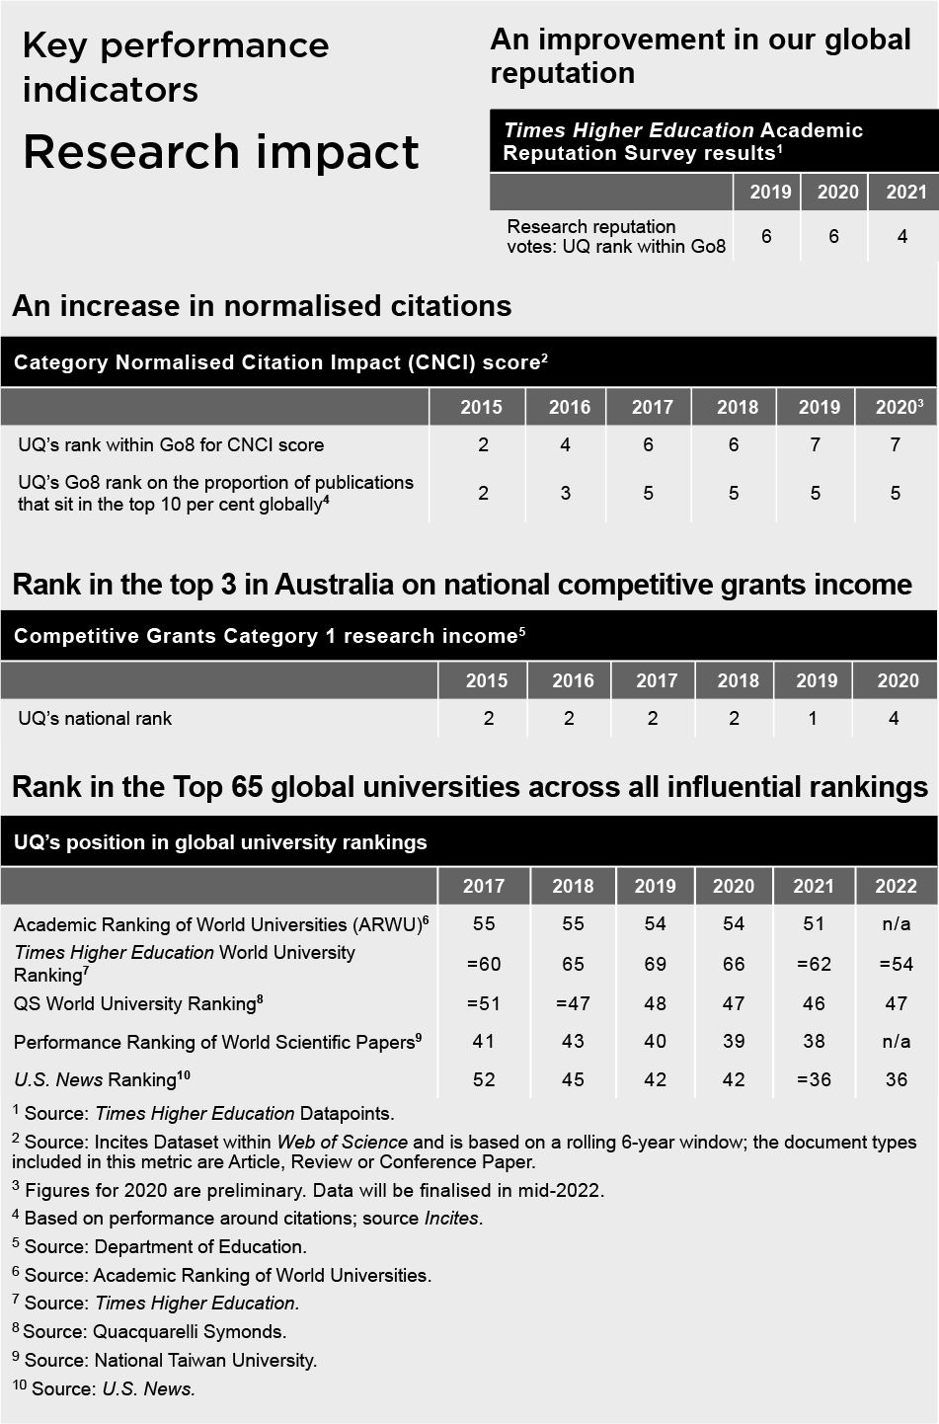

An improvement in our global reputation – research

The Times Higher Education Academic Reputation Survey is an opinion survey of published academics asked to name up to 15 universities they believe are the best in their field for research. With an overall vote improvement from 137 to 149, UQ achieved fourth position within the Go8 in 2021, up from sixth in 2019.

Supporting achievements and initiatives
- By providing quality infrastructure and support, UQ continued its long-term strategy to attract and retain leading international researchers.
Strategic research capabilities focusing on international imperatives such as food security, medical technology, defence and the environment were identified and developed, including:
  - Stryker, a global leader in medical technology, announced it would establish its first Australian R&D facility in Queensland at the Herston Health Precinct, supported by the Queensland Government, UQ and QUT.
  - The Queensland Defence Science Alliance (QDSA) was established in 2021 to focus on sovereign collaboration and innovation to accelerate defence’s capability edge. With UQ as the host organisation, it incorporates 7 Queensland universities plus industry partners, government and defence.
  - The CSIRO-UQ Food Systems and Food Value Chains initiative commenced in 2021 through the Queensland Alliance for Agrifood Innovation (QAAFI) as a collaborative research initiative to broker, design and deliver positive outcomes for Australian food system transformation.
- SMI has established relationships with United Nations Environmental Programme’s Global Sand Observatory, which will further develop UQ’s international reputation.

An increase in normalised citations
The normalised citation metric measures how many citations an institution has per publication compared with how many would be expected. UQ's score of 1.65 is well above world average and has improved substantially since 2015. Work continued during the year on collaborating, partnering and co-authoring to maintain a strong research focus and to attract and retain key influential staff.
The proportion of publications within the top 10 per cent globally remained steady at 17.7 per cent and strategies continued to focus on supporting researchers.

Supporting achievements and initiatives
- Hundreds of research stories were written and published to highlight UQ's strengths and a new Research News site launched.
- UQ received the most Highly Cited Researcher Awards in Australia (43) with 40 researchers being included on the ‘HiCi’ list for 2021, 3 of whom achieved this status in 2 subject areas: Professor Philip Hugenholtz (Microbiology, Biology and Biochemistry), Professor David L Paterson (Pharmacology and Toxicology, Immunology) and Professor Yusuke Yamauchi (Materials Science, Chemistry).
- Faculties and institutes continued to collaborate with international and industry partners to ensure research outputs align to key national and international concerns. These include proposals as diverse as Advanced Biomanufacturing Nucleic Acid through to an Australian Text Analytics Platform.
UQ Library delivered 17 Strategic scholarly publishing principles and communications workshops including:
  - 11 Career Development Framework sessions for HDR candidates with the Graduate School
  - regular staff development sessions for UQ academic and professional staff
  - sessions for participants in the Winter and Summer Research Scholar programs
  - several tailored scholarly publishing sessions for various schools, institutes and research groups. [See also 2021 UQ Honour Roll pg 8]

Rank in top 3 in Australia on national competitive grants income
With the original 2021 target of $200 million being exceeded in 2019, the University directed its focus on establishing university-wide resources and networks to improve efficiency and collaboration. UQ has traditionally been a strong performer in this measure, which includes ARC and NHMRC funding, and 2021 was no exception – despite placing in fourth position nationally.

Supporting achievements and initiatives
- The Research Management Business Transformation program continued to support projects that will deliver automated systems and improved processes to UQ researchers.
- The ethics component of the MyResearch research management system was released in January 2021, ready for full implementation in early 2022.
- Working groups were established to focus on key national research priority areas including infectious diseases, agrifood and bioeconomies, and defence and space.

Rank in the top 65 global universities across all influential rankings
UQ improved and/or maintained its standing in most major rankings tables in 2021, reflecting strong continued brand presence and campaign coverage in global markets. These are important results as they influence the choice of destination for international students, academic staff and industry partnerships.

Supporting achievements and initiatives
- Established in 2020, the Rankings Strategy Steering Group continued to support UQ's aspiration to remain a top-ranking global university, using a whole-of-university approach to showcase UQ's capabilities.
- UQ became a partner in the Times Higher Education Campus Plus clearinghouse for scholarship in tracking.

General activities enabling the enhancement of our high-quality research by improving our capacity to collaborate to achieve greater impact
- UQ was, once again, the leading Australian university on the 2 key commercialisation metrics: amount of commercialisation revenue and value of the equity held in active startup companies: these metrics were considered as part of the 2021 Survey of Commercialisation Outcomes from Public Research (SCOPR) survey based on 2020 data.
- JKTech continued in its role as technology transfer company for UQ's Sustainable Minerals Institute.
- Research and Innovation Week 2021 included the Three Minute Thesis competition (online) and refreshed UQ Partnerships and Translation Awards.
- Emphasis remained on investing in national fellowship schemes, training programs and major grant schemes to attract and retain quality researchers.
- The Impact Tracker software was used to facilitate institutional reporting of research impact and support the Engagement and Impact 2024 submission.
- The UQ Aboriginal and Torres Strait Islander Research and Innovation Strategy was launched with a vision to leverage research as a tool of empowerment for Aboriginal and Torres Strait Islander peoples, communities and organisations.

Review of activities

Building engaged and strategic partnerships with a broad range of local and global networks
Engaging and collaborating with the community, industry, government and other research innovators is critical to UQ’s capacity to meet the rapidly changing needs of society. We aim to enhance our approach to external engagement with a partnership framework, customer relationship management system, deeper international connections, diverse income sources and ongoing commercialisation interests.

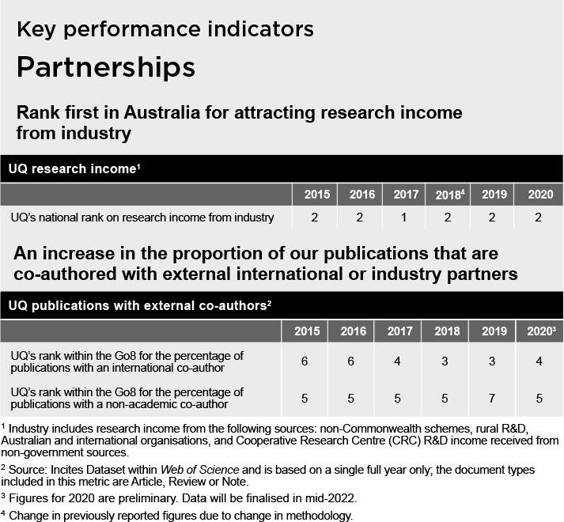

Rank first in Australia for attracting research income from industry
In 2020, UQ received $144 million in research income from industry, and remains one of the country's most consistently strong achievers in the sector.

Supporting achievements and initiatives
- UQ continued to build and strengthen its research collaborations with industry partners, including a new Memorandum of Understanding with Infosys and a research agreement with Stanwell.
- Sector-focused partnerships at scale were explored, with current ones with Stanwell, IBM, CBA, Oracle, ALS Siemens, and New Leaf being strengthened.
- Beyond our involvement in established industries, UQ is positioning to be a key partner for emerging manufacturing fields.
- Formal agreements with national research agencies were put in place, particularly with CSIRO, Queensland Government, and the Defence Science and Technology Alliance.
- Opportunities to boost the Centre for Water in the Minerals Industry were also identified.
- The Global Change Institute (GCI)established Research Networks focusing on digital health, next-generation workplaces and protected cropping, and facilitated multiple Collaborative Research Initiatives (CRIs) designed to help address global challenges.

An increase in the proportion of our publications that are co-authored with external international or industry partners
UQ's target to be ranked within the top 4 in the Go8 for the percentage of publications with an external international co-author was achieved.
From 2016 to October 2021, UQ's international co-publications proportion increased from 53 to 63.6 per cent, reflecting the University's growing emphasis on global partnering. This indicator is sourced from InCites and is based on the proportion of an institution’s publications that have an international co-author – including articles and reviews. The most recent complete year for publication data is 2020.
For the proportion of publications co-authored with external international industry partners, this increased from 41.9 per cent in 2016 to 43 per cent in 2021, moving UQ to fifth position in the Go8.* 1

Supporting achievements and initiatives
- Flagship partnerships with University of Exeter, IIT Delhi and Technical University Munich were nurtured, with significant increases in co-publication numbers.
- A UQ Global Development Impact Plan was launched to bring together the diverse range of development expertise and connections, allowing UQ to actively use its expertise to solve some of the world’s critical development challenges; and UQ was involved in a successful partnership bid with Deloitte to provide a 4-year Pacific Justice Program.
- The Graduate School provided strategic HDR scholarships to boost connectivity with industry, offering industry-relevant projects that would build networks and increase collaboration. This aligns with national priorities to ensure graduates have direct experience with industry during their higher degree enrolment.
- Key research training was conducted for HDR candidates through the Career Development Framework that saw 103 topics offered in 177 workshop sessions for 7,579 attendees.
- The 3MT competition continued to grow globally – now being held in 900 universities across more than 85 countries worldwide – and attracted 340 PhD students in 2021 at UQ alone.

General activities enabling the building of engaged and strategic partnerships with a broad range of local and global networks
- UQ's global connectedness continued to expand through a suite of agreements, partnerships and funding schemes, including with IIT- Delhi and the University of Exeter, along with the hosting of online workshops and webinars.
- The IBM@UQ Centre of Excellence became fully established in 2021, developing training materials and other support strategies for researchers in the health, manufacturing and environmental sciences on how to deal with the challenges of storing and accessing vast amounts of information.
- UQ continues to invest in research, particularly through the new Knowledge Exchange and Translation (Kx&T) internal funding scheme for early-career researchers.
- The implementation of a new CRM and marketing automation platform commenced, to support student recruitment efforts.
- SMI and the Graduate School developed a standard HDR Student and Industry Collaborative Research Agreement to make it easier for industry stakeholders to work with UQ. Standardised Research Service Agreements were also developed to protect intellectual property and to improve the responsiveness of UQ when working with potential industry partners.
- Several faculties are working with the Research and Innovation portfolio to nurture major partnerships, particularly through the use of business development managers.
- Relationship managers were appointed to build strategic partnerships with key partner schools.

* Data sourced from InCites. Dataset updated November 2021. Includes Web of Science content indexed through 31 October 2021. The filter ‘Organisation type’ excludes Academic and Academic System.

Review of activities

Committing to activities that attract, support and retain a diverse and inclusive community of high- achieving staff and students
UQ owes its growing global reputation and successes to the strengths and achievements of all staff and students: attracting people from a broad mix of backgrounds ensures a wide variety of perspectives and experiences. In 2021, UQ continued to address the barriers facing women in academia, people from culturally and linguistically diverse backgrounds, Aboriginal and Torres Strait Islander peoples, people with disability, members of the LGBTIAQ+ community, and students from disadvantaged and remote backgrounds.
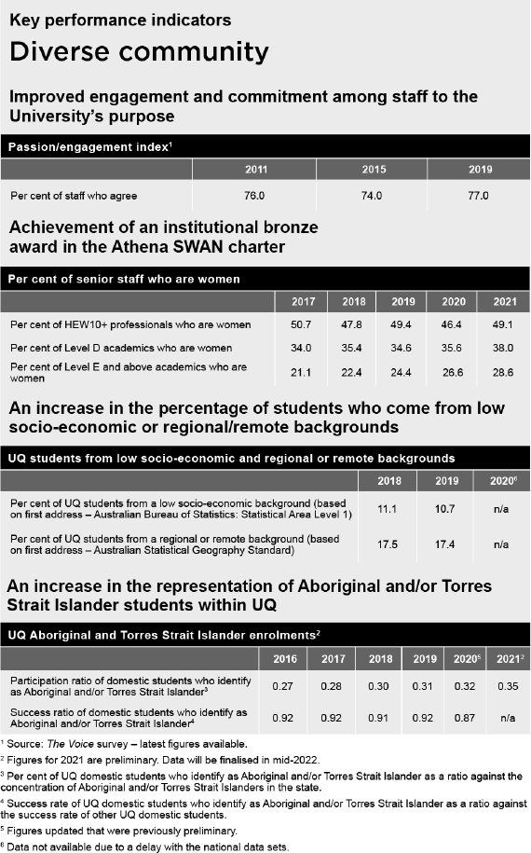

Improved engagement and commitment among staff to the University's purpose
During 2021, a new ‘Pulse Check’ survey was developed, which will be used to gain regular staff feedback and embed a strong, values-led culture. Seventy-three per cent of UQ staff responded positively on their intention to stay, 71 per cent recommended UQ as a great place to work, and 74 per cent were satisfied overall with their job.
Additionally, 74 per cent responded that UQ demonstrated a genuine commitment to diversity and inclusion, 68 per cent felt their team enacted the UQ values, and 73 per cent experienced an inclusive culture. As well, 76 per cent of respondents felt they were kept informed on happenings at UQ, 80 per cent felt supported by their direct supervisor, and 73 per cent felt changes to the way UQ operates associated with COVID-19 were managed well.

Supporting achievements and initiatives
- The People, Planning, Performance (P3) Project framework became formally entrenched in the new Workday HR program, to support better and more effective performance conversations across the University.
- Virtual and face-to-face delivery of cultural competency training continued throughout the year.
- In 2021, 90 Higher Education Academy (HEA) Fellowships were awarded to professional and academic UQ staff.
- From more than 420 nominations, staff excellence awards and commendations were bestowed upon 112 staff at a ceremony in October.

Related performance indicators:
2021 Honour roll page 8
2021 Staff excellence awards page 34

Achievement of an institutional Bronze Award in the Athena SWAN charter
Women now comprise 56 per cent of UQ's workforce but are under-represented in senior academic positions. The University is, however, making gradual progress towards gender parity, with the number of female academics in very senior roles slowly increasing.
In 2020, UQ achieved its 25 per cent target of women among Level E and above academics and in 2021, the rate was 28.6 per cent. The target of 38 per cent representation of women among Level D academics was achieved in 2021, a significant increase over the 2016 figure of 34.4 per cent.
UQ has hovered around the 50 per cent target of women represented at HEW 10+ professional staff for some years, and in 2021 reached 49 per cent – largely due to lower representation in central administrative roles.
UQ received an institutional Bronze Award in the Athena SWAN charter in 2019 and is currently working towards silver accreditation for 2024.

Supporting achievements and initiatives
- The UQ Amplify and Amplify Women's Academic Research Equity (AWARE) programs proactively supported the recruitment, retention and career development of early- and mid-career research fellows through fixed-term contracts and lessening the impact of parental leave.
- The confidence-building Ventures LeadHers program for female-identifying students, staff and alumni across all disciplines at UQ saw 683 attendees in 2021.
- Two guides were developed to address mechanisms to improve pay equity.
- Strategic plans for Disability Inclusion, Ally Action, Gender Pay Equity, Gender Inclusion, and Cultural Inclusion were developed, and governance frameworks were reviewed in a number of areas (Science, QAAFI, AIBN) to ensure equity, diversity and inclusion practices were embedded in their operations.

An increase in the percentage of students who come from low socio-economic or regional/remote backgrounds
UQ is committed to improving opportunities available to students from low socio-economic, disadvantaged, and regional/remote backgrounds. The most recent data shows that in 2019, 10.7 per cent of UQ students came from low socio-economic backgrounds, only slightly below the target of 11 per cent. Although striving to increase the proportion of regional/remote students to 19 per cent, in 2019,
17.4 per cent of the UQ student population was from these locations.

Supporting achievements and initiatives
- The Young Achievers Program – a scholarship and learning opportunities scheme for secondary school students in low SES/regional/ remote communities – celebrated its 13th year of operation and welcomed its 225th graduate from UQ in December 2021.
- A 2-rank adjustment for a range of programs was added to the entry scores of applicants from regional and remote areas.
- Two new Regional Medical Pathway programs were launched to facilitate the training of doctors in the Wide Bay/Central Queensland and Darling Downs/South West Queensland. These new programs will increase students’ access to end-to-end medical training within their own communities.
- Improved access to extended regional placements was also intruduced across a range of allied health programs.
- Increased online program delivery enabled students to have more flexibility for paid employment.
- UQ's outreach engagement program continued to grow, supporting low socio-economic and regional/remote cohorts through the Queensland Widening Participation Consortium.
- Philanthropic funds raised for scholarships increased from $8.7 million in 2020 to $9.4 million in 2021, enabling equity-based distribution of scholarships to more students than in previous years.

An increase in the representation of Aboriginal and/or Torres Strait Islander students within UQ
The participation ratio divides the participation rate of Aboriginal and/or Torres Strait Islander students at UQ by the concentration of Aboriginal and/or Torres Strait Islander persons within the state: a figure of 1 would therefore denote parity. Currently aiming for 0.35, UQ has been steadily increasing its participation rate – from 0.27 in 2016 to 0.35 in 2021.
The success rate goal is for Aboriginal and Torres Strait Islander students to be on par (1.0) with other UQ domestic students. In 2020, it was 0.87, a slight drop over the past few years.

Supporting achievements and initiatives
- UQ's Reconciliation Action Plan continued to provide a framework for Indigenous engagement across the University, and a RAP Network was established to share ideas and to begin preparation of the 2023 Reconciliation Action Plan.
- The Aboriginal and Torres Strait Islander Studies Unit continued to provide a range of opportunities including special entry schemes, scholarships and the InspireU program – although camps were still not held during the year due to COVID-19.
- NAIDOC Week festivities were held across the University with the theme of Heal Country, heal our nation.
- Indigenising the curriculum was a focus in a number of faculties, with the establishment of working parties and curriculum-mapping exercises.
- The Graduate School provided a dedicated staff member to deliver a program of retention and mentoring for Indigenous HDR students; and the Research Office Ethics and Integrity unit appointed dedicated staff to support Indigenous researchers and Indigenous-led research.
- Employment strategies to encourage more representation of Aboriginal and Torres Strait Islander people among UQ staff were implemented.
- A framework for Aboriginal and Torres Strait Islander design at The University of Queensland was finalised.

General activities enabling the commitment to activities that attract, support and retain a diverse and inclusive community of high-achieving staff and students
- A Tertiary Transition Toolbox was launched in 2021 to ease the transition to university for students diagnosed with Autism Spectrum Disorder.
- A range of measures to support Culturally and Linguistically Diverse students became available throughout the year.
- The 2020 UQ Awards for Excellence in Teaching and Learning were announced in March (see page 11), followed by the 2021 Awards in November.
- The Liveris Academy for Innovation and Leadership officially opened in the new Andew N. Liveris building.
- Work continued on the development of the Alumni Court restaurant and events venue as well as the UQ Amphitheatre project at St Lucia.
- UQ College and the Institute of Continuing and TESOL Education officially merged under new UQ College branding with a focus on enhancing the student experience and streamlining access to pathways into UQ. In doing so, UQ College will become the globally renowned pathway provider for UQ, building on years of teaching and learning experience.
- Several Regional Roadshows were conducted to celebrate the impact of UQ students, alumni and partners on their communities, and to consider options for UQ to have greater impact in regional Queensland in the future.

Review of activities

Building an agile, responsive and efficient university operation
UQ is committed to ensuring that our operations and professional services are responsive to the needs of the University, built on a One UQ approach that drives service improvements and creates efficiencies – particularly in the student
administration area. Streamlining and automating business processes, and building professional, advisory and technical skills in our workforce are key priorities.

Improved internal collaboration
A new 'Pulse Check' survey was developed and launched in 2021. It will be used for obtaining regular feedback from staff about their perceptions of UQ, and to embed a strong, values-led culture. In 2021, 76 per cent of respondents felt they were kept informed on happenings at UQ,

Supporting achievements and initiatives
- Further enhancements to the People, Planning, Performance (P3) dashboard provided academic staff with the opportunity to refer to their individual academic profiles in performance appraisals and similar conversations, and to boost their research networks.
- The strong emphasis on collaborative networks across the University continued to underpin research and teaching frameworks, as demonstrated by the Students as Partners, Program Architecture, and UQ2U projects.
- UQ's Learning Analytics team reinforced the usefulness of the Course Insights dashboard to improve the learner experience and communication between staff and students. The early interventions support initiative used data from the course analytics to identify 'at risk' students, and individual students were then contacted to discuss their progress and need for additional support.
- Staff development and learning was supported by the proactive workflow implemented within the new human capital management system, Workday. This will provide all staff with a more systematic approach to ensure an understanding of the University’s values and how these may be enacted in their own workplace.

- UQ Industry Connect continued to create a pathway for strategic industry-UQ partnerships by ensuring that industry has access to a simple, coordinated entry point for interacting with UQ expertise and infrastructure.
- UQ's new streamlined process for infrastructure investment directed funds more easily into opportunities for cooperation, collegial endeavours and connectivity across UQ's research community.
- Through improved stakeholder engagement initiatives, several research institutes collaborated with the Graduate School to enhance the HDR student experience through development activities, seminars, and increased industry connectivity.

General activities enabling the building of an agile, responsive and efficient university operation
- Work continued on a research infrastructure management system to create efficiencies in the use of research facilities.
- A university-wide approach to clinical trials management was developed by the Research and Innovation portfolio in conjunction with Governance and Risk. The review will enable improved institution-wide monitoring and compliance.
- IT Governance continued to ensure compliance with relevant legislation and best practice, developing and implementing policy and frameworks to effectively manage risk within the University’s virtual environment.
- In 2020, Workday was selected as the new Human Capital Management Solution and went live in October 2021. It promises to provide simplified and automated business processing and authorisations, better quality data, and consistent access to career and personnel information.
- An IT Capital Investment Plan included projects and programs delivered in 2021 in support of innovation in teaching and learning, enhanced research capability, streamlining of administrative and professional services, as well as coordinated domestic and international community engagement.
- The Academic Services Division Business Enhancement team developed an automated solution that captures and records student completion of the mandatory Academic Integrity Modules (AIM), and, where necessary, enforces the mandate through automated temporary blocking and releasing of grades and/or future enrolment.
- A new UQMaps app was launched in 2021 to support students on campus. The app provides directions to any location on campus as well as live insights into parking, study space and lab availability, with further enhancements to be added progressively.
- $60 million was set aside from the 2021–2024 program of works for replacing external cladding on UQ buildings deemed potentially hazardous.
- A feasibility study is currently ongoing to establish a Sustainable Future precinct at Long Pocket.

Review of activities

Diversifying our income streams and managing our resources to establish a sustainable financial base
Competing in a world market where government funding is declining in relative terms, UQ needs to achieve a more sustainable financial base to pursue our strategic agenda. We are doing this by carefully considering all expenditure before outlay, increasing non-government research funding from industry and international sources, boosting income from philanthropy, and improving our management of costs with a stable financial budget.
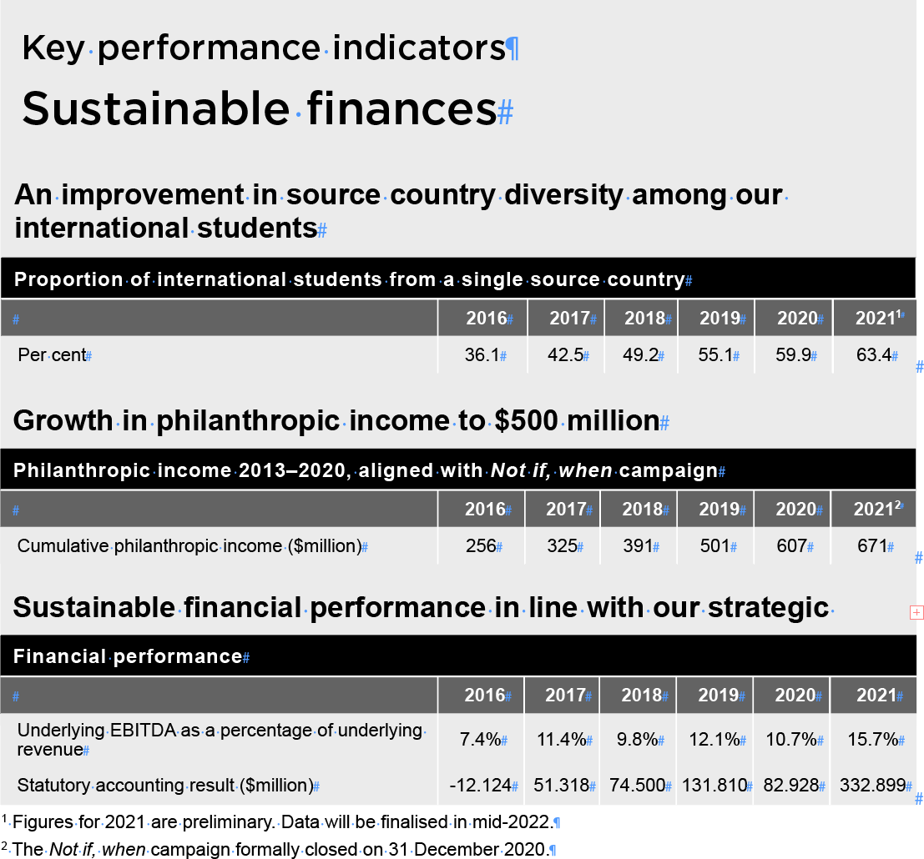

An improvement in source country diversity among our international students
This remains a key priority for the University, but it was a priority that was difficult to pursue during the COVID-19 pandemic because of closed international borders and the significant impacts of the pandemic on many of the University’s traditional markets. In 2021, 63.4 per cent of our international student body was from China.

Supporting achievements and initiatives
- The 3-year Lead Acquisition for Diversity strategy continued, using targeted digital campaigns to raise brand awareness of UQ and its programs – in particular, the profiling of UQ’s thought leadership strengths and research outcomes.
- Operations were realigned to have a sharper focus on diversity markets, with tiered prioritisation across the Future Students portfolio.
- The digital uplift of marketing and communication capabilities (centralised collaboration and planning tool, and digital asset management platform) continued, with business process reengineering to support new technology rollout to the marketing and communication teams.
- UQ's global profile was elevated by 23 international tailored marketing campaigns in key markets, including the launch of UQ’s first Vietnam campaign. The focus of these campaigns was to build brand awareness, generate leads and support conversion.
- Updates to country recruitment plans are currently underway to further integrate multiple-channel partners, e.g. articulation partners and sponsors.
- To support diversity, the India-based recruitment team continued its work to expand UQ’s engagement with key channel partners in target regions across India. In 2021, their efforts focused on campaigns to counter students’ resistance to online learning. The team also launched UQ’s QLabs, a 7-month entrepreneurial education program involving 50 schools across India, the Thinking Schools Initiative with Humanities and Social Sciences involving 20 schools, an Engineering Design Challenge involving 12 institutions, and they progressed articulation partnerships – both new and existing – to create ongoing student pathways for BEL, EAIT and Science.
- An expanded range of UQ scholarships on offer saw 848 international students from 35 different countries being awarded during 2021. An additional 786 international students from 61 countries were awarded scholarships for external providers to study at UQ in 2021.
- The expanded Enabling Partners Scheme was launched in India, Indonesia, Vietnam, Malaysia, Thailand, Taiwan and Singapore in 2021.

- Due to the pandemic, online webinars were delivered to amplify international high school and institutional partner engagement in key markets, with outbound call campaigns to ensure current students felt supported and did not withdraw from studies.
- Global Engagement managed sponsored students from 74 countries in 2021, welcoming students from countries that had not been enrolled in 2020, such as Argentina, Egypt, French Polynesia, Islamic Republic of Iran, Norway, Paraguay, Republic of Korea, Seychelles, Spain and Zimbabwe.
- A new customer relationship management and marketing automation solution (UQEngage) was implemented, which will significantly uplift the customer experience of individuals interested in studying at UQ and greatly enhance UQ’s ability to connect with those individuals and progress them towards enrolment.

Growth in philanthropic income to $500 million
By the end of 2019, UQ had achieved its fundraising target of '$500 million by 2020' – with donations from individuals, corporates, foundations and other organisations – for teaching and learning, research, infrastructure, student experience, and other initiatives. 2020 saw a record $106 million donated, while 2021 saw a further $64 million raised.

Supporting achievements and initiatives
- UQ's third annual Giving Day was held in October, raising more than $2.19 million through the generosity of 1,778 donors, 40 per cent of whom gave to UQ for the first time.
- In 2021, UQ engaged with almost 43,000 global alumni through the ChangeMakers alumni program that continued to deliver mentoring and volunteering opportunities as well as a range of information and networking events.

Sustainable financial performance in line with our strategic ambitions
The normalised EBITDA (before investment revenue) as a percentage of normalised revenue exceeded the target KPI of 10 per cent.

See also, Summary of financial information pg 44 Supporting achievements and initiatives
- UQ’s national market share of international commencements grew by 1.8 percentage points to 7.4 per cent in 2021, and UQ’s Go8 market share of international commencements grew by 1.4 percentage points to 14.8 per cent in 2021. UQ also achieved growth in the number of commencing domestic students – both at undergraduate and postgraduate coursework levels.
- Academic and professional staff salary costs were reduced following the 2020 Voluntary Separation Scheme; and savings were made because of fewer staff travelling due to COVID-related travel and activity restrictions.
- $99.5 million additional Research Support Program funding was received as part of the Commonwealth Government's COVID budget response, and the University sought to leverage strategic Government financial support for the development of new agrifood and biomanufacturing industries to strengthen the Australian economic recovery post-pandemic.
- Changes to internal policies and procedures governing the management of consultancy and research projects improved our capacity to build stronger external partnerships and grow industry income.
- The rollout of commercially orientated professional development and training programs was fast-tracked to offer more options for, and to attract, future students. This included stackable pathways toward postgraduate qualifications to support the provision of lifelong learning opportunities.
- UQ retained its focus on diversifying and reinforcing international student markets through applying the Enabling Partnerships Scholarship Program and the 12.5 per cent Offshore Study Rebate.

General activities enabling the diversification of our income streams and management of our resources to establish a sustainable financial base
- In 2021, UQ received over $57 million in international funding from more than 300 funding partners in 42 countries, including the US, Norway, China, Japan, Switzerland, UK, Canada, Germany, New Zealand and Denmark.
- UQ continued to explore sector-focused partnerships at scale with several large organisations including GRDC, Bureau of Meteorology, Moderna, Stryker and CSIRO.
- Thanks to philanthropic funding, the UQ Art Museum was able to build the collection, enhance student experience through internships and specialised training, and appoint two key positions in Education and Research.
- UQ’s Sustainability Strategy was developed and approved by Senate.
- A proposal for a university-wide approach to new program development was accepted and work began on governance and pricing structures to support this being implemented throughout 2022.
- UQRes operators were established to manage UQ-owned student accommodation assets.

Summary of

Human resources
The Human Resources (HR) division is central to driving UQ's values and culture. By attracting high-quality staff and supporting them in diverse, inclusive, welcoming, safe and progressive workplaces, we create teams that are creative and impactful, with a foundation of integrity and respect, in the pursuit of knowledge leadership for a better world. HR delivers key services in talent acquisition and onboarding, role clarity, staff engagement, learning, recognition, support for personal growth, and career development.

HR overview

New operating model
In 2021, HR underwent a transformation of its target operating model in preparation for the implementation of a Human Capital Management Solution (HCMS), Workday. This created better alignment with the intended strategic direction and service offerings of the HR function. New focus areas included rewards and recognition, culture and capability, a centralised HR advisory support function, AskHR, and a specialist centre focused on HR’s ongoing transformation and internal capability development.

HR Client Partnering
The HR Client Partnering team provides timely advice and guidance to academic and professional staff, including direction on the application and obligations of UQ’s enterprise agreement, policies, procedures and systems. The team also advises on workplace culture, team management, employment-related regulations and case law. The team supports many of UQ’s talent assessment and promotion processes, and advises on complex and sensitive matters of performance and behaviour. Finally, the team provides practical support in the area of organisational change, including structural change and role design.
The past year was a demanding one for the team, supporting multiple change initiatives and dealing with the COVID-19 pandemic.

Organisational Culture and Capability
This specialist centre offers services and expertise in the areas of talent, learning, development, and diversity and inclusion, which includes the delivery of diversity and inclusion programs and pathways, staff development program coordination and delivery, academic development and progression, talent and career development, leadership capacity- building, organisational culture assessment and consultation, change management, and coordination of multiple strategic committees.

Rewards and Workplace Relations
This function is responsible for the management of all employee relations matters, assuming responsibility for enterprise bargaining, policies and procedures, and the management of grievances. Within the team, the global mobility function assumes responsibility for the management of visa and migration arrangements for all employees and visitors to the University. This team also administers the engagement of the adjuncts, academic title holders and unpaid resources who provide assistance for learning activities.

Organisational Effectiveness
Organisational Effectiveness is an in-house HR specialist service focused on complex and cross-divisional strategic projects, inclusive of strategic planning, operational model design, organisational structure design and workforce planning. In 2021, the focus included the School Leadership Capability and Development project, 3 enterprise-level function reviews, and the COO portfolio strategic planning process.

HR Governance, Transformation and Strategy

Governance, Transformation and Strategy section is responsible for managing HR’s ongoing transformation, internal deployment and lateral career moves across HR, HR analytics, and the maturity of the AskHR function.

People Services
People Services comprises 4 core teams: Talent Acquisition, Employee Services, Payroll and Benefits, and HCMS Support. Focused on the attraction, acquiring, onboarding and payment of talent for the University, People Services administers a range of HR-related transactional changes throughout the employee lifecycle including payroll and legislative compliance through the use of advanced technology, which the teams maintain and enhance on an ongoing basis.

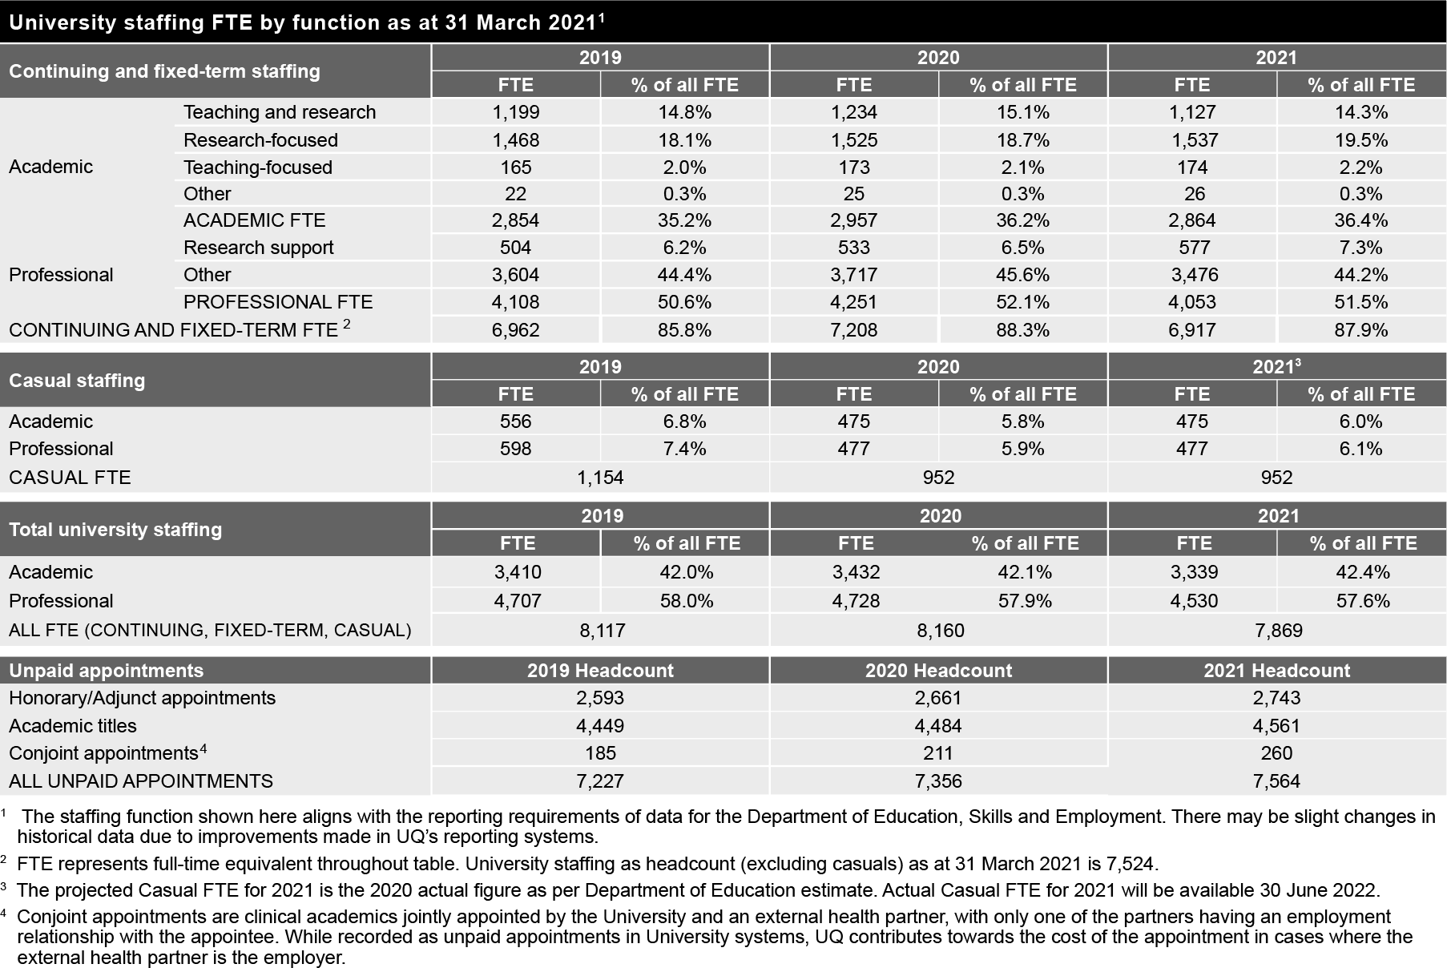

University staff

Recruitment and selection
From 1 January to 31 December 2021, UQ externally advertised close to 2,000 jobs and placed 650+ academic and 1,700+ professional staff positions, along with an additional 1,500 direct appointments. The University received more than 52,000 applications. The primary medium for recruitment was the UQ Careers e-recruitment website, with several externally hosted recruitment websites also used extensively.
From 31 March 2020 to 31 March 2021, the University’s continuing and fixed-term workforce increased to 7,524 FTE, with a retention rate of 96.48 per cent and a separation rate of 3.52 per cent for 'continuing' staff members in 2021.
All new recruits were invited to attend a formal induction program in addition to on-the-job orientation.
Inclusive workplace strategies such as the Aboriginal and Torres Strait Islander Employment Strategy were once again widely promoted by Human Resources.
The table above shows University staff numbers as at 31 March 2021.

Academic promotions
During the year, 179 academic staff members were promoted, comprising 36 promotions to Level B, 69 to Level C, 54 to Level D and 20 to Level E.

Staff support
UQ's Workplace Psychologist continued to provide general assistance, referrals and case management support to staff members with, or at risk of having, mental health issues; and the Employee Assistance Program (provided by Best You by Benestar) offered counselling as required.
Use of the service increased between 2020 and 2021.

UQ Mental Health Strategy
The delivery and implementation of the UQ Mental Health Strategy (2018–2020) action plan for staff continued until July 2021, to consolidate the range of activities introduced from 2018 – such as awareness events, staff development sessions, and a range of online support material.

Organisational and leadership development
In line with UQ’s Strategic Plan 2018–2021, a strong focus continued to be placed on supporting staff development activities. Despite the ongoing resourcing and logistical impacts of the COVID-19 pandemic on the delivery of the Staff Development program, 64,146
learning instances took place. This comprised 1,781 instructor-led (face-to-face) completions and 62,365 digital course completions. There continues to be a strong appetite for mental health first aid, leadership, and diversity-related programs such as the UQ Ally training, all of which were strongly attended.
Several leadership programs for managers and supervisors were offered across the institution, including the popular Career progression for women and Career advancement for senior academic women programs, which continued to help women gain promotion.
Significant support was also provided to teams across the University to facilitate strategic planning sessions, promote team culture development, and support organisational change.

Annual performance and development
In 2021, the refreshed Annual and Performance and Development (APD) process was launched to all academic, professional and executive staff across the University. The aim of refreshing the APD process was to move away from a process that predominantly reflects on the past and past achievements, to a process that focuses on the future and individualised goals that will support each person on
their development journey. The launch of the refreshed APD process in 2021 was the culmination of extensive consultation, design, and engagement across a 2-year period to develop an impactful process for all staff cohorts.
To support the launch of APD, the HR Organisational Culture and Capability team led 59 hours of engagement sessions, reaching approximately 2,164 people across 48 separate engagement sessions.
The refreshed APD process will continue to be implemented throughout 2022 with additional learning being designed and delivered, with the aim of supporting our people to effectively lean into or lead this process.

Workplace relations
The newly established Rewards and Workplace Relations team provided strategic advice, representation and advocacy throughout 2021 on matters relating to organisational change and restructuring, business transfers, disputes, performance, compensation and
conduct. The team also commenced negotiations for a new enterprise agreement, to replace the 2018–2021 one, while also conducting a comprehensive external payroll review.
The global mobility function continues to provide immigration support in a rapidly changing international environment, requiring adaption to traditional processes associated with immigration. During 2021, the policy function concluded a comprehensive review of University policies affected by the implementation of Workday.
The team will be actively involved with the implementation of the recent requirements linked to the COVID-19 vaccination.

UQ Awards for Excellence
For 7 consecutive years, the University has hosted an annual UQ Awards for Excellence program, with nominations remaining strong each year. In 2021, 113 individual and team nominations were received for more than 420 staff, and a new category of Reconciliation was introduced. Across the 6 categories, 112 staff members received an award or commendation (7 team and 6 individual winners, 6 team and
8 individual commendations). By acknowledging and celebrating the achievements and behaviours of staff across all levels of the University, regardless of position, the Awards reflect and support UQ's values.

2021 UQ Awards for Excellence winners

Innovation
Associate Professor Tim Kastelle Learning through COVID-19 engagement and impact team

Service
HASS PA2 team
UQ International Development team

Community, Diversity and Inclusion

Dr Terrance Fitzsimmons Professor Mary Fletcher
LeadHers (UQ Ventures) team

Mental and Physical Health, Safety and Wellness
Dr Chris Lilburne
BEL Wellbeing Academic Group team

Leadership
Professor Linda Hwee-Lin Lua PRME Team
Reconciliation Mia Strasek-Barker UQ Life team

AskHR
AskHR was established in 2020 specifically in response to the COVID pandemic and has since evolved in 2021 to now be the first point
of contact for all HR enquiries. The centralised Service Delivery Model has enabled significant improvements in response times and consistency and has enhanced engagement with colleagues – most notably with the implementation of Workday. Over the course of 2021, the team assisted with more than 35,000 enquiries and 12,000 phone calls.
Feedback on the service has been positive, with a 72 per cent overall rating on net promoter scores.

HR governance and transformation
The Governance, Transformation and Strategy team conducted a whole of HR Ways of Working review, consolidated the HR operating model and integrated systems, and developed a Knowledge Base including 'How to' guides and Manager guides in preparation for the launch of Workday.

Workday go-live
October saw the successful launch of Workday, the first major Human Capital Management System in over 20 years. Workday is a cloud- based software package designed and developed to manage enterprise resource planning and human capital management, and will ultimately enhance the employee experience. This major shift has consolidated thousands of systems and processes onto one platform. Feedback from clients and HR is currently being tracked in order to further refine and improve the system’s functionality. To date:
- 26,000 users have accessed the system
- more than 2,900 enquiries and HR responses were lodged in the first 2 weeks
- more than 8,000 learning activities have been undertaken
- more than 5,000 leave bookings have been processed
- the first and subsequent pay cycles have been successfully completed.

Rewards function
2021 saw the commencement of a rewards function to assume responsibility for compensation and benefit structuring. Its aim is to promote equity, while creating a platform to ensure that the University, through its compensation processes, is able to attract and retain highly skilled talent.

Commitment to diversity, inclusion, culture and capability
In 2021, the Organisational Culture and Capability team:
- released new Annual Performance and Development process, policy and training packages
- delivered a UQ-wide Pulse survey to map workplace culture
- successfully transitioned UQ’s staff learning and development framework and programs into Workday
- saw the achievement of UQ's silver accreditation through the Australian Workplace Equality Index awards; the World Access to Higher Education Day – Champions of Change Award to the Disability Inclusion Group; and an excellence award in the Australian Human Resources Awards being won by the Workplace Diversity and Inclusion team
- noted that 10 per cent of UQ staff are now registered as LGBTIAQ+ Allies; a 1.8 per cent reduction of the overall gender pay gap occurred at the University; UQ’s new Cultural Inclusion Council was highlighted in the Leadership Council on Cultural Diversity's Workplace Cultural Diversity Tool; and UQ’s leadership was referenced in the Australian Human Rights Commission 2021 Disability Action Plan Guide
- delivered the first annual Gender Benchmarking report under the auspices of SAGE Athena SWAN
- in partnership with SBS, launched UQ’s Appropriate Workplace Behaviour online training
- established the Age Friendly Council at UQ.

Work/life balance
UQ aims to promote a positive balance between healthy work and a healthy life through the provision of a variety of health and wellbeing opportunities and programs. In 2021, health and wellbeing initiatives delivered via the UQ Wellness program, a key component of the Health, Safety and Wellness Division, included:
- the staff influenza vaccination program, which provided 5,832 vaccinations to staff (continuing, fixed-term, casual) and HDR students across multiple campuses
- supporting the provision of on-site walk-in COVID-19 vaccination clinics for UQ community and family members
- several physical activity challenges, including:
  - Push-up for mental health challenge, where 34 UQ teams completed a total of 377,535 push-ups across 25 days
  - Australasian University Health Challenge – a 6-week community health challenge where UQ competed against 16 other Australian and New Zealand universities; UQ participants completed a total of 167,208,240 steps during the 6-week period
- 1,187 free health check appointments being offered to staff across multiple campuses, with clinics conducted for skin checks and heart health, as well as back and posture assessments
- a broad range of health and wellbeing programs – including nutrition support, mindfulness activities, mental health week and RU OK day initiatives, Men’s Health week virtual series, and Women’s Health Week activities. More than 1,300 staff and students participated in these programs during 2021
- recruiting more than 40 staff volunteer 'Wellness Ambassadors' to support health and wellbeing in local areas
- providing workplace and team-based support through wellbeing sessions on topics such as sleep and stress, as well as personal and workplace wellbeing
- facilitating programs and resources to increase awareness of work-related factors that may compromise the health and wellbeing of staff, including the implementation of the UQ People@Work program
- promoting access to multiple gyms and pool facilities across Queensland through the UQ Fitness Passport program.

See also: Health, safety and wellness pg 42

Our governance
The governing body of the University is the Senate, as constituted by the University of Queensland Act 1998.

University governing body
Senate currently has 21 members, comprising official members, appointed members, elected members and additional members.
Members serve a 4-year term, except for the President of the Academic Board and student members, who serve for a minimum of 2 years. The 34th Senate began its term on 1 January 2018 and expired on 31 December 2021.
Senate met 7 times during 2021.
On 11 September, Professor Craig Franklin joined the Senate, following the retirement of Professor Peter Adams as President of the Academic Board on 10 September. An election was held to appoint several new members for the 35th Senate, commencing 1 January 2022.
The University complies with the Voluntary Code of Best Practice for the Governance of Australian Public Universities.

Senate membership

Official members
- Chancellor Peter N Varghese AO, BA (Hons), H.DLitt Qld (leads the University’s governing body, the Senate)
- Vice-Chancellor and President, Professor Deborah Terry AO, BA (Hons) ANU, PhD ANU, H.LLD Aberd, FASSA, FQA
– President of the Academic Board, Professor Craig Franklin, BSc (Hons), PhD Cant

Members appointed by the Governor-In- Council
- Julieanne Alroe, BEc Qld, GAICD
- Timothy B Crommelin, BCom Qld, AdvMgmtProg Hawaii, FSIA
- Philip Hennessy AO, BBusAcc QUT
- Jamie Merrick, BA, MSc
- Grant Murdoch, BCom, MCom Cant, FCA, FAICD
- Adjunct Professor Dr Sally Pitkin AO, LLB, LLM QUT, PhD Qld, FAICD
- Cecile Wake, BEcon, LLB (Hons) Qld,
ExecDevptProg Wharton
- [Vacancy]

Elected members
- One member of the Academic Board, Professor Greg Hainge, BA (Hons), MA, PhD Nott, GCELead Qld, FAHA, SFHEA
- One member of the full-time or part- time academic staff of the University, Professor Bronwyn Lea, BA, MA, PhD Qld, FQA
- One member of the full-time or part- time general staff of the University, Rebecca Hurst, BA (Hons) Griffith
- One postgraduate student, Richard Lee, BA, BEd (MidYsSch) Qld, JP (Qual)
- One undergraduate student, Gabrielle Starr, BSc Qld (studying Dentistry)

Three (elected) graduates of the University
- Associate Professor Douglas Cavaye, MBBS Qld, FRACS
- Adjunct Professor Dimity Dornan AO, DipSpTh, BSpTh, PhD Qld, HonDUniv USQ, FSPAA, FTSE, CpSp, LSLS Cert AVT
– Elliott Johnson, BCom/BEcon Qld

Appointed by Senate
- Anne Cross AM, BSocWk, MSocWk
Qld, FAICD
- Deputy Chancellor Tonianne Dwyer, BJuris (Hons), LLB (Hons) UWA, GAICD (acts as Chancellor in the absence of the Chancellor, or if the office of the Chancellor is vacant)
- Michelle Tredenick, BSc Qld, FAICD.

Senate achievements
In 2021, UQ Senate:
- under the Seal of the University, conferred 15,972 awards* to 14,739 students – including 612 PhD candidates
- approved the UQ Strategic Plan 2022–2025
- approved UQ's budget for 2021 and preliminary budget for 2022–2024
- appointed the President of the Academic Board, Professor Craig Franklin, who commenced on 11 September 2021
- led the development of the new student disciplinary framework for implementation in 2022
- developed UQ’s attestation for freedom of speech and academic freedom
- approved the Australian Universities Vice-Chancellor and Senior Staff Remuneration Code for adoption at UQ
- developed the UQ and Residential Colleges Relationships Framework
- approved UQ becoming a signatory to the University commitment to the UN Sustainable Development Goals
- approved new capital projects including the Plant Growth Facility and the acquisition of student accommodation at 48 Walcott Street
- invited 12 nominees to accept honorary doctorates, University fellowships and the Gatton Gold Medal.
- had 4 members complete the Australian Institute of Company Directors courses on Governance in the University Sector.

* This figure includes dual degrees as 2 awards because 2 testamurs are produced 'under the Seal of the University'. It also includes a subset of programs that
are not considered federal government-reported awards
– hence the variation from the Key Statistics table on page 15.

GOVERNANCE

Senate Committee memberships

Senate Advancement Committee
- Timothy Crommelin (Chair)
- Peter N Varghese AO
- Professor Deborah Terry AO
- Professor Aidan Byrne
- Associate Professor Douglas Cavaye
- Adjunct Professor Dimity Dornan AO
- Jennifer Karlson
- Rongyu Li
- Gabrielle Starr
- Dr Catherine Lawrence

Senate Campus Infrastructure Committee
- Tonianne Dwyer (Chair)
- Peter N Varghese AO
- Professor Deborah Terry AO
- Professor Craig Franklin
- Julieanne Alroe
- Philip Hennessy AO
- Richard Lee
- Malcolm Middleton OAM
- Cecile Wake

Senate Discipline Appeals Committee**
- Adjunct Professor Dr Sally Pitkin AO (Chair)
- Grant Murdoch
- Professor Craig Franklin
- 2 students

Senate Committee for Equity, Diversity and the Status of Women
- Julieanne Alroe (Chair)
- Anne Cross AM
- Adjunct Professor Dimity Dornan AO
- Rebecca Hurst
- Professor Deborah Terry AO
- Professor Aidan Byrne
- Gabrielle Starr

Senate Finance Committee
- Philip Hennessy AO (Chair)
- Peter N Varghese AO
- Professor Deborah Terry AO
- Professor Craig Franklin
- Timothy Crommelin
- Tonianne Dwyer
- Grant Murdoch
- Professor Bronwyn Lea
- Cecile Wake
- President UQU or nominee

Senate Governance Committee
- Peter N Varghese AO (Chair)
- Professor Deborah Terry AO
- Professor Craig Franklin
- Tonianne Dwyer
- Professor Greg Hainge
- Philip Hennessy AO
- Grant Murdoch

Senate Honorary Awards Committee
- Peter N Varghese AO (Chair)
- Professor Deborah Terry AO
- Professor Craig Franklin
- Julieanne Alroe
- Tonianne Dwyer
- Adjunct Professor Dr Sally Pitkin AO

Senate Remuneration Committee
- Peter N Varghese AO (Chair)
- Anne Cross AM
- Tonianne Dwyer
- Philip Hennessy AO
- Professor Deborah Terry AO

Senate Risk and Audit Committee
  - Grant Murdoch (Chair)
  - Peter N Varghese AO
  - Professor Craig Franklin
  - Anne Cross AM
  - Philip Hennessy AO
  - Elliott Johnson
  - Michelle Tredenick

Senate Student Appeals Committee***
  - Professor Joanne Wright (Chair)
  - Professor Peter Adams
  - Professor Greg Hainge
  - Professor Bronwyn Lea
  - Director, Student Support Services
  - President (UQU) or nominee
  - Student appointed by Senate after consultation with President UQU
  - 3 members of the academic staff nominated by DVC (Academic)

Financial reporting
The financial statements are general purpose financial reports prepared in accordance with prescribed requirements. The University of Queensland is a statutory body and is audited by the Queensland Audit Office.
See also: about.uq.edu.au/annual-reports.
[See Also, UQ basis of authority/ functions pg 12]
** To be disestablished 31 December 2021
*** Disestablished 1 September 2021

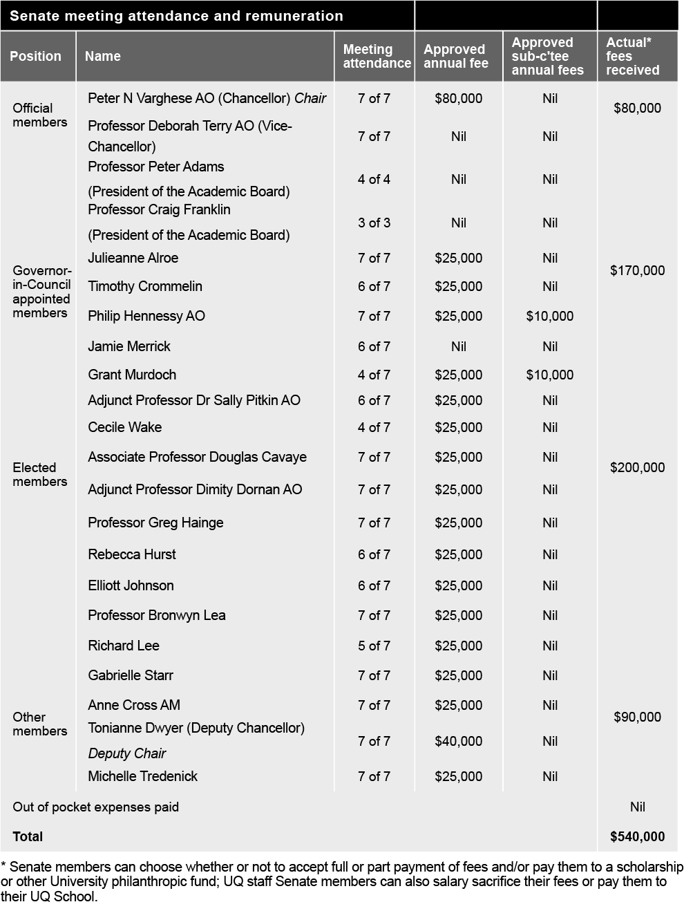

Executive management
While the Chancellor and Deputy Chancellor lead the University Senate, the Vice-Chancellor and President is the University’s Chief Executive Officer, responsible to Senate for overall strategic planning, finance and external affairs direction.
The Vice-Chancellor and President was supported in 2021 by the Senior Executive Team comprising:
    - Provost and Senior Vice-President
    - Deputy Vice-Chancellor (Academic)
    - Deputy Vice-Chancellor (Global Engagement)*
    - Deputy Vice-Chancellor (Research and Innovation)
    - Chief Operating Officer
    - Executive Dean, Faculty of Business, Economics and Law
    - Executive Dean, Faculty of Engineering, Architecture and Information Technology
    - Executive Dean, Faculty of Health and Behavioural Sciences
    - Executive Dean, Faculty of Humanities and Social Sciences
    - Executive Dean, Faculty of Medicine
    - Executive Dean, Faculty of Science
    - Director, Queensland Brain Institute (representing the research institutes).
The Senior Executive Team has responsibility for advising the Vice-Chancellor on whole-of-university management, strategic direction, budget setting, oversight of risk and assurance, and organisational culture.

* On 5 July 2021, this position was renamed from Deputy Vice-Chancellor (External Engagement) due to the refocusing of the role to broaden UQ's global reach and impact by enhancing engagement with a diverse range of overseas partners and prospective students.

Organisational structure / lines of responsibility

As at December 2021
Issued by the Office of the Chief Operating Officer
uq.edu.au/about/docs/org-chart.pdf

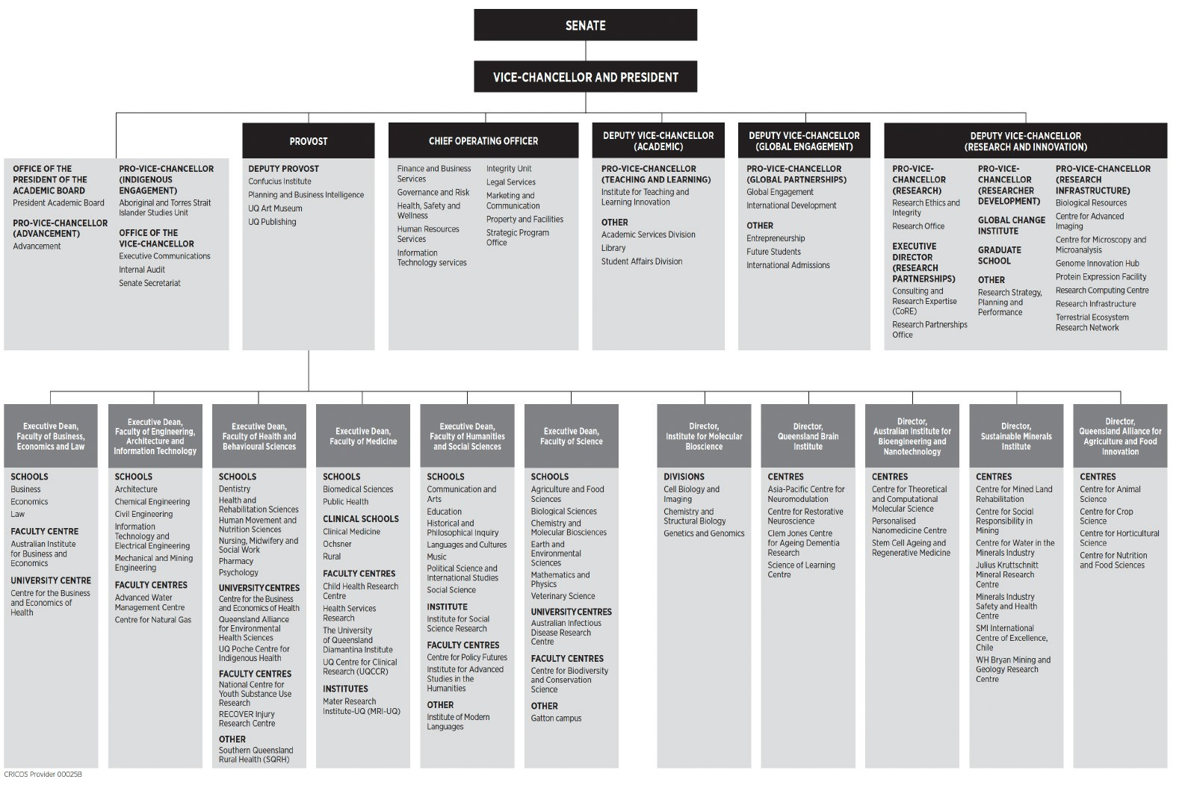

Public Sector Ethics
In terms of its obligations under the Public Sector Ethics Act 1994, the University has a Code of Conduct that sets out the expectations for University staff in relation
to professional conduct. All continuing and fixed-term staff are required to complete an assessable online course to learn how the Code of Conduct applies to them; casual staff are also strongly encouraged to complete the course.
The training is consistent with the University’s obligations under the Public Sector Ethics Act 1994, which requires the University to provide appropriate education about public sector ethics.
Given the high profile of the Code of Conduct, administrative procedures and management practices across the University reflect the objectives and
requirements set out. It is also referenced in position descriptions and offers of appointment, forms part of employee induction programs, and is incorporated into relevant training and development programs.
In 2021, the University commenced a review of the Code of Conduct to ensure it is fit for purpose, up to date and meeting the strategic needs of the University.
The review specifically considered the alignment of the current Code of Conduct with UQ’s Model Code for the Protection of Freedom of Speech and Academic Freedom and requirements under the Human Rights Act 2019. In accordance with the Public Sector Ethics Act 1994, the University will consult all staff and relevant stakeholders on the revised Code of Conduct in 2022.

Freedom of speech and academic freedom
The University of Queensland (UQ) has adopted a Model Code for the Protection of Freedom of Speech and Academic Freedom, which has been embedded in the University’s Governance and Management Framework. The hierarchy of UQ's legislative and policy framework establishes the Governance and Management Framework as an overarching university policy.
In the drafting, review and amendment of policies, UQ has regard for the Principles for the Protection of Freedom of Speech and Academic Freedom (the Principles), as set out in UQ’s Model Code.
The majority of policies that intersect most closely with the Principles have been reviewed to ensure consistency with the University’s commitment to the protection of freedom of speech and academic freedom. Reviews of remaining policies are anticipated to be finalised in the new year.
Further, freedom of speech and academic freedom have been incorporated as important concepts into UQ’s next Strategic Plan (for 2022–2025) and have informed the revision of UQ’s values.
Prior to approval, all new policies and policy amendments were reviewed for consistency with the commitment to the Principles for the Protection of Freedom of Speech and Academic Freedom.
Throughout the policy review process, where appropriate, advice was offered to policy owners about opportunities to strengthen provisions related to the Principles, and amendments were requested in cases where drafting was identified that may restrict freedom of speech or academic freedom at UQ.
As part of the process for reviewing policies for alignment with the Principles of the Model Code, a range of feedback was provided to policy owners for consideration prior to approval. As an example, amendments to policies were made to ensure that discretionary powers provided to decision-makers clearly precluded actions that could limit freedom of speech. Policies were also amended to remove references to preserving the reputation of the University as an expected standard of behaviour.
A statement from this process of review accompanied all policies approved, and
any new or amended policies in future will be reviewed to ensure alignment with the Principles of the Model Code.
Beyond the policy setting, the University partnered with the ABC to participate in a program in the Think Twice series, with the topic ‘Freedom of Speech in the Digital Age’, which explored freedom of speech on university campuses.
The University Senate recently received a presentation and discussion regarding the Ridd v James Cook University High Court of Australia decision, which included a briefing on the case, and its implications for the University’s policy environment.
Students are represented on all university committees that consider business associated with student experience. This includes the Academic Board, where considerable discussion on matters associated with freedom of speech and academic freedom has taken place.
Students were consulted in the development of a Student Code of Conduct, and regard was also had to the Principles of the Model Code. The University will continue to explore opportunities to engage closely with student representative bodies.
The University has recently delivered the inaugural Pulse Check survey of staff. The intent is to employ a staff survey annually. The University will explore the inclusion of questions that seek staff views on matters associated with academic freedom and freedom of speech in the future.
Qualitative responses in student surveys are closely monitored to ensure that any issues regarding freedom of speech and academic freedom can be identified and acted upon. The University will consider opportunities to seek student feedback on the management of freedom of speech and academic freedom on campus in the future.
The University’s Model Code was assessed as being aligned with the French Model Code. The Walker Review identified some minor areas the University could address. The University is considering the issues raised in the Walker Review as part of the review of the UQ Governance and Management Framework.
The governing body is not aware of any matters of concern regarding freedom of speech or academic freedom in the last year.

Risk management
The University has a Senate Risk and Audit Committee that assists Senate in discharging its risk management, and internal compliance and control oversight responsibilities.
The role of this committee is to oversee the University’s governance, risk and compliance frameworks, including policies, procedures, information systems, and systems of internal control surrounding key financial and operational processes.
The Committee also provides oversight of the leadership and direction in terms of organisational culture and ethical behaviour.
The Committee receives advice and assurance from senior management and Internal Audit across the following functions and activities:
- Enterprise Risk
- Occupational Health and Safety
- Governance
- Compliance
- Integrity and Investigations
- Research Integrity.
All members of the Senate Risk and Audit Committee are appointed by Senate. The Committee met 4 times during 2021 and the members were:
- Grant Murdoch, BCom Cant, MCom
Cant, FCA, FAlCD (Chair)
- Professor Peter Adams, BSc (Hons), BComm, PhD Qld (January–September)
- Anne Cross AM, BSocWk, MSocWk
Qld, FAICD
- Professor Craig Franklin, BSc (Hons), PhD Cant (October–December)
- Philip Hennessy AO, BBusAcc QUT (as Chair of Finance Committee)
- Elliott Johnson, BCom/BEcon Qld
- Michelle Tredenick, BSc Qld, FAICD
- Peter N Varghese AO, BA (Hons) Qld, H.DLitt Qld (Chancellor, ex officio).
No members were remunerated for their attendance apart from Grant Murdoch, who received $10,000 in his role as Chair.
UQ’s key risk management governance instruments are the Senate-approved Risk Appetite Statement and the Enterprise Risk Management Framework.
The Enterprise Risk Management Framework is built on and supported by 5 ‘pillars’:
- Senate’s expectations and risk appetite
- Management/leadership commitment and support for risk management function, organisational culture and relationships
- External compliance obligations relating to risk management
- Risk management objectives, strategies, delegated authority and accountabilities
- Risk management resources, plans, processes and activities.

The University has adopted a ‘3 lines’ assurance model as part of its governance, risk and compliance frameworks.
During 2021, the Committee provided direction and oversaw the following:
- Risk Appetite Statement (RAS): The new RAS and the related Risk Matrix were endorsed.
- Top risks: Reporting continued on the University’s top academic and non- academic risks, considering changes in both the internal and external environment, and progress reporting on the implementation of proposed new risk treatments.
- Emerging and existing risk developments: Reporting of significant emerging and existing risk developments took place, including deep dives of specific risk exposures.
- Significant programs and projects: A high-level performance summary report of UQ’s most significant programs
and projects highlighting status of the overall program or project and specific project aspects, e.g. project budget, schedule, scope, resources, etc, was prepared. The committee also received presentations and submissions on specific major programs and projects such as the HCMS project and the Building Cladding Replacement project.
- Research Integrity: Work continued on implementing further improvements
to the declaration process related to the management of conflict of interest
– including consultancy, secondary employment and internal work, and foreign influence.
- Health, safety and wellness: In addition to reviewing regular reports, Senate also received an annual report on occupational health and safety matters and their management for reference.
- Cybersecurity: There was a continued focus on cybersecurity risk management, in particular on
strengthening the University’s controls framework to mitigate this high-risk exposure.
The Senate Risk and Audit Committee has operated effectively as per its charter and had due regard to Treasury’s Audit Committee Guidelines.

Integrity Unit
The Integrity Unit is responsible for the management and conduct of investigations into breaches of policies, activities directed against the University and/or its people, misuse of public money and public
interest disclosures. The Unit also leads the delivery of misconduct prevention strategies, including training, information and advice.

The Director, Integrity Unit, reports administratively to the Chief Operating Officer and has direct access to the Vice- Chancellor and President, the Provost and Senior Vice-President, Chair – Senate Risk and Audit Committee, and Chancellor, as required.

Internal Audit
The Internal Audit function adds value by assisting Senate and University management to effectively execute their responsibilities by providing assurance on the effectiveness of governance, risk management and internal controls.
Internal Audit also assesses and provides assurance on the quality of financial, managerial and operating information, and whether resources are acquired economically, used efficiently and managed effectively.
Internal Audit operates under an Internal Audit Charter, last reviewed and approved by the Senate Risk and Audit Committee in November 2020. As per this Charter, the Internal Audit function is independent of management and, as such, has no direct responsibilities for, or authority over, any of the activities it audits.
Internal Audit reports functionally to the Senate Risk and Audit Committee and administratively to the Office of the
Vice-Chancellor, and has direct access to the Vice-Chancellor and President, Chair
- Senate Risk and Audit Committee, Chair
- Vice-Chancellor’s Risk and Compliance Committee, and Chancellor.
Internal Audit activities take into account applicable legislative requirements, such as the University of Queensland Act 1998, the Financial Accountability Act 2009, Financial and Performance Management Standard 2019 and Tertiary Education Quality and Standards Agency Act 2011 (TEQSA Act). Internal Audit activities also consider the Queensland Treasury Audit Committee Guidelines 2020. The University’s Internal Audit activity conforms with the International Standards for the Professional Practice of Internal Auditing and The Institute of Internal Auditors’ Code of Ethics.
An annual risk-based planning process is undertaken in consultation with

management, and the Annual Internal Audit Plan is approved by the Senate Risk and Audit Committee. During 2021, Internal Audit completed 17 engagements across the University, including assurance reviews, grant certifications, advisory services and the ongoing review of several large programs and projects.

Health, safety and wellness
In line with the University strategy for 2021, the key focus areas for Heath, Safety and Wellness (HSW) at UQ were:
  - Risk management
  - Systems and compliance
  - Culture and capabilities
  - Innovation
  - Enhancing wellbeing.

These focus areas help guide university activities towards reducing the health and safety risks to staff, students and visitors at the University to as low as reasonably practicable. Alongside support for the University COVID-19 response, cultural capability initiatives, and managing the staff wellness program, key HSW activities and achievements in 2021 included:
  - a review of the HSW Strategy 2017– 2021 and the development of the next strategy for 2022–2026
  - review of the University’s health and safety risk register and top health and safety risks list
  - continued support for building the capability of staff and students, with 64,030 completions of 26 online safety training modules, and 827 attendees at 17 instructor-led professional development sessions
  - the successful completion by the Work Injury Management team of the mid- term claims management audit and the workers’ compensation regulator accepting the mid-term audit of UQ’s WHS management systems: the
team assisted more than 140 injured workers in 2021, with 125 accepted claims
  - (78 work-related, 47 journey-related)
  - the successful conduct by the internal HSW audit program of 8 organisational HSW management systems audits, 12 local audits, and 143 audit corrective actions
  - successful launch of the early intervention injury management program, with 74 UQ staff participating
  - UQ Wellness events and health and safety events held in October to coincide with national Safe Work
Month, to provide a collective focus for the UQ community
- aligning all UQ biosecurity facilities to new legislation, a continual process that will strengthen and maintain linkages between the University and its relevant regulators
- auditing and certifying new facilities to conduct work with (i) genetically modified organisms as
authorised by the Office of the Gene Technology Regulator or (ii) imported biological material as required by
the Commonwealth Department of Agriculture, Water and the Environment
- assisting researchers and supporting the UQ Institutional Biosafety Committee and subcommittee to assess applications for work with genetically modified organisms or high-risk biological material, e.g. GM sorghum field trials, GM mosquitos, and COVID-related research
- continuing to promote and support staff health and wellbeing through UQ Wellness, the University's staff wellness program, using an
evidence-informed approach across the 4 key areas of lifestyle factors, psychological health, physical health, and organisational engagement
- continued provision of specialist HSW services to faculties and institutes, with 257 people on the health surveillance program and 167 people on the hearing conservation program
- a continued focus on proactive risk management and a strong
reporting culture, with 1,757 new risk assessments created and approved, and 1,323 incident and hazard reports via UQSafe.

Three safety-dedicated senior management risk committee meetings were scheduled during the year.
In 2021, UQ also made 21 notifications to regulators and was issued one improvement notice. From a cohort of more than 1,000 tertiary institutions globally, UQ was ranked number 8 in the
STARS Wellbeing category in the AASHE Sustainable Campus Index publication for its sustainability performance. UQ is the only non-North American university in the top 10.

UQ’s workers’ compensation function
All aspects of the University’s workers’ compensation operations are managed by the Work Injury Management team in the Health, Safety and Wellness Division, according to the provisions of the regulatory licence issued under the
Queensland Workers’ Compensation and Rehabilitation Act 2003. These operations include managing statutory injury claims and personal injury litigation claims, and managing the rehabilitation and return to work of injured workers. The University also manages the workers’ compensation risk of 7 of its controlled corporate entities.
2021 achievements were many:
- The University accepted 141 statutory claims and received 2 damages claims during the year. Claims involved a range of injuries including orthopaedic, neurological and psychological. The average time to evaluate and admit a claim was 1.7 days in 2021, compared to the Scheme average of 8.7 days.
- UQ continued to maintain a high level of customer service to injured workers, with emphasis on early intervention, efficient claims, and medical management, combined with an effective rehabilitation program
to return injured workers to full employment. In 2021, 100 per cent of workers who lodged a claim were
successfully returned to work, with the claim resolved. One court appeal was made by an injured worker against the regulator – the regulator upheld the UQ Work Injury Management decision to reject the worker’s application for workers' compensation. This appeal is ongoing.
- The work health and safety regulator continues to assess UQ as 'low
risk' across all 10 assessed criteria necessary to keep its self-insurance licence for workers’ compensation. These criteria include resources and systems, legislative compliance, licence compliance, privacy, business relationship, compliance with regulatory standards, perception of stakeholders, and workplace health and safety. (UQ’s self-insurance licence was renewed in 2019 for the maximum period of 4 years, following the successful fulfilment of the workers’ compensation regulator’s stringent criteria. The current licence expires on 31 March 2023.)
See also: Work/life balance pg35

Information systems and recordkeeping
The University continues to promote compliance with the Public Records Act 2002, Information Standard 18 (2018) and the ISO27001 information security management system.
In 2021, UQ made key system improvements to recordkeeping, information management, and security and information systems to support University objectives and priorities, including:
  - The Tertiary Collection of Student Information (TCSI) provides Services Australia with real-time student data to better support students’ claims. UQ began reporting curriculum data to the Department of Education, Skills and Employment in April and now reports student information directly to the ATO via TCSI.
  - The new human capital management system, Workday, was launched delivering Human Resources (HR) functionality. It provides a single source of core information for staff and integrates with many related processes and systems.
UQ continued work delivering components of the Information Governance and Management Framework, encapsulating the whole of University’s strategic intent for information governance. The Framework underpins the Information Management Policy released late 2019. Activities included:
  - implementation of Office 365 Sensitivity Labelling for all UQ staff
  - development, endorsement and release of UQ’s Enterprise Data Ethics Framework
  - development, release and communication of a data ethics portal, including training and self-assessment tools
  - increased compliance with UQ’s data and information legislative obligations
  - development of the Corporate Data Governance Operating Model, outlining the data governance and management expectations and decision rights for administrative data
  - completion of a comprehensive review of the information management policy and supporting procedures, to support information accountability, including
specific reference to recordkeeping and records lifecycle management under the broader and inclusive information governance program
- delivery of a data awareness campaign and staff development training aimed at increasing the data literacy of all UQ stakeholders
- oversight of records management approaches and compliance, moved to the Governance and Risk Division
(G&R) to better position the function for more seamless whole-of-organisation approaches in touch with overall University governance strategies
- establishment of a cross-functional Strategic Information Leaders’ Group focused on influencing and leveraging talent and resources for
growing information, records and data management maturity
- establishment of a comprehensive register of key University information processes and systems, inclusive of guidance on the records retention value, as part of the University’s growth in record keeping maturity to guide decisions prioritising high-risk, high-value and permanent value record capture and lifecycle management
- re-write of records disposal authorisation procedures reflecting growing maturity of the University in the lifecycle management of records contained within various information systems, including hybrid scenarios when paper and digital co-exist.
UQ also conducted a comprehensive cyber security improvement program that:
- delivered a cyber security awareness campaign, which decreased information security risk through changed behaviour, including procurement of a new cyber security training platform
- protected more services with multi- factor authentication (MFA)
- migrated the UQ email filter to a cloud service
- commissioned the Security Operations Centre Service delivered by AARNet for the university sector
- implemented a new software vulnerability management solution
- upgraded firewalling infrastructure.

Human rights
The Human Rights Act 2019 has been in operation since 1 January 2020, with its main objectives being to:
- protect and promote human rights
- help build a culture in the Queensland public sector that respects and promotes human rights
- help promote a dialogue about the nature, meaning and scope of human rights.

The University is committed to ensuring all decisions and actions taken are compatible with human rights. During 2021, the University continued to embed processes to ensure new or revised policies and procedures were compatible with human rights. Further decision-making training and resources were made available to UQ staff, which included tailored training in making decisions consistent with human rights.
In 2021, UQ received no new human rights complaints.

External scrutiny
No significant findings or issues about The University of Queensland were identified by a State entity in 2021.

Glossary

3MT Three Minute Thesis
AAHMS Australian Academy of Health and Medical Science
AAN American Academy of Nursing
AAS Australian Academy of Science
AASHE Association for the Advancement of Sustainability in Higher Education
AAUT Australian Awards for University Teaching
ACEMID Australian Centre of Excellence in Melanoma Imaging and Diagnoses
ACRF Australian Cancer Research Foundation
AGI Agricultural Institute: Australia
AIA Australian Institute of Architects
AIBN Australian Institute for Bioengineering and Nanotechnology
ANU Australian National University
ARC Australian Research Council
ARTU Aggregate Ranking of Top Universities ARWU Academic Ranking of World Universities ASA Astronomical Society of Australia
ASCB American Society of Cell Biology
ASSA Academy of Social Sciences in Australia
ATO Australian Taxation Office
ATSE Australian Academy of Technology and Engineering
AUIDF Australian Universities International Directors' Forum
AWA Australian Water Association
AWARE Amplify Women's Academic Research Equity
AWC Australian Writers' Centre
BEL Business, Economics and Law (Faculty of) CDF/L Career Development Framework/Learning CFO Chief Financial Officer
CGS Commonwealth Grant Scheme CNCI Category normalised citation impact COO Chief Operating Officer
CPD Continuing Professional Development
CQU Central Queensland University CRE Centre of Research Excellence CRI Collaborative Research Initiative
CSIRO Commonwealth Scientific and Industrial Research Organisation
DECRA Discovery Early Career Researcher Award
EAIT Engineering, Architecture and Information Technology (Faculty of)
EBITDA Earnings before interest, tax, depreciation and amortisation
edX – an online learning destination and MOOC provider, offering high-quality courses from
the world’s best universities and institutions to learners everywhere
EFTSL Equivalent full-time student load ERA Excellence in Research in Australia ESSA Exercise and Sports Science Australia
FEE-HELP – a federal government loan scheme that assists eligible fee-paying students to pay all or part of their tuition fees
FTE Full-time equivalent
G&R Governance and Risk
Go8 Group of Eight – a coalition of leading Australian universities intensive in research and comprehensive in general and professional education
HaSS Humanities and Social Sciences (Faculty of)
HCMS Human Capital Management Solution
HDR Higher degree by research – PhD, MPhil, DBiotech, DVCSc
HEA Higher Education Academy, a fellowship scheme to recognise outstanding teaching
HECS–HELP Higher Education Contribution Scheme–Higher Education Loan Program
HEW Higher Education Worker (professional staff classification level)
HiCi Highly cited (Clarivate Analytics awards)
HR Human Resources
HSW Health, Safety and Wellness
ICMJ Intercollegiate Meat Judging
ICTE Institute of Continuing and TESOL Education
IGCS International Gynecologic Cancer Society
IMB Institute for Molecular Bioscience
INDE InDesign (LaptrinhX)
InspireU – a tertiary aspiration-building program for Aboriginal and Torres Strait Islander secondary students, involving a series of residential camps
ISSR Institute for Social Science Research
IT Information Technology
ITaLI Institute of Teaching and Learning Innovation
JKMRC Julius Kruttschnitt Mineral Research Centre
KPI Key performance indicator
LGBTQIA+ Lesbian, gay, bisexual, transgender, queer/questioning, intersex and asexual
LSQ Life Sciences Queensland
MD Doctor of Medicine
MOOC Massive Open Online Course MRA Melanoma Research Alliance MRFF Medical Research Future Fund
mRNA Messenger RNA – a type of vaccine
NAIDOC National Aborigines and Islanders Day Observance Committee
NHMRC National Health and Medical Research Council
NPILF National Priorities and Industry Linkages Funding
OCD Obsessive-Compulsive Disorder PDL Pharmaceutical Defence Ltd PEP Professional entry pathways
PIA Planning Institute of Australia
PSA Pharmaceutical Society of Australia
QAAFI Queensland Alliance for Agriculture and Food Innovation
QBI Queensland Brain Institute
QILT Quality Indicators for Learning and Teaching
QIMR Queensland Institute of Medical Research
QS Quacquarelli Symonds (World University Rankings)
QUEX Queensland University/Exeter University
RAP Reconciliation Action Plan RAS Risk Appetite Statement RTP Research Training Program
SAGE Science in Australia Gender Equity
SEED Student Enrichment and Employability Development
SFC Shorter Form Credentials
SMI Sustainable Minerals Institute
SQHR Southern Queensland Rural Health
SRI Socially Responsible Investment
STARS Sustainability, Tracking, Assessment and Rating System
STEM/STEMM Science, technology, engineering and mathematics/and medicine

SWAN Scientific Women's Academic Network
TAFE Technical and Further Education
TCSI Tertiary Collection of Student Information
TESOL Teaching English to Speakers of Other Languages
The Act University of Queensland Act 1998 TMS The Minerals, Metals and Materials Society UNSW The University of New South Wales
UQ The University of Queensland
UQAM University of Queensland Art Museum
UQDI University of Queensland Diamantina Institute
UQIDAR Partnership between UQ and Indian Institute of Technology Delhi Academy of Research
UQP University of Queensland Press
UQ2U – blended learning experience for students
UQU University of Queensland Union
UQx – UQ’s participation in edX, developing MOOCs, researching online learning, and collaborating with partner institutes
USQ University of Southern Queensland WEHI Walter and Eliza Hall Institute (Victoria) WHS Workplace health and safety
WIL Work-integrated learning
WSSA Weed Science Society of America
WWL Who's Who Legal

Qualifications/Honorifics
Aberd Aberdeen, AC Companion of the Order of Australia, AdvMgmtProg Advanced Management Program, AM Member of the Order of Australia, ANU Australian National University, AO Officer of the Order of Australia, Auck Auckland, BA Bachelor of Arts, BBusAcc Bachelor of Business (Accountancy), BCom Bachelor of Commerce, BComm Bachelor of Communication, BE
Bachelor of Engineering, BEc/BEcon Bachelor of Economics, BEd Bachelor of Education, BJuris (Hons) Bachelor of Jurisprudence (Honours),
BSc Bachelor of Science, BSocWk Bachelor of Social Work, BSpTh Bachelor of Speech Therapy, Cant Canterbury, CpSp Certified
Practising Speech Pathologist, DipSpTh Diploma of Speech Therapy, DLitt Doctor of Letters, DUniv (Honoris Causa) Doctor of the University (honorary degree), ExecDevptProg Executive Development Program, FAA Fellow, Australian Academy of Science, FAHA Fellow, Australian Academy of the Humanities, FAICD Fellow, Australian Institute of Company Directors, FAPS Fellow, Australian Psychological Society, FASSA Fellow, Academy of the Social Sciences in Australia, FCA Financial Counselling Australia,
FQA/FQAAS Fellow, Queensland Academy of Arts and Sciences, FRACS Fellow of the Royal Australasian College of Surgeons, FRS Fellow, Royal Society, FSIA Fellow of the
Securities Institute of Australia, FSPAA Fellow, Speech Pathology Australia, FTSE Fellow of the Australian Academy of Technological Sciences and Engineering, GAICD Graduate Member of the Australian Institute of Company Directors, GCELead Graduate Certificate in Leadership, H/Hon Honorary, Hons Honours, JP (Qual) Justice of the Peace (Qualified), LLB Bachelor of Laws, LLD Doctor of Laws, LLM Master of Laws, LSLS Cert AVT Listening and Spoken Language Specialist Certified Auditory-Verbal Therapist, MA Master of Arts, MBBS Bachelor of Medicine/Bachelor of Surgery, MCom Master of Commerce, MidYsSch Middle Years Schooling, MSc Master of Science, MSocWk Master of Social Work, Nott Nottingham, OAM Medal of the Order of Australia, OBE Officer of the Order of the British Empire, PhD Doctor of Philosophy,
Qld Queensland, QUT Queensland University
of Technology, SFHEA Senior Fellow Higher Education Academy, USQ University of Southern Queensland, UWA University of Western Australia

ANNUAL REPORT 2021
The University of Queensland uq.edu.au

